CalcSurfHeight Procedure

CalcSurfHeight calculates SurfHeight grids along a coastline using Swell/Period, Swell2/Period2, WindWaveHgt, and the direction of the Wind grid. However, Swell2 and Period2 grids are not mandatory for CalcSurfHeight, to accommodate the situation where there is no secondary swell.
The procedure addresses changes in SurfHeight due to wave shoaling only. Changes in SurfHeight due to beach slope, refraction, diffraction and frictional differences are neglected. These parameters are neglected because they are sub GFE grid processes, and therefore cannot be adequately accounted for within the given infrastructure.
The procedure performs the following steps to make the SurfHeight grid.

Select timeRange and Acquire the grids
The user must select a desired timeRange in the SurfHeight grid.
CalcSurfHeight then retrieves Swell/Period, Swell2/Period2, WindWaveHgt, and the direction of the Wind grid. CalcSurfHeight does not require these grids to be the same time resolution.
CalcSurfHeight does not require a Swell2 and Period2.
The Swell/Swell2 grids are a vector (height, direction), while the WindWaveHgt grid and the direction of the Wind grid are used to make a third vector grid (WindWaveHgt, Wind direction).
NOTE: CalcSurfHeight creates a SurfHeight Grid with the same time resolution as the Swell grids.

Normalize the Swell, Swell2 and WindWaveHgt Vectors
All three vector grids are “normalized” based on the local topography. Swells and wind waves moving parallel to a coastline contribute much less to breaking surf height than swells or wind waves normal to the coastline, which contribute greatly to the surf height. To account for this, the normalization process calculates the dot product of the swell vector and the topography gradient.

Unfortunately, calculating the topography gradient using an unmodified version of the topography grid produces poor results. Some areas of a particular coastline slope gently toward the water, while other areas slope more steeply. This would ultimately reduce the wave height over the shallow sloped coastline, and artificially increase wave height values over steeply sloped coastlines. To compensate, we make a copy of the topography grid and assign an arbitrary value (e.g., 1000 feet) to every point above sea level (greater than zero). This produces a grid that accurately captures the directional orientation of the coastline while disregarding its actual slope over land. The figure below illustrates this technique.

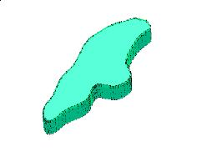
This grid is then smoothed with a simple 9-point filter to create a smooth slope with a direction normal to the coastline. Finally we calculate the vector gradient of this “topography” grid to get a representative orientation of the coastline with respect to the ocean.
Next, we calculate the dot product of the topography gradient (above) and the swell vector. The result is a new grid that represents how much each wave field (primary swell, secondary swell, and wind-wave) affects a particular part of the coastline. The figure below illustrates this concept.

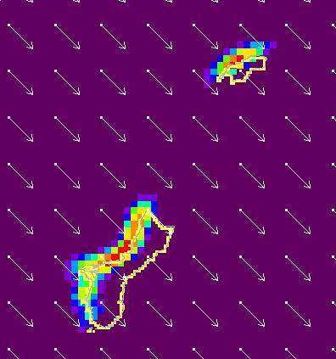
In the figure above, the arrows represent the magnitude and direction of a swell while the colors indicate the relative contribution of that swell to the wave height. Note that the bright colors (red, yellow) on the waveward (i.e. windward) side of the island show a greater contribution from the northwest swell on the northwest side of the island. Negative values on the leeward side (southeast) of the island are clipped at zero so that this side of the island does not contribute to the normalized wave height grid.

Three temporary grids are created so one can check the values of the normalizedSwell, normalizedSwell2 and normWindWave wave grids.

Calculate the temporary SurfHeight Grids: SurfHeightfromSwell, SurfHeightfromSwell2, SurfHeightfromWindWave
CalcSurfHeight now has three normalized wave fields from the Swell, Swell2 and WindWaveHgt grids. These three wave fields are considered deep water waves. As these waves approach the shoreline, they begin to feel the bottom of the ocean. Eventually, the water is shallow enough for the waves to break, creating surf. This process of the wave speed and wavelength decreasing as wave height is increasing, is termed wave shoaling. CalcSurfHeight uses the parameters that have been shown to have the largest impact on surf heights (deep water swell period, height, and direction) to estimate the surf height (Coastal Engineering Manual, 2003).
CalcSurHeight calculates three separate temporary SurfHeight Grids from the normalized wave fields (Swell, Swell2, WindWave) using the Komar and Gaughan (1973) shoaling index. Komar and Gaughan (1973) derived this semi-empirical relationship for surf height from linear wave theory. The coefficient 0.56 was determined empirically from laboratory and field data.

Shoaling Index = 0.56 * (normalizedSwell/1.56(Period*Period))^(-.2)

There are many studies that have established shoaling indices based on wavelength, deep water swell height, and beach slope (e.g. Munk (1949), Iversen (1952), Goda (1970), Weggel (1972), Komar and Gaughan (1973), Singamsetti and Wind (1980), Sunamura (1980), and Smith and Kraus (1991)).

NOTE: WFO Eureka has found the Munk (1949) method to be most useful for their coastal zone. This index has been included in CalcSurfHeight code, commented out below Komar and Gaughan (1973). CalcSurfHeight can be easily configured to evoke the best shoaling index for each coastal zone.

Calculate the SurfHeight Grid
CalcSurfHeight takes the maximum SurfHeight from the SurfHeightfromSwell, SurfHeightfromSwell2 and SurfHeightfromWindWave grids, and assigns that value to the SurfHeight Grid. Therefore, for each gridpoint, the Swell which was giving that gridpoint the largest SurfHeight, is the value returned.

NOTE: There will be times when more than one wave field is affecting a particular gridpoint. For example, if the Swell2 and the WindWave are both from the same direction, there could be instances of constructive interference between the wave fields resulting in slightly larger SurfHeights. CalcSurfHeight does not account for constructive or destructive interference between separate wave fields.

Mask Out Areas Over Land
The final step is to set the surfGrid to zero for all grid points over land and all grid points that are not actually touching the shore. The only gridpoints left are those that are closest to land.

Result
The final result of the procedure is a SurfHeight grid for grid points along the coastline. The SurfHeight Grid will have the same time resolution as the Swell grids, and will populate the selected timeRange.

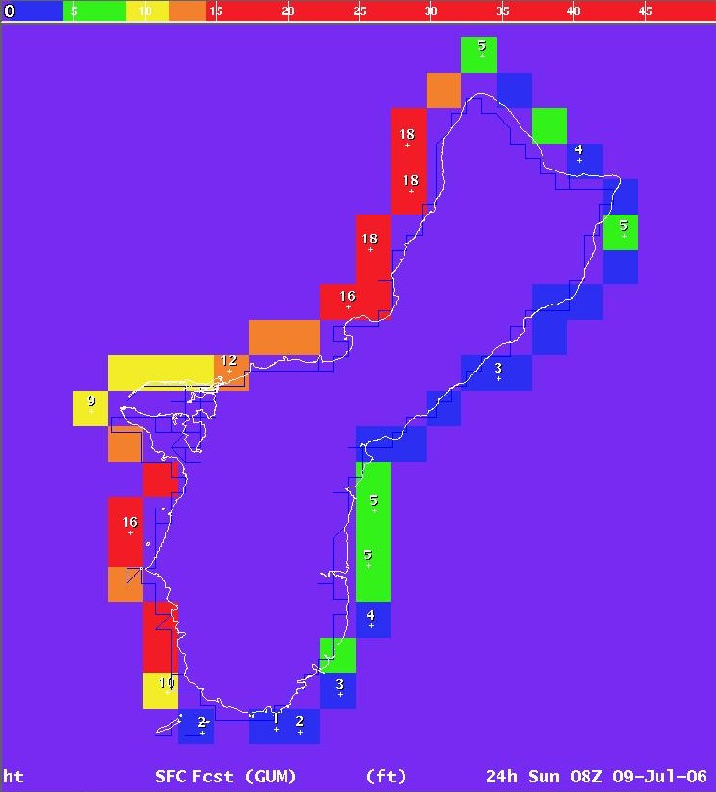

Installing the Procedure
Before installing the Procedure, it is necessary to add the SurfHeight grid to the FCST database. For detailed information on how to add the SCALAR Weather Element, SurfHeight, to your FCST database read "Syntax for localConfig.py" under the Server Configuration section of the GFESuite Documentation available at:
http://www-md.fsl.noaa.gov/eft/AWIPS/17e/onlinehelp/GFESuiteDoc.html

A copy of GFE_module_installer.sh, authored by Paul Jendrowski, has been included in the distribution for convenience. To use it, utar the SurfTool.tar file included with this distribution in a directory. Then run the GFE_module_installer to install the CalcSurfHeight.py file. For more information on the GFE_module_installer see the web page at:

http://140.90.90.253/~applications/LAD/generalappinfoout.php3?appnum=1389

If you choose not to use the GFE_module_installer, you can install these files by hand using the ifpServerText command. Type ifpServerText in the gfe bin directory for more information.

References

Coastal Engineering Manual – Part II: 2003. US Army Corps of Engineers: EM 1110-2-100, Chapter 4, pp 1-6.
Goda, Y: 1970. A Synthesis of Breaker Indices. Transactions of the Japan Society of Civil Engineers,Vol 2, Part 2, pp 227-230.
Iversen, H. W.: 1952. Waves and Breakers in Shoaling Water. Proceedings of the 3rd Coastal Engineering Conference, American Society of Civil Engineers, pp 1-12.
Komar, P. D., and Gaughan, M. K.: 1973. Airy Wave Theory and Breaker Height Prediction. Proceedings of the 13th Coastal Engineering Conference, American Society of Civil Engineers, pp 405-418.
Munk, W. H.: 1949. The Solitary Wave Theory and Its Applications to Surf Problems. Annals of the New York Academy of Sciences, Vol 51, pp 376-462.
Singamsetti, S. R., and Wind, H. G.: 1980. Characteristics of Breaking and Shoaling Periodic Waves Normally Incident on to Plane Beaches of Constant Slope. Report M1371, Delft Hydraulic Laboratory, Delft, The Netherlands.
Smith, E. R., and Kraus, N. C.: 1991. Laboratory Study of Wave-Breaking Over Bars and Artificial Reefs. Journal of Waterway, Port, Coastal, and Ocean Engineering, Vol 117, No. 4, pp 307-325.
Sunamura, T.: 1980. A Laboratory Study of Offshore Transport of Sediment and a Model for Eroding Beaches. Proceedings of the 17th Coastal Engineering Conference, American Society of Civil Engineers, pp 1051-1070.
Weggel, J. R.: 1972. Maximum Breaker Height. Journal of Waterways, Harbors and Coastal Engineering Division, Vol 98, No. WW4, pp 529-548.

