




Supervisor | Miss Aqsa Ahmed
Batch | PR2-202211B1+10B+09B
Group | A
Serial No. | Enrollment Number | Student’s Name
1. | Student1427029 | Jaffer Junaidi
2. | Student1435824 | Muhammad Ahrar
3. | Student1434308 | Saadequain Yousuf Khan
4. | Student1364034 | Waqas Bhatti
5. | Student1419626 | Muhammad Salman Naseer

Table of Content

- Table of Contents.……………………………….…….……………...1
- Certificate of Completion……….………………………….….……....2
- Acknowledgement………………………………………….……...….3
- Problem Statement….………………………………………………...4
- Functional Requirements.……………………………………...………4-5
- Non-Functional Requirements.…………………………………………6-7
- Hardware and Software Requirements………….…….….……………...7
- Project Synopsis…………………………………….………………...8
- EduPredict Features ……………………………..…….……………..8
- EduPredict Dashboard…………….………………….…….…..……..9
- Flow Chart and Data Flow…...………………....………….….…..…....10
- Test Data Used in the Project ……………………….…………………11

Certificate of Completion

This is to certify that Jaffer Junaidi, Muhammad Ahrar, Saadequain Yousuf Khan, Waqas Bhatti, Muhammad Salman Naseer have successfully completed their ACCP Prime 2.0
Semester VI E-Project.

Submitted to: Aptech Computer Education
On
November 16th, 2025

Acknowledgement

First of all, we would like to thank Almighty Allah for giving us strength and ability to complete this project and then, we would like to acknowledge all those who have given moral support and helped us make the project a success we would like to express my special thanks of gratitude to our teacher Miss Aqsa Ahmed who guided us on the project EduPredict, which also helped us in doing a lot of new learning and we came to know about so many new things we are really thankful to her.
We are highly thankful to Miss Aqsa Ahmed for giving us brilliant guidance and constant supervision as well as for her support in completing the project. Lastly, we would also like to thank our parents and friends who helped us a lot in finalizing this project within the limited time frame. We also express our sincere gratitude to E-Project team from Aptech Head Office, for their valuable guidance and support for the completion of this project. We earnestly hope that this project will provide all the necessary information required by the user to fulfill his/her inspiration. However, suggestion and feedbacks for improvements will be thankfully welcomed & acknowledged.
Problem Statement
Education institutions worldwide face numerous challenges, such as declining student retention rates, inefficient resource allocation, and the need to personalize learning experiences. At the same time, advancements in technology and data availability present significant opportunities to address these challenges through data-driven approaches. By leveraging the capabilities of Hadoop and predictive analytics, EduPredict aims to overcome these challenges, capitalize on data-driven opportunities, and ultimately enhance the educational experience for the students.

Functional Requirements

The EduPredict is to be created based on the following requirements.

User Authentication and Authorization:

Implement a secure authentication system for users with different roles, such as an administrator,
teachers, students, and analysts. Define access controls to restrict data access based on user roles and responsibilities.

Data Ingestion:

The system should support the ingestion of diverse educational datasets, including academic records, student demographics, LMS data, and attendance records. Implement mechanisms to handle both historical and real-time data sources. Ensure compatibility with common data formats used in education.

Data Storage:

Utilize the Hadoop Distributed File System (HDFS) for scalable and fault-tolerant storage of large educational datasets. Implement data partitioning and organization strategies optimize retrieval and processing.

Data Processing:

Implement parallel processing of educational data to handle large datasets efficiently. Develop algorithms for identifying patterns, anomalies, and correlations in educational data. Include mechanisms to handle missing or incomplete data gracefully.

Real-time Data Processing:

Integrate real-time data streaming capabilities. Ensure seamless integration with batch processing for a comprehensive analysis.

Machine Learning Models:

Develop machine learning models for a predictive analysis of student performance, dropout rates,
and course demand. Include algorithms for anomaly detection, trend prediction and analysis. Regularly update and refine models based on the latest available data.

Data Visualization:

Create interactive dashboards for visualizing key metrics and predictions. Develop visual representations of student performance patterns, anomalies, and predictions. Provide customizable and user-friendly interfaces for stakeholders to explore data.

Notifications and Alerts:

Set up automated notifications and alerts for stakeholders based on the predefined thresholds for
academic anomalies or significant events. Enable configurable alerting mechanisms to notify users in real-time.

Feedback and Support:

A support system for users to contact for assistance, report issues, and provide feedback.

Non-Functional Requirements

Performance:

The system must handle large volumes of data with minimal latency to ensure timely analysis and reporting. Implement monitoring tools to track system performance, resource utilization, and data processing times. Include optimization strategies for enhancing the overall efficiency of the system.

Data Security:

Implement encryption mechanisms to secure sensitive educational data during storage and transmission. Ensure compliance with relevant data protection regulations and standards.

Data Integrity:

Ensure the accuracy and consistency of data throughout its lifecycle. Implement mechanisms to handle missing or incomplete data gracefully.

Reliability:

Uptime the application should aim for a minimum of 99% uptime, with scheduled maintenance communicated in advance.

Data Backup:
Regular automated data backups must be performed to prevent data loss in case of system failures.

Scalability:
The architecture should support horizontal scaling to accommodate increased data volumes and processing demands. Implement load balancing mechanisms for optimal resource utilization.

Performance Monitoring:
Implement monitoring tools to track system performance, resource utilization, and data processing times. Include optimization strategies for enhancing the overall efficiency of the system.

Compliance and Standards:
Ensure adherence to relevant environmental data standards and protocols. Comply with industry best practices for big data processing and analytics.

Hardware and Software Requirements

Hardware
- Minimum i5 with 4 Cores but i7 is recommended.
- 16 GB of RAM
- 500 GB of SSD storage
- Graphics Card
- 64Bit Windows 10 or higher

Operating System
- Linux/ MacOS/ Windows 10 home (or higher if possible)

Software
- Jupiter Anaconda Notebook 3
- RStudio
- Visual Code Studio / PyCharm
- Mongo Db Compass, and Shell
- Hadoop, HDFS and Apache server
- Tableau
- Impala server

Project Synopsis
EduPredict is a data-driven educational analytics system designed to improve student learning outcomes through predictive insights. By using Hadoop, HDFS, and machine learning, it processes large volumes of academic, demographic, and behavioral data to identify patterns and predict performance trends. The system supports secure user authentication, scalable data storage, and real-time analytics for timely decision-making. Interactive dashboards in Tableau provide visual insights for teachers, administrators, and analysts. Predictive models forecast dropout risks, course demand, and academic anomalies, helping institutions take proactive action. EduPredict ensures data security, reliability, and compliance with educational standards.

EduPredict Features

EduPredict offers a comprehensive set of features that make educational data analysis efficient and insightful. It provides secure user authentication with role-based access for administrators, teachers, students, and analysts. The system supports large-scale data ingestion from multiple sources such as attendance, LMS, and academic records. Using Hadoop and HDFS, it ensures scalable and reliable data storage with fast retrieval. Advanced machine learning models enable predictive analysis for student performance, dropout trends, and course demand. Real-time data streaming allows continuous updates for accurate insights. Interactive dashboards in Tableau present visual summaries and key performance indicators for easy interpretation. Automated alerts and feedback options keep users informed and engaged throughout the learning analytics process.

EduPredict Dashboard
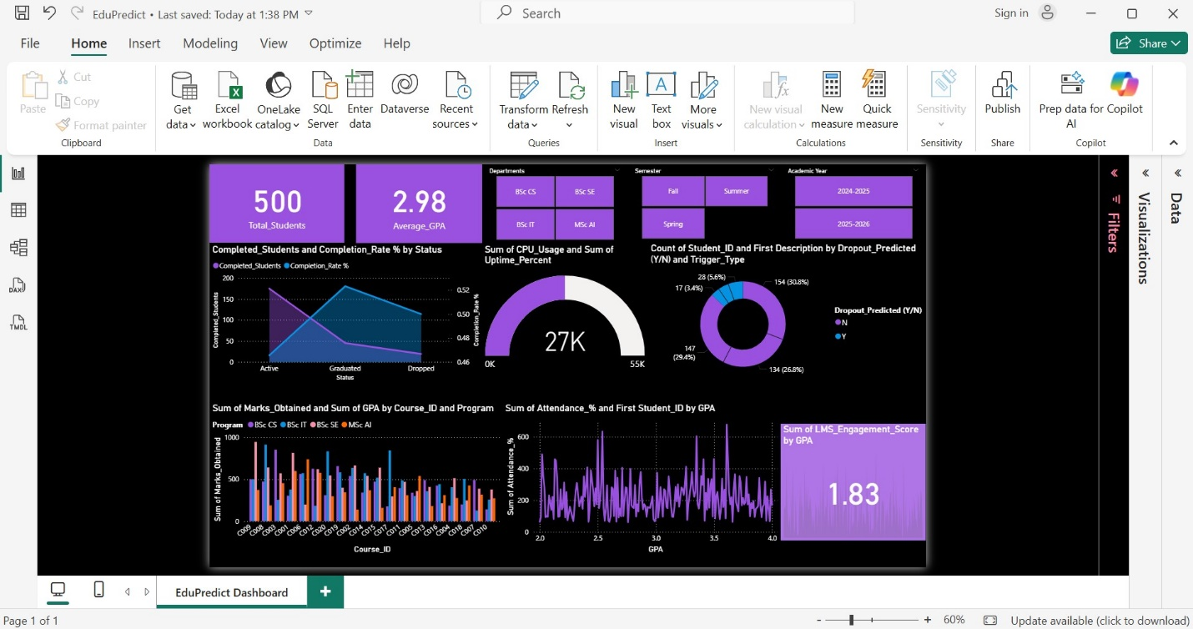

Flow Chart and Data Flow

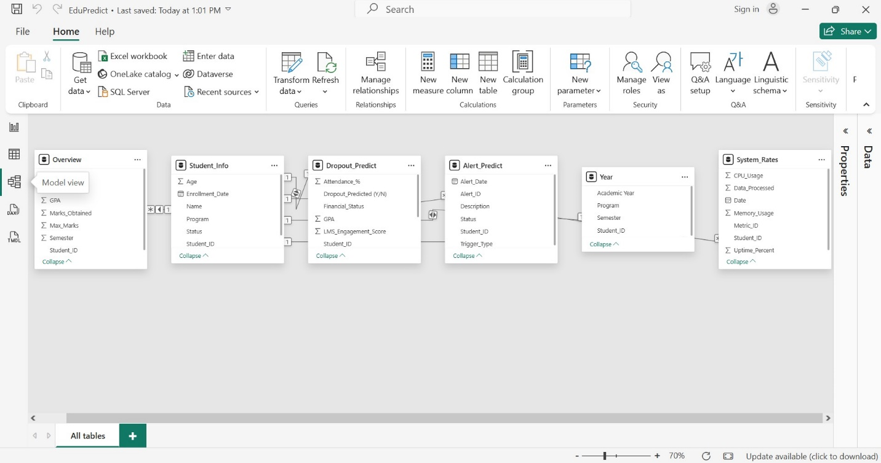

Test Data Used in Project

