University of Kentucky
Center on Trauma and Children
Certificate of Completion
This certifies that
<<NAME>>
is awarded <<HOURS>> out of <<TOTALHOURS>> Continuing Education Hours for:
<<TRAINING>>
on <<DATE>>, <<LOCATION>>
Trainer: <<TRAINER>>
Approval Statements: <<CEU_APPROVALS>>
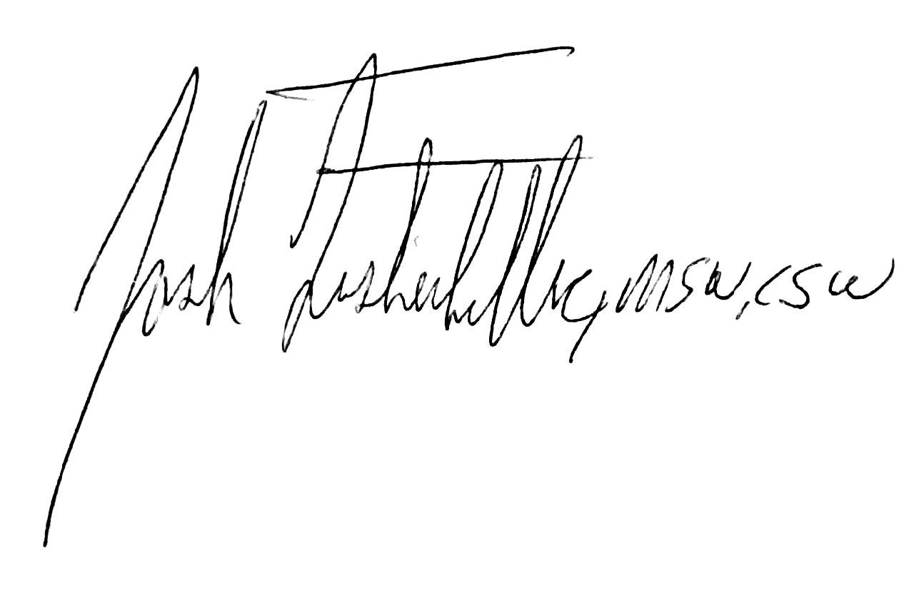
Josh Fisherkeller, MSW
Training and Education Manager
University of Kentucky Center on Trauma and Children

