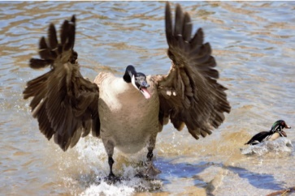**Design Document – *Don’t Hit the Goose***

* **High Concept:** In *Don’t Hit the Goose,* players use their reaction time and speed to avoid hitting Canadian geese on the highway.
* **Player Experience Goals:** The purpose of this game is to have players feel satisfied using their reaction times and speed to defeat the opposing player. The overall feel of the game should be tense and very competitive, as players are forced to wait and react to the dealt card correctly.
* **Rules:**

1. There are 2 Drivers and 1 Dealer.
2. The Dealer simply deals out a card, while the Drivers hit either the “Swerve” or “Hit” button.
3. Each Driver puts a “Swerve” on their left/right, and a “Hit” button on the opposite side.
4. The Dealer deals out a card and puts it in between both players.
5. If the card is a Goose, the player must hit their “Swerve” button. If it’s not a Goose, the player must hit their “Hit” button.
6. The slowest player hitting the “Swerve” button when a Goose is dealt gets a ticket; and if a player hits the “Swerve” button whenever the card dealt is not a Goose also gets a ticket. If the player doesn’t hit the “Hit” button before the next card is dealt, and the card is not a Goose, they also get a ticket.
7. In the case of a tie or when there are no cards left, bring all remaining cards back into the Dealer’s hand and shuffle the deck.
8. If a player receives 3 tickets, they lose.

* **Resources:** 3 or more players are required to play the game. Players need 4 buttons in total and a set of at least 15 cards containing 6 geese. Both of these can be made with paper.
* **Play time:** The play time should be around 5 minutes.
* **Strategies:** Given the simple nature of this game, the strategies wouldn’t be too complex. The simplest strategy I can think of is players preparing themselves to move their hand as the dealer puts the card down. Another strategy I could see being employed is players putting the “Swerve” button on their dominant side, so that they can hit the button quicker.