**cppdynamic**

1. install biicode
2. Create a new project:
   1. bii init dyn
   2. cd dyn
   3. bii new jafroch/cppdynamic
3. Clone in our new project our github fork:
   1. cd blocks/jafroch/cppdynamic
   2. git clone [https://github.com/jafroch/cppdynamic](https://github.com/jafroch/cppdynamichttps://github.com/jafroch/cppdynamic) .
   3. find dependencies:
   4. bii deps
   5. 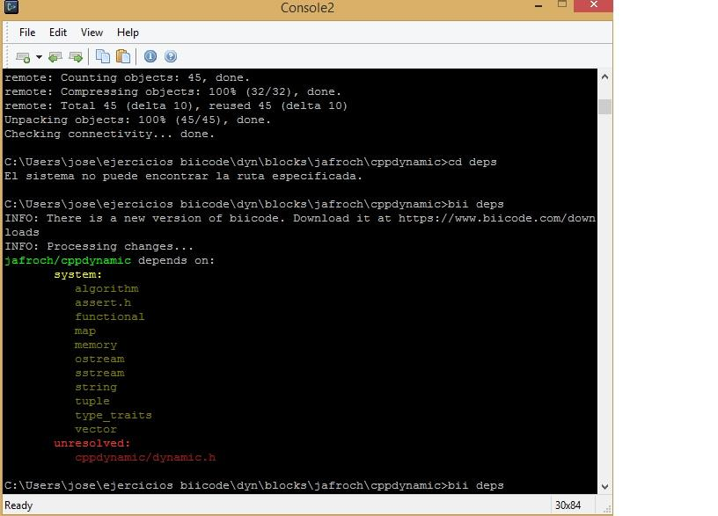
   6. add file <bii/paths.bii>, and write inside “include/”
   7. 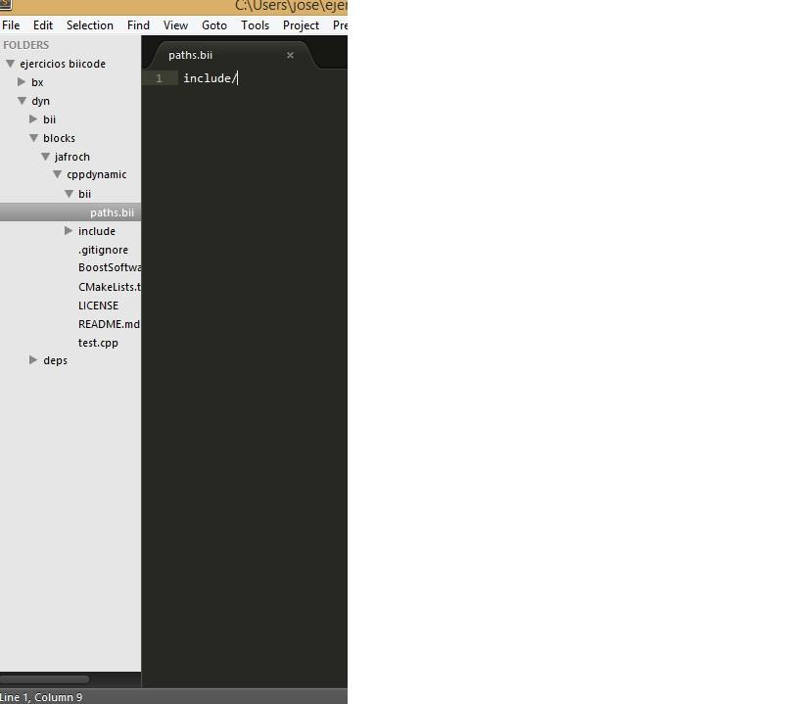
   8. Check dependencies again: bii deps
   9. 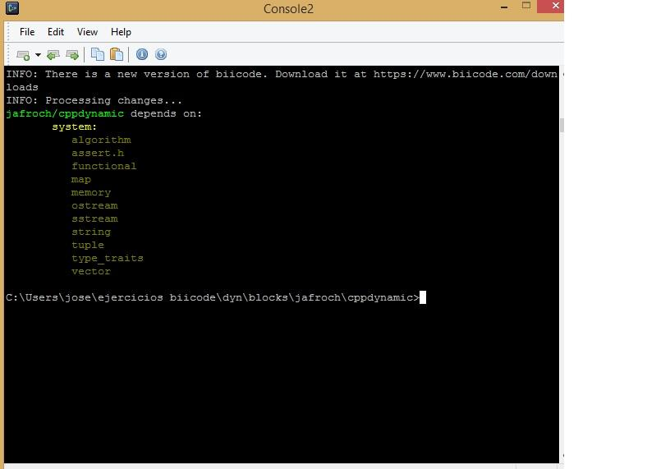
4. Edit cmake:

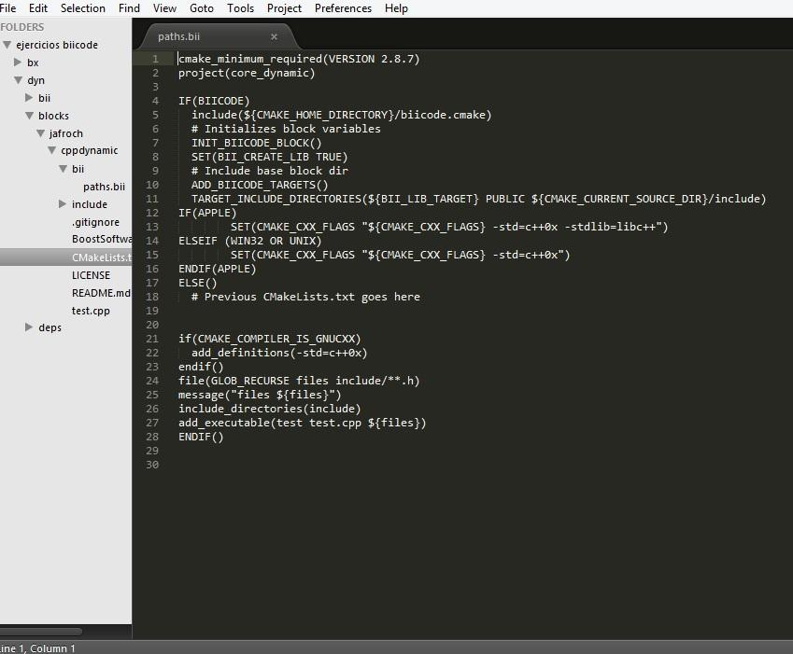

#Vemos que hay que usar c++0x ya que en el anmtiguo cmake es el que usa.

1. Check if it builds:
   1. bii cpp:build
   2. 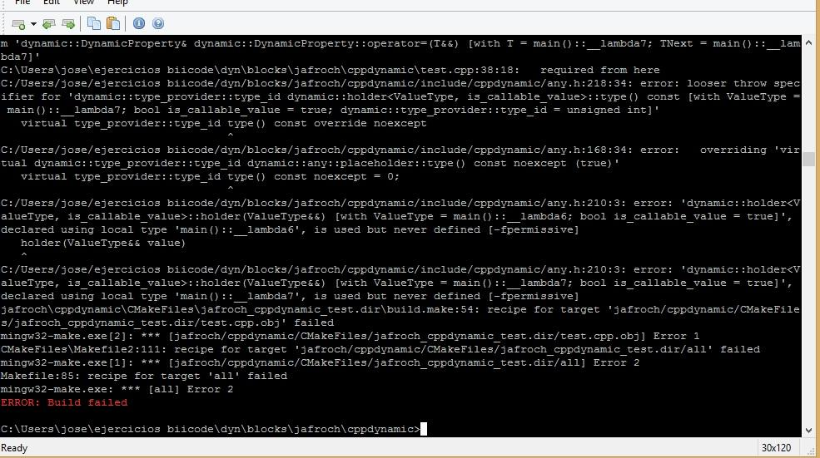
   3. As we see there is an error in file includes/cppdynamic/any.h, open it and correct the line 218:
   4. 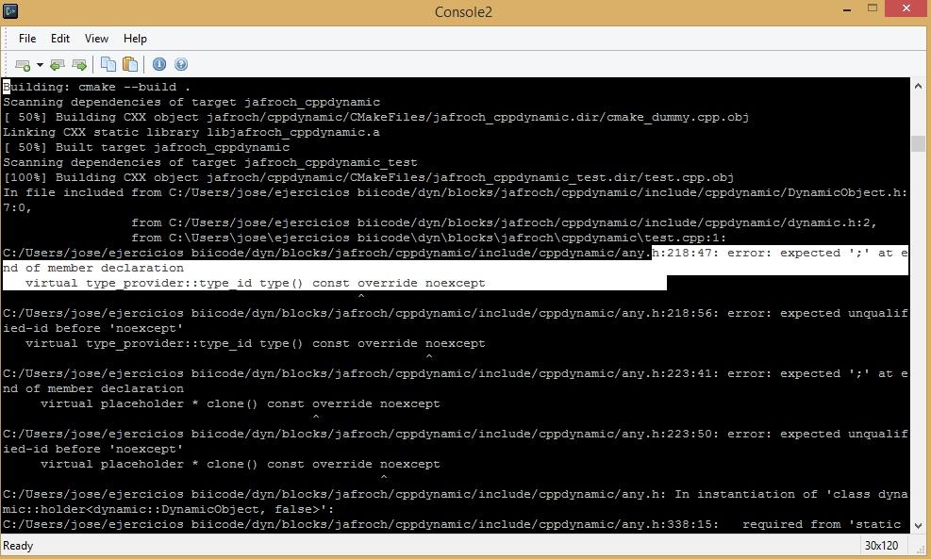

virtual type_provider::type_id type() const override noexcept ->virtual type_provider::type_id type() const noexcept override

virtual placeholder * clone() const override noexcept -> virtual placeholder * clone() const noexcept override

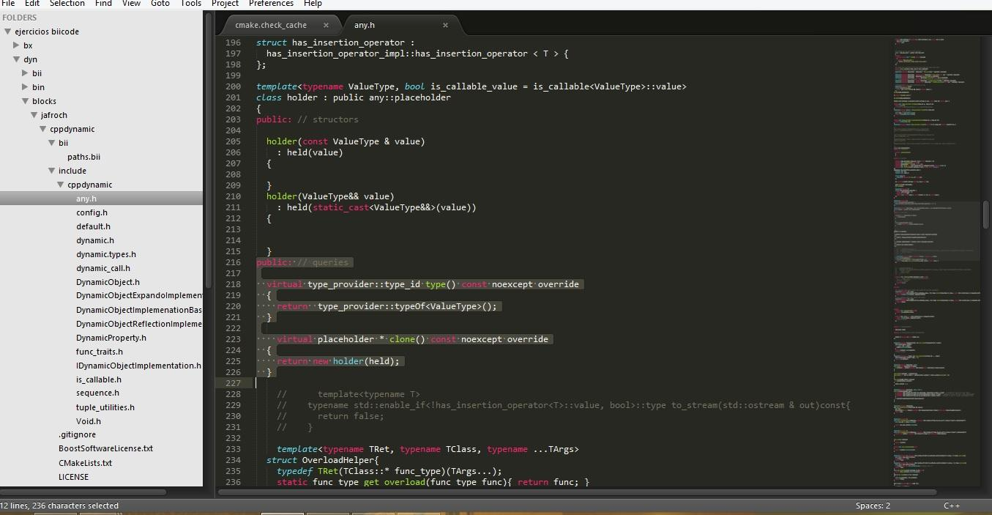

1. Build again, it works now.
2. Exec test-file. (inside dir /dyn/bin)
3. jafroch_cppdynamic_test
4. This test only shows how can be used the Dynamic variables, there is no output so we wont see anything on console, we have to check test.cpp to see how it works.