**Documentation**

For this Project I have launch infrastructure through Terraform as code was provide above i have created a VPC, Route table, Route53, Ec2(Ubuntu 18.04), 2 public subnets Internet gateway and Elastic Load balancer

once we SSH into the machine it came up with the docker and nginx server installed in a container as we already mentioned in the script along with the terraform

My goal in this project is to server the static content in a text file which shows the version Num 1.0.6 for achieving this i need to make some changes in the nginx configuration file as we already know by default nginx goes to the /var/www/html looks for the static content in this path we add a directory named version and add index.txt file which serves our version num after this I changed the configuration in /etc/nginx/sites-enabled editing the default file by adding our version directory and index.txt. restart the nginx server we come up with version num 1.0.6

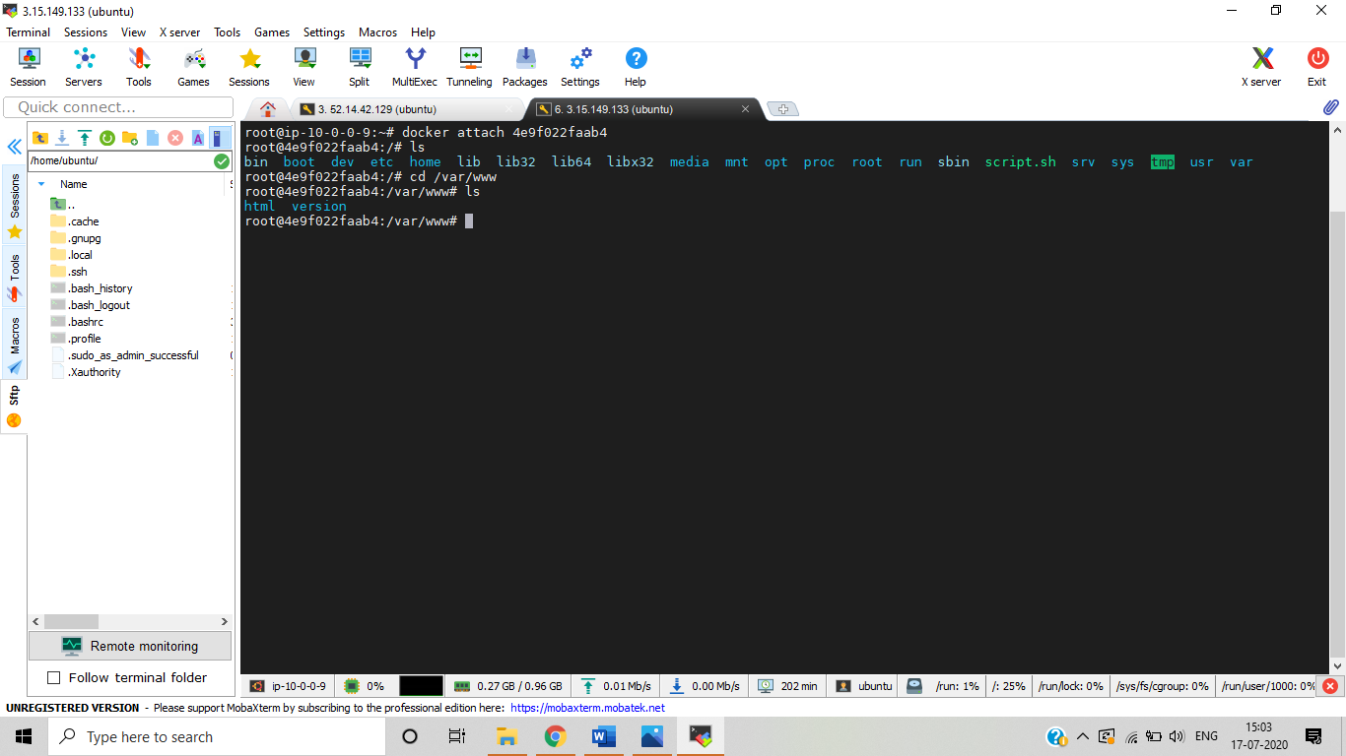

As I do some modifications in /etc/nginx/sites-enabled and edit the default file

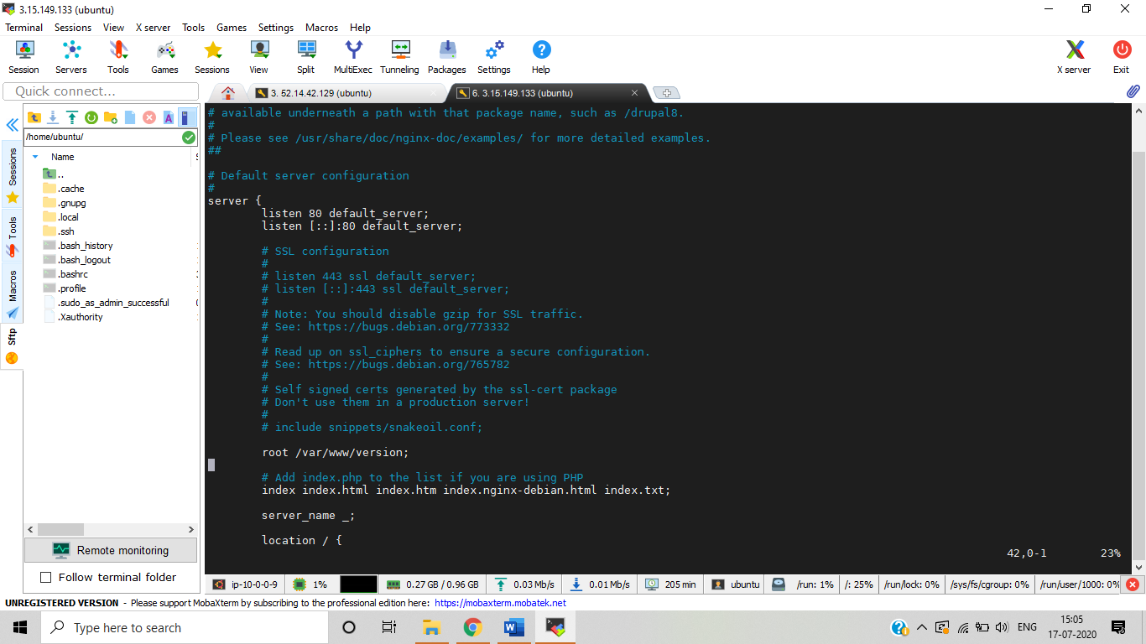

I have made a bash script which runs every 60 sec to check the server is up and serving with the version num 1.0.6

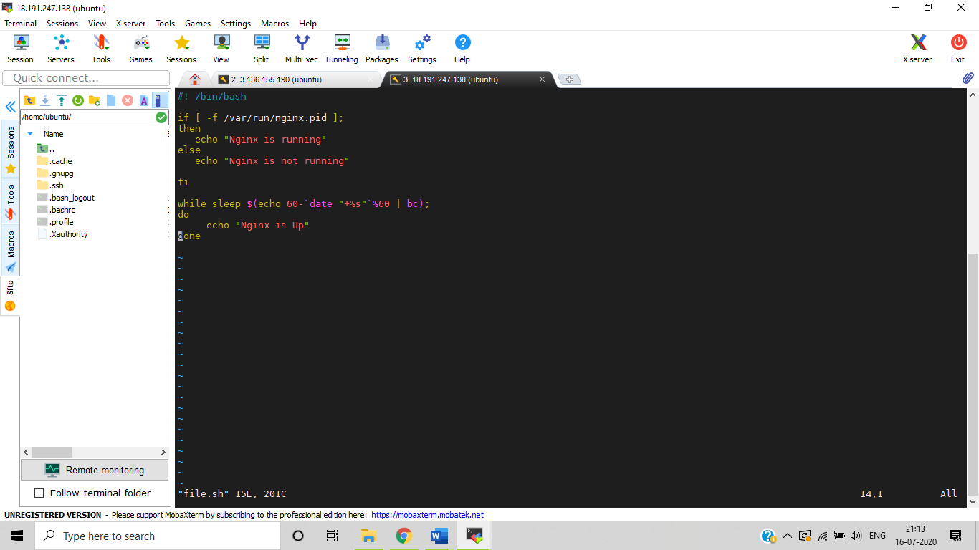

**Output of the script**

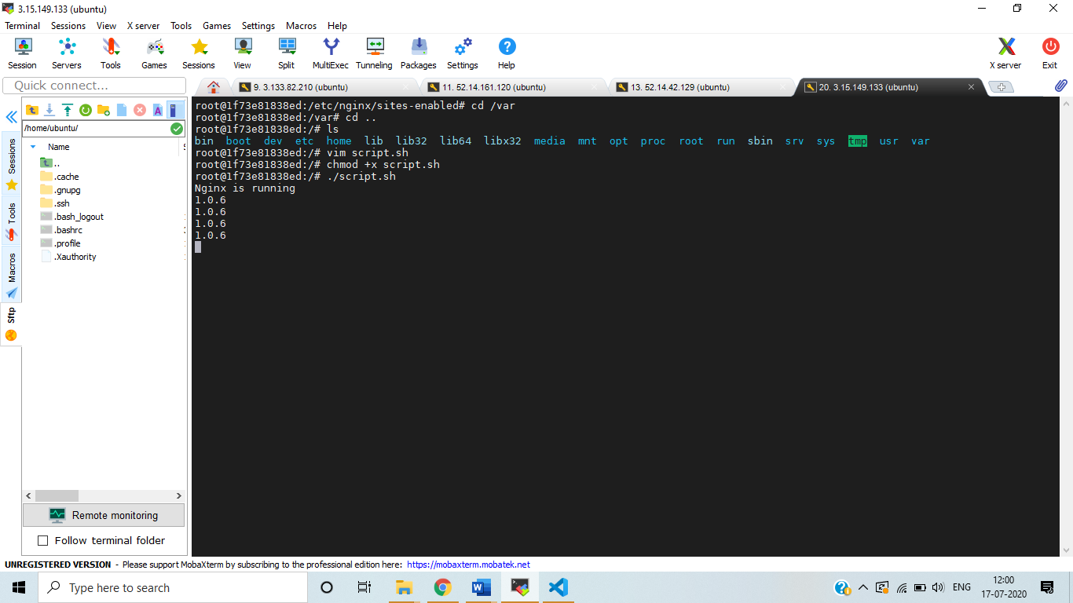

**SSL certificate**

for achieving SSL certificates i used certbot commands, i made my container to run on 90 port i enabled nginx reverse proxy in host machine, so it directs the traffic receive from host machine to the container port

I have created a free domain in freenom.com and I created record sets in route53

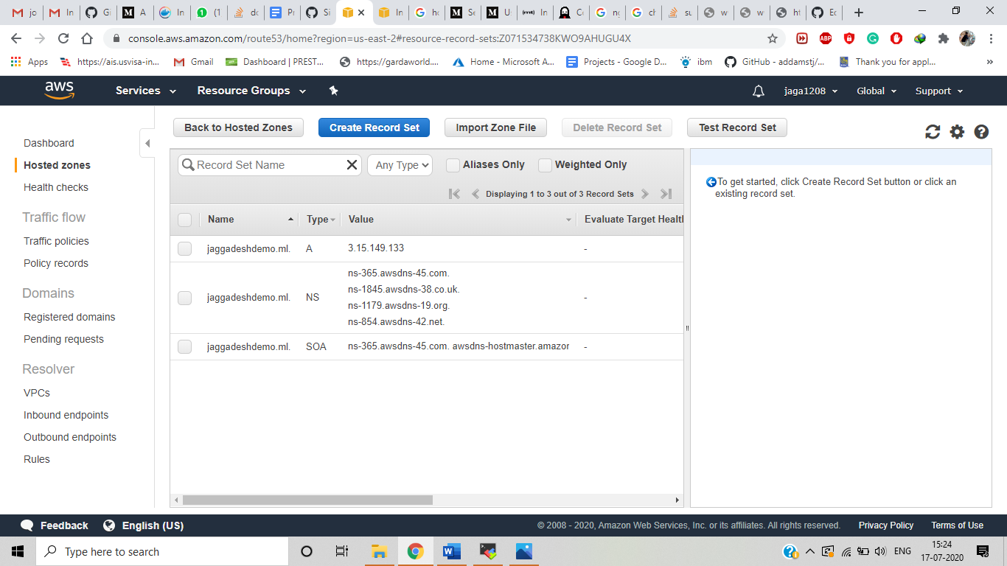

**steps to achieve SSL**

1. ADD Certbot PPA by following commands

$ sudo apt-get update

$ sudo apt-get install software-properties-common

$ sudo add-apt-repository ppa:certbot/certbot

1. Install certbot

$ sudo apt -get install certbot python3-certbot-nginx

1. Run certbot

Sudo certbot – nginx

For reverse Proxy we need to create a file under /etc/ngnix/sites-enabled

Reverse proxy .conf

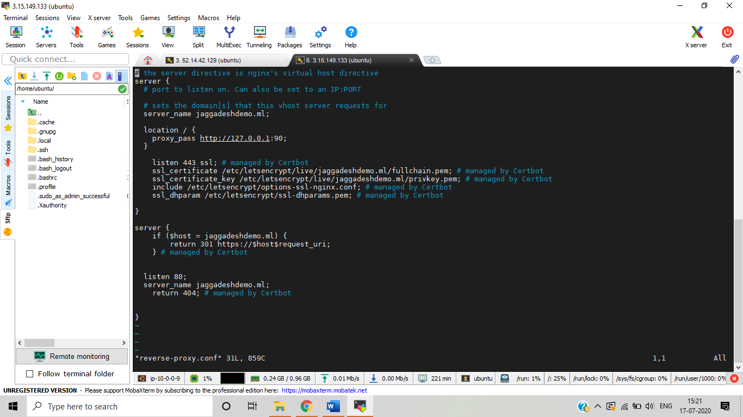

**SSL certificate Output**

