ospf-pcaket

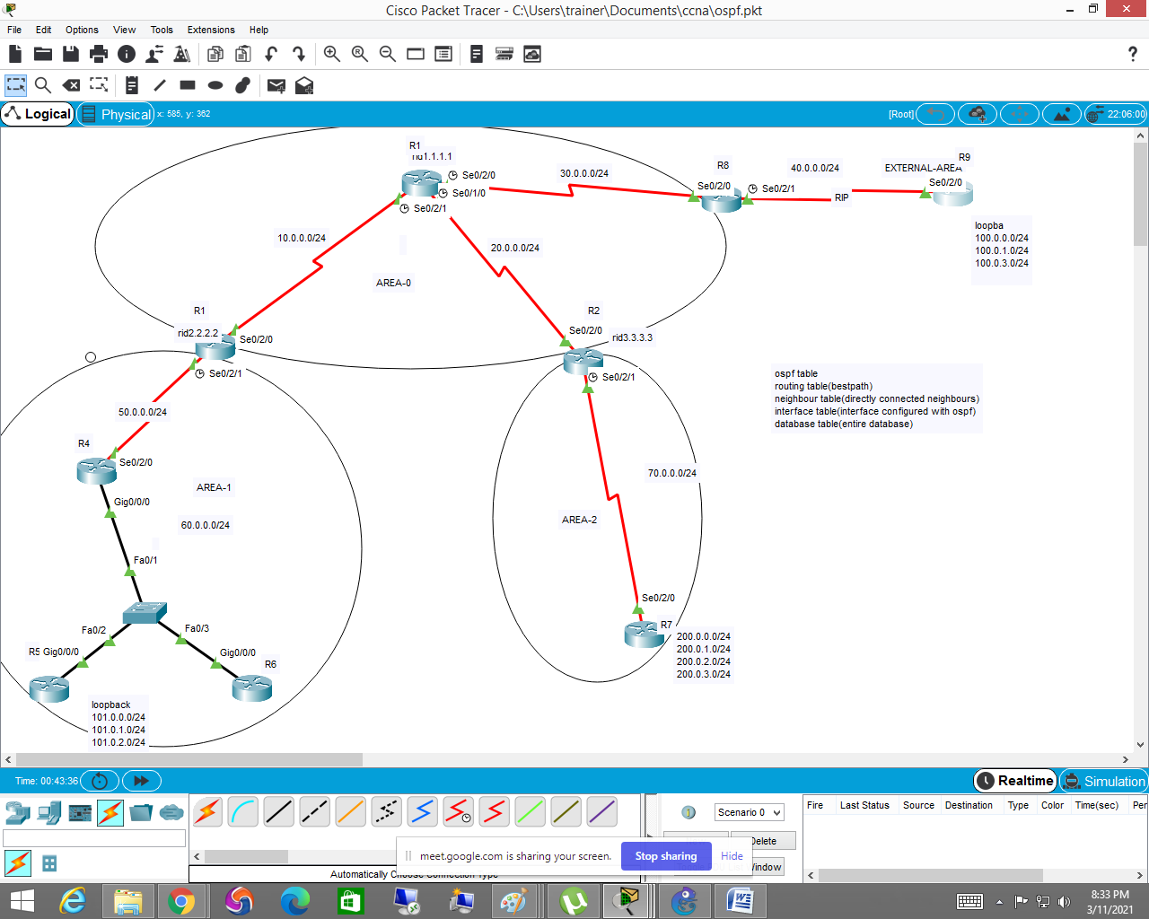

R1

R1(config)#interface se0/2/1

R1(config-if)#ip address 10.0.0.1 255.255.255.0

R1(config-if)#no shut

R1(config-if)#no shutdown

%LINK-5-CHANGED: Interface Serial0/2/1, changed state to down

R1(config-if)#

R1(config-if)#interface se0/1/0

R1(config-if)#ip address 20.0.0.1 255.255.255.0

R1(config-if)#no shut

R1(config-if)#no shutdown

%LINK-5-CHANGED: Interface Serial0/1/0, changed state to down

R1(config-if)#

R1(config-if)#

R1(config-if)#interface se0/2/0

R1(config-if)#ip address 30.0.0.1 255.255.255.0

R1(config-if)#no shut

R1(config-if)#no shutdown

%LINK-5-CHANGED: Interface Serial0/2/0, changed state to down

R1(config-if)#

R1(config-if)#

R1(config-if)#router ospf 1

R1(config-router)#ro

R1(config-router)#router-id 1.1.1.1

R1(config-router)#net

R1(config-router)#network 10.0.0.0 0.0.0.255 area 0

R1(config-router)#network 20.0.0.0 0.0.0.255 area 0

R1(config-router)#network 30.0.0.0 0.0.0.255 area 0

R2

R2(config)#interface se0/2/0

R2(config-if)#ip address 10.0.0.2 255.255.255.0

R2(config-if)#no shutdown

R2(config-if)#

%LINK-5-CHANGED: Interface Serial0/2/0, changed state to up

R2(config-if)#interface se0/2/1

R2(config-if)#

%LINEPROTO-5-UPDOWN: Line protocol on Interface Serial0/2/0, changed state to up

ip address 50.0.0.1 255.255.255.0

R2(config-if)#no shutdown

%LINK-5-CHANGED: Interface Serial0/2/1, changed state to down

R2(config-if)#

R2(config-if)#

R2(config-if)#router ospf 1

R2(config-router)#router-id 2.2.2.2

R2(config-router)#network 10.0.0.0 0.0.0.255 area 0

R2(config-router)#network 50.0.0

00:08:25: %OSPF-5-ADJCHG: Process 1, Nbr 1.1.1.1 on Serial0/2/0 from LOADING to FULL, Loading Done

.0 0.0.0.255 area 1

R3

R3(config)#interface se0/2/0

R3(config-if)#ip address 20.0.0.2 255.255.255.0

R3(config-if)#no shut

R3(config-if)#no shutdown

R3(config-if)#

%LINK-5-CHANGED: Interface Serial0/2/0, changed state to up

R3(config-if)#

R3(config-if)#interface se0/2/1

R3(config-if)#ip

%LINEPROTO-5-UPDOWN: Line protocol on Interface Serial0/2/0, changed state to up

address 70.0.0.1 255.255.255.0

R3(config-if)#no shut

R3(config-if)#no shutdown

%LINK-5-CHANGED: Interface Serial0/2/1, changed state to down

R3(config-if)#

R3(config-if)#

R3(config-if)#router ospf 1

R3(config-router)#net

R3(config-router)#network 70.0.0.0 0.0.0.255 area 2

R3(config-router)#network 20.0.0.0 0.0.0.255 area 0

R3(config-router)#

00:12:14: %OSPF-5-ADJCH

R4

R4(config)#interface se0/2/0

R4(config-if)#ip address 50.0.0.2 255.255.255.0

R4(config-if)#no shut

R4(config-if)#no shutdown

R4(config-if)#

%LINK-5-CHANGED: Interface Serial0/2/0, changed state to up

R4(config-if)#interface g0/0/0

R4(config-if)#ip address

%LINEPROTO-5-UPDOWN: Line protocol on Interface Serial0/2/0, changed state to up

60.0.0.1 255.255.255.0

R4(config-if)#no shut

R4(config-if)#no shutdown

R4(config-if)#

%LINK-5-CHANGED: Interface GigabitEthernet0/0/0, changed state to up

%LINEPROTO-5-UPDOWN: Line protocol on Interface GigabitEthernet0/0/0, changed state to up

R4(config-if)#

R4(config-if)#router ospf 1

R4(config-router)#network 60.0.0.0 0.0.0.255 area 1

R4(config-router)#network 50.0.0.0 0.0.0.255 area 1

R5

R5(config)#interface lo0

R5(config-if)#

%LINK-5-CHANGED: Interface Loopback0, changed state to up

%LINEPROTO-5-UPDOWN: Line protocol on Interface Loopback0, changed state to up

ip address 101.0.0.1 255.255.255.0

R5(config-if)#interface lo1

R5(config-if)#

%LINK-5-CHANGED: Interface Loopback1, changed state to up

%LINEPROTO-5-UPDOWN: Line protocol on Interface Loopback1, changed state to up

ip address 101.0.1.1 255.255.255.0

R5(config-if)#interface lo2

R5(config-if)#

%LINK-5-CHANGED: Interface Loopback2, changed state to up

%LINEPROTO-5-UPDOWN: Line protocol on Interface Loopback2, changed state to up

ip address 101.0.2.1 255.255.255.0

R5(config-if)#interface g0/0/0

R5(config-if)#ip address 60.0.0.2 255.255.255.0

R5(config-if)#no shut

R5(config-if)#no shutdown

R5(config-if)#

%LINK-5-CHANGED: Interface GigabitEthernet0/0/0, changed state to up

%LINEPROTO-5-UPDOWN: Line protocol on Interface GigabitEthernet0/0/0, changed state to up

R5(config-if)#

R5(config-if)#router ospf 1

R5(config-router)#network 101.0.0.0 0.0.0.255 area 1

R5(config-router)#network 101.0.1.0 0.0.0.255 area 1

R5(config-router)#network 101.0.2.0 0.0.0.255 area 1

R5(config-router)#network 60.0.0.0 0.0.0.255 area 1

R5(config-router)#

R5(config-router)#

R5(config-router)#

00:15:40: %OSPF-5-ADJCHG: Process 1, Nbr 60.0.0.1 on GigabitEthernet0/0/0 from LOADING to FULL, Loading Done

R6

R6(config)#interface g0/0/0

R6(config-if)#ip address 60.0.0.3 255.255.255.0

R6(config-if)#nop shut

R6(config-if)#nop shut

^

% Invalid input detected at '^' marker.

R6(config-if)#

R6(config-if)#no shut

R6(config-if)#

%LINK-5-CHANGED: Interface GigabitEthernet0/0/0, changed state to up

%LINEPROTO-5-UPDOWN: Line protocol on Interface GigabitEthernet0/0/0, changed state to up

R6(config-if)#

R6(config-if)#router ospf 1

R6(config-router)#network 60.0.0.0 0.0.0.255 area 1

R6(config-router)#

R6(config-router)#

R6(config-router)#

R7

R7(config)#interface lo0

R7(config-if)#

%LINK-5-CHANGED: Interface Loopback0, changed state to up

%LINEPROTO-5-UPDOWN: Line protocol on Interface Loopback0, changed state to up

R7(config-if)#ip address 200.0.0.1 255.255.255.0

R7(config-if)#no shut

R7(config-if)#no shutdown

R7(config-if)#

R7(config-if)#

R7(config-if)#interface lo1

R7(config-if)#

%LINK-5-CHANGED: Interface Loopback1, changed state to up

%LINEPROTO-5-UPDOWN: Line protocol on Interface Loopback1, changed state to up

ip address 200.0.1.1 255.255.255.0

R7(config-if)#interface lo2

R7(config-if)#

%LINK-5-CHANGED: Interface Loopback2, changed state to up

%LINEPROTO-5-UPDOWN: Line protocol on Interface Loopback2, changed state to up

ip address 200.0.2.1 255.255.255.0

R7(config-if)#

R7(config-if)#

R7(config-if)#interface se0/2/0

R7(config-if)#ip address 70.0.0.2 255.255.255.0

R7(config-if)#no shutdown

R7(config-if)#

%LINK-5-CHANGED: Interface Serial0/2/0, changed state to up

R7(config-if)#

R7(config-if)#router ospf 1

R7(config-router)#network

%LINEPROTO-5-UPDOWN: Line protocol on Interface Serial0/2/0, changed state to up

200.0.0.0 0.0.0.255 area 2

R7(config-router)#network 200.0.1.0 0.0.0.255 area 2

R7(config-router)#network 200.0.2.0 0.0.0.255 area 2

R7(config-router)#network 70.0.0.0 0.0.0.255 area 2

R7(config-router)#

00:18:21: %OSPF-5-ADJCHG: Process 1, Nbr 70.0.0.1 on Serial0/2/0 from LOADING to FULL, Loading Done

R8

Router(config)#interface se0/2/0

Router(config-if)#ip address 30.0.0.2 255.255.255.0

Router(config-if)#no shutdown

Router(config-if)#

%LINK-5-CHANGED: Interface Serial0/2/0, changed state to up

Router(config-if)#

Router(config-if)#interface se0/2/1

Router(config-if)#

%LINEPROTO-5-UPDOWN: Line protocol on Interface Serial0/2/0, changed state to up

ip address 40.0.0.1 255.255.255.0

Router(config-if)#no shutd

Router(config-if)#no shutdown

%LINK-5-CHANGED: Interface Serial0/2/1, changed state to down

Router(config-if)#

Router(config-if)#

Router(config-if)#

Router(config-if)#router ospf 1

Router(config-router)#network 30.0.0.0 0.0.0.255 area 0

Router(config-router)#

Router(config-router)#

Router(config-router)#

Router(config-router)#exi

00:32:14: %OSPF-5-ADJCHG: Process 1, Nbr 1.1.1.1 on Serial0/2/0 from LOADING to FULL, Loading Done

t

Router(config)#

Router(config)#

Router(config)#router rip

Router(config-router)#version 2

Router(config-router)#no auto-summary

Router(config-router)#network 40.0.0.0

Router(config-router)#exit

Router(config)#

Router(config)#router ospf 1

Router(config-router)#red

Router(config-router)#redistribute rip sub

Router(config-router)#redistribute rip subnets

Router(config-router)#

R9

R9(config)#interface se0/2/0

R9(config-if)#ip address 40.0.0.2 255.255.255.0

R9(config-if)#no shutdown

R9(config-if)#

%LINK-5-CHANGED: Interface Serial0/2/0, changed state to up

R9(config-if)#

R9(config-if)#int lo0

R9(config-if)#

%LINK-5-CHANGED: Interface Loopback0, changed state to up

%LINEPROTO-5-UPDOWN: Line protocol on Interface Loopback0, changed state to up

ip ad

%LINEPROTO-5-UPDOWN: Line protocol on Interface Serial0/2/0, changed state to up

dress 100.0.0.1 255.255.255.0

R9(config-if)#int lo1

R9(config-if)#

%LINK-5-CHANGED: Interface Loopback1, changed state to up

%LINEPROTO-5-UPDOWN: Line protocol on Interface Loopback1, changed state to up

ip address 100.0.1.1 255.255.255.0

R9(config-if)#int lo2

R9(config-if)#

%LINK-5-CHANGED: Interface Loopback2, changed state to up

%LINEPROTO-5-UPDOWN: Line protocol on Interface Loopback2, changed state to up

ip address 100.0.2.1 255.255.255.0

R9(config-if)#

R9(config-if)#

R9(config-if)#router rip

R9(config-router)#version 2

R9(config-router)#no auto-summary

R9(config-router)#network 40.0.0.0

R9(config-router)#network 100.0.0.0

R9(config-router)#network 100.0.1.0

R9(config-router)#network 100.0.2.0