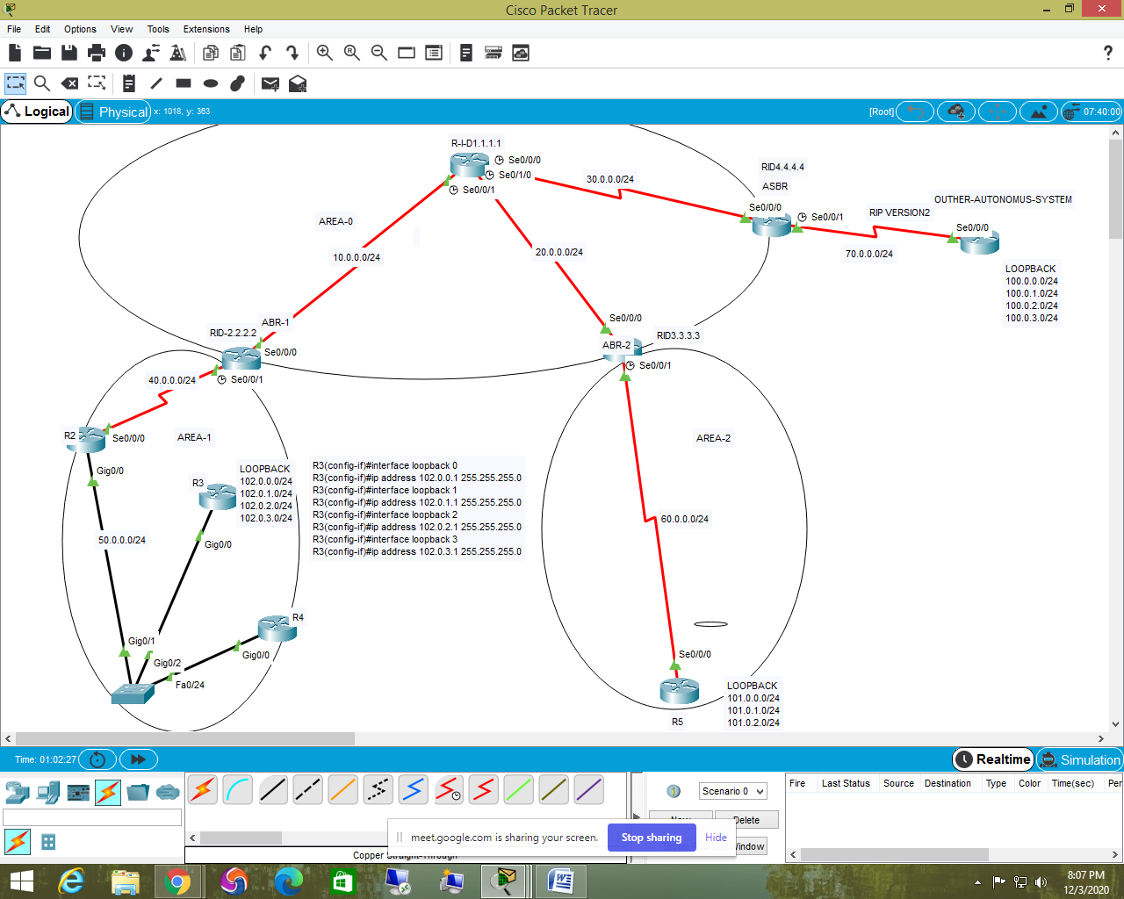

R1 ospf configuration

R1(config)#router ospf 1

R1(config-router)#router-id 1.1.1.1

R1(config-router)#network 10.0.0.0 0.0.0.255 area 0

R1(config-router)#network 20.0.0.0 0.0.0.255 area 0

R1(config-router)#network 30.0.0.0 0.0.0.255 area 0

-------------------------------------------------------------------------------------

ABR-1

ABR-1(config)#router ospf 1

ABR-1(config-router)#router-id 2.2.2.2

ABR-1(config-router)#network 10.0.0.0 0.0.0.255 area 0

ABR-1(config-router)#network 40.0.0.0 0.0.0.255 area 1

------------------------------------------------------------------------------------------------------------------------

ABR-2

ABR-2(config)#router ospf 1

ABR-2(config-router)#router-id 3.3.3.3

ABR-2(config-router)#network 60.0.0.0 0.0.0.255 area 2

ABR-2(config-router)#network 20.0.0.0 0.0.0.255 area 0

------------------------------------------------------------------------------------------------------------------------

ASBR

ASBR(config)#router ospf 1

ASBR(config-router)#router-id 4.4.4.4

ASBR(config-router)#network 30.0.0.0 0.0.0.255 area 0

-----------------------------------------------------------------------------------------------------------------------

R2

R2(config)#router ospf 1

R2(config-router)#network 50.0.0.0 0.0.0.255 area 1

R2(config-router)#network 40.0.0.0 0.0.0.255 area 1

-----------------------------------------------------------------------------------------------------------------------

R3

R3(config-router)#router ospf 1

R3(config-router)#network 50.0.0.0 0.0.0.255 area 1

R3(config-router)#network 102.0.0.0 0.0.0.255 area 1

R3(config-router)#network 102.0.1.0 0.0.0.255 area 1

R3(config-router)#network 102.0.2.0 0.0.0.255 area 1

R3(config-router)#network 102.0.3.0 0.0.0.255 area 1

-----------------------------------------------------------------------------------------------------------------------------

R4

R4(config-router)#router ospf 1

R4(config-router)#network 50.0.0.0 0.0.0.255 area 1

--------------------------------------------------------------------------------------------------------------------------------

R5

R5(config)#router ospf 1

R5(config-router)#network 101.0.0.0 0.0.0.255 area 2

R5(config-router)#network 101.0.1.0 0.0.0.255 area 2

R5(config-router)#network 101.0.2.0 0.0.0.255 area 2

R5(config-router)#network 101.0.3.0 0.0.0.255 area 2

R5(config-router)#network 60.0.0.0 0.0.0.255 area 2

--------------------------------------------------------------------------------------------------------

ASBR to other autonomus system RIP configuration

ASBR(config)#router rip

ASBR(config-router)#version 2

ASBR(config-router)#no auto-summary

ASBR(config-router)#network 70.0.0.0

-----------------------------------------------------------------------------------------------

OTHER AUTONOMUS SYSTEM ROUTER RIP CONFIGURATION

OAS(config)#router rip

OAS(config-router)#version 2

OAS(config-router)#no auto-summary

OAS(config-router)#network 100.0.0.0

OAS(config-router)#network 100.0.1.0

OAS(config-router)#network 100.0.2.0

OAS(config-router)#network 100.0.3.0

OAS(config-router)#network 70.0.0.0

-------------------------------------------------------------------------------

using REDISTRIBUTION INCONNECTING RIP NETWORK ON OSPF protocol

configuration in ASBR

ASBR(config-router)#router ospf 1

ASBR(config-router)#redistribute rip subnets

---------------------------------------------------------------------------------------------------------------------------------

show ip ospf neighbor

show ip ospf database

show ip route

show ip ospf interface (interface name ) se2/0

==================================================================================

ospf authentication