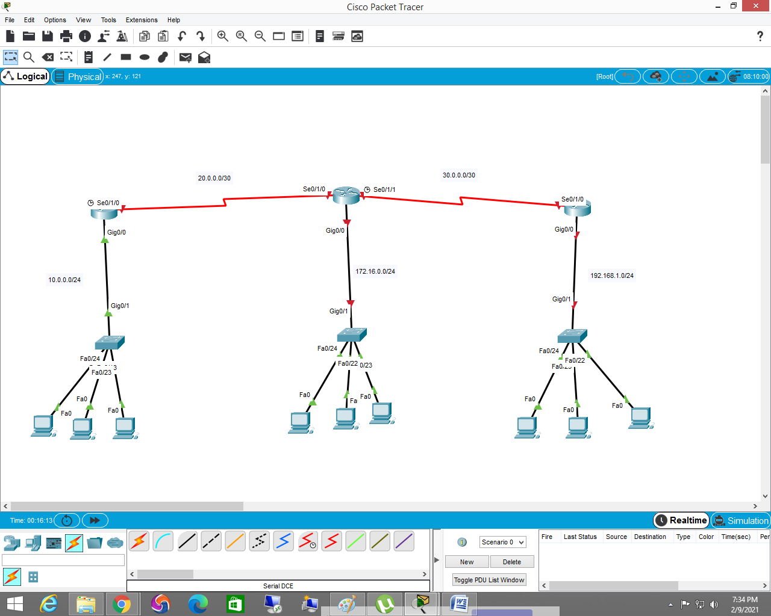

Router>enable

Router#configure terminal

Router(config)#hostname R1

R1(config)#interface gig0/0

R1(config-if)#ip address 10.0.0.1 255.255.255.0

R1(config-if)#no shutdown

R1(config-if)#interface se0/1/0

R1(config-if)#ip address 20.0.0.1 255.255.255.252

R1(config-if)#no shutdown

R2 interface configuration

Router>enable

Router#conf t

Router(config)#hostname R2

R2(config)#int se0/1/0

R2(config-if)#ip address 20.0.0.2 255.255.255.252

R2(config-if)#no shutdown

R2(config-if)#int g0/0

R2(config-if)#ip address 172.16.0.1 255.255.255.0

R2(config-if)#no shutdown

R2(config-if)#interface se0/1/1

R2(config-if)#ip address 30.0.0.1 255.255.255.252

R2(config-if)#no shutdown

R3 interface configuration

Router(config)#hostname R3

R3(config)#interface se0/1/0

R3(config-if)#ip address 30.0.0.2 255.255.255.252

R3(config-if)#no shutdown

R3(config-if)#interface g0/0

R3(config-if)#ip address 192.168.1.1 255.255.255.0

R3(config-if)#no shutdown

-----------------------------------------

static routing on R1

R1(config)#ip route 30.0.0.0 255.255.255.252 20.0.0.2

R1(config)#ip route 172.16.0.0 255.255.255.0 20.0.0.2

R1(config)#ip route 192.168.1.0 255.255.255.0 20.0.0.2

static routing on R2

R2(config)#ip route 10.0.0.0 255.255.255.0 20.0.0.1

R2(config)#ip route 192.168.1.0 255.255.255.0 30.0.0.2

static routing on R3

R3(config)#ip route 10.0.0.0 255.255.255.0 30.0.0.1

R3(config)#ip route 20.0.0.0 255.255.255.252 30.0.0.1

R3(config)#ip route 172.16.0.0 255.255.255.0 30.0.0.1

==============================================