1.

2.

3.
GIT

Git is a software that allows you to keep track of changes made to a project over time. Git works by recording the changes you make to a project, storing those changes, then allowing you to reference them as needed.

-----------------------------------------------------

git init

The word init means initialize. The command sets up all the tools Git needs to begin tracking changes made to the project.
-----------------------------------------------------

Nice! We have a Git project. A Git project can be thought of as having three parts:
- A Working Directory: where you'll be doing all the work: creating, editing, deleting and organizing files.
- A Staging Area: where you'll list changes you make to the working directory.
- A Repository: where Git permanently stores those changes as different versions of the project
The Git workflow consists of editing files in the working directory, adding files to the staging area, and saving changes to a Git repository. In Git, we save changes with a commit, which we will learn more about in this lesson.

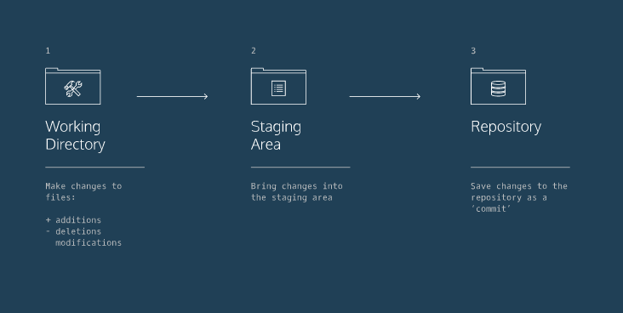

-----------------------------------------------------

As you write the screenplay, you will be changing the contents of the working directory. You can check the status of those changeswith:
1. git status
In the output, notice the file in red under untracked files. Untracked means that Git sees the file but has not started tracking changes yet.
-----------------------------------------------------

In order for Git to start tracking scene-1.txt, the file needs to be added to the staging area.
We can add a file to the staging area with:
2. git add filename
The word filename here refers to the name of the file you are editing, such as scene-1.txt.
-----------------------------------------------------

Imagine that we type another line in scene-1.txt. Since the file is tracked, we can check the differences between the working directory and the staging area with:

3.git diff filename
-----------------------------------------------------

-----------------------------------------------------

In Git, the commit you are currently on is known as the HEAD commit. In many cases, the most recently made commit is the HEAD commit.

To see the HEAD commit, enter:

4. git show HEAD

The output of this command will display everything the git log command displays for the HEAD commit, plus all the file changes that were committed.

-----------------------------------------------------

Acommit is the last step in our Git workflow. A commit permanently stores changes from the staging area inside the repository.
git commit is the command we'll do next. However, one more bit of code is needed for a commit: the option -m followed by a message. Here's an example:
5.git commit -m “commit message”

-----------------------------------------------------

-----------------------------------------------------
Often with Git, you'll need to refer back an earlier version of a project. Commits are stored chronologically in the repository and can be viewed with:
6. git log
From the terminal, log a list of your commits.
In the output, notice:
- A 40-character code, called a SHA, that uniquely identifies the commit. This appears in orange text.
- The commit author (you!)
- The date and time of the commit
- The commit message
-----------------------------------------------------

You have now been introduced to the fundamental Git workflow. You learned a lot! Let's take a moment to generalize:
- Git is the industry-standard version control system for web developers
- Use Git commands to help keep track of changes made to a project:
  - git init creates a new Git repository
  - git status inspects the contents of the working directory and staging area
  - git add adds files from the working directory to the staging area
  - git diff shows the difference between the working directory and the staging area
  - git commit permanently stores file changes from the staging area in the repository
  - git log shows a list of all previous commits
--------------------------------------------------------------------------------

What if you decide to change the ghost's line in the working directory, but
then decide you wanted to discard that change?
You could rewrite the line how it was originally, but what if you forgot the exact wording? The command
7. git checkout filename

will restore the file in your working directory to look exactly as it did when you last made a commit.
Here, filename again is he actual name of the file. If the file is named changes.txt, the command would be

--------------------------------------------------------------------------------
The hamlet we are working on contains five files. In Git, it's common to change many files, add those files to the staging area, and commit them to Git in a single commit.
For example, say you want to change the character "LARRY" to "LAERTES" in the script. The name currently appears in two files. After you change the name in both files, you could add the changed files to the staging area with:
8.git add filename-1 filename -2
Note the word filename above refers to the name of the file you are adding to the staging area, such as scene-3.txt.
--------------------------------------------------------------------------------

What if, before you commit, you accidentally delete an important line from scene- 2.txt? Unthinkingly, you add scene-2.txt to the staging area. The file change is unrelated to the Larry/Laertes swap and you don't want to include it in the commit.
We can unstage that file from the staging area using

9.git reset HEAD filename
This command resets the file in the staging area to be the same as the HEAD commit. It does not discard file changes from the working directory, it just removes them from the staging area

--------------------------------------------------------------------------------

Creating a project is like hiking in a dark forest. Sometimes you take a wrong turn, then another wrong turn. Before you know it, you're surrounded by bears.
Git enables you to rewind to the part before you made the wrong turn and create a new destiny for the project. You can do this with:
10.git reset SHA
we can sha from git log 40char commit
This command works by using the first 7 characters of the SHA of a previous commit.
By entering this command commit done after the one you pick will be deleted
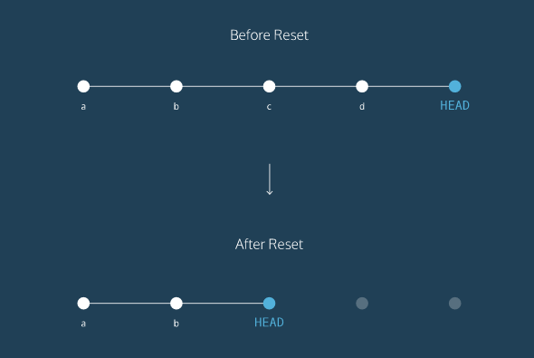

--------------------------------------------------------------------------------
Congratulations! You've learned three different ways to backtrack in Git. You can use these skills to undo changes made to your Git project.
Let's take a moment to review the new commands:
- git checkout HEAD filename: Discards changes in the working directory.
- git reset HEAD filename: Unstages file changes in the staging area.
- git reset SHA: Can be used to reset to a previous commit in your commit history.
Additionally, you learned a way to add multiple files to the staging area with a single command:
--------------------------------------------------------------------------------

11.git branch

shows which branch you are on

---------------------------------------------------------------------------------

12.git branch new_branchname

create a new branch
---------------------------------------------------------------------------------

13.git checkout branchname

shift from present brnach to branchname

---------------------------------------------------------------------------------

What if you wanted include all the changes made to the fencing branch on the master branch? We can easily accomplish this by merging the branch into master with:

14.git merge branch_name

For example, if I wanted to merge the skillsbranch to master, I would enter

git merge skills

Let's say you decide you'd like to merge the changesfrom fencing into master.
Here's where the trouble begins!
You've made commits on separate branches that alter the same line in conflicting ways. Now, when you try to merge fencing into master, Git will not know which version of the file to keep.
Switch to the master branch.
From the terminal, enter the command below:
git merge fencing
This will try to merge fencing into master.
In the output, notice the lines:
CONFLICT (content): Merge conflict in resumé.txt
Automatic merge failed; fix conflicts and then commit the result.
We must fix the merge conflict.
In the code editor, look at resume.txt. Git uses markings to indicate the HEAD(master) version of the file and the fencing version of the file, like this:
<<<<<<< HEAD
master version of line
=======
fencing version of line
>>>>>>> fencing
Git asks us which version of the file to keep: the version on master or the version on fencing. You decide you want the fencing version.
From the code editor:
Delete the content of the line as it appears in the master branch
Delete all of Git's special markings including the words HEAD and fencing. If any of Git's markings remain, for example, >>>>>>> and =======, the conflict remains.
Try reloading the page if Git's markings don't show up.

-----------------------------------------------------------------------

15. git branch -d branchname

deletes a branch usually done after merging is done as because its requirement is done.

-----------------------------------------------------------------------

The following commands are useful in the Git branch workflow.
- git branch: Lists all a Git project's branches.
- git branch branch_name: Creates a new branch.
- git checkout branch_name: Used to switch from one branch to another.
- git merge branch_name: Used to join file changes from one branch to another.
- git branch -d branch_name: Deletes the branch specified.
-------------------------------------------------------------------

--------------------------------------------------------------------------

16. git clone remote-location clone_name(directory name)

remote-location= repository url
clone_name = which directory want to clone

In this command:
- remote_location tells Git where to go to find the remote. This could be a web address, or a filepath, such as:
/Users/teachers/Documents/some-remote
- clone_name is the name you give to the directory in which Git will clone the repository.
--------------------------------------------------------------------------

Nice work! We have a clone of Sally's remote on our computer. One thing that Git does behind the scenes when you clone science-quizzes is give the remote address the name origin, so that you can refer to it more conveniently. In this case, Sally's remote is origin.
17.git remote -v
You can see a list of a Git project's remotes with the command:
first we need to move to cloned directory and then type this till then it is not remote repo

--------------------------------------------------------------------------

After you cloned science-quizzes, you had to run off to teach a class. Now that you're back at your computer, there's a problem: what if, while you were teaching, Sally changed the science-uizzes Git project in some way. If so, your clone will no longer be up-to-date.
An easy way to see if changes have been made to the remote and bring the changes down to your local copy is with
18.git fetch
This command will not merge changes from the remote into your local repository. It brings those changes onto what's called a remote branch. Learn more about how this works below

--------------------------------------------------------------------------

19. git merge origin/master

merge files from remote to master

--------------------------------------------------------------------------

Now it's time to share our work with Sally.
The command:
19.git push origin branch name
will push your branch up to the remote, origin. From there, Sally can review your branch and merge your work into the master branch, making it part of the definitive project version.

--------------------------------------------------------------------------

Congratulations, you now know enough to start collaborating on Git projects! Let's review.
- A remote is a Git repository that lives outside your Git project folder. Remotes can live on the web, on a shared network or even in a separate folder on your local computer.
- The Git Collaborative Workflow are steps that enable smooth project development when multiple collaborators are working on the same Git project.
We also learned the following commands
- git clone: Creates a local copy of a remote.
- git remote -v: Lists a Git project's remotes.
- git fetch: Fetches work from the remote into the local copy.
- git merge origin/master: Merges origin/master into your local branch.
- git push origin <branch_name>: Pushes a local branch to the origin remote.
Git projects are usually managed on Github, a website that hosts Git projects for millions of users. With Github you can access your projects from anywhere in the world by using the basic workflow you learned here.
------------------------------------------------------------------------------

