Skill-experiment-3
SKILL 3:
- Launch an Ubuntu EC2 instance, install the Nginx web server through a user data script at launch time and open the default page in a browser. Record the differences you observed compared to the Amazon Linux and Apache steps.
STEP-1: Log in to the AWS Management Console.
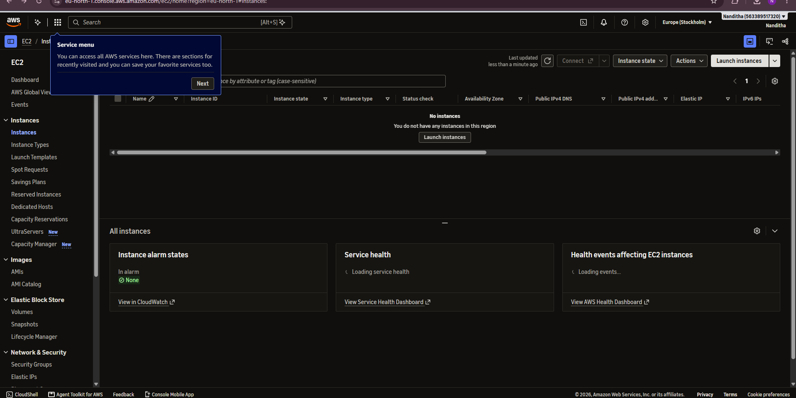
STEP-2: Under Instance type, select an eligible instance type, such as t3.micro, depending on availability and Free Tier eligibility.
Under Key pair (login), select an existing key pair or create a new key pair if SSH access is required.
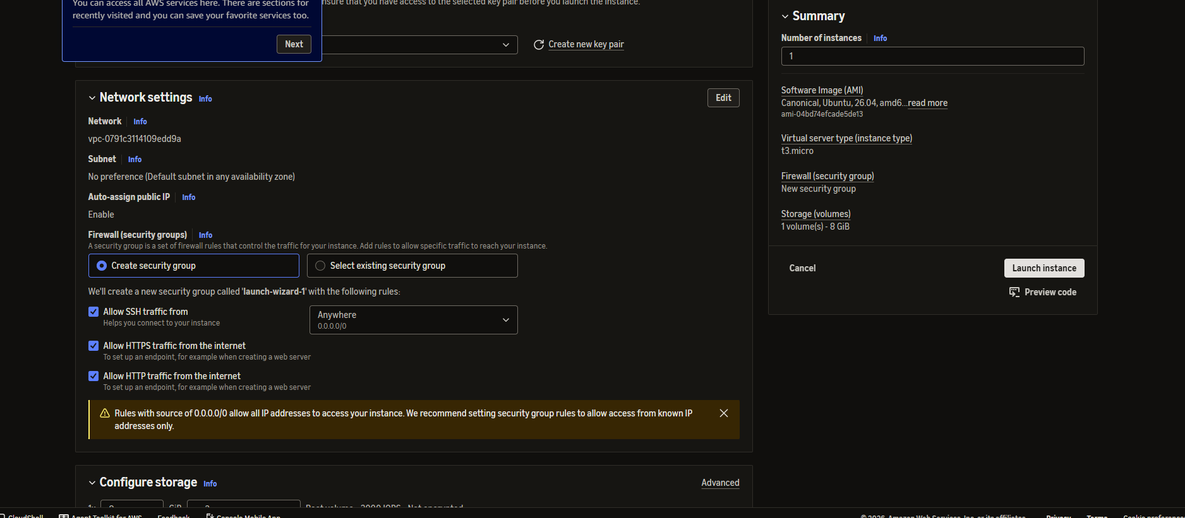
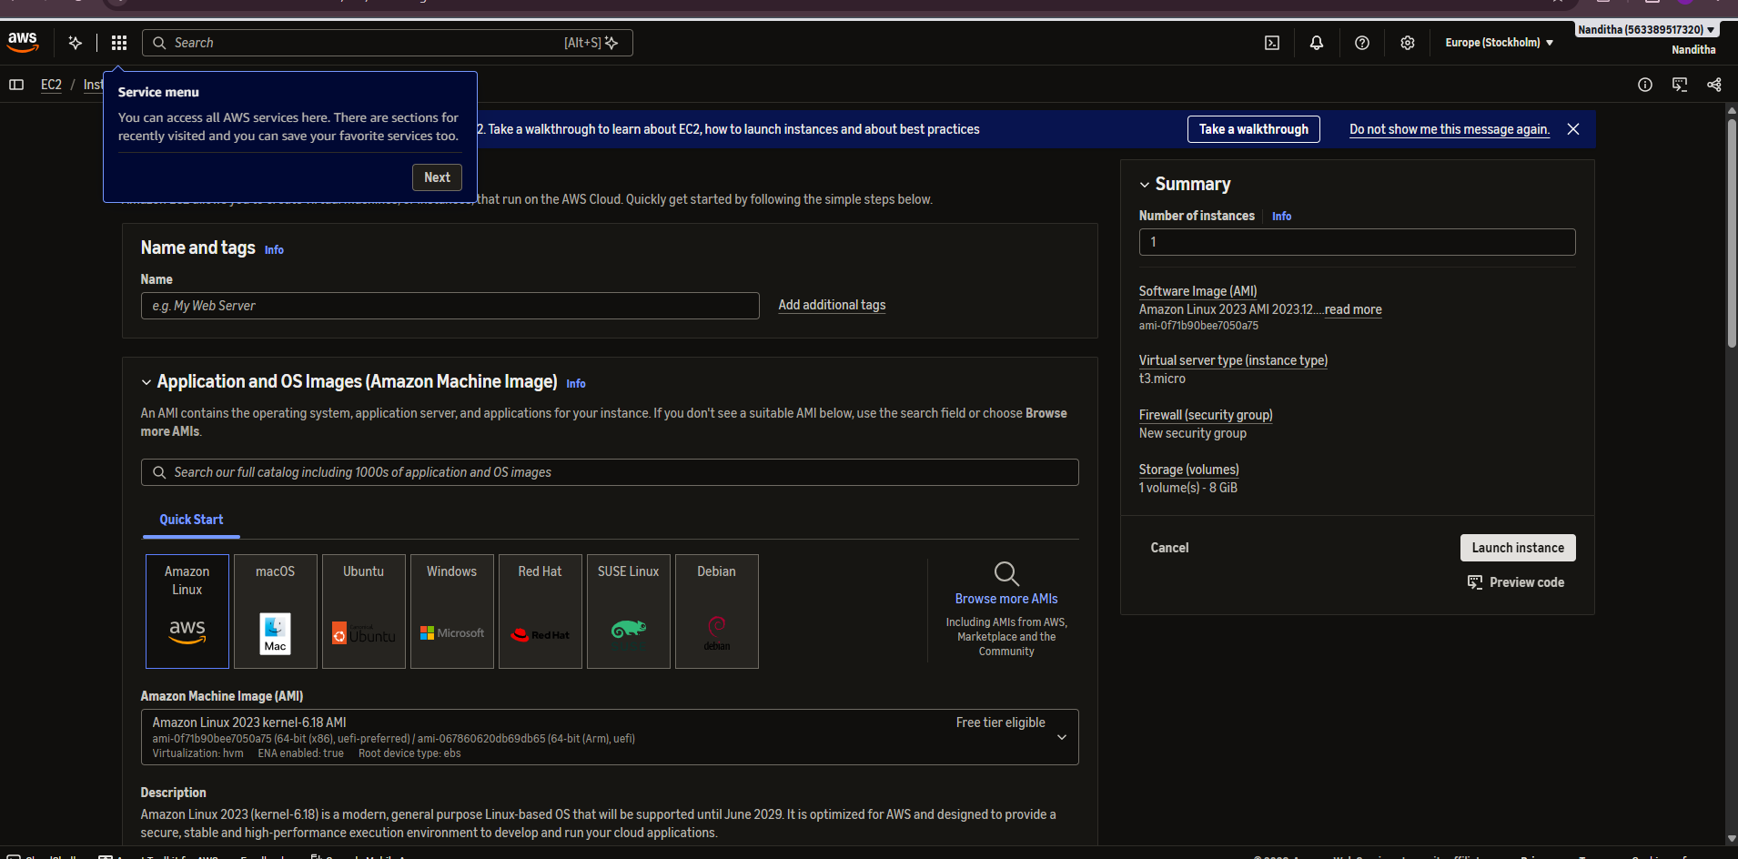
STEP-3:
sudo apt update -y
sudo apt install nginx -y
sudo systemctl start nginx
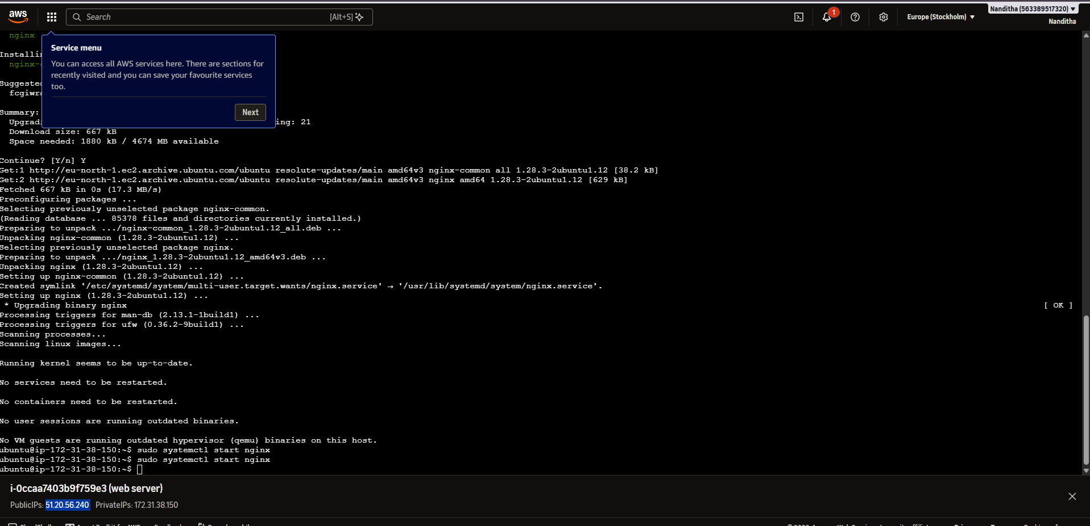

Expected Outcome:


