

Department of CSE

B.Tech. CSE Trimester -5

2520030013
Jagadabi Nanditha

Cloud Infrastructure and Services
25CS2206E

LAB RECORD
2026

Experiment -1a

AIM: To create an AWS free tier account to provision the resources.

Description:
The objective of this task is to create an Amazon Web Services (AWS) Free Tier account to access cloud computing services and provision the required cloud resources. AWS provides various cloud services, including EC2 (virtual servers), S3 (cloud storage), RDS (database management), and IAM (identity and access management). By creating an AWS account, users can explore cloud infrastructure, deploy applications, store data, and manage resources through the AWS Management Console.
The AWS Free Tier allows beginners and students to gain practical experience with cloud computing while using eligible free-tier services within the specified usage limits. This account will be used to create, configure, and manage cloud resources for learning and project development.

Steps:
1. Open the AWS Website. Open a web browser (Chrome/Edge recommended). Go to: https://aws.amazon.com/free
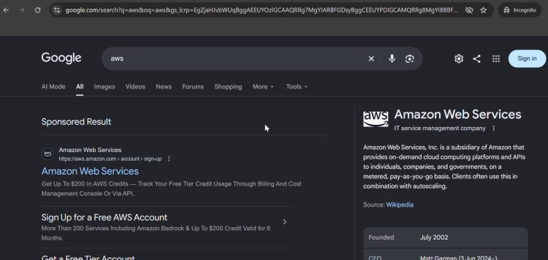
2.Click Sign in to console
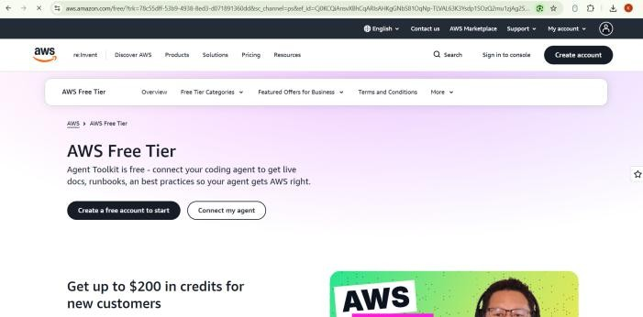

1. Click Create a new AWS account.
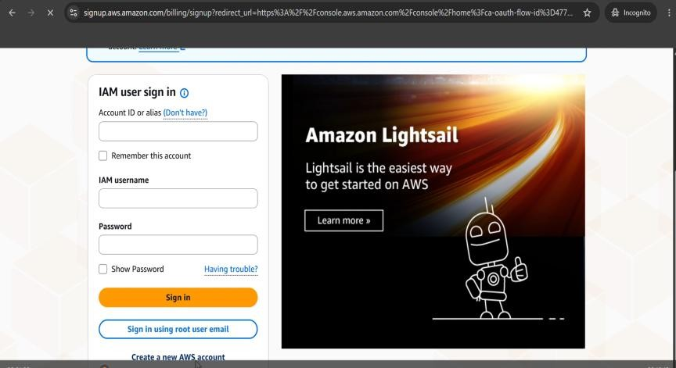
- Enter the following details:
o Email address o Password o AWS Account Name (e.g., StudentAWSAccount)
- Click Verify email address and enter the OTP sent to your email.
- Choose your Account plan Free(6 months)-click Choose Free plan
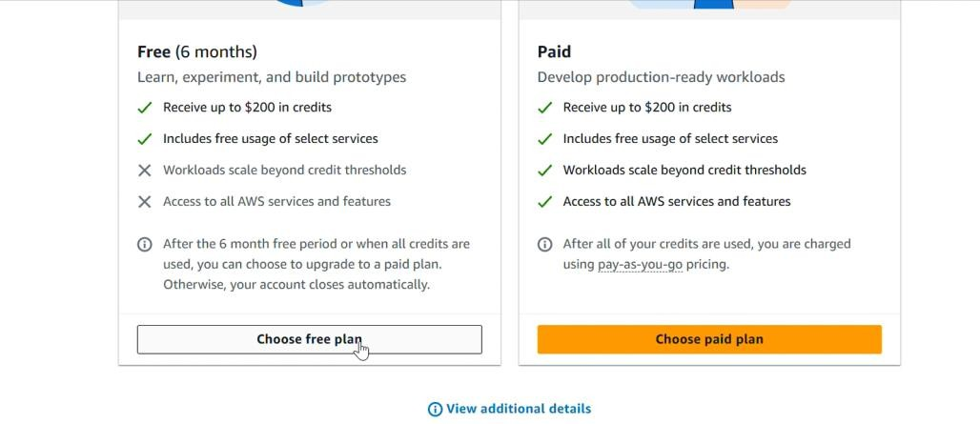
- Give all contact information. Enter personal details:
o Full name o Phone number o Address…………..Click agree and continue
- In the next steps provide Billing information
You can choose UPI or Debit/Credit Card option and accordingly give the details. If UPI (Automatic Payment limit 15000 should be there) just for authorization later autopay can be deleted
Note: For AWS India accounts using the advanced registration process, card verification may involve a temporary ₹2 charge, which AWS refunds after verification. UPI is also supported for AWS India bill payments and UPI AutoPay.
- In the next step Confirm your Identity.
Choose primary purpose of Acount registration as Academic,
Ownership type as Individual
Document type as AADHAR…verification to be done through digilocker
Or voter id or driving license also can be provided….then click continue
- Provide Mobile number and click send SMS…..
Enter code for verification..continue
- Setting up of AWS account.( around 1 to 2 mins)
- AWS Management Console dashboard is visible.
or Login at: https://console.aws.amazon.com. and then sign in using root user email. (Sign in using your registered credentials)

Output:


