11. To Install Linux VM, Configure GCC, Setup Git Repository, Create Project Structure, Understand Shell Architecture, Build Initial Makefile
To Analyze process abstraction, execute fork(), understand exec() family, analyze parent-child relationships, inspect process tree, practice system call tracing
Step 1: Open PowerShell as Administrator
1. Press Windows.
2. Search for PowerShell.
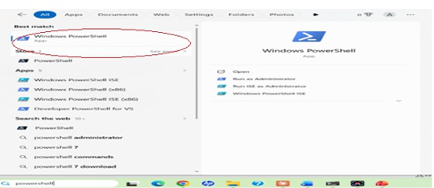
3. Right-click Windows PowerShell.
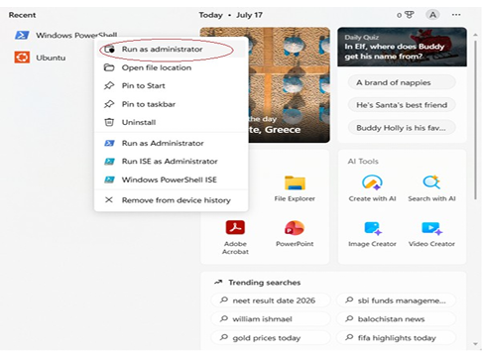
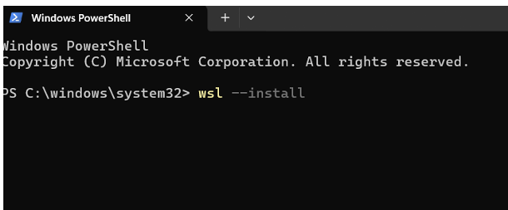
Step 3: Restart Your Computer
After installation, restart your PC when prompted.
Step 4: Complete Ubuntu Setup After restarting:
1. Ubuntu opens automatically (or search for Ubuntu in the Start menu).
2. Wait for the installation to finish.
3. Create a Linux username.
Example: Enter new UNIX username: Nanditha
Step 5: Create a Password
You'll then be prompted to create a password.
New password: ****
Retype new password:****
Step 6: Update Ubunt

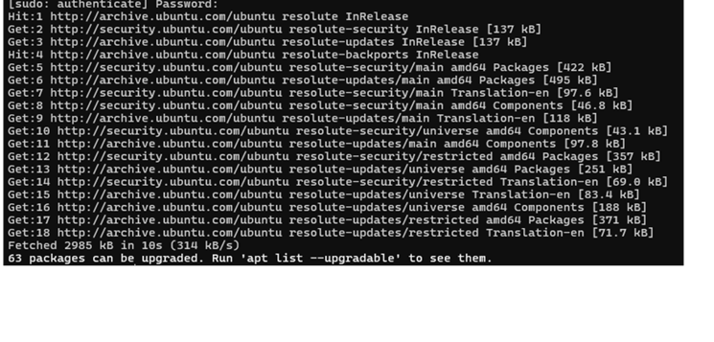

Step 7: Install GCC (C Compiler)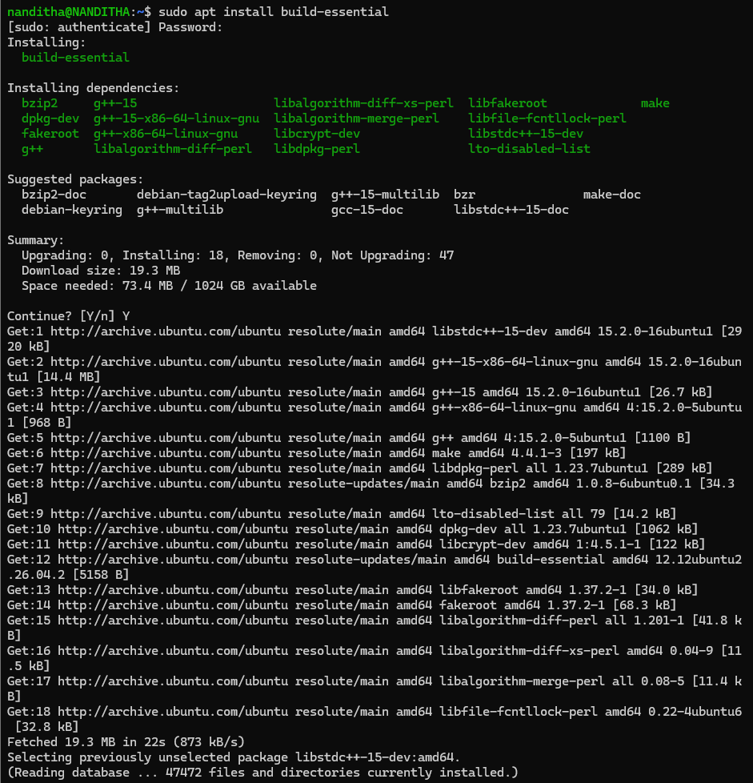
Step 8: Verify the Installatio

