Operating Systems(Practical-1)
1)Code
#include <stdio.h>
#include <stdlib.h>
#include <unistd.h>
#include <sys/types.h>
#include <sys/wait.h>
#include <string.h>

int main()
{
char command[100];
pid_t pid;
int status;

printf("Enter a Linux command: ");
scanf("%s", command);

pid = fork();

if (pid < 0)
{
printf("Fork failed\n");
return 1;
}
else if (pid == 0)
{
// Child process
printf("\nChild Process\n");
printf("Child PID: %d\n", getpid());
printf("Parent PID: %d\n", getppid());

execlp(command, command, (char *)NULL);

// This executes only if exec fails
printf("Command execution failed\n");
exit(1);
}
else
{
// Parent process
printf("\nParent Process\n");
printf("Parent PID: %d\n", getpid());
printf("Child PID: %d\n", pid);

wait(&status);

printf("\nChild process completed.\n");
}

return 0;
}
Output:
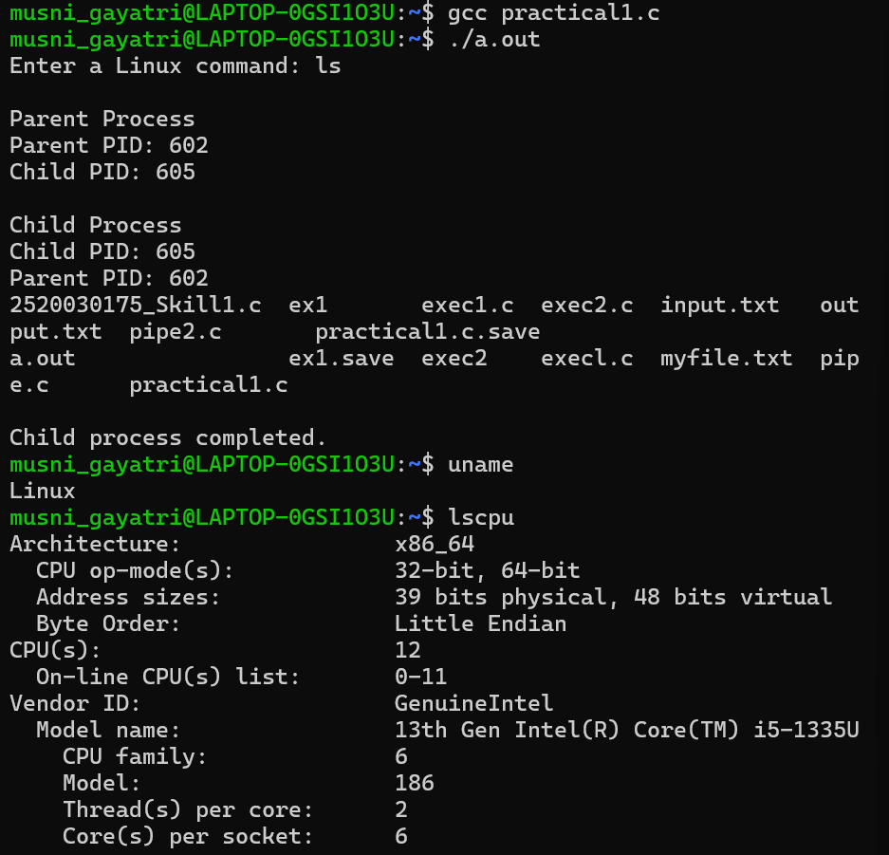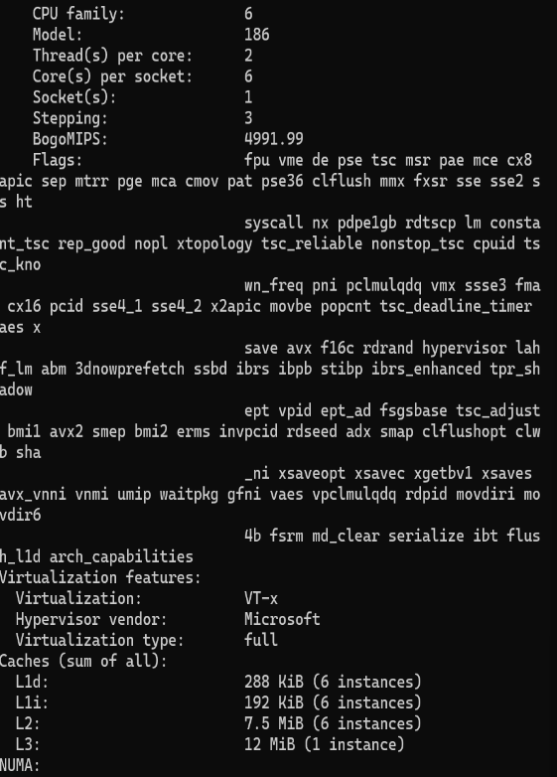

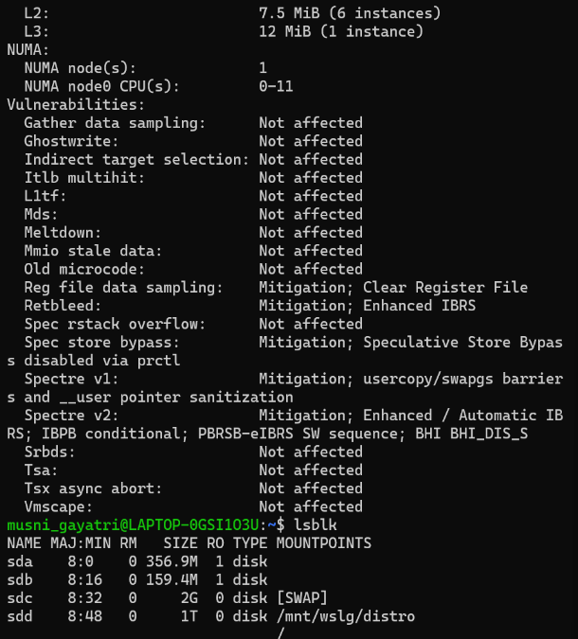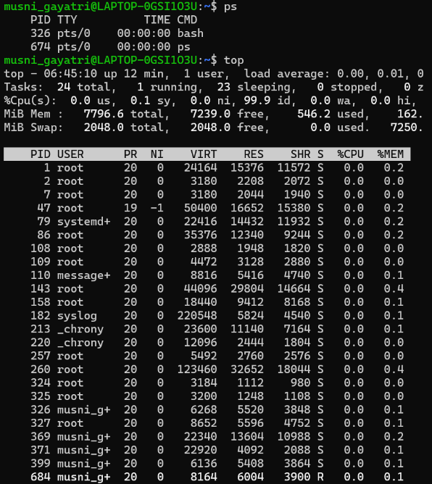

Command Purpose
Uname- Displays basic information about the operating system.
Lscpu- Displays detailed information about the CPU and its architecture.
Lsblk- Lists the available block devices such as hard disks and partitions.
Ps- Displays the currently running processes and their process IDs.
Top- Continuously displays running processes along with CPU and memory usage.

