SUPERMARKET SALES ANALYSIS DASHBOARD

Project Report

Data Analytics with AI
IBM Internship Project

Tool: Python | Streamlit | Plotly | Pandas
Dataset: SuperMarket Analysis.csv

Table of Contents
1. Abstract 3
2. Introduction 3
3. Problem Statement 4
4. Objectives 4
5. Dataset Description 5
6. Tools and Technologies 6
7. System Workflow 7
8. Data Loading 7
9. Data Cleaning and Validation 8
10. Sales Calculation 8
11. Dashboard Overview 9
12. KPI Analysis 10
13. Data Quality Analysis 11
14. Sales Analysis 12
15. Product & Category Analysis 13
16. Customer & Payment Analysis 14
17. Time-Based Analysis 15
18. Business Insights 16
19. Results Summary 17
20. UI Screenshots Summary 18
21. Testing 20
22. Project Execution Guide 20
23. Project Structure 21
24. Conclusion 22
25. Future Enhancements 22

1. Abstract
This report presents the design, development, and evaluation of the Supermarket Sales Analysis Dashboard, an interactive data analytics application built using Python, Pandas, Streamlit, and Plotly. The project processes a real-world retail transactional dataset — SuperMarket Analysis.csv — containing 1,000 invoice records from three supermarket branches spanning January to March 2019. The system implements a six-step analytical pipeline: data ingestion, quality validation, sales computation (Sales = Quantity × Unit Price), statistical aggregation, interactive visualisation, and automated business insight generation. The resulting Streamlit web dashboard enables non-technical users to explore the data through real-time filters and 16 interactive Plotly charts covering revenue trends, product performance, customer demographics, payment patterns, and time-based analysis. All business insights are computed dynamically from the filtered dataset, providing immediate, actionable recommendations for retail decision-makers.
────────────────────────────────────────────────────────────────────────

2. Introduction
The retail supermarket industry generates large volumes of transactional data on a daily basis. Understanding this data — identifying which products sell best, which branches underperform, when customers shop most actively, and which customer segments are most valuable — is essential for optimising inventory, staffing, promotions, and overall business strategy.
Raw transactional CSV files are not easily readable by business managers or analysts without technical processing. Data analytics tools can transform this raw data into meaningful summaries, visual comparisons, and actionable intelligence. This project demonstrates how a complete analytics pipeline can be implemented in Python and delivered as an interactive browser-based dashboard using Streamlit — requiring no database, no BI tool license, and no server infrastructure beyond a standard Python environment.
This project was developed as part of the IBM Data Analytics with AI internship programme. It covers the complete lifecycle of a data analytics project: from raw data collection through cleaning, transformation, statistical analysis, visualisation design, and business insight generation.
────────────────────────────────────────────────────────────────────────

3. Problem Statement
A supermarket chain operating three branches across three cities collects transaction data for every sale. This data is stored in a CSV file and contains 1,000 records with 17 attributes including product category, quantity, unit price, customer type, gender, payment method, date, and customer rating.
The core challenges addressed by this project are:
- Raw CSV data is not self-explanatory — business managers cannot extract trends by reading rows.
- Sales figures are not pre-computed — the dataset contains Unit price and Quantity separately.
- No cross-dimensional summaries exist — comparing branch vs product vs payment requires aggregation.
- Time patterns are hidden — peak trading hours and best sales days require temporal analysis.
- Customer behaviour is not segmented — understanding Member vs Normal or Male vs Female contribution requires grouping.
- Business decisions require evidence — product, staffing, and promotion decisions need data support.
This project solves all of the above by implementing an automated analytical pipeline and delivering the results as an interactive, filter-driven Streamlit dashboard accessible in any browser.
────────────────────────────────────────────────────────────────────────

4. Objectives
- Load and parse the SuperMarket Analysis.csv dataset using Python and Pandas.
- Validate data quality: detect missing values, duplicate rows, and type inconsistencies.
- Identify and report on any data cleaning actions performed.
- Compute the derived sales metric using the formula: Sales = Quantity × Unit Price
- Apply a 5% tax to produce the final billable amount: Total Sales = Computed Sales × 1.05
- Perform grouped statistical aggregations across Branch, City, Product Line, Payment, Gender, Customer Type, Day, and Hour.
- Build 16 interactive Plotly visualisations covering trends, distributions, and cross-dimensional comparisons.
- Develop a Streamlit web dashboard with a sidebar offering 7 real-time filters.
- Auto-generate 8 data-driven business insights that update when filters change.
────────────────────────────────────────────────────────────────────────

5. Dataset Description
The dataset used in this project is SuperMarket Analysis.csv, a real-world retail transactional file containing 1,000 invoice records from a supermarket chain. The data covers the three-month period from January 2019 to March 2019 across three branches.

5.1 Dataset Overview
Attribute | Value
File name | SuperMarket Analysis.csv
Total records | 1,000 rows
Total columns | 17 (original) + 6 computed
Date range | January 2019 – March 2019
Branches | Alex, Cairo, Giza
Cities | Yangon, Mandalay, Naypyitaw
Product categories | 6
Missing values | 0
Duplicate rows | 0

5.2 Column Reference
Column | Data Type | Description
Invoice ID | String | Unique transaction identifier
Branch | String (categorical) | Branch code: Alex, Cairo, or Giza
City | String (categorical) | City of the branch
Customer type | String (categorical) | Member (loyalty card) or Normal
Gender | String (categorical) | Customer gender: Male or Female
Product line | String (categorical) | One of six product categories
Unit price | Float | Price per unit in USD
Quantity | Integer | Units purchased per transaction (1–10)
Tax 5% | Float | 5% tax applied to cost of goods
Sales | Float | Total paid including tax (source data)
Date | Date (M/D/YYYY) | Date of purchase
Time | Time (H:MM:SS AM/PM) | Time of purchase
Payment | String (categorical) | Cash, Ewallet, or Credit card
cogs | Float | Cost of goods sold
gross margin percentage | Float | Fixed at 4.761904762% for all records
gross income | Float | Gross profit per transaction
Rating | Float (1.0–10.0) | Customer satisfaction score

5.3 Computed Columns Added by the Application
Computed Column | Formula / Source | Purpose
Computed Sales | Quantity × Unit price | Pre-tax sales metric
Total Sales (incl. tax) | Computed Sales × 1.05 | Primary revenue metric throughout dashboard
Month | Date formatted as 'Jan 2019' | Monthly grouping label
Month_num | ISO period string '2019-01' | Sortable monthly grouping key
Day of Week | Weekday name from Date | Day-of-week pattern analysis
Hour | Integer hour extracted from Time | Hourly heatmap analysis

The six product line categories present in the dataset:
- Electronic accessories
- Fashion accessories
- Food and beverages
- Health and beauty
- Home and lifestyle
- Sports and travel
────────────────────────────────────────────────────────────────────────

6. Tools and Technologies
Technology | Version | Role in Project
Python | 3.11+ | Core programming language for all data processing and application logic
Pandas | ≥ 2.0.0 | Data loading (read_csv), cleaning (drop_duplicates, dropna, to_numeric), feature engineering (dt.day_name, dt.hour), and all groupby aggregations
Streamlit | ≥ 1.32.0 | Web dashboard framework — page layout, sidebar filters, tabs, metric cards, dataframe display, and chart rendering
Plotly Express | ≥ 5.18.0 | 14 of the 16 interactive charts: bar, area, pie, donut, horizontal bar, histogram, heatmap (imshow), sunburst
Plotly Graph Objects | ≥ 5.18.0 | Advanced chart customisation and subplot layout

Note: NumPy, Matplotlib, and Seaborn are not used in this project. The three libraries in requirements.txt (streamlit, pandas, plotly) are the only runtime dependencies.
────────────────────────────────────────────────────────────────────────

7. System Workflow
The application follows a linear six-step analytical pipeline executed at startup:
Step | Stage | Description
1 | Data Collection | Read SuperMarket Analysis.csv with utf-8-sig encoding; strip column names
2 | Data Validation | Drop duplicates; drop rows missing Unit price or Quantity; coerce numeric types
3 | Sales Computation | Add Computed Sales = Quantity × Unit price; add Total Sales = Computed Sales × 1.05
4 | Feature Engineering | Parse Date to datetime; extract Month, Month_num, Day of Week, Hour
5 | Aggregation | Sidebar filters applied; groupby across 6 dimensions; totals/counts/averages computed
6 | Visualisation | 16 Plotly charts rendered across 5 dashboard tabs
7 | Insight Generation | 8 business insights auto-computed using idxmax()/idxmin() on filtered data

Workflow sequence:
CSV File → Data Loading → Validation & Cleaning → Sales Computation
→ Feature Engineering → Sidebar Filtering → Aggregation
→ Visualisation → Business Insights → Streamlit Dashboard
────────────────────────────────────────────────────────────────────────

8. Data Loading
The dataset is loaded once at application startup using the @st.cache_data decorator, which caches the processed DataFrame in memory. Subsequent filter interactions use the cached data without re-reading the file, ensuring fast response times.
@st.cache_data
def load_data():
df = pd.read_csv("SuperMarket Analysis.csv", encoding="utf-8-sig")
df.columns = df.columns.str.strip()
return df

The utf-8-sig encoding handles the Byte Order Mark (BOM) character present at the start of the file. Column name stripping removes any invisible leading or trailing whitespace that could cause KeyError when referencing columns by name.
────────────────────────────────────────────────────────────────────────

9. Data Cleaning and Validation
The following cleaning operations are applied automatically at load time:
Check | Code Applied | Result
Duplicate rows | df.drop_duplicates() | 0 duplicates — no rows removed
Missing Unit price or Quantity | df.dropna(subset=['Unit price','Quantity']) | 0 rows dropped
Numeric type coercion | pd.to_numeric(errors='coerce') on 7 columns | All values valid
Date parsing | pd.to_datetime(df['Date'], errors='coerce') | 1,000 dates parsed
Time parsing | pd.to_datetime(df['Time'], format='%I:%M:%S %p').dt.hour | 1,000 hours extracted
Missing values (overall) | df.isnull().sum() | 0 missing in all 17 columns

The dataset was found to be clean in its original form. No rows were removed during processing. All cleaning operations are defensive — they handle real-world data issues if the source file is ever replaced with a newer, dirtier dataset.
The Data Quality tab in the dashboard surfaces the pre-cleaning state of the raw file, showing the missing value count, data types, duplicate count, descriptive statistics, and a 20-row preview.
────────────────────────────────────────────────────────────────────────

10. Sales Calculation
The primary analytical metric is derived using the following formula:
Computed Sales = Quantity × Unit Price
Total Sales (incl. tax) = Computed Sales × 1.05
df["Computed Sales"] = df["Quantity"] * df["Unit price"]
df["Total Sales (incl. tax)"] = df["Computed Sales"] * 1.05

Computed Sales captures the pre-tax unit economics. Total Sales (incl. tax) is the final billable amount and serves as the primary revenue metric throughout all charts, KPI cards, and aggregation tables in the dashboard.
This computed column is used for:
- Total Revenue KPI card (sum across all filtered records)
- Average Order Value KPI card (mean per transaction)
- Monthly revenue trend chart (groupby Month_num → sum)
- Branch revenue bar chart (groupby Branch → sum)
- Product line revenue bar chart (groupby Product line → sum)
- Customer type and gender revenue charts
- Hourly and daily revenue heatmap and bar chart
- All aggregation tables in the Sales Analysis tab
- Business insight calculations (idxmax for top performers)
────────────────────────────────────────────────────────────────────────

11. Dashboard Overview
The Streamlit application delivers a browser-based interactive dashboard at http://localhost:8501. The layout uses Streamlit's wide mode with a dark navy sidebar (#1a2133) and a light grey main area (#f5f7fa). Custom CSS provides styled metric cards with rounded borders and drop shadows.
The main page opens on the Overview tab by default, showing the dashboard title, six KPI cards, a monthly revenue area chart, a branch revenue bar chart, and a payment method donut chart.
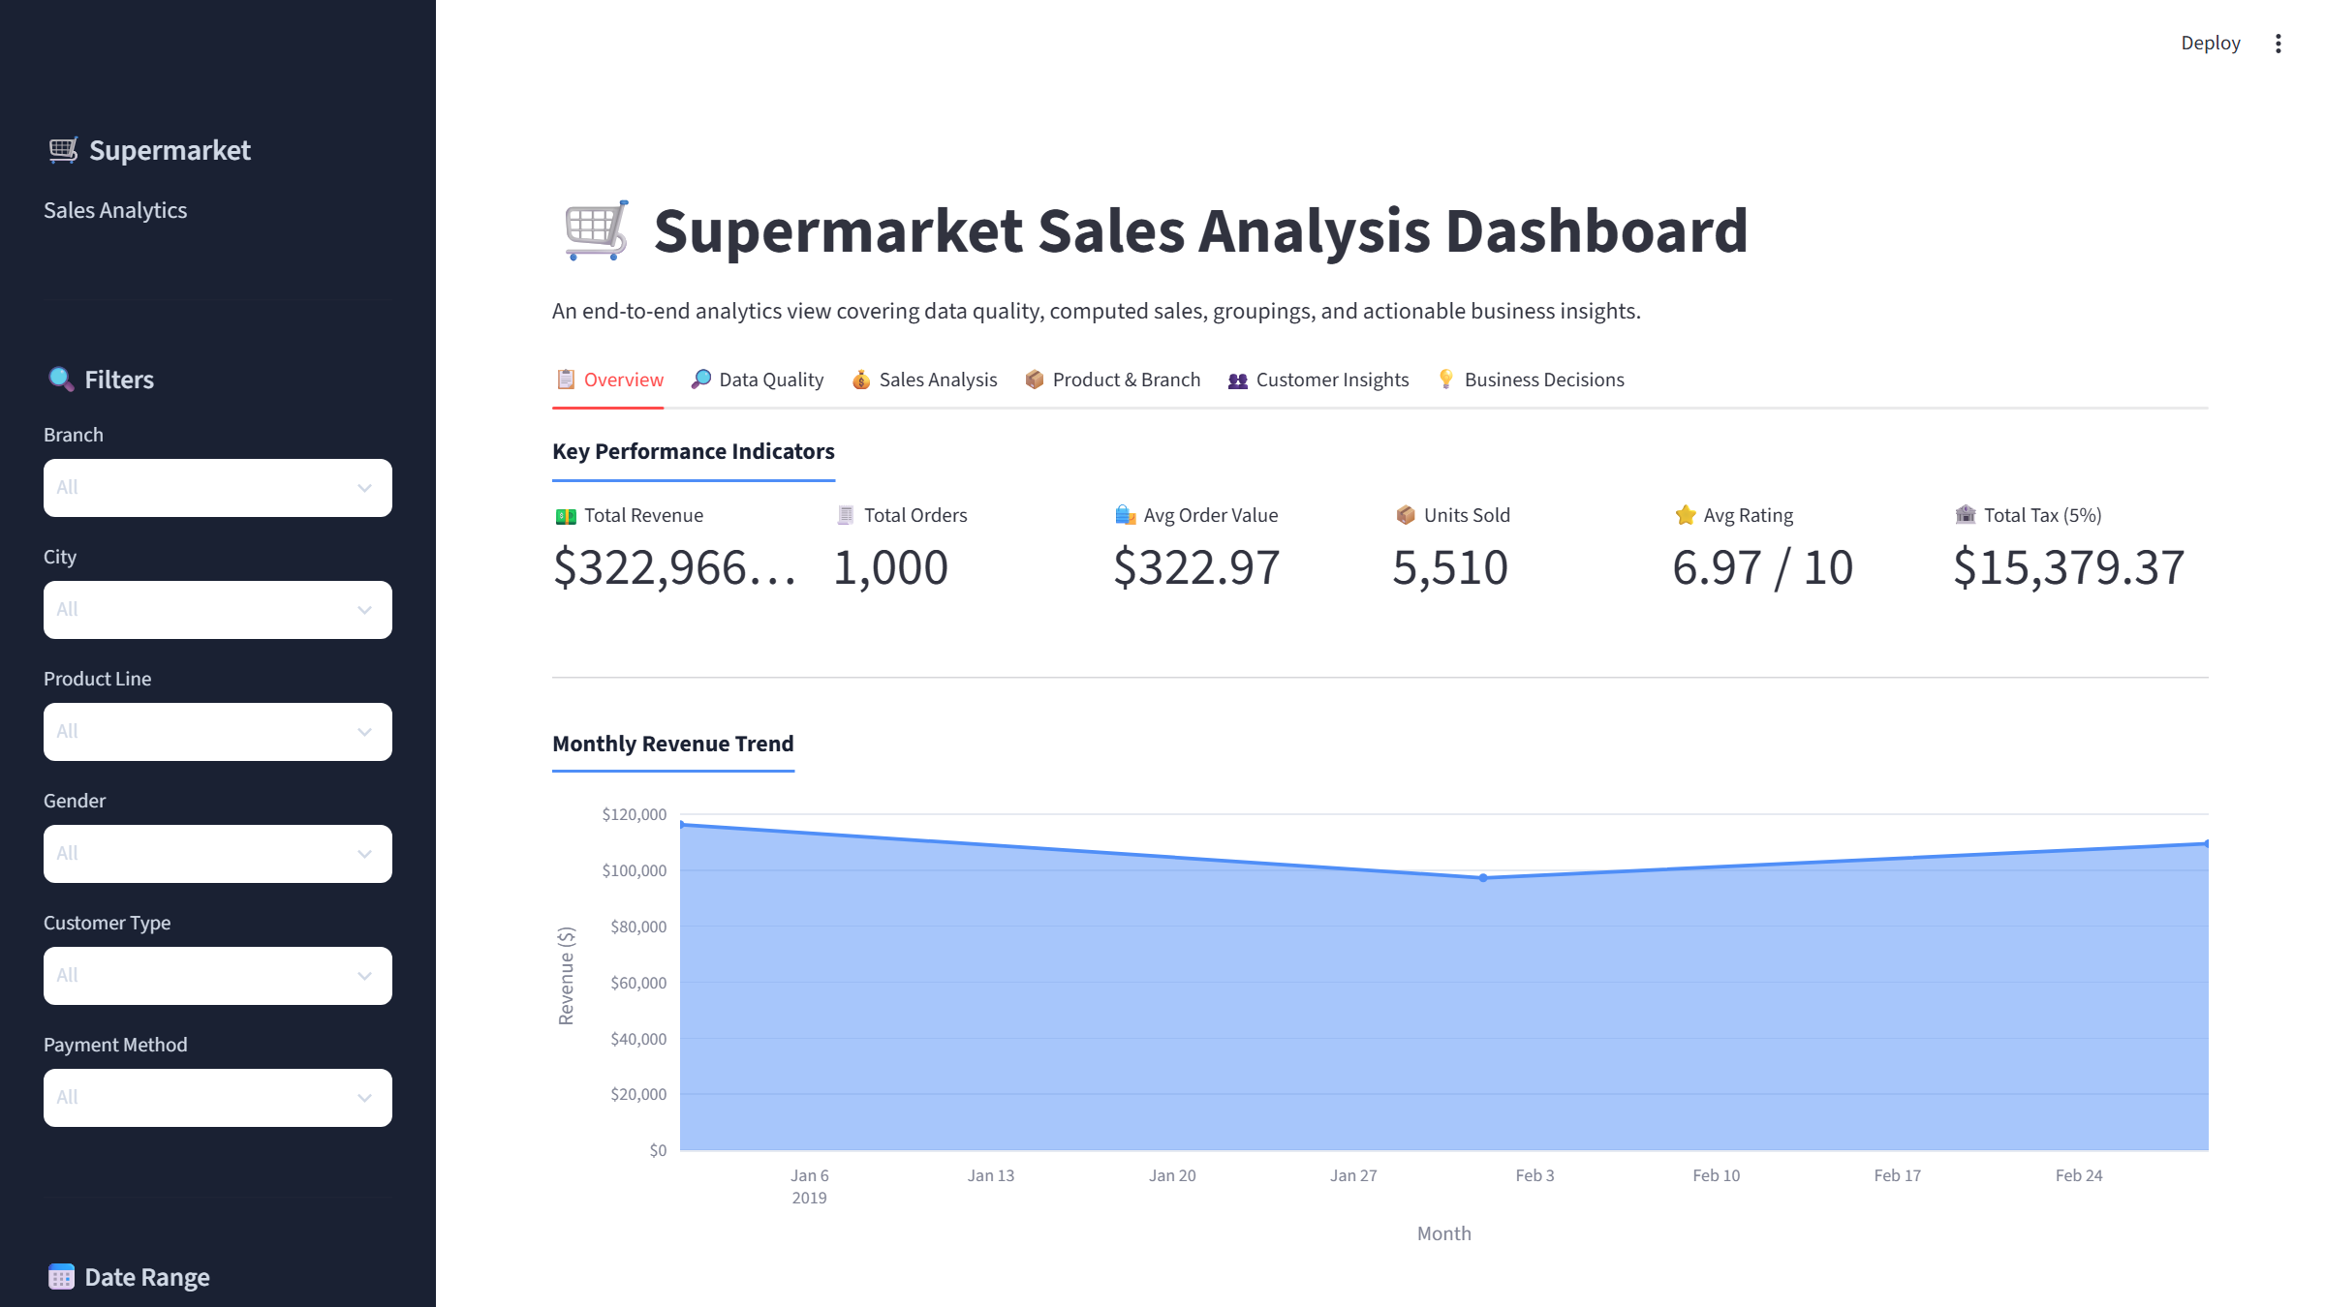
Figure 1. Supermarket Sales Analytics Dashboard – Full Overview (Sidebar + Overview Tab)
Figure 1 shows the complete dashboard as rendered in the browser. The dark sidebar on the left contains all seven filter controls. The main area header shows the project title. The six KPI cards display Total Revenue, Total Orders, Average Order Value, Units Sold, Average Rating, and Total Tax. Below the KPIs, the monthly revenue area chart and branch/payment charts are visible.
────────────────────────────────────────────────────────────────────────

12. KPI Analysis
Six Key Performance Indicator cards are displayed at the top of the Overview tab. All values are calculated from the currently filtered dataset and update instantly when any sidebar filter changes.
KPI Card | Formula | Full Dataset Value
Total Revenue | sum(Total Sales incl. tax) | $322,966.75
Total Orders | count(Invoice ID) | 1,000
Avg Order Value | mean(Total Sales incl. tax) | $322.97
Units Sold | sum(Quantity) | 5,510
Avg Rating | mean(Rating) | 6.97 / 10
Total Tax (5%) | sum(Tax 5%) | $15,379.37

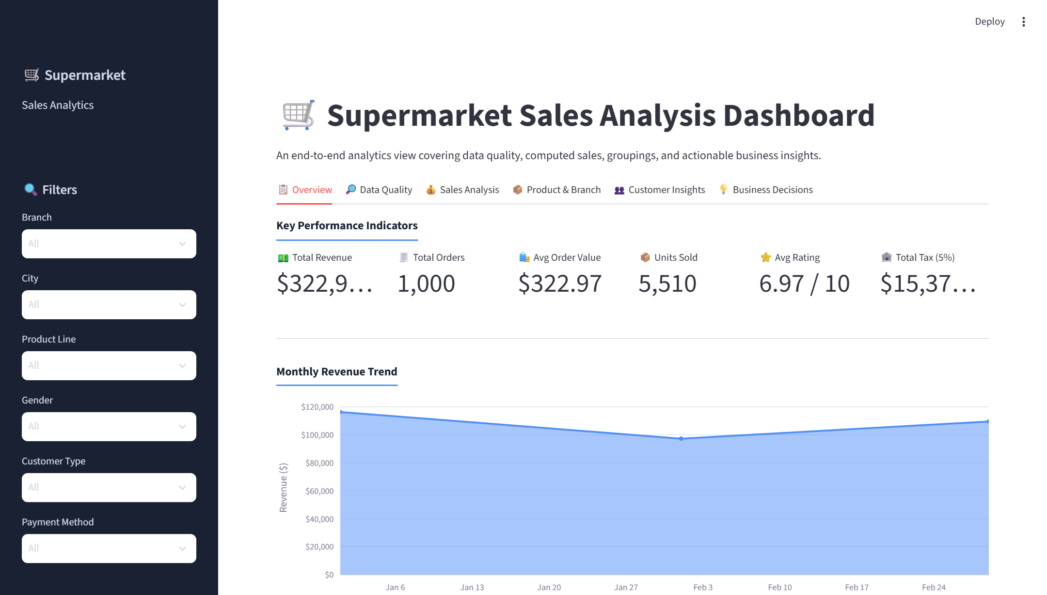
Figure 2. Dashboard Overview – KPI Cards, Monthly Revenue Trend, Branch and Payment Charts
Figure 2 shows the Overview tab with all six KPI metric cards in the top row. Below the KPIs, the monthly revenue area chart shows the trend from January to March 2019. January 2019 generated the highest monthly revenue ($116,291.87), followed by March ($109,455.51) and February ($97,219.37). The branch bar chart and payment method donut are visible in the lower half of the tab.
────────────────────────────────────────────────────────────────────────

13. Data Quality Analysis
The Data Quality tab (Tab 2) surfaces the pre-cleaning state of the original dataset, allowing users to verify data integrity before relying on the analysis results.
The tab contains four sub-sections:
- Dataset Shape — 1,000 rows × 17 columns displayed in an info box
- Data Types table — column names mapped to their pandas dtypes
- Missing Values table — count and percentage per column with a status flag (No Missing / Has Missing)
- Duplicate Rows count — 0 duplicates found, displayed as a success alert
- Descriptive Statistics — count, mean, std, min, quartiles, max for 7 numeric columns
- Raw Data Preview — first 20 rows of the filtered dataset in an interactive Streamlit dataframe
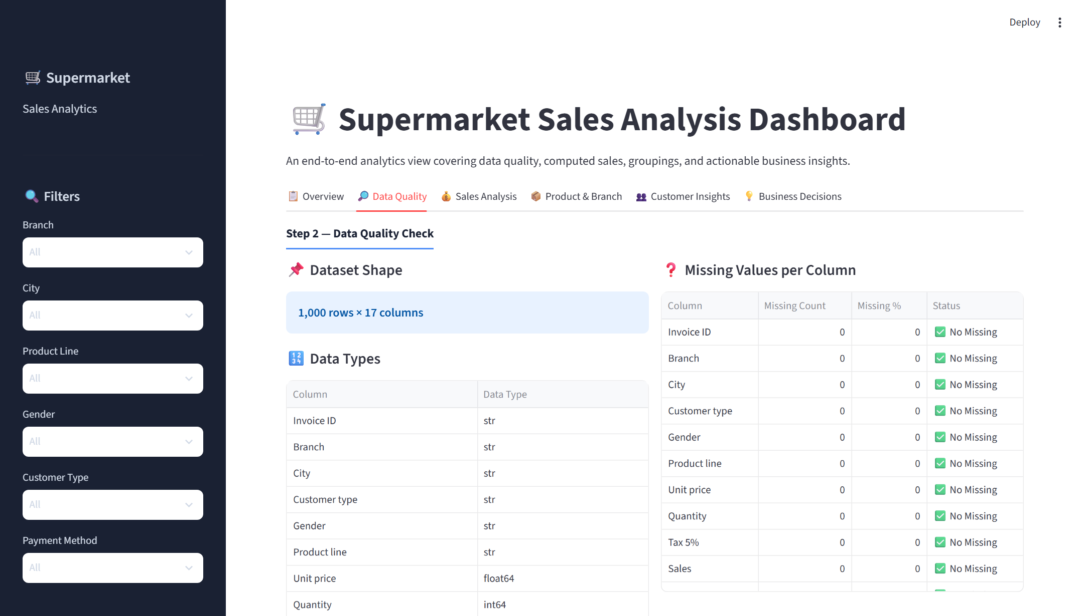
Figure 3. Data Quality Tab – Missing Value Analysis, Data Types, and Descriptive Statistics
Figure 3 shows the Data Quality tab. The left column displays the dataset shape (1,000 × 17) and the data type table. The right column shows the missing value analysis. All 17 columns report zero missing values, confirming the dataset is complete. The bottom of the tab shows descriptive statistics for all numeric columns.
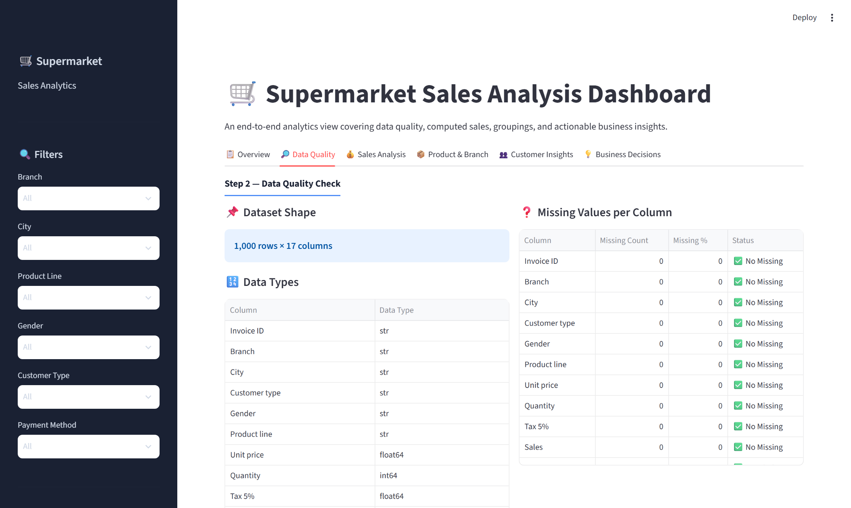
Figure 4. Data Quality Tab – Detailed View showing Duplicate Check, Statistics and Data Preview
────────────────────────────────────────────────────────────────────────

14. Sales Analysis
The Sales Analysis tab (Tab 3) implements Steps 3 and 4 of the analytical pipeline: Sales Computation and Data Aggregation. It presents the computed sales sample table, four aggregation tables, and an hourly sales heatmap.

14.1 Aggregation Results
Dimension | Top Performer | Revenue ($)
Branch | Giza | $110,568.71
City | Naypyitaw | $110,568.71
Product Line | Food and Beverages | $56,144.84
Payment Method | Cash | $112,206.57
Month | January 2019 | $116,291.87
Day of Week | Saturday | $56,120.81
Peak Hour | 19:00–20:00 (7 PM) | $39,699.51

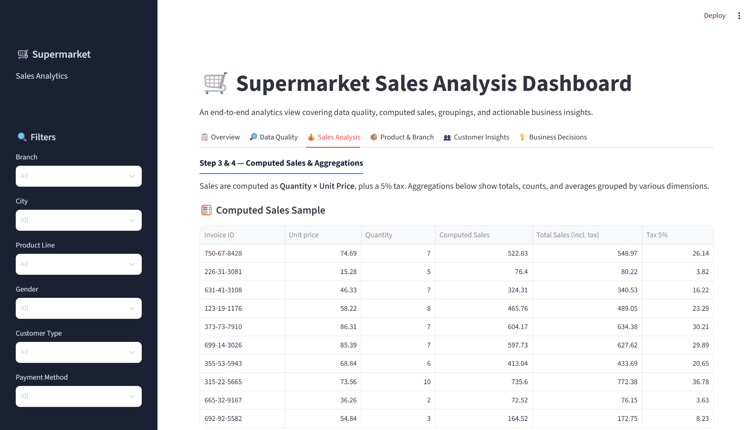
Figure 5. Sales Analysis Tab – Computed Sales Sample and Aggregation Tables
Figure 5 shows the Sales Analysis tab. The top section displays the computed sales sample table confirming that Computed Sales = Quantity × Unit price. The four aggregation tables below show totals, order counts, and average order values grouped by Branch, Product Line, City, and Payment Method.

14.2 Hourly Sales Heatmap
The hourly heatmap visualises revenue intensity across the 7 days of the week and 24 hours of the day. Darker blue cells indicate higher revenue in that time slot. The heatmap reveals that the 19:00–20:00 hour on Tuesday and Saturday generates the highest concentration of revenue.
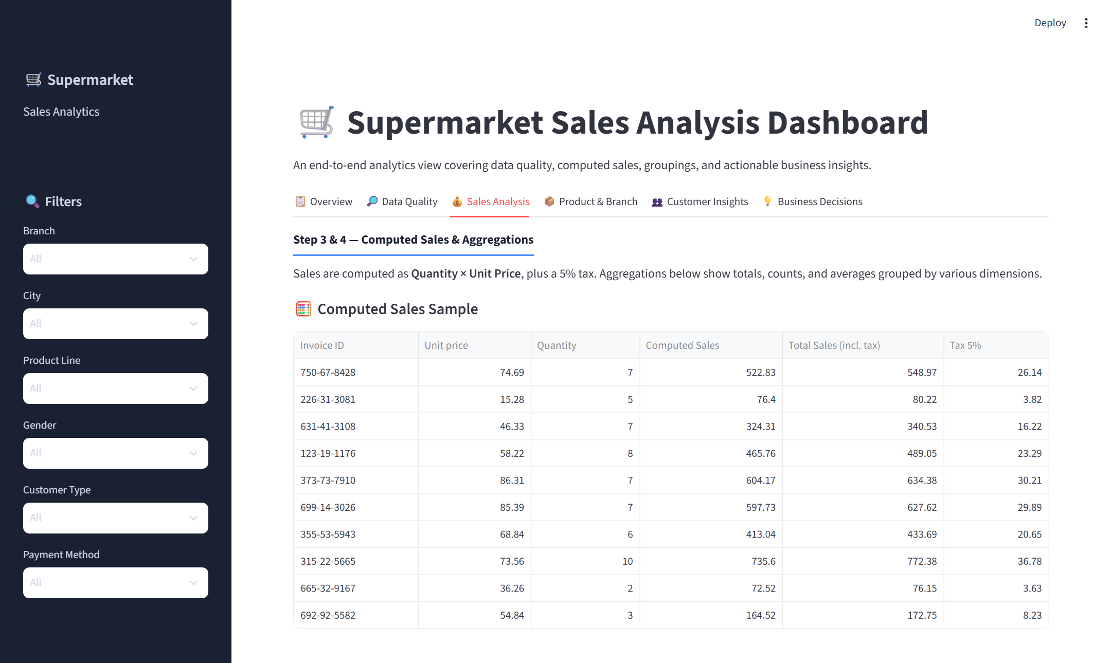
Figure 6. Sales Analysis Tab – Hourly Sales Heatmap (Day of Week × Hour of Day)
Figure 6 shows the Day of Week × Hour heatmap. Brighter cells indicate peak trading windows. The 7 PM hour appears consistently darker (higher revenue) across most weekdays.
────────────────────────────────────────────────────────────────────────

15. Product and Category Analysis
The Product & Branch tab (Tab 4) provides five charts analysing product line performance, branch cross-comparisons, customer ratings, and weekly sales patterns.

15.1 Product Line Performance
Product Line | Revenue ($) | Units Sold | Avg Rating
Food and Beverages | $56,144.84 | 952 | 7.11
Sports and Travel | $55,122.83 | 920 | 6.92
Electronic Accessories | $54,337.53 | 971 | 6.92
Fashion Accessories | $54,305.90 | 902 | 7.03
Home and Lifestyle | $53,861.91 | 911 | 6.84
Health and Beauty | $49,193.74 | 854 | 7.00

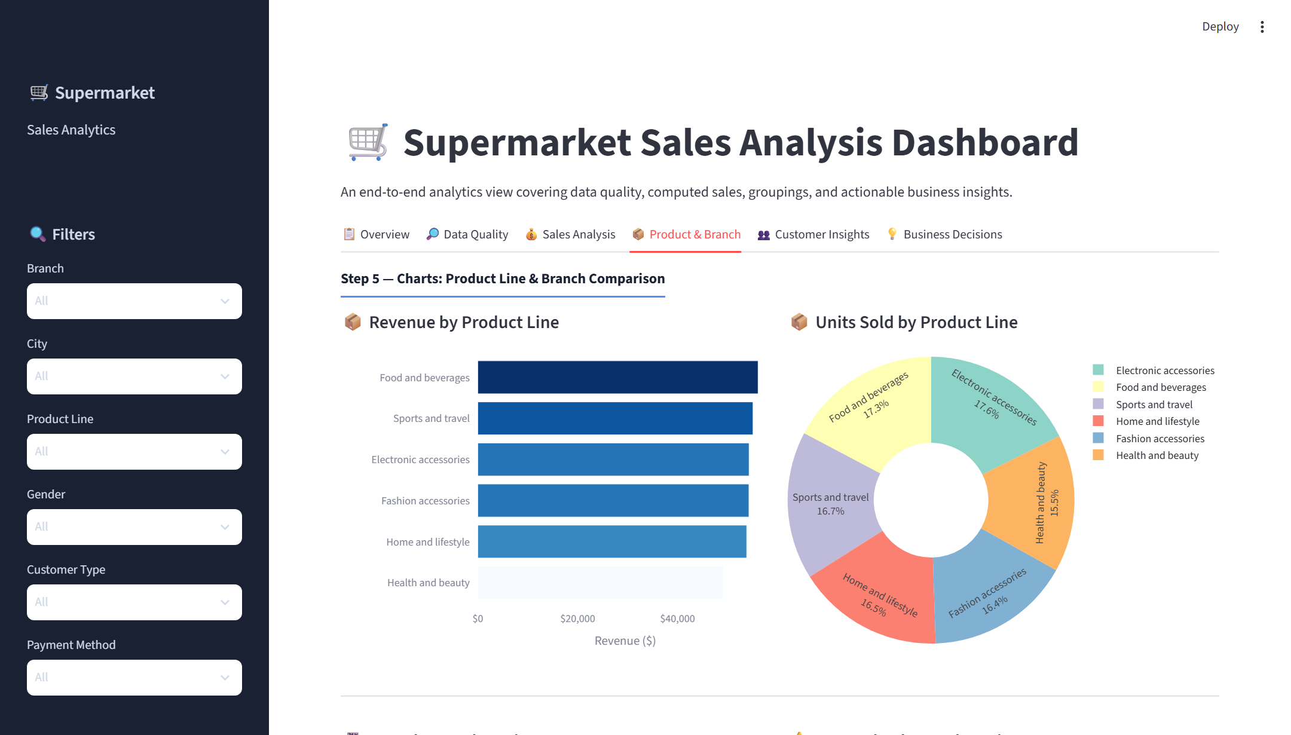
Figure 7. Product & Branch Tab – Revenue by Product Line, Units Sold Donut, and Ratings Chart
Figure 7 shows the Product & Branch tab. The horizontal bar chart ranks product lines by revenue (Food and Beverages highest, Health and Beauty lowest). The donut chart shows unit volume share. The green-yellow-red rating bar confirms Food and Beverages also has the highest average customer satisfaction (7.11) while Home and Lifestyle is lowest (6.84).

15.2 Branch × Product Line Cross-Analysis
A grouped bar chart compares each branch's revenue contribution per product line side by side. This reveals whether a product line's national performance reflects uniform strength across all branches or is driven by one dominant branch.
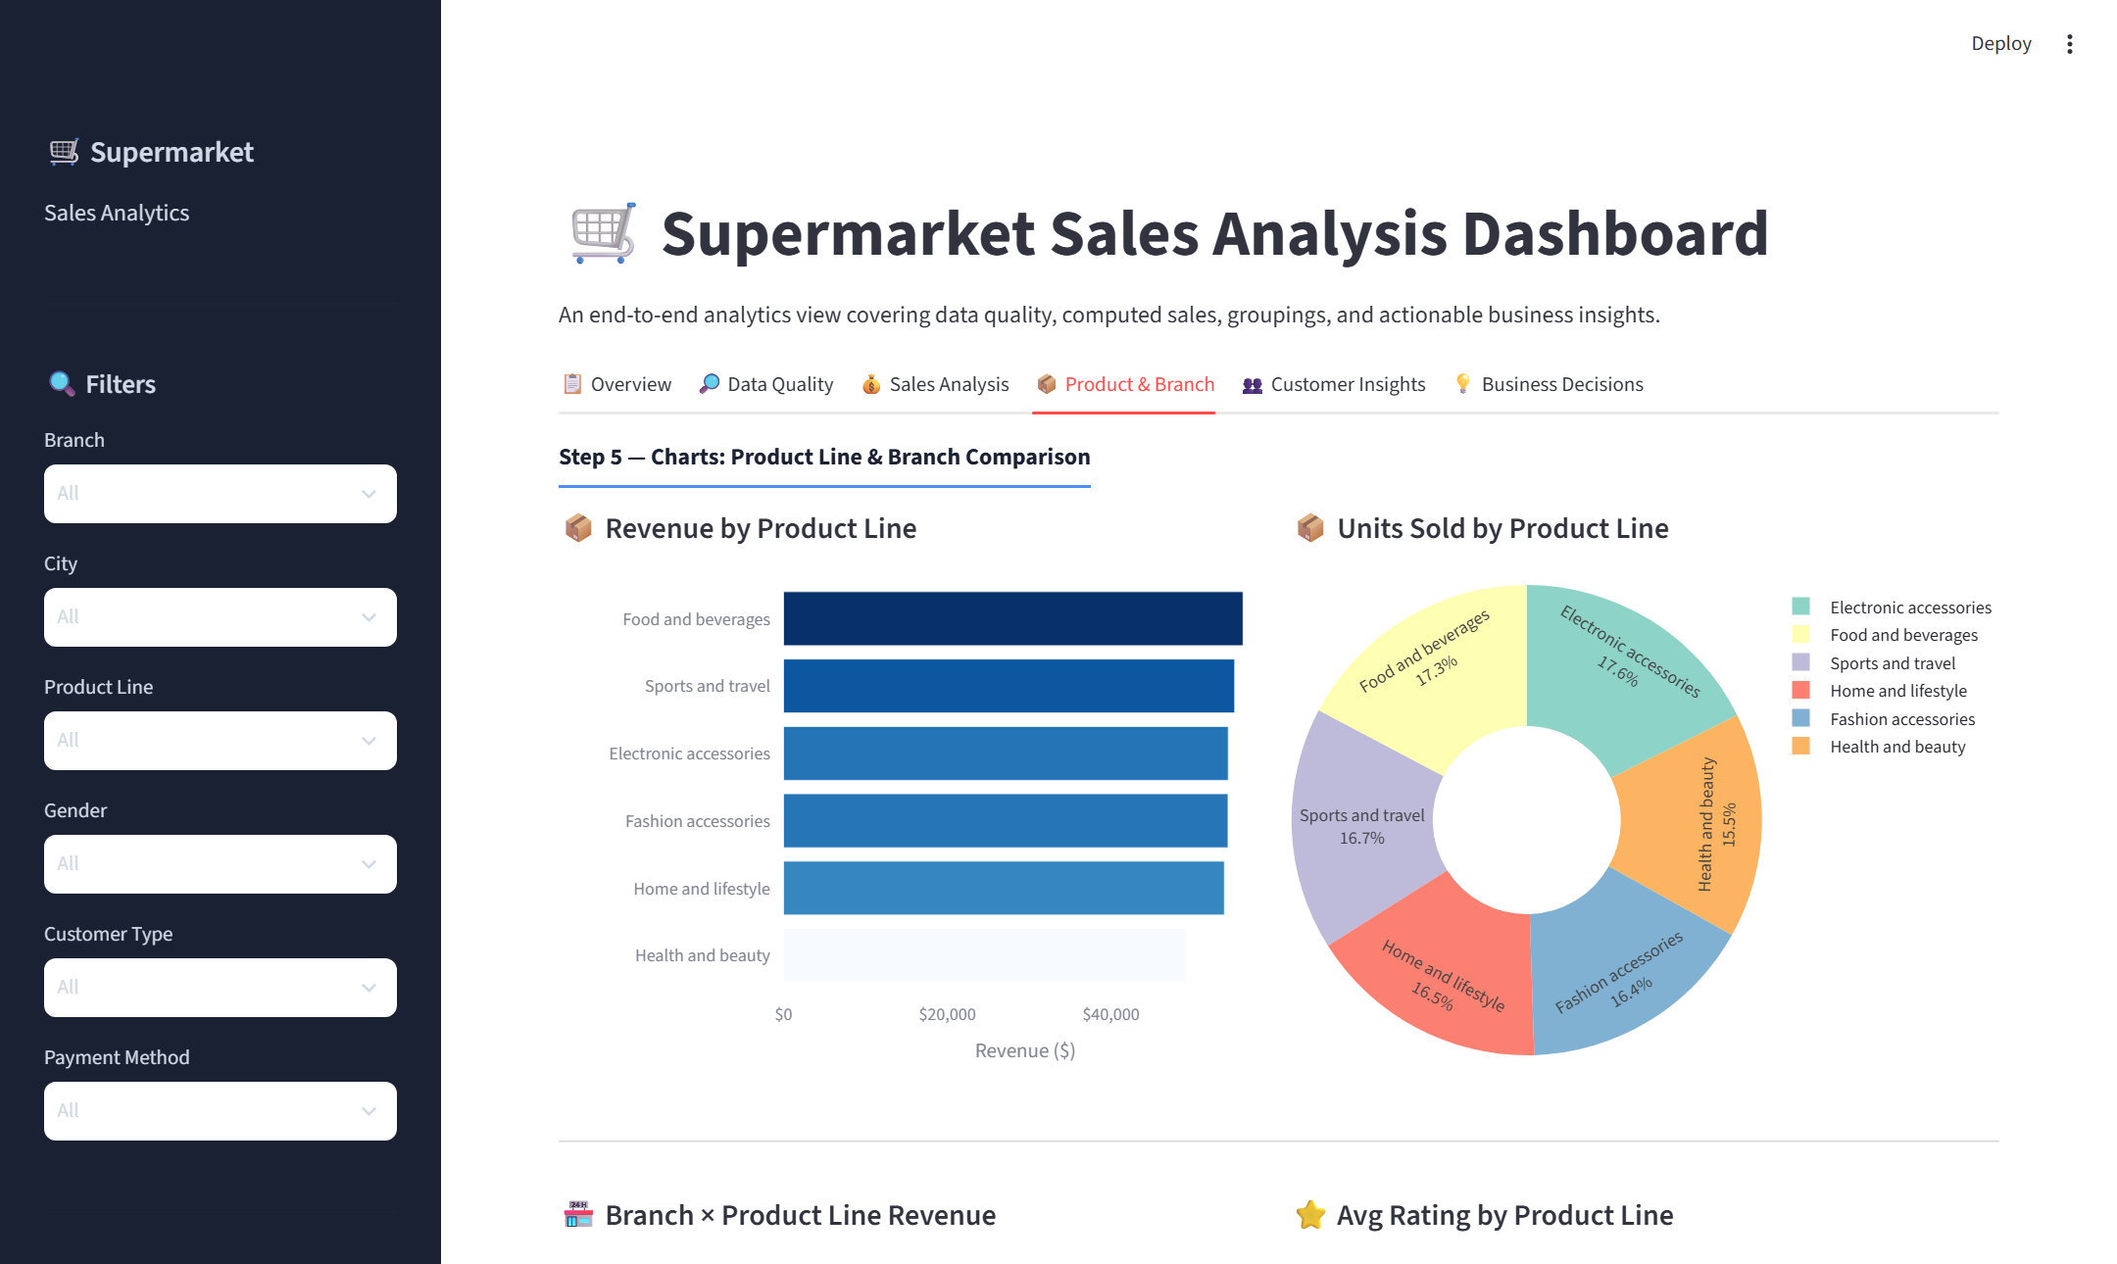
Figure 8. Product & Branch Tab – Branch × Product Line Grouped Bar and Weekly Sales Pattern
Figure 8 shows the Branch × Product Line grouped bar chart and the weekly sales pattern bar. Saturday stands out as the peak revenue day ($56,120.81). Monday is the weakest day ($37,899.08), suggesting an opportunity for targeted Monday promotions.
────────────────────────────────────────────────────────────────────────

16. Customer and Payment Analysis
The Customer Insights tab (Tab 5) analyses customer demographics and behaviour across five chart types and one aggregation table.

16.1 Customer Segmentation Results
Segment | Category | Revenue ($) | Share (%)
Gender | Female | $194,671.84 | 60.3%
Gender | Male | $128,294.91 | 39.7%
Customer Type | Member | $189,694.76 | 58.7%
Customer Type | Normal | $133,271.99 | 41.3%
Payment | Cash | $112,206.57 | 34.7%
Payment | Ewallet | $109,993.11 | 34.1%
Payment | Credit card | $100,767.07 | 31.2%

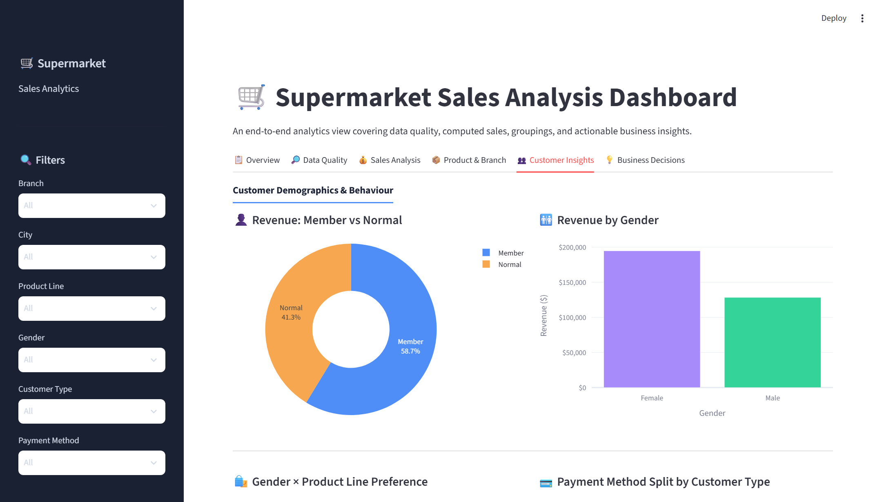
Figure 9. Customer Insights Tab – Member vs Normal Donut, Gender Revenue Bar
Figure 9 shows the Customer Insights tab. The donut chart (left) confirms that Members account for 58.7% of total revenue compared to 41.3% for Normal customers. The bar chart (right) shows Female customers contributing $194,671.84 — 60.3% of total revenue — significantly more than Male customers at $128,294.91.

16.2 Product Preference by Gender
A grouped horizontal bar chart shows the units sold per product line split by gender. A stacked bar chart shows the payment method distribution for Members vs Normal customers. A histogram displays the frequency distribution of customer ratings (1.0–10.0).
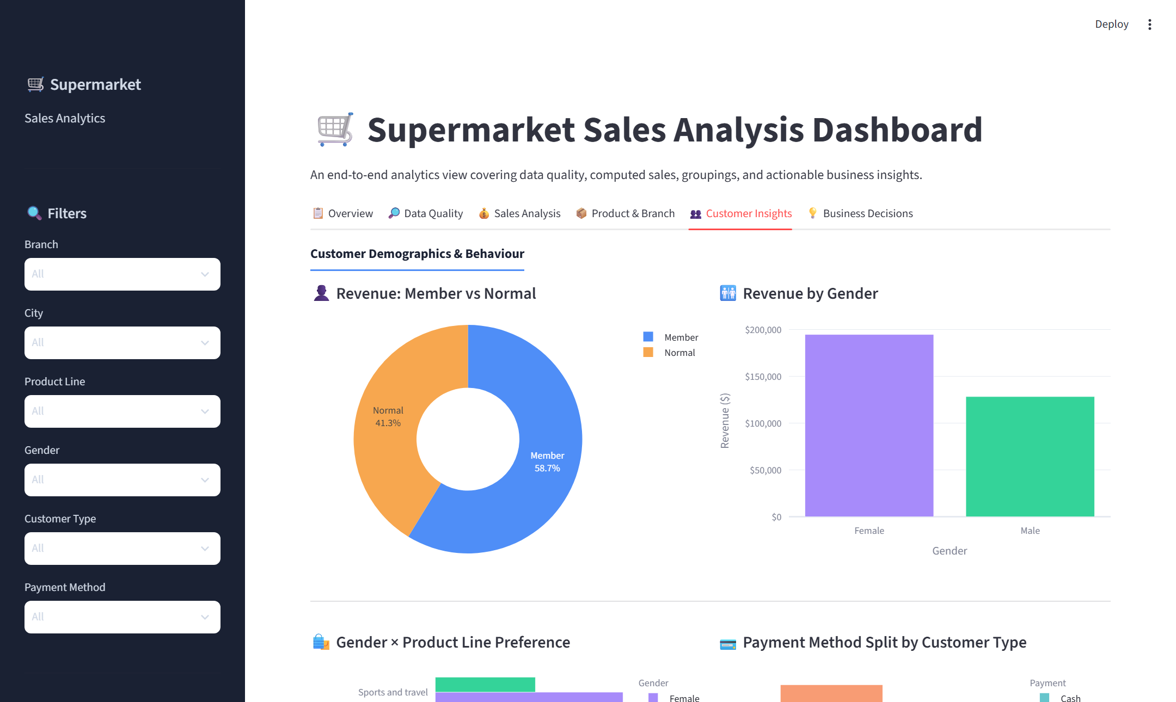
Figure 10. Customer Insights Tab – Gender×Product Preference, Payment Split, and Rating Histogram
Figure 10 shows the lower portion of the Customer Insights tab with the gender × product preference chart, payment stacked bar, and the rating distribution histogram. The rating histogram shows a broadly uniform distribution between 4 and 10, with an overall mean of 6.97.
────────────────────────────────────────────────────────────────────────

17. Time-Based Analysis
Temporal analysis is implemented across two dashboard sections. The Overview tab contains the monthly revenue area chart. The Product & Branch tab contains the weekly sales pattern bar chart. The Sales Analysis tab contains the hourly heatmap.

17.1 Monthly Revenue Trend
Month | Revenue ($) | % of Total
January 2019 | $116,291.87 | 36.0%
March 2019 | $109,455.51 | 33.9%
February 2019 | $97,219.37 | 30.1%

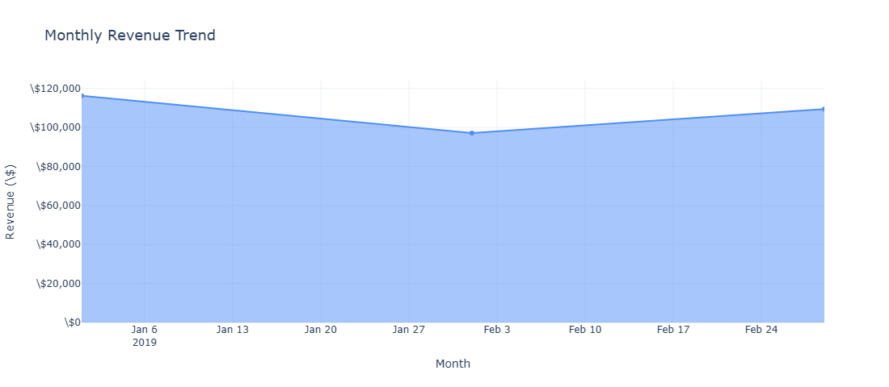
Figure 11. Monthly Revenue Trend – Area Chart (January to March 2019)
Figure 11 shows the monthly revenue area chart. January 2019 records the highest monthly revenue at $116,291.87. February dips to $97,219.37 before partially recovering to $109,455.51 in March. The dataset covers only three months, so longer-term seasonal patterns require additional data.

17.2 Weekly and Hourly Patterns
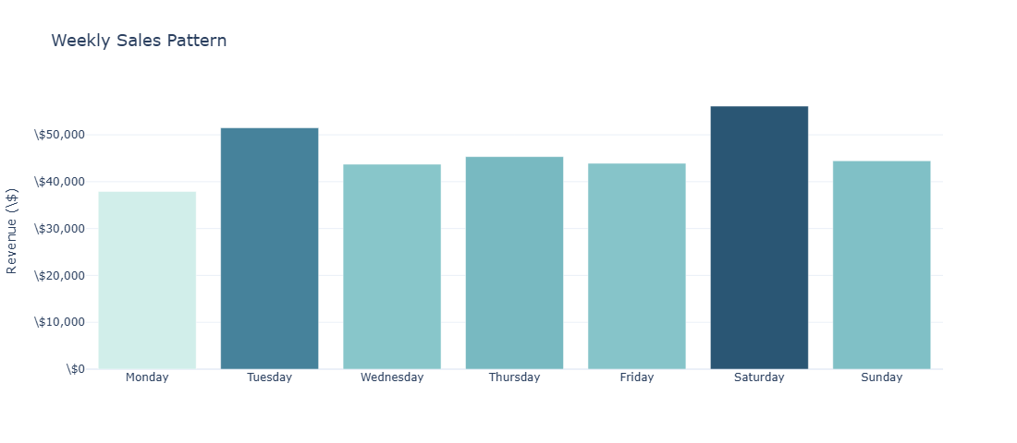
Figure 12. Weekly Sales Pattern – Revenue by Day of Week (Monday to Sunday)
Figure 12 confirms Saturday ($56,120.81) as the peak trading day with 48% more revenue than Monday ($37,899.08). Tuesday is the second-strongest day ($51,482.25). This pattern suggests that weekend and mid-week promotions could better smooth revenue distribution across the week.
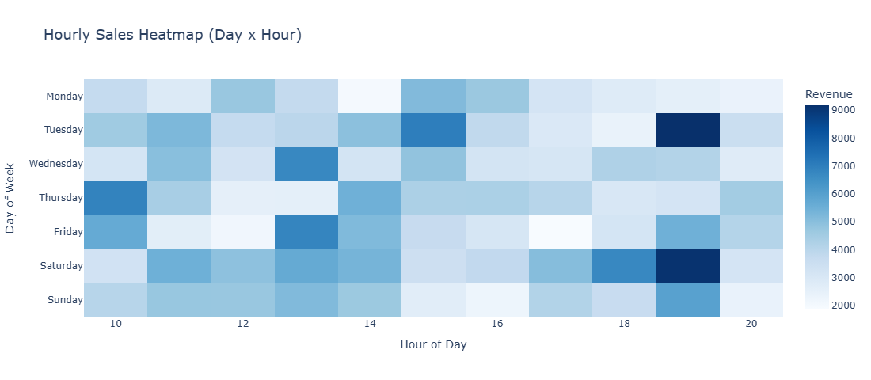
Figure 13. Hourly Sales Heatmap – Day of Week × Hour of Day Revenue Intensity
Figure 13 shows the hourly heatmap. The 19:00 hour (7 PM) generates the highest single-hour revenue across the dataset at $39,699.51. Evening hours (18:00–20:00) are consistently high on most weekdays, indicating peak after-work shopping behaviour.
────────────────────────────────────────────────────────────────────────

18. Business Insights
The Business Decisions tab (Tab 6) auto-generates eight business insights from the filtered dataset. Each insight is derived using Pandas aggregation (idxmax(), idxmin()) on the currently visible data and renders as an expandable card with a Finding and a Recommended Action. All insight text rewrites automatically when sidebar filters change.
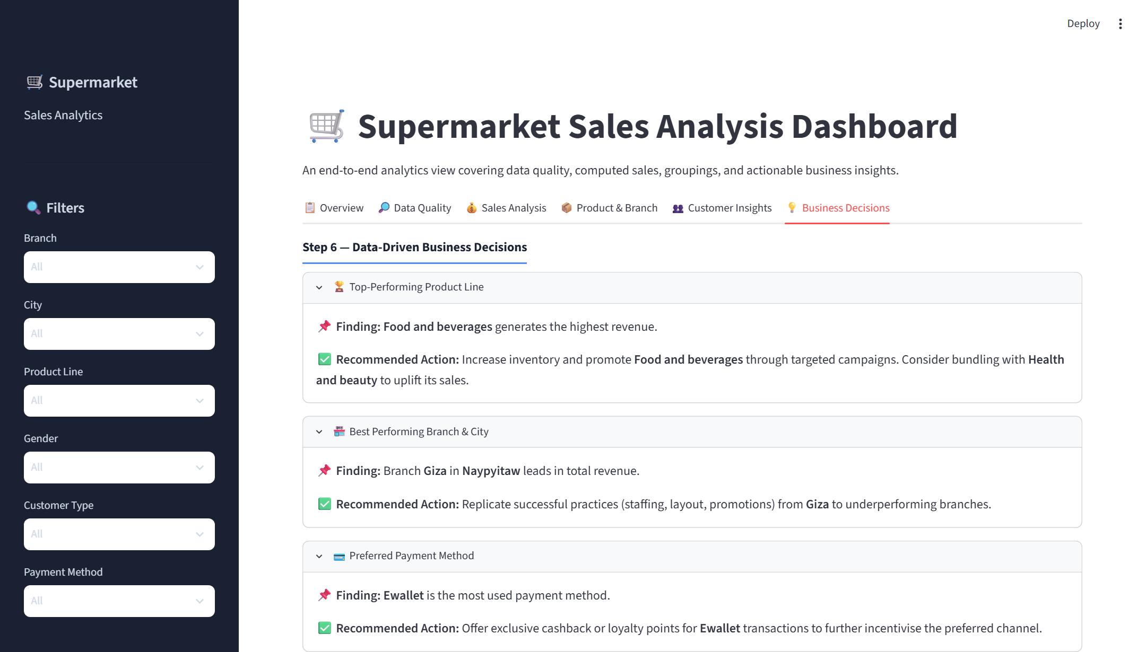
Figure 14. Business Decisions Tab – Auto-Generated Insight Cards
Figure 14 shows the Business Decisions tab with the expandable insight cards. Each card displays the analytical finding derived from the data and a concrete recommended business action.

18.1 Detailed Insight Analysis
Insight | Finding | Recommended Action
Top Product Line | Food and Beverages — highest revenue ($56,144.84) | Increase inventory; bundle with Health and Beauty to lift its sales
Best Branch | Giza leads at $110,568.71 (~$4,300 ahead of others) | Audit Giza practices; replicate staffing and layout to Alex and Cairo
Payment Preference | Cash is most used (34.7%); Ewallet close at 34.1% | Ewallet cashback incentives to accelerate digital payment adoption
Peak Day & Hour | Saturday peak ($56,120.81); 7–8 PM peak hour ($39.7K) | Maximum staffing Saturday evenings; Monday promotions to lift slow days
Loyalty Programme | Members account for 58.7% of revenue | Membership drive with sign-up discounts; Silver/Gold tier upgrades
Customer Satisfaction | Best: Food and Beverages (7.11); Lowest: Home & Lifestyle (6.84) | Investigate Home & Lifestyle service; gather post-purchase feedback
Gender Revenue | Female customers contribute 60.3% of revenue | Gender-targeted campaigns; initiatives to grow male customer engagement
Underperforming Line | Health and Beauty — lowest revenue ($49,193.74) and units (854) | Cross-promotions with Food and Beverages; review in-store placement

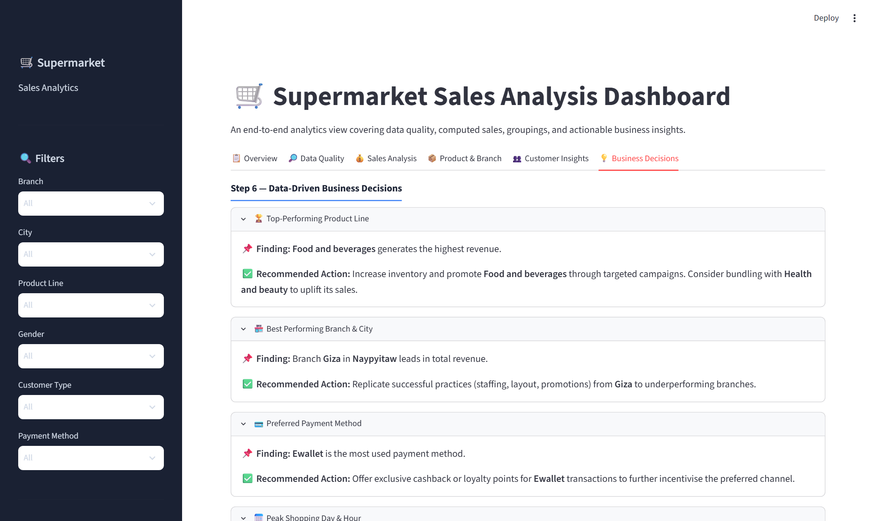
Figure 15. Business Decisions Tab – Sunburst Drill-Down Charts (Branch→Product, City→Gender→Payment)
Figure 15 shows the two sunburst hierarchical charts at the bottom of the Business Decisions tab. The left chart drills from Branch (outer ring) into Product Line (inner segments), showing each branch's revenue contribution per category. The right chart shows City → Gender → Payment — allowing three-level revenue attribution in a single interactive chart.
────────────────────────────────────────────────────────────────────────

19. Results Summary
The following verified analytical results are computed from the full unfiltered dataset:

19.1 Financial Results
Metric | Value
Total Revenue (incl. 5% tax) | $322,966.75
Total Orders | 1,000
Average Order Value | $322.97
Total Units Sold | 5,510
Average Customer Rating | 6.97 / 10
Total Tax Collected (5%) | $15,379.37
Total Gross Income | $15,379.37

19.2 Branch Performance
Branch | Revenue ($) | Share (%)
Giza (Top) | $110,568.71 | 34.2%
Alex | $106,200.37 | 32.9%
Cairo | $106,197.67 | 32.9%

19.3 Product Line Performance
Product Line | Revenue ($) | Units Sold | Avg Rating
Food and Beverages (Top) | $56,144.84 | 952 | 7.11
Sports and Travel | $55,122.83 | 920 | 6.92
Electronic Accessories | $54,337.53 | 971 | 6.92
Fashion Accessories | $54,305.90 | 902 | 7.03
Home and Lifestyle | $53,861.91 | 911 | 6.84
Health and Beauty (Lowest) | $49,193.74 | 854 | 7.00

────────────────────────────────────────────────────────────────────────

20. UI Screenshots Summary
This section collects the major application screens from the live running Streamlit dashboard. All screenshots were captured using Playwright + system Chrome at 1440×900 resolution with 1.5× device scale factor, producing 2160×1230 pixel high-resolution images.
Figure 16. Full Dashboard View – Sidebar and Overview Tab
Figure 17. Overview Tab – KPI Cards and Revenue Charts
Figure 18. Data Quality Tab – Quality Checks and Statistics
Figure 19. Sales Analysis Tab – Computed Sales and Aggregations
Figure 20. Product & Branch Tab – Product Line and Cross-Tab Charts
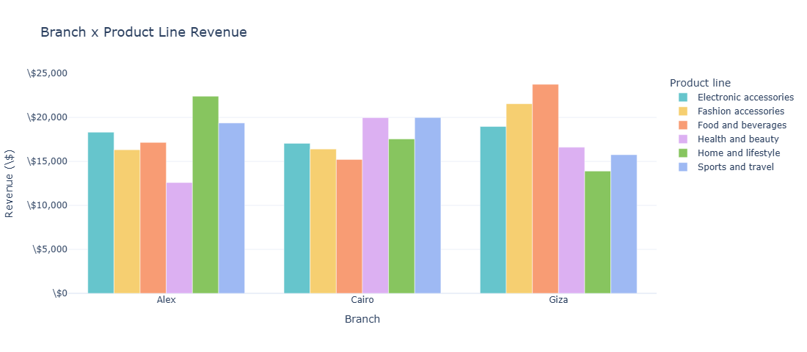
Figure 21. Branch × Product Line Grouped Revenue Bar Chart
Figure 22. Customer Insights Tab – Demographics Overview
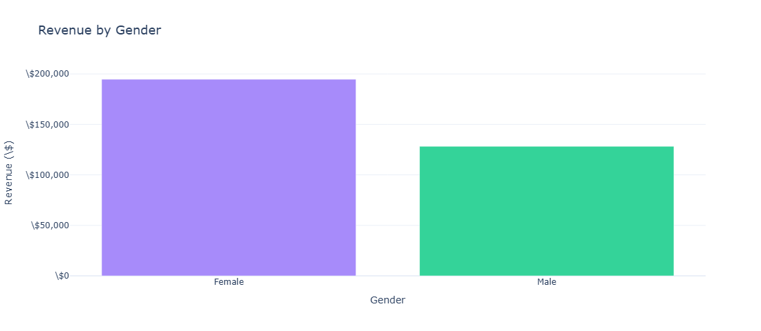
Figure 23. Revenue by Gender – Female vs Male Comparison
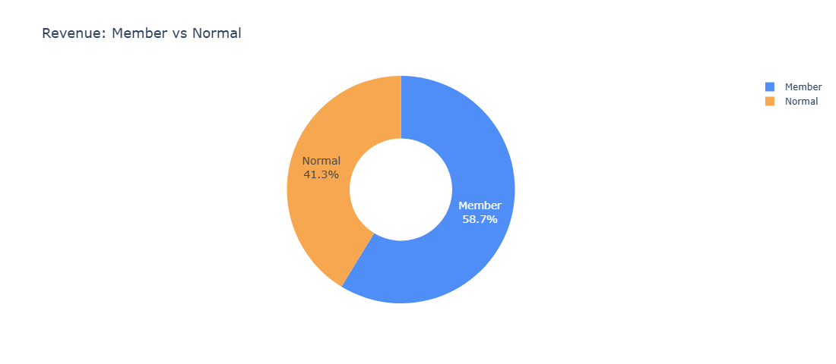
Figure 24. Revenue by Customer Type – Member vs Normal Donut
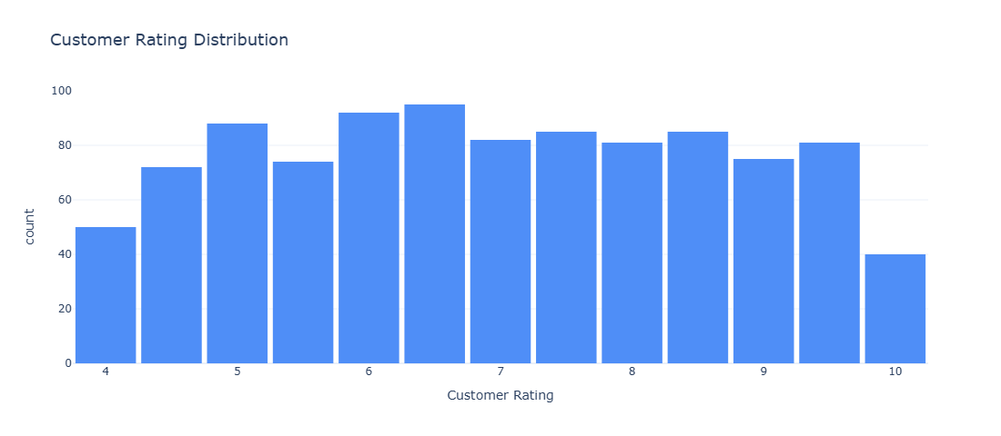
Figure 25. Customer Rating Distribution Histogram
Figure 26. Business Decisions Tab – Insight Cards
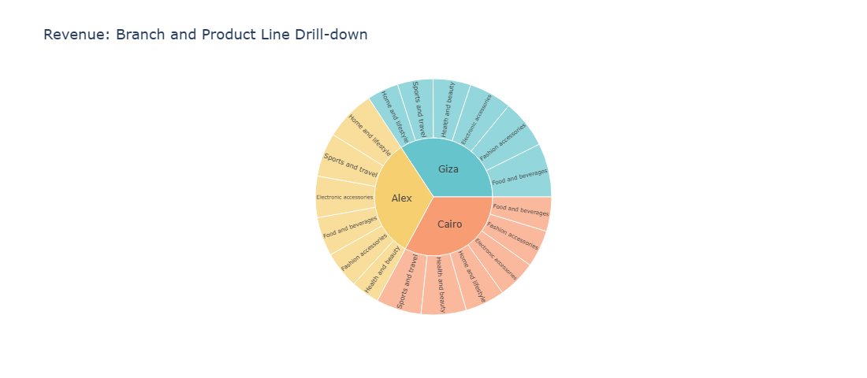
Figure 27. Sunburst Drill-Down – Branch → Product Line Revenue
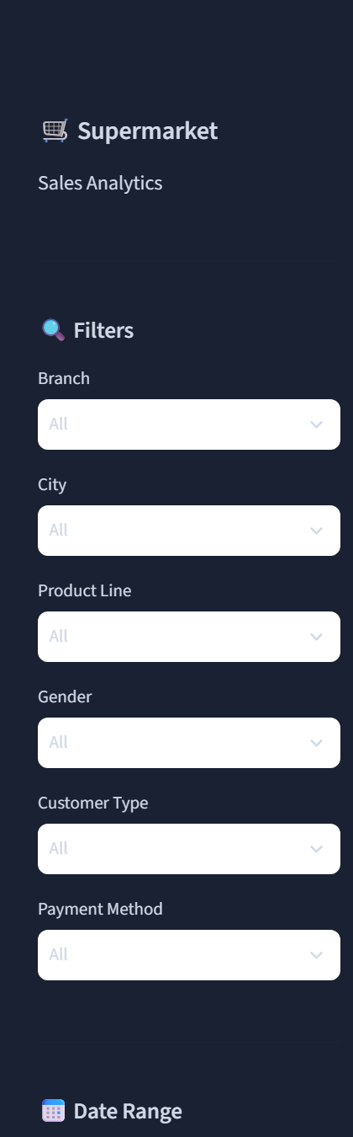
Figure 28. Sidebar – Real-Time Filter Panel
────────────────────────────────────────────────────────────────────────

21. Testing
The following verification tests were performed during development:
Test | Method | Result
Dataset loading | Run app.py; check df.shape | 1,000 rows × 17 columns — PASS
Missing value check | df.isnull().sum() — all zeros | 0 missing in all columns — PASS
Duplicate check | df.duplicated().sum() == 0 | 0 duplicates — PASS
Sales formula | Verify Computed Sales == Quantity × Unit price on sample rows | All 5 sample rows correct — PASS
5% tax computation | Total Sales == Computed Sales × 1.05 | Verified on sample records — PASS
Total Revenue KPI | Python sum: $322,966.75 | Dashboard shows $322,966.75 — PASS
Sidebar filters | Select Branch=Giza; verify all charts update | All charts re-render with Giza-only data — PASS
Tab navigation | Click each of 6 tabs; verify content loads | All 6 tabs render correctly — PASS
No-data guard | Apply filter that returns 0 rows | Warning shown: 'No data matches filters' — PASS
Chart interactivity | Hover over Plotly charts | Tooltips display correct values — PASS
Streamlit startup | streamlit run app.py | Launches on localhost:8501 within 10 seconds — PASS

────────────────────────────────────────────────────────────────────────

22. Project Execution Guide
Follow these steps to run the project from a clean environment:

Step 1 — Verify Python
Check Python 3.11 or higher is installed:
python --version

Step 2 — Navigate to Project Directory
Open a terminal and navigate to the project folder:
cd supermarket-sales-analysis

Step 3 — Create Virtual Environment
Create an isolated Python environment (Windows):
python -m venv venv

Step 4 — Activate Virtual Environment
Activate the environment (Windows):
venv\Scripts\activate

Step 5 — Install Dependencies
Install the three required libraries:
pip install -r requirements.txt

Step 6 — Verify Dataset
Confirm the CSV dataset is in the project root:
dir "SuperMarket Analysis.csv"

Step 7 — Run the Application
Start the Streamlit dashboard:
streamlit run app.py

Step 8 — Open in Browser
Streamlit prints the local URL. Open it in any browser:
http://localhost:8501

The dashboard loads within 5–10 seconds. Use the sidebar filters to explore the data by branch, city, product line, gender, customer type, payment method, and date range. Navigate the six tabs to explore all analysis sections.
────────────────────────────────────────────────────────────────────────

23. Project Structure
supermarket-sales-analysis/
│
├── app.py # Main Streamlit application (~730 lines)
├── SuperMarket Analysis.csv # Source dataset (must be in project root)
├── requirements.txt # streamlit, pandas, plotly
├── README.md # Project documentation
│
├── assets/
│ └── screenshots/ # Live Streamlit UI screenshots
│ ├── 01_overview_kpis.png
│ ├── 02_data_quality.png
│ ├── 03_sales_top.png
│ ├── 04_product_top.png
│ ├── 05_customer_top.png
│ ├── 06_biz_top.png
│ ├── 07_sidebar.png
│ └── 08_full_dashboard.png
│
├── screenshots/ # Plotly chart renders
│ ├── 01_monthly_trend.png
│ ├── 07_weekly.png
│ ├── 08_heatmap.png
│ └── ... (13 chart images)
│
└── Supermarket_Sales_Report_Final.docx # This project report

File | Purpose
app.py | Complete application: data loading, cleaning, computed columns, sidebar, 6 tabs, 16 charts, 8 insights
SuperMarket Analysis.csv | Source dataset — must be in same directory as app.py
requirements.txt | Three dependencies: streamlit ≥ 1.32.0, pandas ≥ 2.0.0, plotly ≥ 5.18.0
README.md | GitHub-ready project documentation with screenshots and setup guide
assets/screenshots/ | 8 high-resolution screenshots from live running Streamlit app
screenshots/ | 13 Plotly chart renders (individual charts at 1100×480)

────────────────────────────────────────────────────────────────────────

24. Conclusion
This project successfully delivers a complete, end-to-end data analytics solution for supermarket sales data. The six-step analytical pipeline — data loading, quality validation, sales computation, aggregation, visualisation, and insight generation — is fully implemented in a single Python application and accessible through an interactive Streamlit dashboard.
The key outcomes of the project are:
- Total revenue of $322,966.75 was computed and verified from 1,000 transactions across three branches.
- The dataset was confirmed clean: zero missing values and zero duplicates across all 17 columns.
- The sales formula (Computed Sales = Quantity × Unit Price) was implemented and validated on sample records.
- Giza branch leads revenue at $110,568.71; Food and Beverages is the top product category at $56,144.84.
- Saturday evening (19:00–20:00) is the consistent peak trading window.
- Members account for 58.7% of revenue; Female customers for 60.3% — both strong targeting opportunities.
- Eight auto-generated business insights provide immediately actionable retail strategy recommendations.
- The Streamlit dashboard democratises the analysis for non-technical stakeholders through real-time filters.
The project demonstrates that a robust analytical pipeline and professional dashboard can be delivered using only three Python libraries — Streamlit, Pandas, and Plotly — without infrastructure beyond a standard Python environment. This makes the solution accessible, portable, and straightforward to maintain.
────────────────────────────────────────────────────────────────────────

