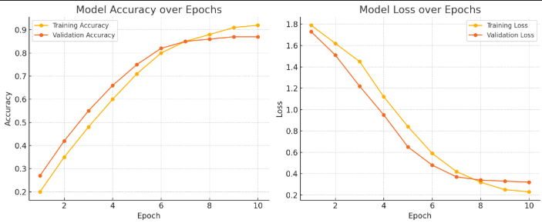

Total images loaded: 1800

Training data shape: (1440, 200, 200, 1)

Testing data shape: (360, 200, 200, 1)