**Sonar Qube Reports**

Below Image represents the dashboard of the SonarQube where the user can able to monitor the over view

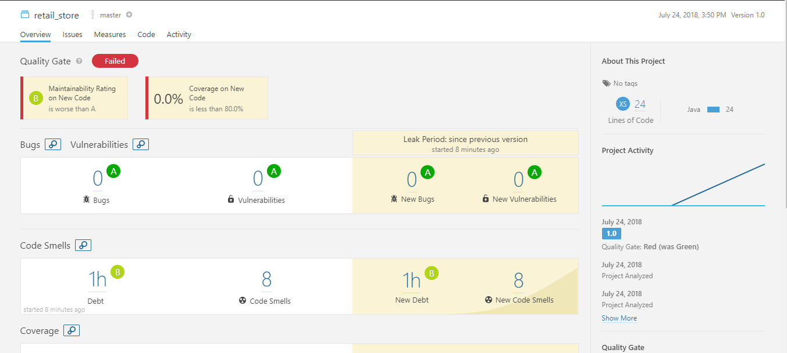

Dashboard

1. uribuilder.java

Below Image represents the issues details where the user can able to know the issues.

The issues were displayed in the following severities,

1. Blocker
2. Critical
3. Major

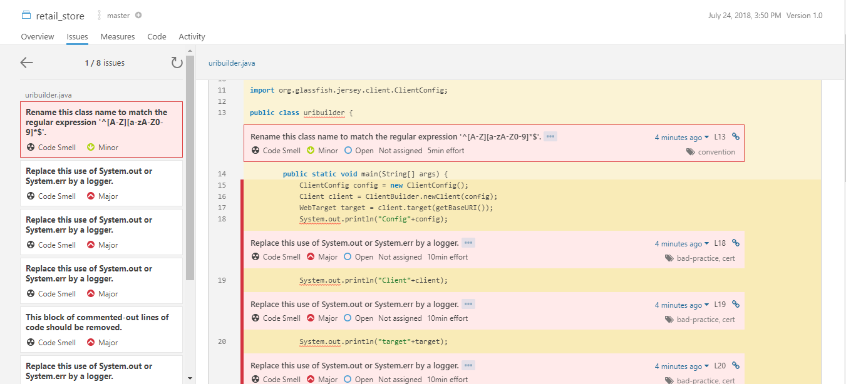

Issue severities

Below Image represents the issues happened in code.

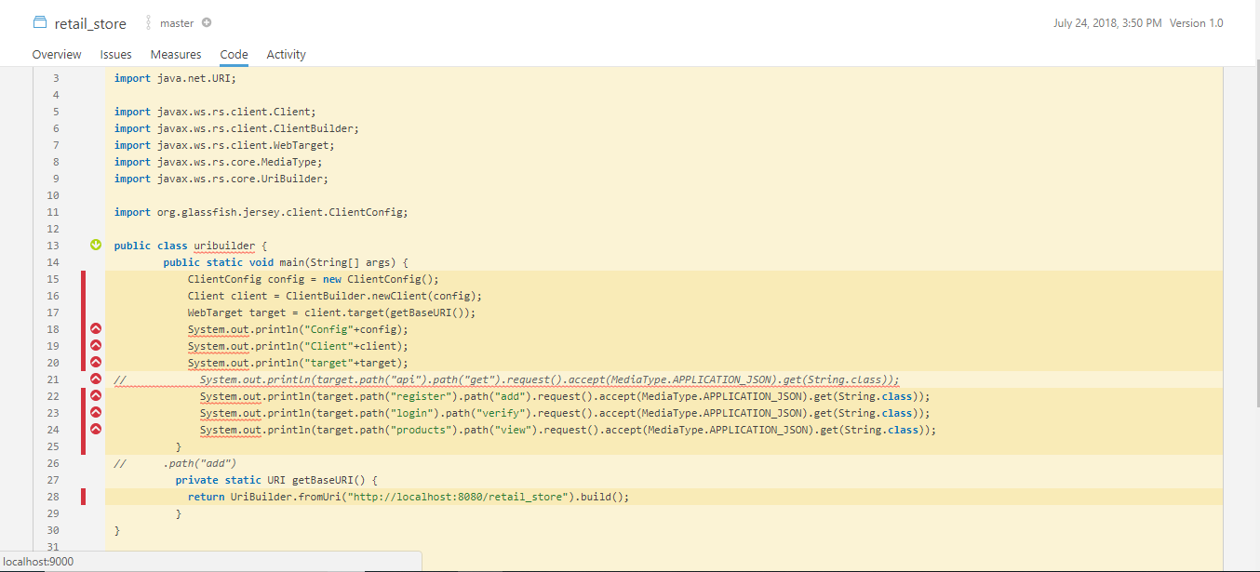

Issue Code

Below Image represents the issue coverages happened in the code.

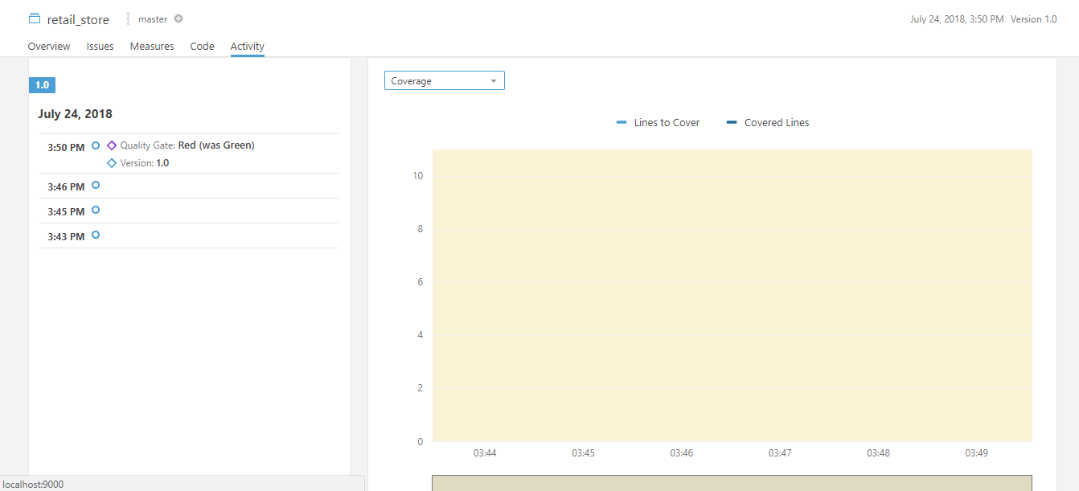

Issue Coverage

Below Image represents the issue activity in the code.

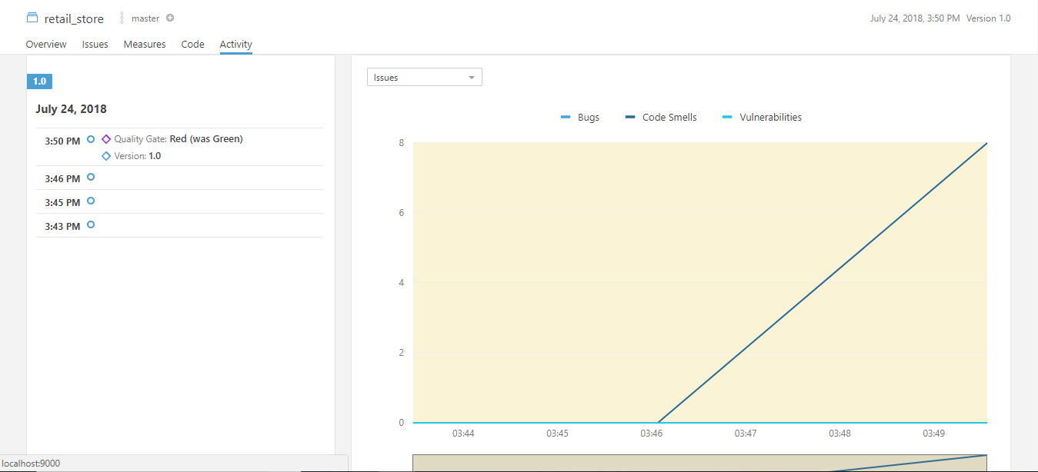

Issue Activity

1. dbconnectivity.java

Below Image represents the issues details where the user can able to know the issues.

The issues were displayed in the following severities,

1.Blocker

2.Critical

3.Major

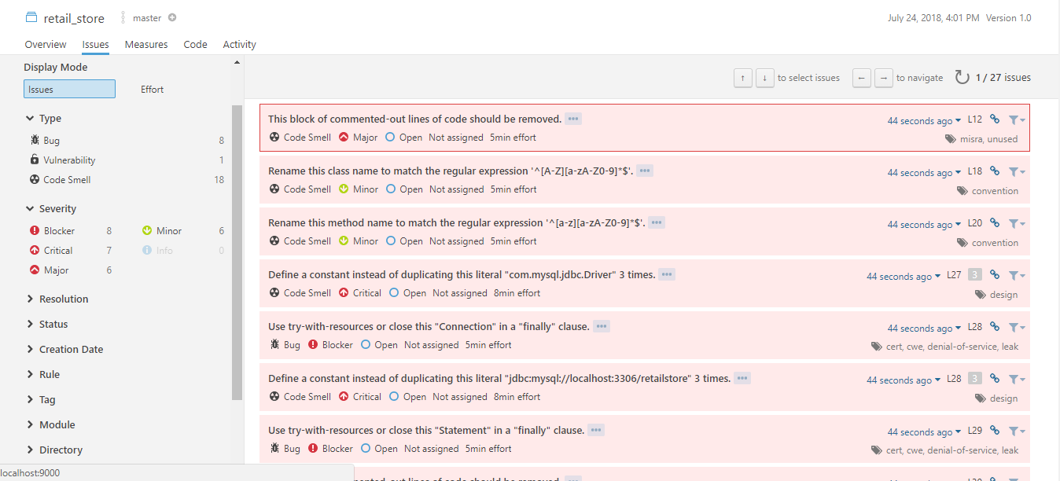

Issue Severeties