Project Title: Sales Intelligence Hub
Login page:
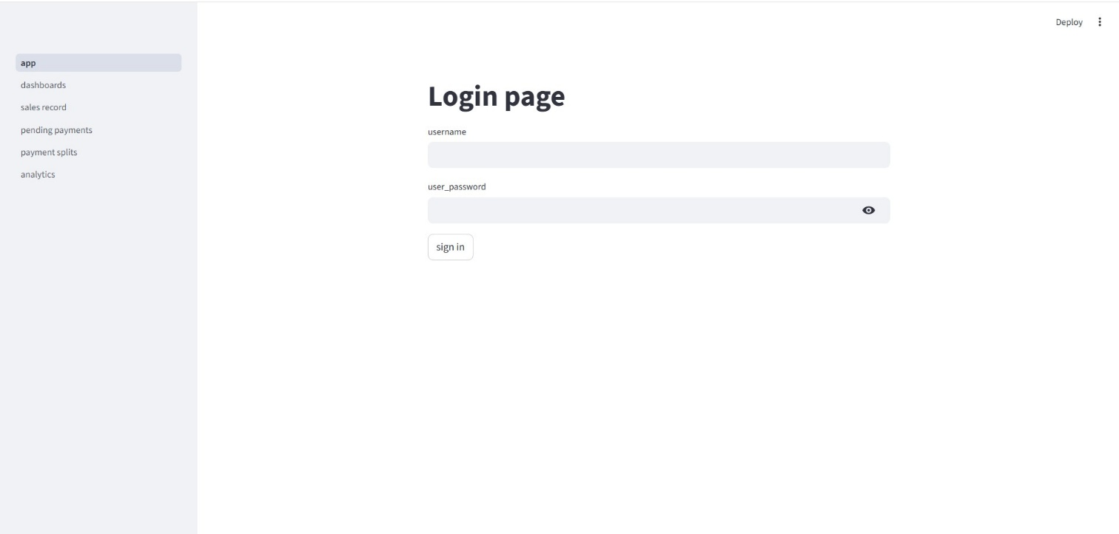
- This is the login page of the application, which is the key to move towards inside the application pages by giving correct login credentials.

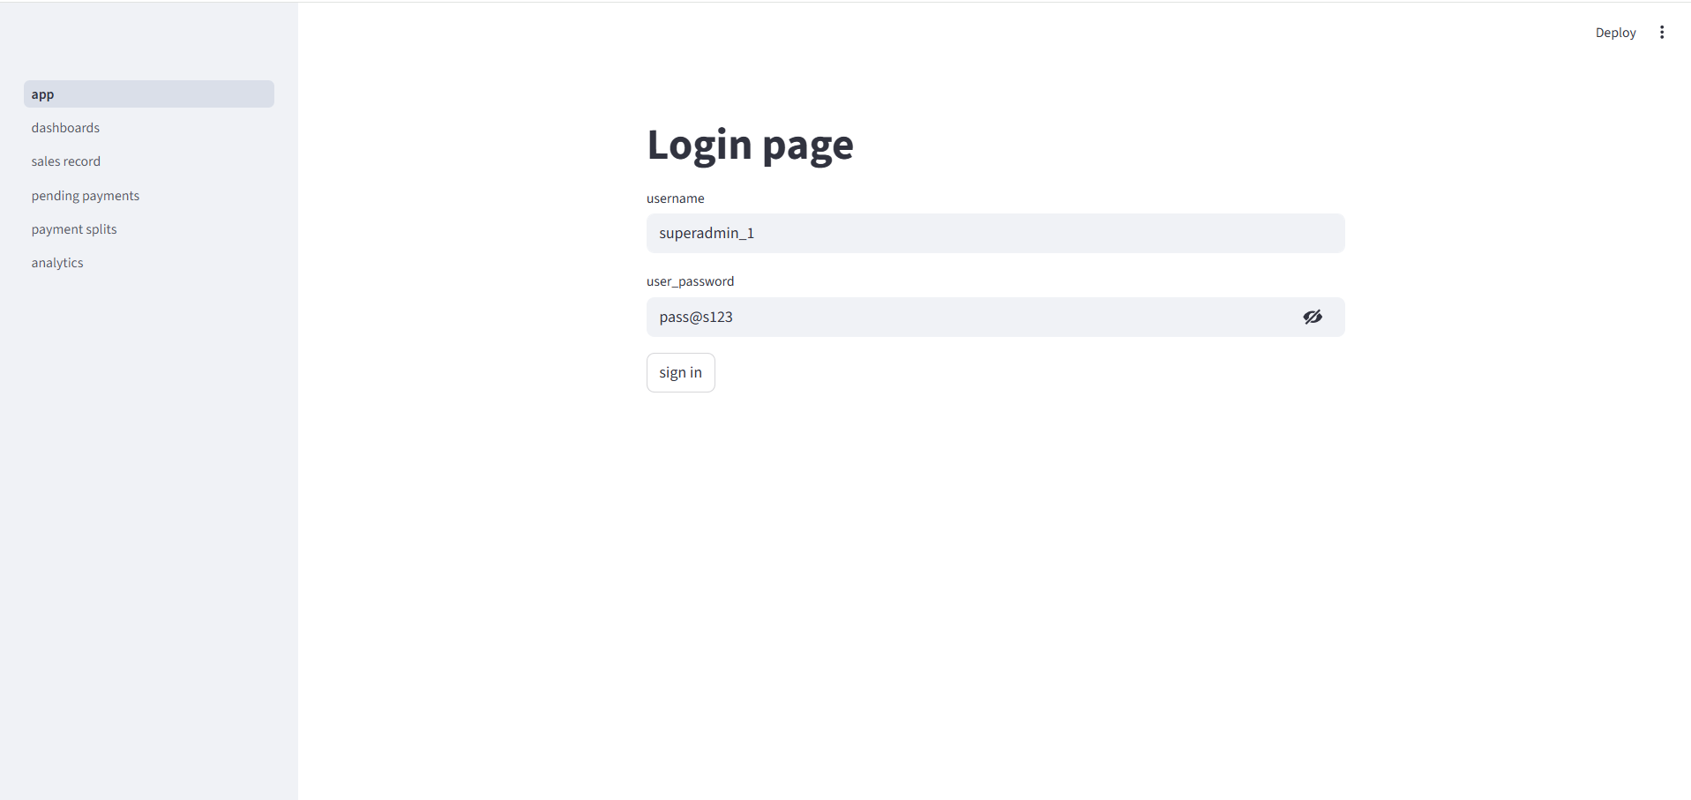
- Now enter the username and password to sign in.
- In this page username = “superadmin_1” and password = “pass@s123” is typed in that place.
- Like that each branch admin has individual login credentials.

Dashboard page:
Super admin dashboard page:
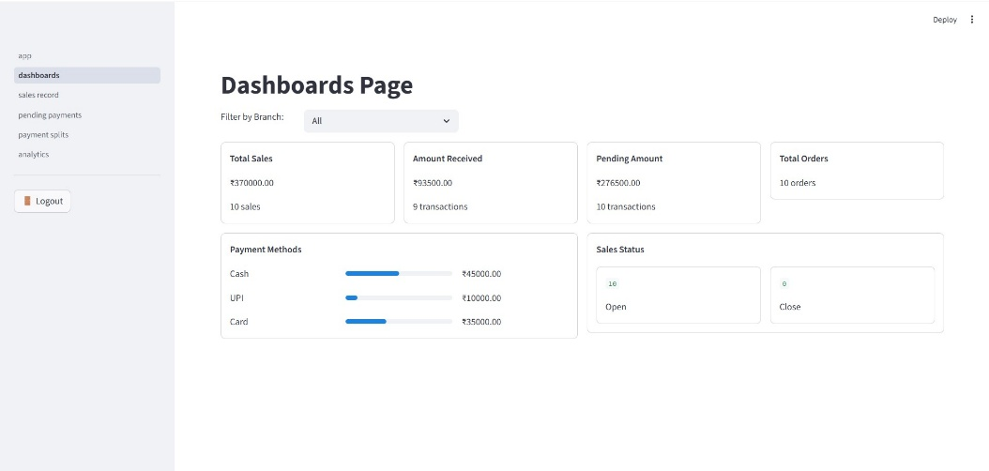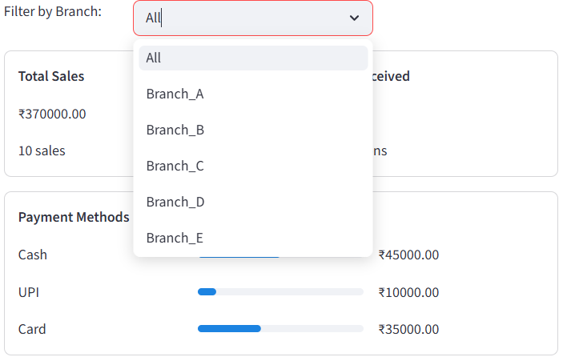
- Dashboard page shows sales overview which contains total sales, amount received, pending amount, total orders, payment methods and sales status.
- In this image it shows overview of all branch sales with help of “Filter by branch” dropdown box.
- Using this filter option “Super admin” can view each branch sales.

Branch admin dashboard page:
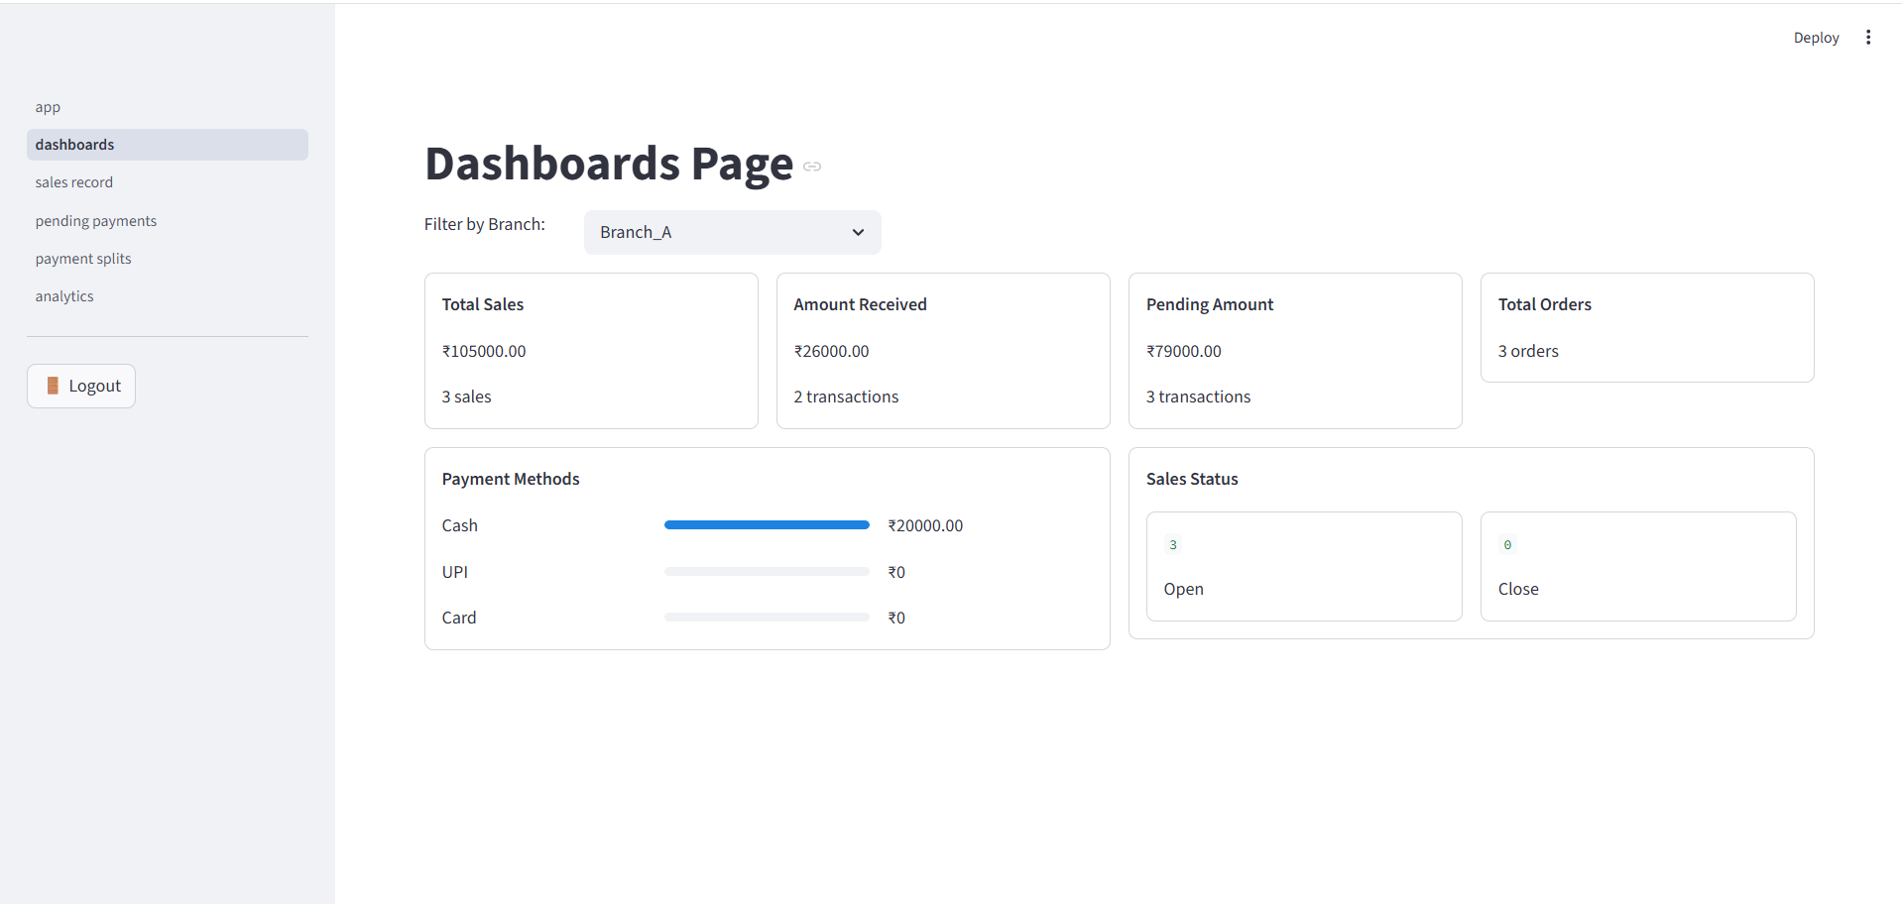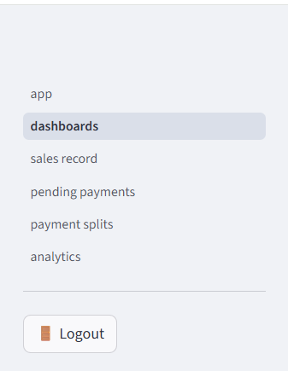
- In this image “Branch A” is selected in filter dropdown box. So that image shows “Branch A” sales overview alone.
- Like “Super admin” login credentials, each branch has their own login.
- Each branch has an individual admin and their login credentials to sign in. While entering separate branch admin login credentials, they can access only their respective branch alone. Whereas Super admin can access all branches.
- There was “sidebar” in left side of the window. It has a page of sales record, payment splits, payment pending, analytics and finally one Logout button.

Sales Record:
Super admin sales record:
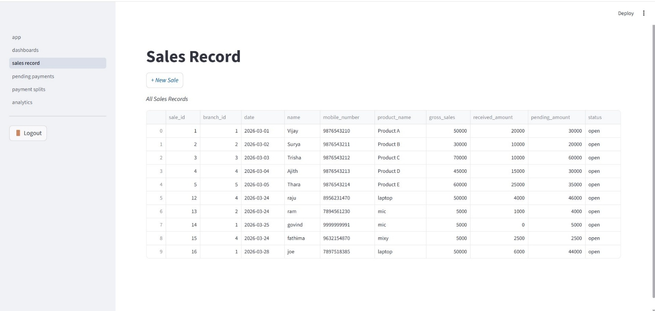
- This page shows all branch “sales record” details since the “logged in” is “super admin”.
- It shows sales details like sale id, branch id, date (due date), name (customer name), mobile number, product name, gross sales, received amount, pending amount and status.
New sale form:
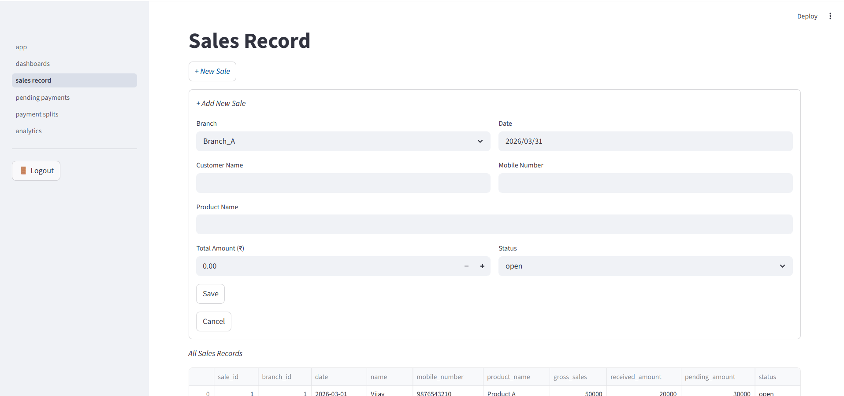
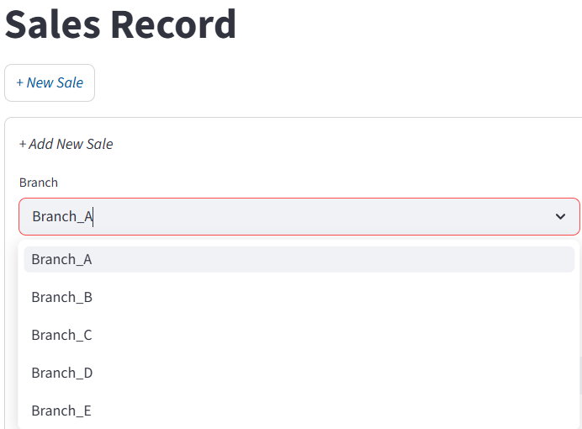
- This page contains “New sale” button, after selecting that button “New sale” form can be created by filling the details are branch, date, customer name, product name, total amount (product price), status. After filling the details click “save” button to submit the form and click “cancel” button to cancel the creation.

Payment splits:
Super admin payment splits page:
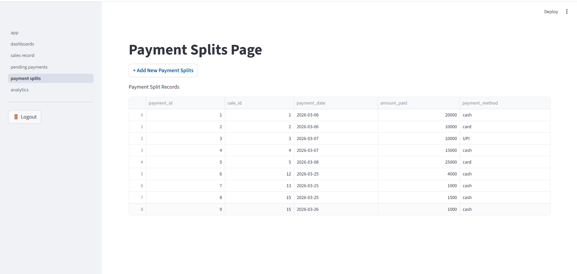
- This page shows the details of payment splits records, there are product id, sale id, payment date, amount paid, payment method. Here the page is logged in as “Super admin”. So, it shows all branch sale id and amount paid details in a single tabular column.
- If branch admin is logged in, then payment splits page shows only its respective branch details alone.
New payment splits form:
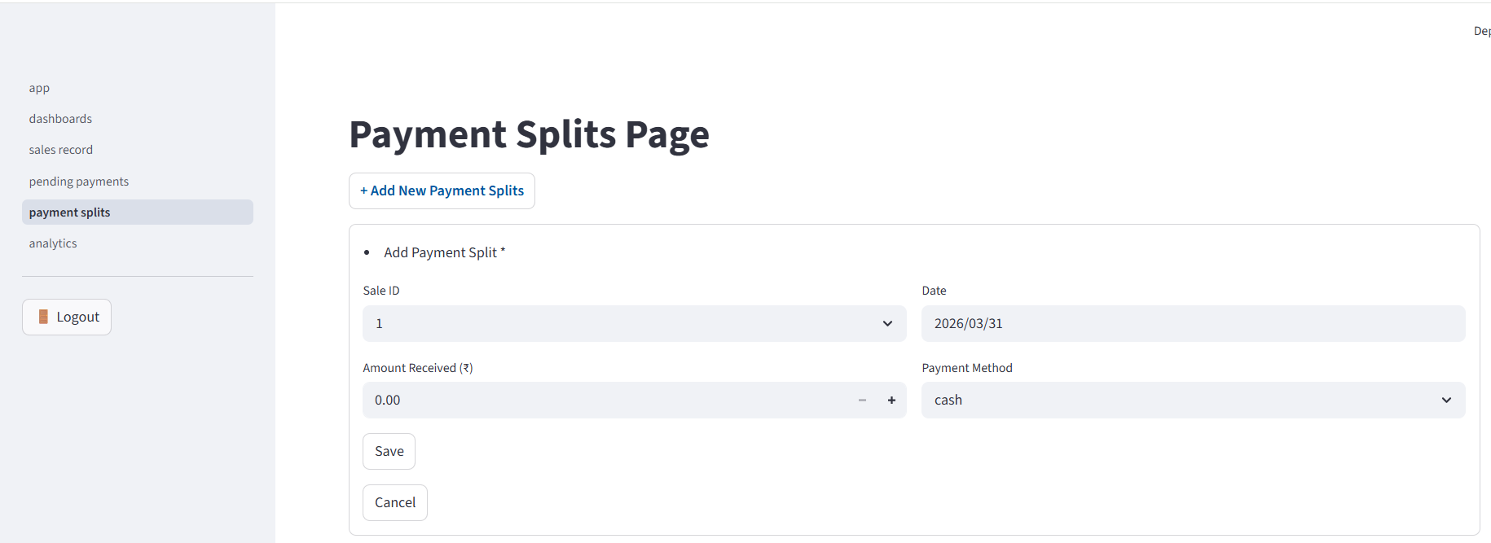
- In this page “Add new payment splits” button is present, after clicking that button a new payment splits form is opened where it contains “sale id” dropdown box which is already created one, “date” box is used to fill the amount paying date, “amount received” box is shown to enter the amount paid by customer at the time, “payment method” dropdown box is shown to select what type of payment.
- Here logged in as “Super admin” so, “sale id “dropdown box shows all branch sale id. But if logged in as individual branch admin, it shows only respective branch sale id’s alone in “sale id” dropdown box. It will not show other branch sale id in “sale id “dropdown box.
- After filling the details, please select the “save” button to submit and it shows in the payment records. If want to cancel the process, please select the “cancel” button.

Pending payments:
Super admin pending payment:
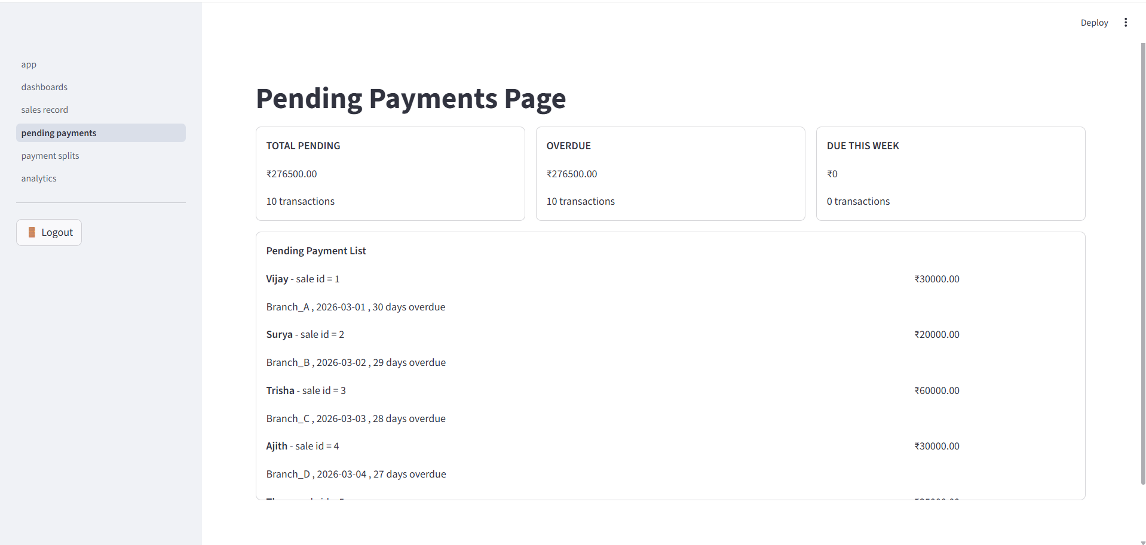
- This image shows pending payments page of “Super admin”. So, it shows all branches pending payment list. Even it contains total pending, overdue, due of this week and pending payment list of all branches.
- If individual branch admin is logged it shows only data related to that branch alone and other branch data will not show.

Branch admin pending payments page:
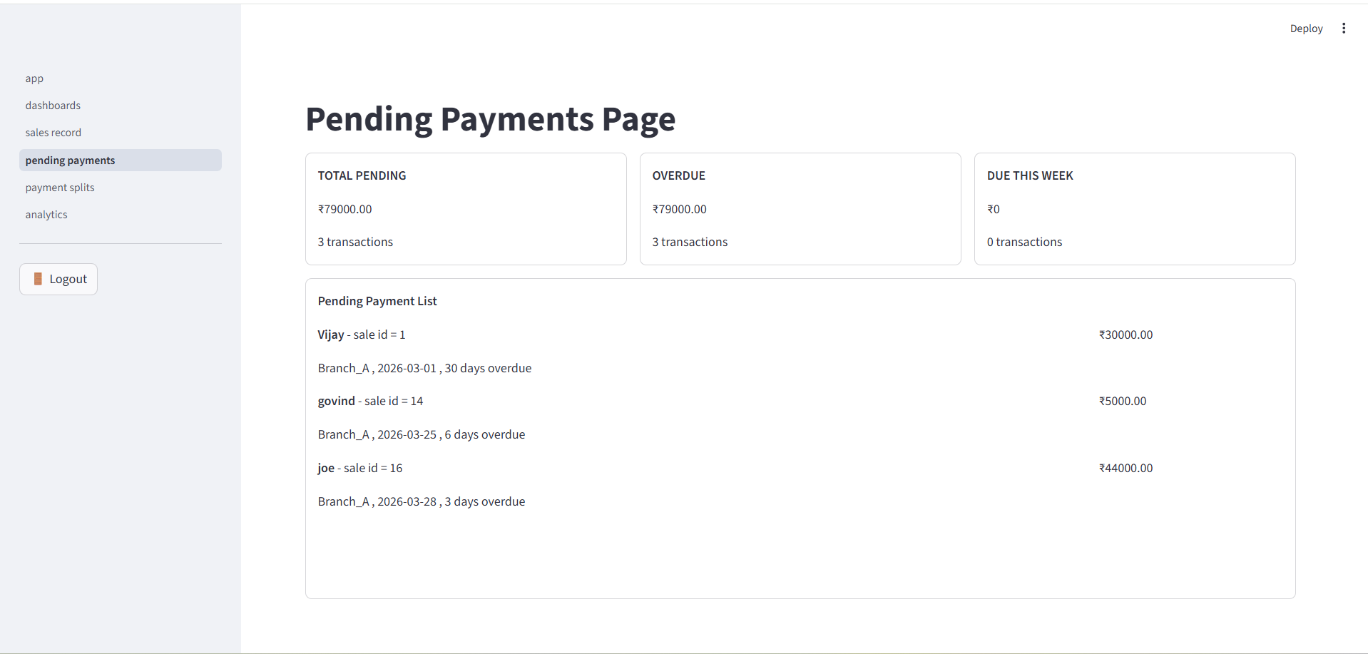
- This image is Branch A pending payments page where it shows only pending details of their branch alone and it will show other branch data.

Analytics:
Super admin’s Analytics Page:
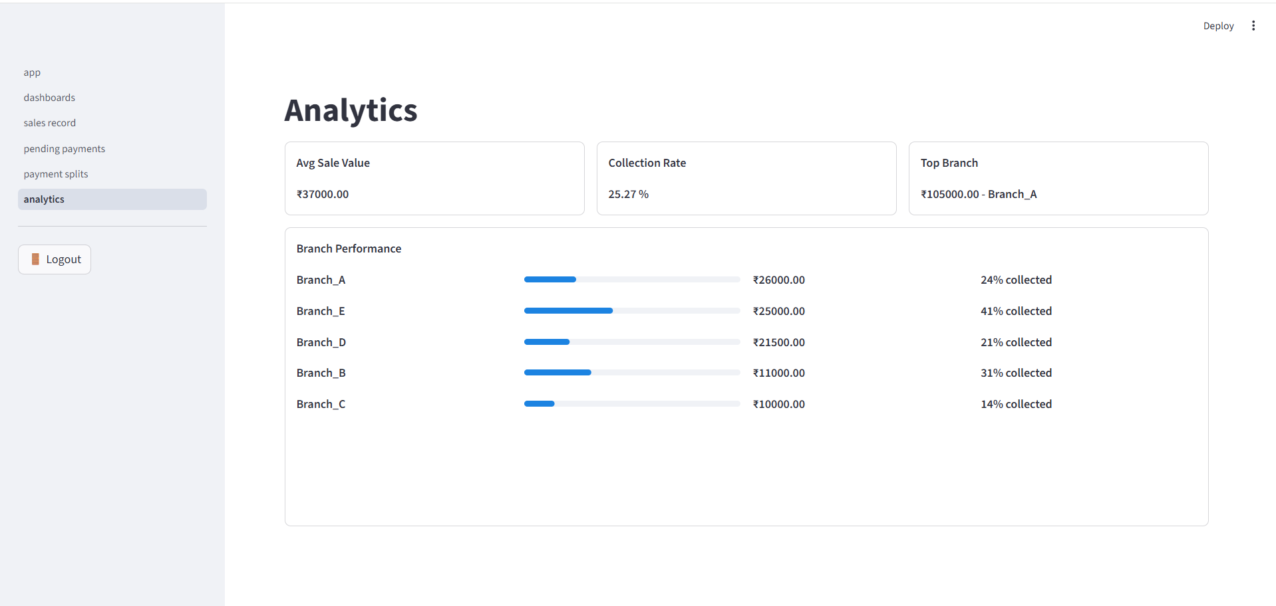
- This page shows Analytics summary of all branches details with Avg. sale values of gross sale, collection rate amount received, Top branch of gross sales and final part is all branch performance based on collection of amounts.

Branch A analytics:
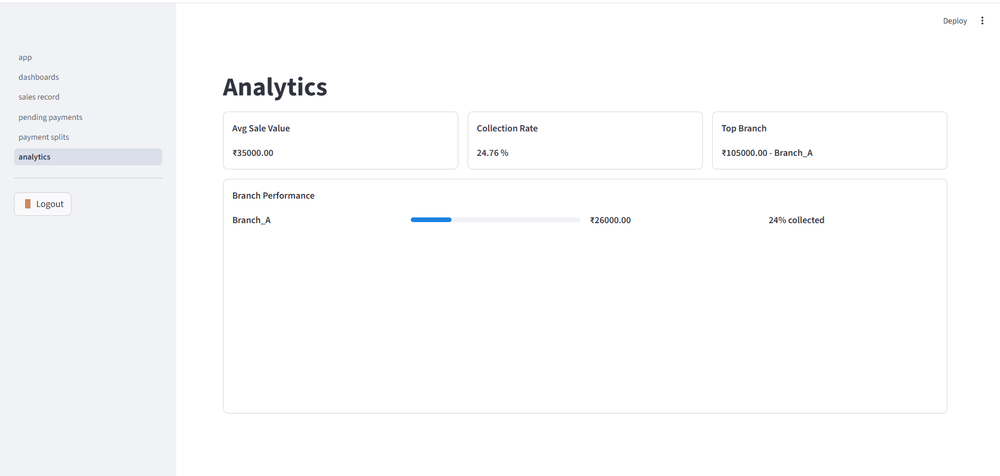
- This page shows Branch A analysis part alone and doesn’t show other branch performance.

