Assignment-20.5 Name: M.Jagadeesh
Batch:44
H. No:2303A52290
Task 1 – Password Storage Vulnerability Check
Analyze an AI-generated signup script for insecure password storage.

Prompt:
Generate a Python user registration and login program that stores user credentials. Then improve it using secure password hashing instead of plain text storage.

Code:

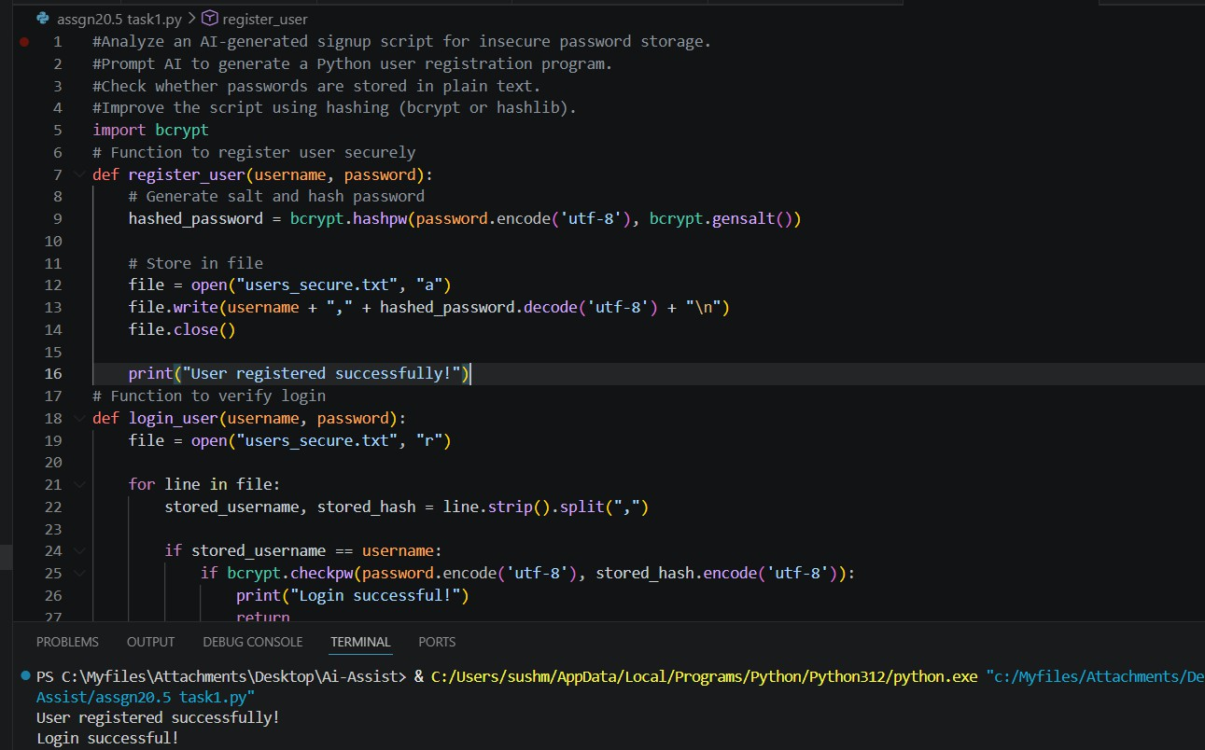
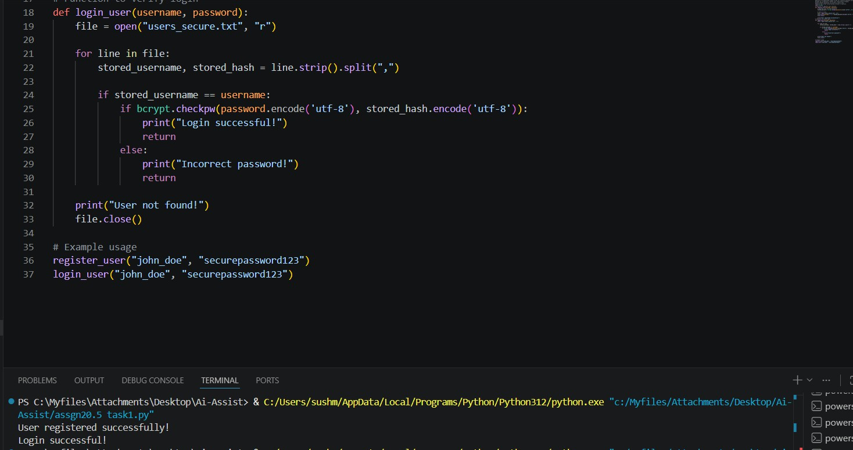
Observation:
- Password is hashed using bcrypt
- Original password is not stored
- Uses salt automatically
- Even same password → different hash
- Secure against attacks like:

- brute force (harder)
- rainbow table attacks

Task 2 – Hardcoded Secrets Detection
Evaluate AI-generated code for hardcoded API keys or credentials.

Prompt:
Generate a Python script that connects to an external API (OpenWeather) and retrieves weather data. Then evaluate whether API keys are securely handled and improve the code using environment variables instead of hardcoding.

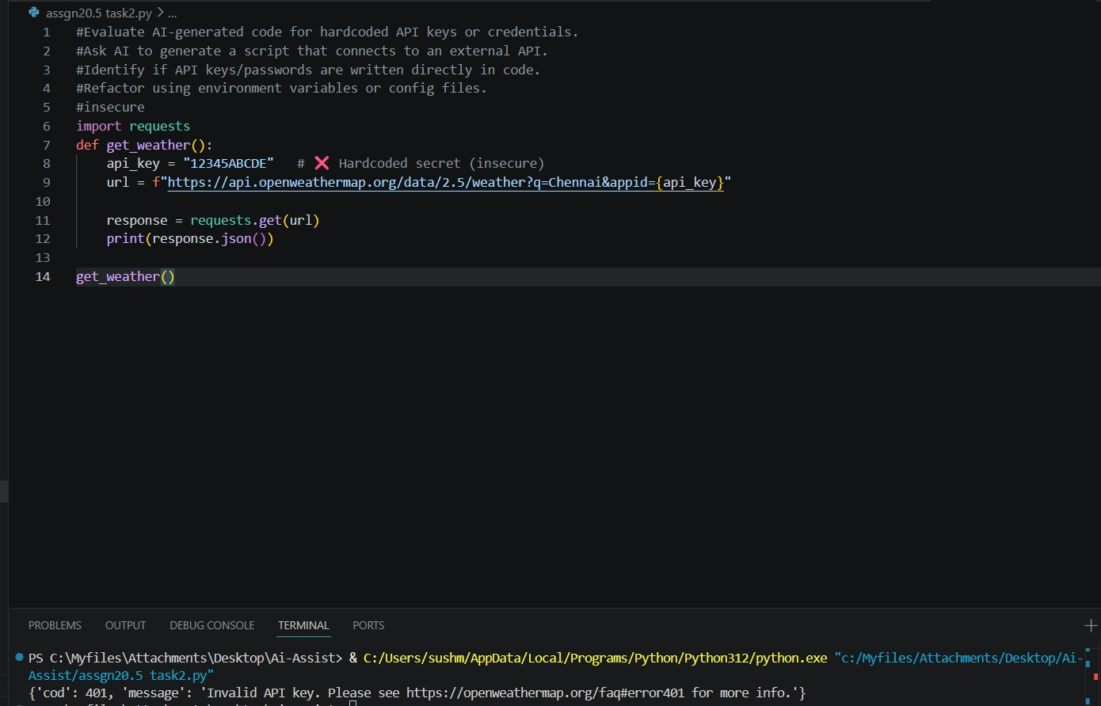
Code:

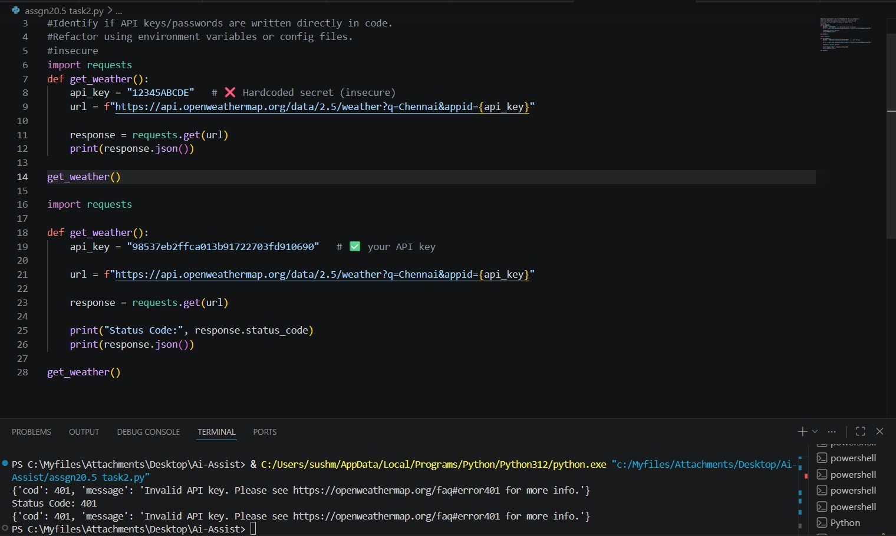
Observation:
The AI-generated code initially stored API keys directly in the source code, which is insecure and can lead to unauthorized access if the code is shared. Even with a valid key, hardcoding remains a risk. This

was improved by using environment variables, which keeps sensitive information outside the code and ensures secure handling of credentials.

Task 3 – File Upload Security Validation
Test an AI-generated file upload program for unsafe file handling.

Prompt:
Generate a Flask-based file upload application. Then analyze it for
security issues such as unsafe file handling and improve it by adding validation for file type, size, and secure filename handling.

Code:

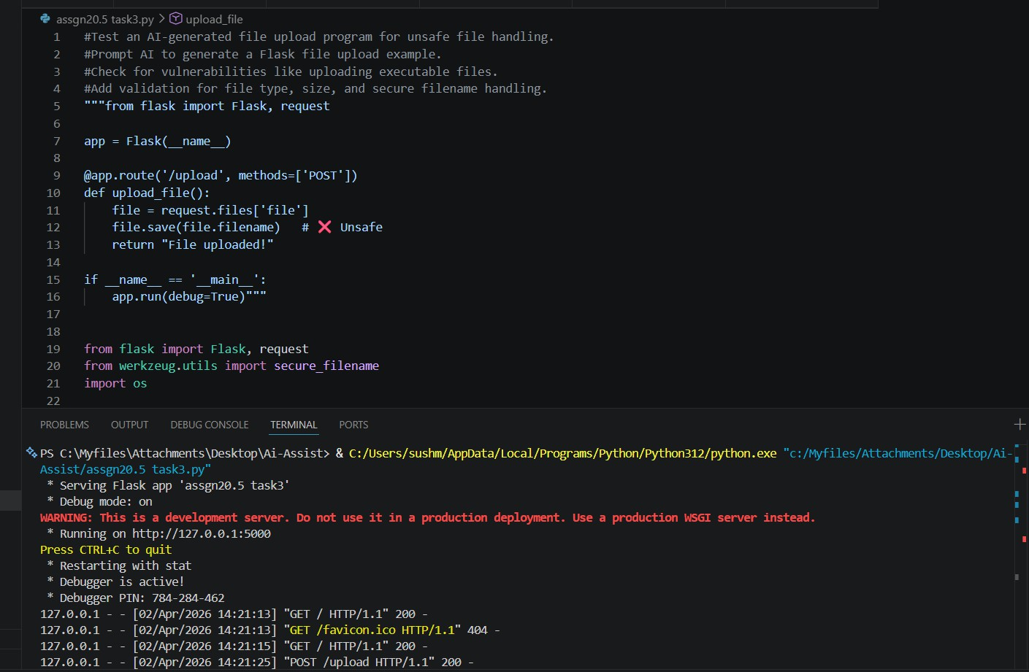
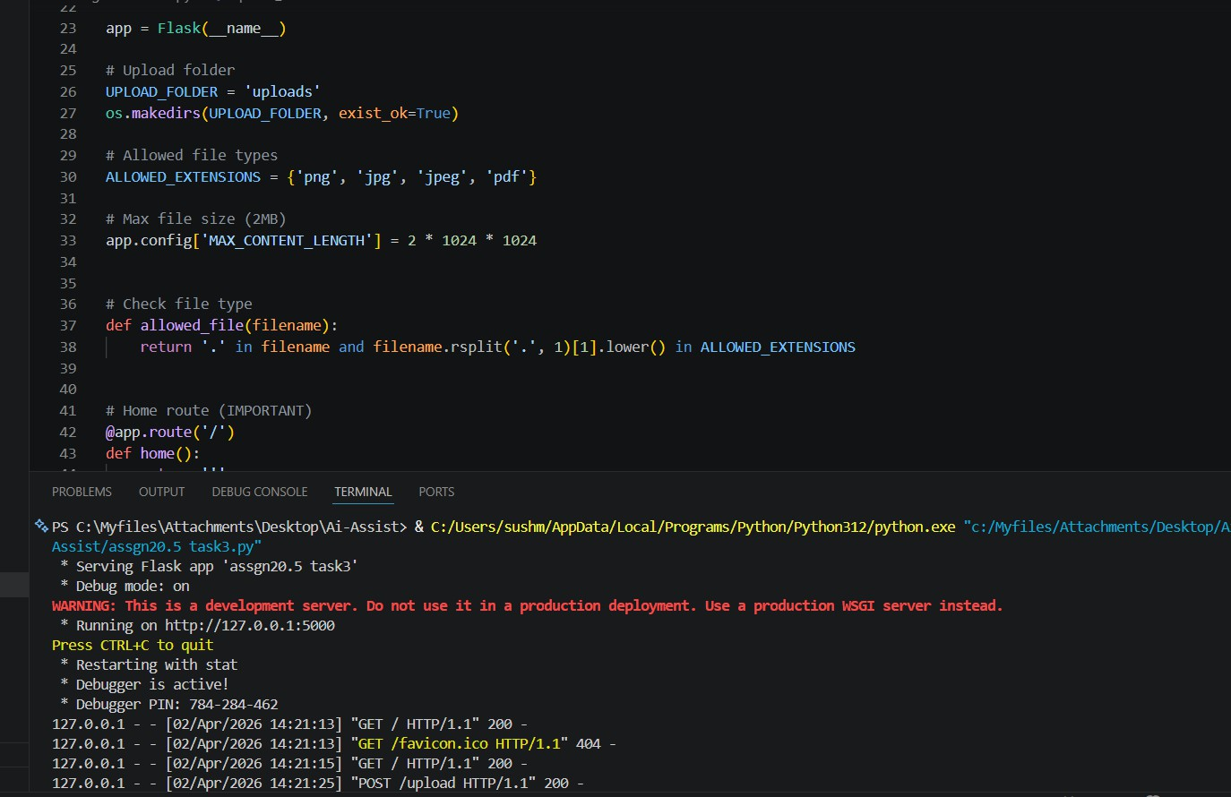

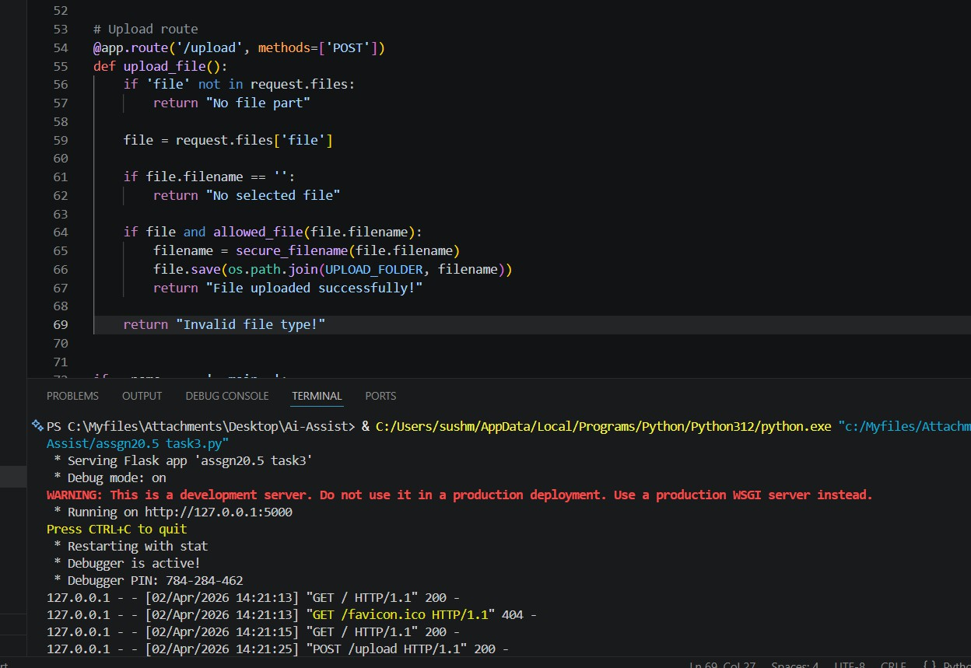

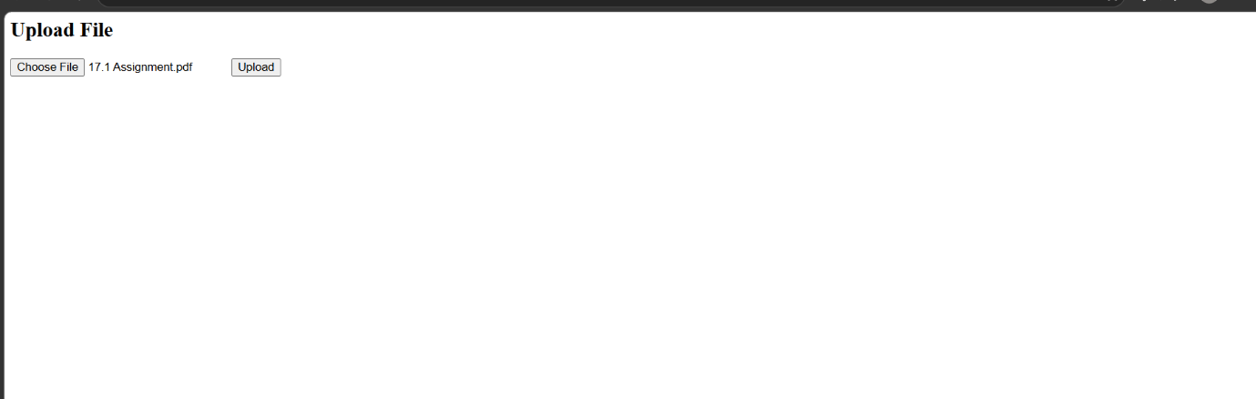

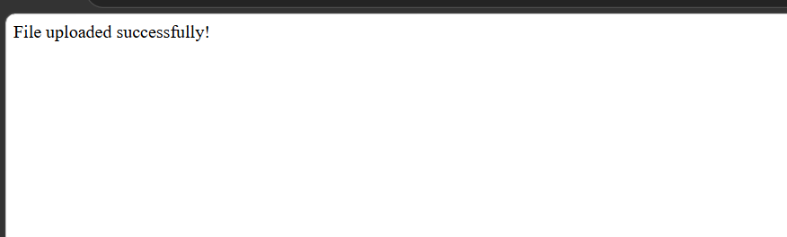
Observation:
The AI-generated file upload code was initially insecure as it allowed unrestricted file uploads, used unsafe filenames, and

lacked validation, making it vulnerable to attacks like uploading malicious files. The improved version adds file type restrictions, size limits, and uses secure filename handling, ensuring safe and controlled file uploads.

Task 4 – Command Injection Prevention
Analyze an AI-generated Python script that executes system commands.

Prompt:
Generate a Python script that executes system commands using user input. Then analyze it for command injection vulnerabilities and improve it using safe subprocess methods and input validation.

Code:

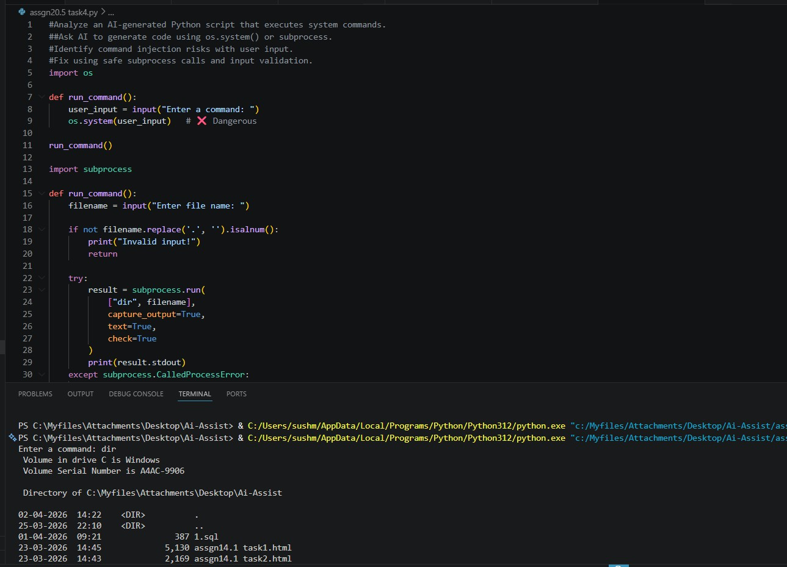
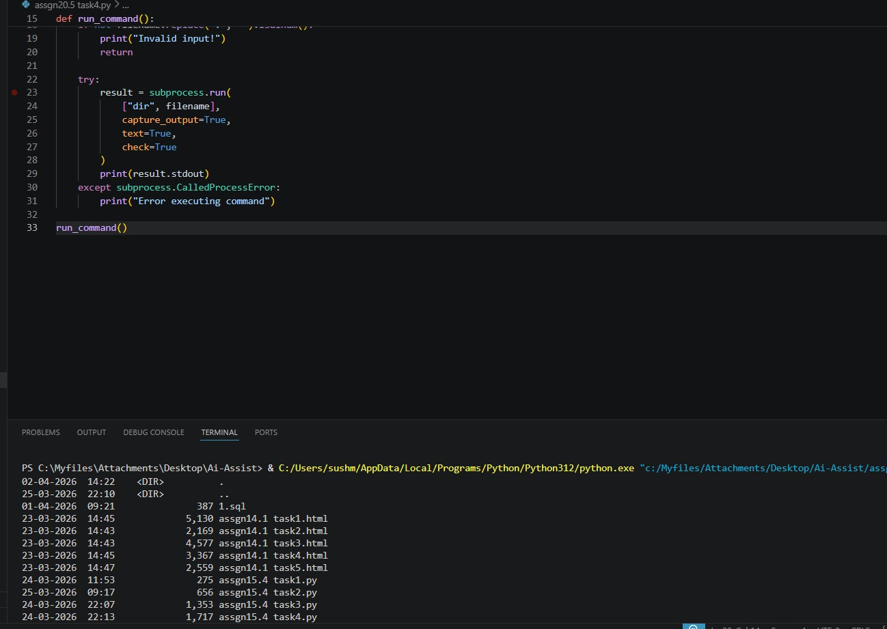

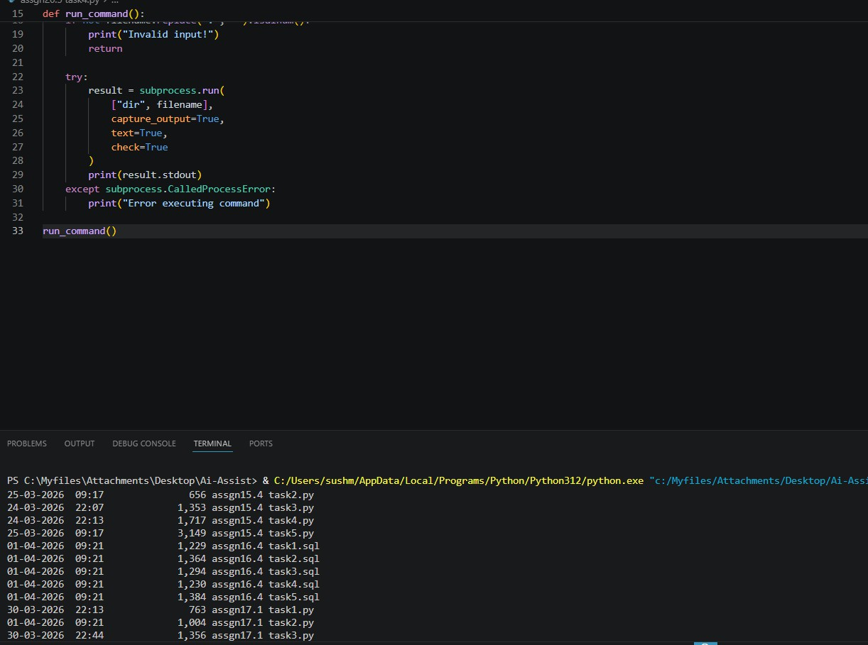
Observation:
The AI-generated code initially used os.system() with direct user input, making it vulnerable to command injection attacks where
malicious commands can be executed. The improved version replaces it with subprocess.run() without using a shell and adds input validation to restrict unsafe characters. This ensures that only safe commands are executed and prevents unauthorized system access.

Task 5 – Secure Input Handling in Web Forms
Check AI-generated web form code for improper input validation.

Prompt:
Generate an HTML and Flask-based feedback form. Then analyze it for improper input validation and unsafe rendering, and improve it using server-side validation and input sanitization.

Code:
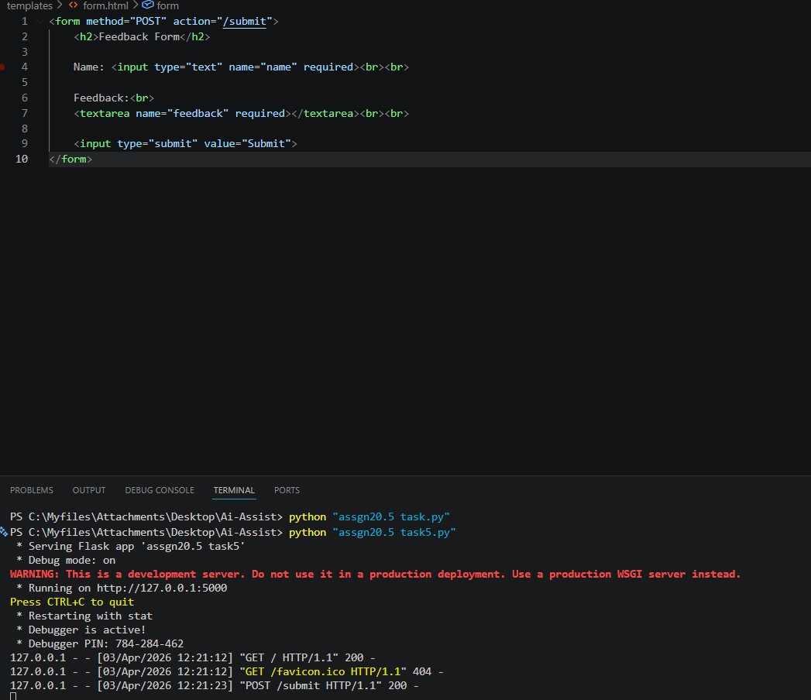

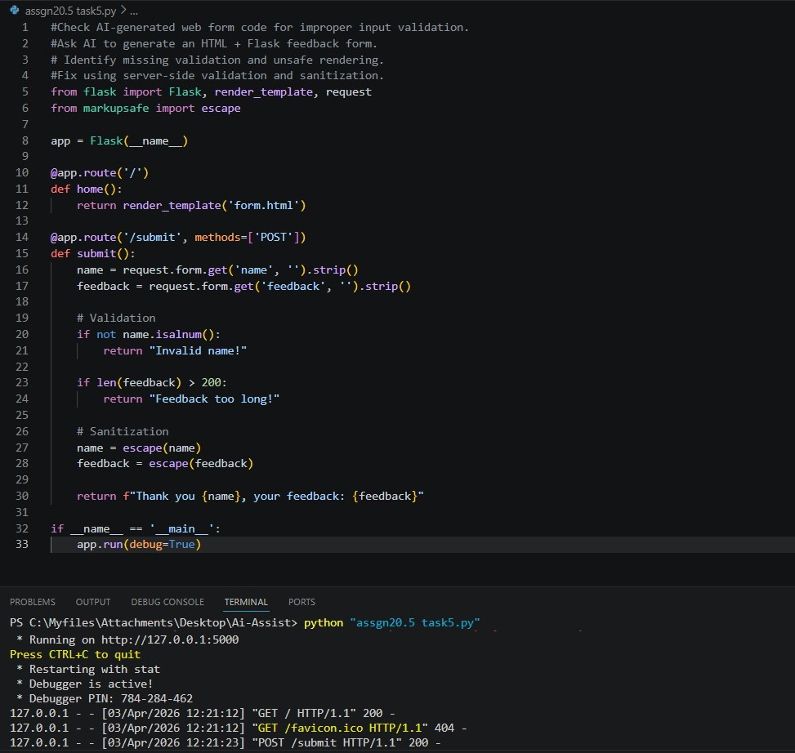
Observation:
The AI-generated form initially lacked proper input validation and directly rendered user input, making it vulnerable to injection attacks like XSS. The improved version adds server-side validation to restrict invalid inputs and uses escape() to sanitize user data before displaying it. This ensures that malicious scripts cannot be executed and the application handles user input securely.

