Install these before hand:

npm i nodemon

npm install --save dotenv

npm install -g typescript

1. Use command tsc –build –clean to clear the files inside dist folder and tsc --build to compile the files

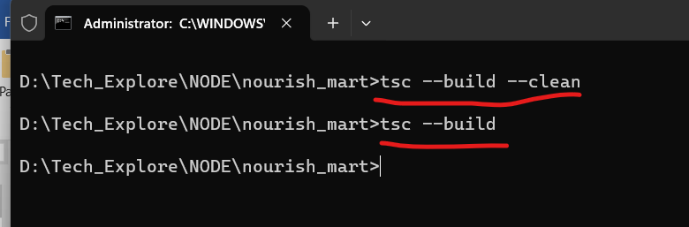

1. A dist folder will be created.

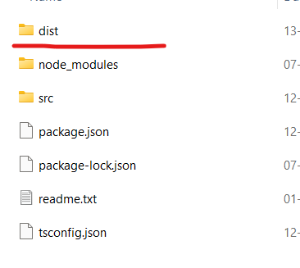

1. .env file will be there by default, If not place the .env file next to app.js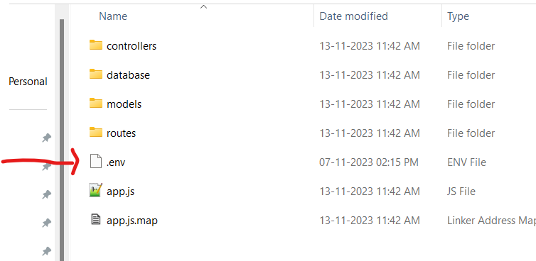

**VS Code Debugging:**

To setup vs code debugging:

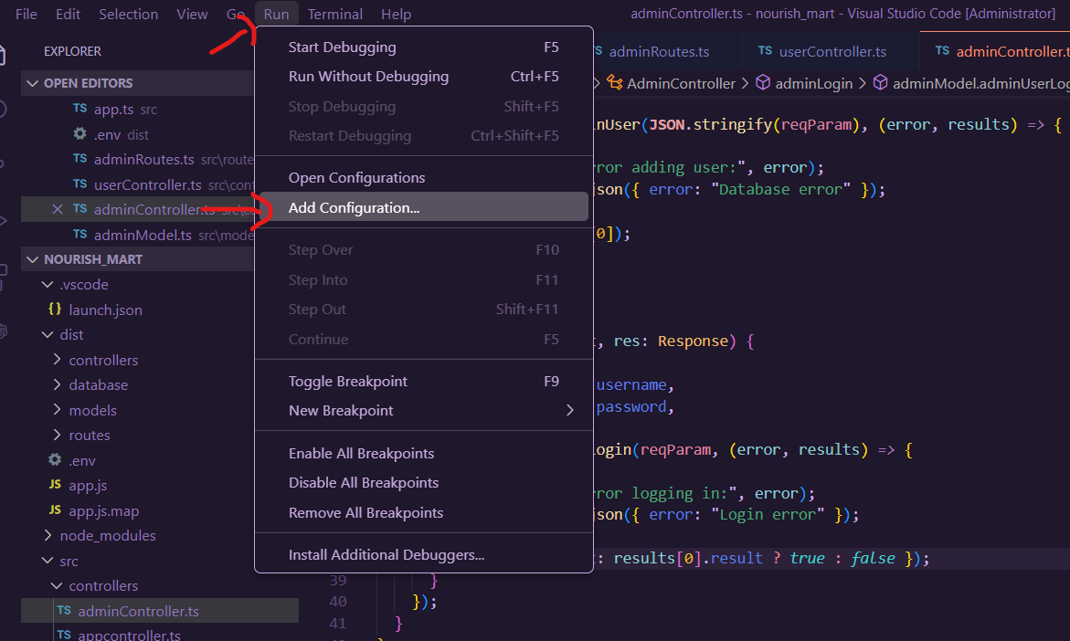

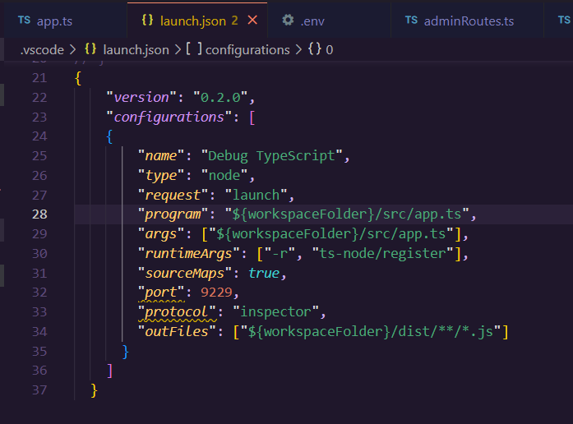

{

"version": "0.2.0",

"configurations": [

{

"name": "Debug TypeScript",

"type": "node",

"request": "launch",

"program": "${workspaceFolder}/src/app.ts",

"args": ["${workspaceFolder}/src/app.ts"],

"runtimeArgs": ["-r", "ts-node/register"],

"sourceMaps": true,

"restart": true,

"runtimeExecutable": "nodemon",

"outFiles": ["${workspaceFolder}/dist/**/*.js"]

}

]

}

Place breakpoints

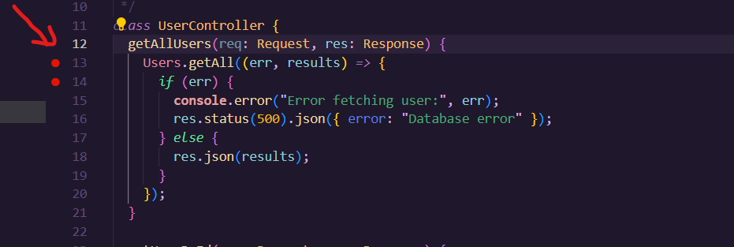

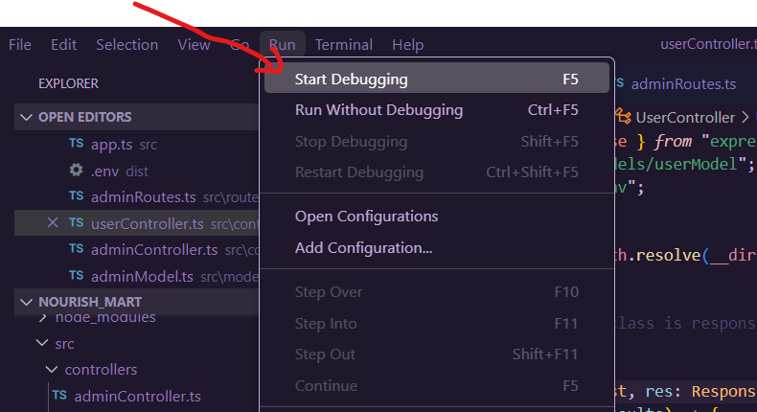

Hit the API either from postman or through the app.

**Chrome Debugging**

