ACADEMIC INTEGRITY AND AI-TOOL USAGE DECLARATION

1. Academic Integrity Declaration
I hereby declare that the project titled “AI-Assisted Functional Safety HARA and Safety Requirement Management Assistant” is my original work, completed as part of my TATA TechPulse Program.
I confirm that all external sources, including code, datasets, pre-trained models, technical documents, and other references used in the project, will be appropriately acknowledged and cited. I declare that the results and findings presented in the project are based on actual implementation and evaluation, and no results have been deliberately fabricated. I have accurately represented my contributions to the project and acknowledge the assistance received from external tools and resources.
I understand that I am responsible for the originality, correctness, and integrity of the submitted work.

2. AI-Tool Usage Declaration
I declare that AI tools and pre-trained models were used to support selected activities during the development and documentation of this project. Their use included coding assistance, understanding technical concepts, document analysis, and generating candidate HARA outputs. The tools and models used, their purposes, and the affected project artifacts are listed below.
AI Model/Tool | Purpose | Artifact Affected | Verified by Student
ChatGPT | Coding assistance, clarification of technical concepts, debugging guidance, and documentation drafting | Source code, technical explanations, and project documentation | Reviewed the suggestions, checked their relevance to the implementation, and tested code changes where applicable
Llama 3.1 70B Versatile via Groq | Generate candidate hazards, hazardous events, S/E/C assessments, and draft safety goals and requirements | HARA analysis and safety requirement outputs | Reviewed generated outputs against retrieved document evidence and checked ASIL results using the implemented rule-based mapping
Sentence Transformers – all-MiniLM-L6-v2 | Generate vector embeddings for semantic document retrieval | Document retrieval and FAISS vector store | Examined retrieved document chunks for relevance to the analysis queries
I understand that AI-generated outputs may contain inaccuracies and must not be accepted without review. I remain responsible for understanding the implementation, verifying the correctness of the results, and explaining the submitted work during evaluation. The use of AI tools does not replace my responsibility for academic integrity or the validation of safety-related outputs.
Student Name: Muchumarri Jagadeesh Kumar Reddy
Register Number: 127156099
Signature: 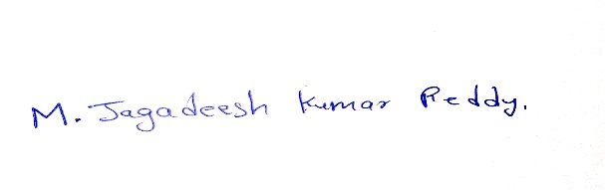

Date: 20/Oct/2026

