Functional Safety HARA & Safety Requirement Management Assistant

Technical Specification & System Documentation

1. Introduction
In modern automotive engineering, electronic and electrical (E/E) architectures have grown exponentially in complexity. Advanced Driver Assistance Systems (ADAS), electric powertrains, autonomous drive controllers, and steer-by-wire platforms operate under stringent safety constraints where any hardware malfunction or software bug could lead to catastrophic consequences.
To govern the safety lifecycle of safety-related automotive systems, the International Organization for Standardization established ISO 26262 (“Road vehicles — Functional safety”). A foundational pillar of this standard is the Hazard Analysis and Risk Assessment (HARA), defined in ISO 26262-3: Concept Phase.
The purpose of HARA is to: 1. Identify hazards resulting from malfunctioning behavior of the system. 2. Formulate hazardous events across defined operational situations. 3. Classify these events according to Severity (S), Exposure (E), and Controllability (C). 4. Determine the required Automotive Safety Integrity Level (ASIL) ranging from QM (Quality Management) to ASIL D (most stringent). 5. Establish high-level Safety Goals (SGs), cascaded down into Functional Safety Requirements (FSRs) and Technical Safety Requirements (TSRs).
The Functional Safety HARA Assistant is an intelligent, human-in-the-loop engineering platform that bridges technical system architecture documentation with formal ISO 26262 workflows. By coupling Retrieval-Augmented Generation (RAG) with a deterministic ASIL rule engine, the platform accelerates hazard identification and requirement authoring while strictly eliminating AI hallucination in safety-critical classification.

2. Problem Statement
Automotive safety engineers face severe challenges when conducting traditional HARA processes:
- Information Overload in Architecture Specifications: System specifications, interface control documents (ICDs), and functional architecture models frequently span hundreds of pages. Manually indexing failure modes across complex signal interfaces is slow and error-prone.
- Risk of Hallucination and Regulatory Rejection: While modern Large Language Models (LLMs) can generate fluent text, purely generative AI cannot be trusted to calculate ASIL ratings. An LLM might arbitrarily assign an ASIL B to a fatal, uncontrollable highway runaway event that legally mandates ASIL D, exposing OEMs to non-compliance, liability, and product recalls.
- Subjectivity & Inconsistency in S/E/C Assessment: Different safety engineers often assign disparate severity, exposure, and controllability ratings to the same hazardous event due to differing interpretations of driving scenarios.
- Traceability Fractures: Maintaining bidirectionally linked traceability from an architectural failure mode to a hazardous event, safety goal, FSR, TSR, and verification status across disjointed spreadsheets is notoriously difficult.
- The “Black-Box” Automation Hazard: Unsupervised AI generation is strictly unacceptable in safety-critical engineering audits. The workflow demands transparent citation of source documentation and explicit human approval checkpoints.

3. Proposed Solution
The HARA Assistant addresses these challenges through a hybrid architecture combining verifiable document retrieval, guided generative intelligence, deterministic standard-compliant logic, and human governance:
- Document-Grounded RAG Pipeline: Uses PyMuPDF and pdfplumber alongside local dense embeddings (all-MiniLM-L6-v2) and FAISS to ingest system architecture PDFs, preserving page numbers and table data. The LLM only analyzes verified, cited excerpts.
- Deterministic Rule Engine (Zero-Hallucination ASIL): ASIL determination completely bypasses the LLM. It is calculated by a deterministic lookup table implementing the exact mathematical matrix of ISO 26262-3:2018 Table 4.
- Structured Automotive Prompts: Custom system instructions enforce ISO 26262 taxonomy (Hazard → Hazardous Event → Operational Situation) and produce structured JSON schemas.
- Human-in-the-Loop (HITL) Workflow: Safety engineers retain total authority to Accept, Edit, or Reject AI-suggested hazards, override S/E/C classifications, and approve safety goals.
- Automated Traceability Matrix: Generates a production-ready, styled Excel sheet (.xlsx) mapping each failure mode to its ASIL, rationale, safety goals, FSRs, TSRs, and approval statuses.

4. System Architecture
The application is structured into four distinct layers: Presentation Layer, Application / API Layer, RAG & Inference Pipeline, and Data Persistence / Export Layer.
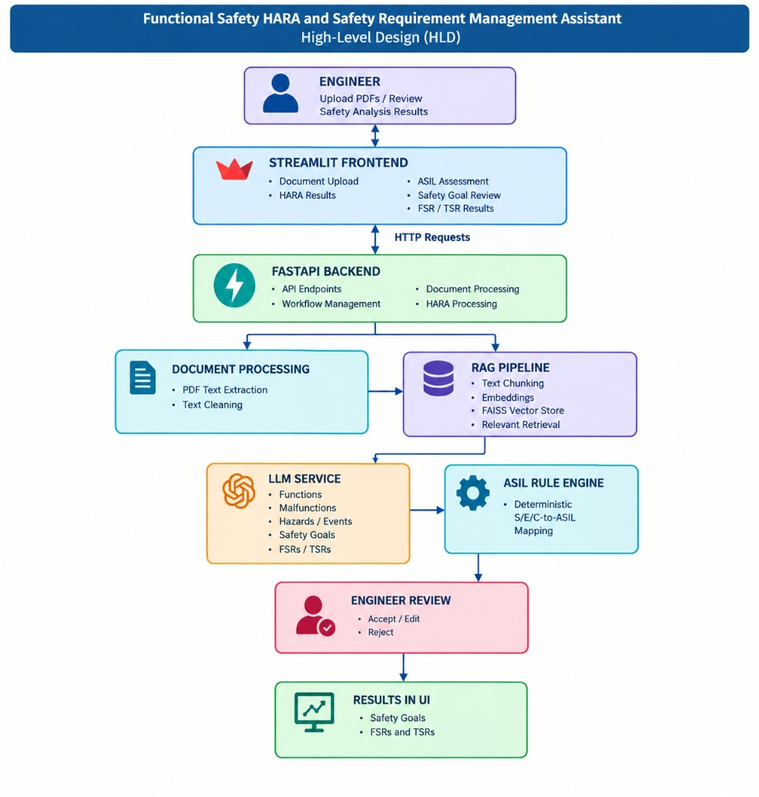
Functional Safety HARA Assistant High-Level Design

Layer Details:
- Presentation Layer (frontend/app.py):
  - Built with Streamlit for interactive, state-driven workflow navigation.
  - Organized into 5 distinct sequential phases with persistent sidebar tracking.
  - Enables in-place editing of generated hazards and requirements.
- Application Layer (backend/main.py):
  - High-throughput asynchronous REST API built using FastAPI.
  - Handles multi-part file uploads, JSON payload validation via Pydantic models, and cross-origin resource sharing (CORS).
  - Manages isolated session workspaces using UUID keys.
- RAG Pipeline (backend/rag_engine.py):
  - Combines PyMuPDF for raw text extraction and pdfplumber for structured table extraction.
  - Chunks text into overlapping windows (800 chars, 120 char overlap).
  - Embeds chunks using sentence-transformers/all-MiniLM-L6-v2.
  - Utilizes FAISS Maximal Marginal Relevance (MMR) retrieval (lambda_mult=0.7) to maximize context diversity.
- Intelligence & Rule Engine (backend/hara_chain.py & backend/asil_rules.py):
  - LLM generation powered by Groq cloud inference (ChatGroq) for sub-second generation speeds.
  - Deterministic rule engine performing $O(1)$ lookups into the ISO 26262-3 matrix.

5. HARA Workflow
The end-to-end processing lifecycle follows a 13-stage sequential flow, moving from raw engineering documentation to structured safety requirements:
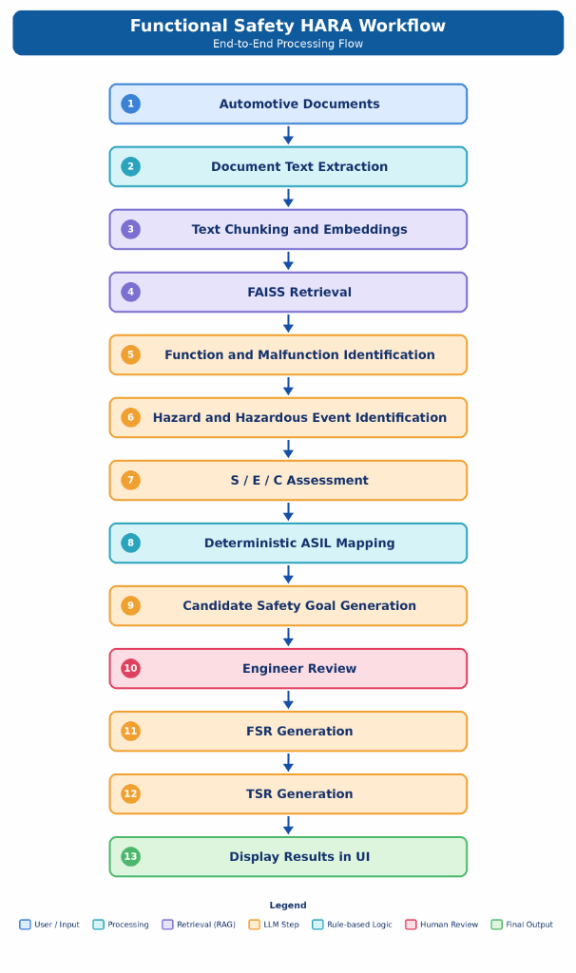
Functional Safety HARA Workflow End-to-End Flow

The 13 Workflow Stages
Step # | Stage Name | Category | Description
1 | Automotive Documents | User / Input | Safety engineer uploads system specifications, architecture blueprints, or datasheets in PDF format.
2 | Document Text Extraction | Processing | Text blocks, image references, and tabular layouts are parsed using PyMuPDF and pdfplumber.
3 | Text Chunking & Embeddings | Retrieval (RAG) | Content is split into chunks of 800 characters and transformed into 384-dimensional dense vectors.
4 | FAISS Retrieval | Retrieval (RAG) | High-dimensional vector space is queried using MMR to return the most relevant, non-redundant system sections.
5 | Function & Malfunction Identification | LLM Step | The LLM parses retrieved architecture context to identify target functions and unintended failure modes.
6 | Hazard & Hazardous Event Identification | LLM Step | Failure modes are contextualized with operational driving situations (e.g., highway overtaking, icy curves).
7 | S / E / C Assessment | LLM Step | The model evaluates Severity ($S0-S3$), Exposure ($E0-E4$), and Controllability ($C0-C3$) with explanatory rationales.
8 | Deterministic ASIL Mapping | Rule-based Logic | Pure mathematical matrix lookup computes the ASIL level ($QM,A,B,C,D$) with zero possibility of LLM hallucination.
9 | Candidate Safety Goal Generation | LLM Step | Top-level safety goals (SGs) are synthesized to prevent or mitigate each identified hazardous event.
10 | Engineer Review | Human Review | The safety engineer inspects, modifies, accepts, or rejects every suggested hazard, ASIL, and goal.
11 | FSR Generation | LLM Step | Functional Safety Requirements are drafted, detailing implementation-independent safety behavior.
12 | TSR Generation | LLM Step | Technical Safety Requirements are generated with specific technical mechanisms, thresholds, and fault-handling times.
13 | Display Results in UI | Final Output | Complete traceability matrix is presented interactively and exported to an ISO 26262 audit-ready Excel report.

6. Module Description

6.1 backend/rag_engine.py
This module serves as the ingestion and document intelligence backbone.
- Primary Responsibilities:
  - Ingest PDF documents containing system architecture descriptions.
  - Extract textual content, image metadata, and embedded tabular structures.
  - Chunk, embed, store, and retrieve document fragments using vector similarity.
- Core Functions:
  - get_embeddings(): Instantiates HuggingFaceEmbeddings referencing sentence-transformers/all-MiniLM-L6-v2 running locally on CPU with normalized vectors.
  - extract_pdf_content(pdf_path: str) -> List[Document]:
    - Opens the PDF with PyMuPDF (fitz), iterating through pages to extract raw text and record image occurrences.
    - Re-opens the document with pdfplumber to extract tables, converting tabular cells into pipe-delimited text representations (col1 | col2 | col3) that preserve structural semantics.
  - build_faiss_store(documents: List[Document], session_path: str) -> FAISS:
    - Applies RecursiveCharacterTextSplitter(chunk_size=800, chunk_overlap=120).
    - Computes vector embeddings and saves the FAISS index to the specified session directory.
  - load_faiss_store(session_path: str) -> FAISS: Loads a persisted FAISS index with allow_dangerous_deserialization=True.
  - retrieve_context(store: FAISS, query: str, k: int = 5) -> List[Document]: Employs Maximal Marginal Relevance (MMR) retrieval (fetch_k=k*3, lambda_mult=0.7) to balance semantic relevance with chunk diversity.
  - format_context(docs: List[Document]) -> str: Concatenates retrieved document chunks with explicit source page references ([Page X | TEXT]) to enable citations.

6.2 backend/hara_chain.py
This module orchestrates all generative AI tasks using LangChain and Groq LLM inference.
- Primary Responsibilities:
  - Maintain formal, audited ISO 26262 system prompts as module-level constants.
  - Query Groq LLMs at low temperature ($T=0.2$) for consistency.
  - Enforce strict JSON output schemas, automatically sanitizing markdown fences.
- Key Prompts:
  - HAZARD_SYSTEM_PROMPT: Instructs the model as a certified Functional Safety Engineer. Mandates strict citation of page numbers and adherence to the schema:
  - [
{
"id": "HE-001",
"hazard": "...",
"hazardous_event": "...",
"operational_situation": "...",
"affected_function": "...",
"source_evidence": "..."
}
]
  - SEC_SYSTEM_PROMPT: Directs the assessment of Severity ($S0-S3$), Exposure ($E0-E4$), and Controllability ($C0-C3$) based on worst-case realistic scenarios, requiring a one-sentence justification per rating.
  - GOAL_SYSTEM_PROMPT: Directs the drafting of Safety Goals (SG), Functional Safety Requirements (FSR), and Technical Safety Requirements (TSR). Features automated quality checks to flag vague or untestable requirements.
- Core Functions:
  - get_llm(): Configures ChatGroq with model parameters, low temperature, and API keys.
  - _parse_json_response(response_text: str): Strips markdown wrappers (json ...) and parses JSON with robust regex error handling.
  - suggest_hazards(context, system_description): Generates candidate hazardous events from retrieved context chunks.
  - suggest_sec(context, hazardous_event, operational_situation): Suggests initial S, E, and C ratings with rationale.
  - draft_safety_goals(context, hazardous_event, asil, affected_function): Produces candidate SGs, FSRs, and TSRs aligned with the determined ASIL.

6.3 backend/asil_rules.py
This module implements the deterministic safety classification engine. It contains zero AI or LLM components.
- Primary Responsibilities:
  - Guarantee 100% reproducible, audit-compliant ASIL determinations.
  - Provide human-readable ISO 26262 definitions for engineering rationale.
  - Supply standard UI color mappings for ASIL levels.
- ISO 26262-3 Table 4 Implementation: Implements the standard lookup matrix across Severity ($S0-S3$), Exposure ($E0-E4$), and Controllability ($C0-C3$):
$$\text{ASIL}=f(S,E,C)$$
ASIL_TABLE = {
"S0": { ... all QM ... },
"S1": {
"E0": { "C0": "QM", "C1": "QM", "C2": "QM", "C3": "QM" },
"E1": { "C0": "QM", "C1": "QM", "C2": "QM", "C3": "QM" },
"E2": { "C0": "QM", "C1": "QM", "C2": "QM", "C3": "QM" },
"E3": { "C0": "QM", "C1": "QM", "C2": "A", "C3": "B" },
"E4": { "C0": "QM", "C1": "QM", "C2": "A", "C3": "B" },
},
"S2": {
"E0": { "C0": "QM", "C1": "QM", "C2": "QM", "C3": "QM" },
"E1": { "C0": "QM", "C1": "QM", "C2": "QM", "C3": "QM" },
"E2": { "C0": "QM", "C1": "QM", "C2": "A", "C3": "B" },
"E3": { "C0": "QM", "C1": "A", "C2": "B", "C3": "C" },
"E4": { "C0": "QM", "C1": "A", "C2": "B", "C3": "C" },
},
"S3": {
"E0": { "C0": "QM", "C1": "QM", "C2": "QM", "C3": "QM" },
"E1": { "C0": "QM", "C1": "QM", "C2": "A", "C3": "B" },
"E2": { "C0": "QM", "C1": "A", "C2": "B", "C3": "C" },
"E3": { "C0": "A", "C1": "B", "C2": "C", "C3": "D" },
"E4": { "C0": "A", "C1": "B", "C2": "C", "C3": "D" },
},
}
- Core Functions:
  - compute_asil(S: str, E: str, C: str) -> str: Normalizes parameters and performs instant dictionary key lookup. Raises ValueError if any parameter is outside standard ranges.
  - asil_rationale(S, E, C): Generates an audit rationale string documenting the standard’s exact classification thresholds.
  - get_asil_color(asil): Maps ASIL levels to standard visual color indicators (QM: gray, A: yellow, B: orange, C: red, D: dark red).

6.4 backend/main.py
This module acts as the central API gateway and orchestration controller.
- Primary Responsibilities:
  - Expose RESTful endpoints for each stage of the HARA lifecycle.
  - Enforce CORS policies allowing secure frontend access.
  - Maintain active session indexes and manage lifecycle cleanup.
  - Generate styled, formatted Excel traceability matrices using openpyxl.
- API Endpoints:
  - GET /health: Liveness probe returning {"status": "ok"}.
  - POST /ingest: Accepts PDF file upload, extracts content, compiles FAISS vector index, assigns a session UUID, and returns page extraction metrics.
  - POST /suggest-hazards: Accepts session_id and system_description, executes MMR vector query, and returns candidate hazards with source citations.
  - POST /suggest-sec: Accepts hazardous_event and operational_situation, retrieves targeted context, and returns AI-suggested S/E/C ratings with justifications.
  - POST /compute-asil: Calls compute_asil() to return deterministic ASIL level and rationale without contacting any LLM.
  - POST /draft-goals: Generates candidate Safety Goals, FSRs, TSRs, and quality flag warnings.
  - POST /export-traceability: Ingests the list of validated TraceabilityRow records, applies corporate styling, auto-adjusts cell dimensions, color-codes ASIL badges and review tags, and streams back an .xlsx workbook.
  - @app.on_event("shutdown"): Cleans up temporary FAISS directory stores from the host filesystem upon server termination.

7. Conclusion
The Functional Safety HARA Assistant demonstrates an optimal paradigm for deploying Artificial Intelligence in mission-critical and highly regulated domains. By deliberately decoupling unstructured document discovery (delegated to RAG and LLMs) from safety-critical classification (strictly retained by a deterministic ISO 26262 rule engine), the platform provides maximum engineering speedup without compromising compliance or safety integrity.

Key Strengths:
- Zero Hallucination in ASIL Ratings: ISO 26262-3 Table 4 logic is immutable and provably correct.
- Auditability & Traceability: Every identified hazard cites its source document page, and the final output produces an end-to-end requirement traceability matrix.
- Human Authority: The safety engineer maintains continuous oversight across all 5 operational phases.
- Modularity: Individual modules (rag_engine, hara_chain, asil_rules, main) maintain separation of concerns, allowing easy upgrades to newer embedding models or specialized vector databases.

