JAWAHARLAL NEHRU TECHNOLOGICAL UNIVERSITY
COLLEGE OF ENGINEERING
(Autonomous)
ANANTHAPURAMU-515002
Department of computer science & engineering

Certificate
This is to certify that the project entitled, “ACCURACY COMPARISON OF PARKINSON’S DISEASE DETECTION BEFORE AND AFTER FEATURE SELECTION ”, is bonafide work of L JAGADEESH bearing Admn.No: 17001F0008 submitted to the faculty of Computer Science & Engineering, in partial fulfillment of the requirements for the award of MASTER OF COMPUTER APPLICATIONS from Jawaharlal Nehru Technological University Anantapur, College of Engineering (Autonomous), Ananthapuramu.

Signature of the Supervisor Signature of the Head
Dr.C.SHOBA BINDU _{M.Tech, Ph.D.} Dr.A.SURESH BABU _{M.Tech, Ph.D.}
Professor Professor & HOD
Dept.of Computer Science &Engg. Dept.of Computer Science &Engg.
JNTUA College of Engineering JNTUA College of Engineering
Ananthapuramu-515002 Ananthapuramu-515002
JAWAHARLAL NEHRU TECHNOLOGICAL UNIVERSITY
COLLEGE OF ENGINEERING
(Autonomous)
ANANTHAPURAMU-515002
Department of computer science & engineering
DECLARATION
I L JAGADEESH bearing Admn no. 17001F0008, hereby declare that the project report entitled “ACCURACY COMPARISON OF PARKINSON’S DISEASE DETECTION BEFORE AND AFTER FEATURE SELECTION ” under the guidance of Dr. C.SHOBA BINDU _{M.Tech, Ph.D}, JNTUA Ananthapuramu is submitted in partial fulfillment of the requirements for the award of the degree of MASTER OF COMPUTER APPLICATIONS in COMPUTER SCIENCE AND ENGINEERING.
This is a record of bonafied word carried out by me and the results embodied in this project have not been reproduced or copied from any source. The results embodied in this project report have not been submitted to any other university or institute for the award of any degree or diploma.
L JAGADEESH (17001F0008)

ACKNOWLEDGENT
The satisfaction and exhilaration that accompany the successful completion of any task would be incomplete without the mention of people who made it possible, whose constant guidance and encouragement crowned our efforts with success. It is a pleasant aspect that I have now the opportunity to express my gratitude for all of them.
The first person I would like to thank is my guide Dr. C.SHOBA BINDU _{M.Tech, Ph.D}. Her wide knowledge and logical way of thinking have made a deep impression on me. Her understanding, encouragement and personal guidance have provided the basis for this thesis. She is a source of inspiration for innovative ideas and her support is known to all his students and colleagues.
I wish to thank teaching staff and non-teaching staff of Computer Science and Engineering Department, JNTUA College of Engineering (Autonomous),Ananthapuramu, for their support to complete my project successfully.
Last but far from least, I also thank my family members and my friends for their moral support and constant encouragement. I am very much thankful to one and all that helped me for the successful completion of the project
L JAGADEESH
(17001F0008)

Abstract
Parkinson’s disease is a long term disorder of the brain .it is a nuero-degenerative disorder, mainly caused by the low level of the dopamine-producing cells of the brain . The main causes of this disease remains unidentified, but according to researchers, this disease may be caused by either genetic or environmental factors. It is an incurable condition; however , treatment may help control the disease. This disease majorly affects the cognitive and speech abilities of the patients. Parkinson’s disease is one of the most widespread disease in older people . This disease largely limits the patient’s movements and speech abilities. The patients develop a tendency to fall frequently hence, ending up hurt with various injuries. Thus ,it is essential to monitor and notify either the patients or their caregivers about the severity of the disease.

In the existing method Recursive Feature Elimination method was considered for feature selection and Support Vector Machine were used for classification task and achieved lesser accuracy. In the proposed approach , there is a chance of improving classification accuracy with better feature selection method like Filter-Based Feature Selection Method and with other classifier like Random Forest Classifier .This work identifies the best algorithm among available classification algorithms for classifying Parkinson’s disease. This project aims to find if the patient is prone to Parkinson’s disease or not.

Contents
Acknowledgement iii
Abstract iv
Contents v
List of figures vii
List of Abbreviations viii
1. Introduction 1
2.Data Set Description 3
3. Introduction To Python 7
3.1 Python Features 6
3.2 Standard Data Types 9
3.3 Python Libraries 9
4. Hardware And Software 12
4.1 Hardware Specifications 12
4.2 Software Specifications 12
4.2.1 Numpy 12
4.2.2 Scikit-learn 13
4.2.3 Pandas 16
4.2.4 Matplotlib 16
4.2.5 Os And Environment 17
4.2.5.1 Windows 17
4.2.5.2 Anaconda(Python) 17

5.Machine Learning Techniques 18
5.1 Support Vector Machine 19
5.1.1 Working Of Support Vector Machine 19
5.1.2 Implementation Of Support Vector Machine 25
5.2 Random Forest Classifier 26
5.2.1 Working Of Random Forest Classifier 27
5.2.2 Implementation Of Random Forest Classifier 27
5.3 Naïve Bayes Classifier 28
5.3.1 Working Of Naïve Bayes Classifier 29
5.3.2 Implementation Of Naïve Bayes Classifier 32
5.4 Logistic Regression 33
5.4.1 Working of Logistic Regression 34
5.4.2 Implementation of Logistic 34
6. Feature Selection Methods 35
6.1 Select From Model 36
6.2 Recursive Feature Elimination Using Random Forest Classifier 37
6.3 Recursive Feature Elimination Using Gradient Boosting Classifier 39
7.Comparing the Result Before And After Feature Selection 40
8. Confusion Matrix for Test Data 42
Conclusion 42
References 44

List Of Figures
Figure No Figure Name Page No
1.1 percentage of Parkinson’s disease patients and 3
non Parkinson’s disease patients in dataset
2.1 flow chart of proposed decision support system 6
5.1 support vector machine hyper plane separates data points 19
5.2 working of Random Forest Classifier 27
5.4 Sigmoid Function 33
6.1 accuracies of algorithms after 36
–select from model feature selection method
6.2 accuracies of algorithms after 39
–RFE using Random Forest Classifier feature selection method

6.3 accuracies of algorithms after 41
–RFE using Gradient Boosting Classifier feature selection method
7.1 accuracies of algorithms before feature selection 42
7.2 accuracy comparison of before and after feature selection 44
8.1 Confusion matrix for test data 44

List of Abbreviations
RF Random Forest
SVM Support Vector Machine
NB Naïve Bayes
RFE Recurssive Feature Elimination
RFE-RF Recurssive Feature Elimination using Random Forest
RFE-GB Recurssive Feature Elimination using Gradient Boosting
LR Logistic Regression
PD Parkinson’s Disease
MSE Mean Squared Error
OOB Out Of Bag
FS Feature Selection
FI Feature Importance

- INTRODUCTION
Parkinson’s is a slow progressing neurodegenerative brain disease. These cells are concentrated in a certain area of the brain called substantia nigra. Dopamine is a chemical that transmits messages between the substantia nigra and other brain regions that control body movements .
Dopamine allows people to make smooth and harmonious movements. When 60% to 80% of dopamine producing cells are lost, not enough dopamine can be produced and motor symptoms of Parkinson's disease (PD) appear. The earliest symptoms of PD appear in the enteric nervous system, lower brain stem and olfactory tracts.
PD spreads from these regions to the higher parts of the brain, namely the substantia nigra and the brain shell . It is thought that the disease begins many years before the motor symptoms such as loss or decrease of sense of smell, sleep disturbances and constipation, tremor and slowing of movement. Therefore, researchers are looking for ways to recognize these non-motor symptoms that appear early in the disease as early as possible, thereby halting the progression of the disease. 90% of PD patients faces with vocal impairments .
Machine learning (ML) is frequently used for medical disease diagnosis recently because of its implementation convenience and high accuracy. ML has been used for the treatment of PD in the literature.
reviewed the papers for feature selection (FS) to be used for ML in brain surgery. During brain surgery for PD, the true region to be operated is determined by an ML based approach.
Stage prediction of PD was also performed by ML . But mostly, the researchers focus on the early diagnosis of PD by this popular approach, ML. tried to predict PD based on the motion data acquired from upper limbs of people. The researchers make the experimental objects (both PD patients and healthy people) wear a device into their upper limbs and directed them to do several performance tasks.
Spatiotemporal and frequency data analysis was performed to obtain parameters and then different supervised learning methods were used for classification. Different feature extraction methods and ML methods were used for the detection of PD . They showed that phonation is the most convenient task for PD detection.
Logistic Regression ,
Support Vector Machine (SVM),
Random Forest Classifier ,
Naïve Bayes were the evaluated classifications in the study.
also different types of feature selection methods we have used in this, Like select from model and recursive feature elimination combination of random forest classifier, recursive feature elimination combination of gradient boosting classifier etc.. and here we are using hyper tuning parameter to select the best parameters for algorithms.

- Data set Description
The dataset used in the experiments of this study consists of the features obtained from the speech signals of people at the National Centre for Voice and Speech, Denver, Colorado. The dataset is created by Max Little from University of Oxford and donated to UCI Machine Learning Repository .
The total number of instances are 12009 . that means we have taken the 12009 people samples out of it 9810 people have Parkinson’s Disease , and 2199 people doesn’t have PD.

Fig 1.1
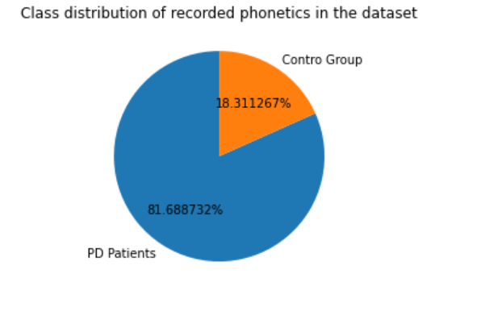

THE VOICE MEASURES USED IN THE EXPERIMENTS :
Feature No Voice Measure Meaning
1 MDVP:Fo(Hz) Average vocal fundamental frequency
2 MDVP:Fhi(Hz) Maximum vocal fundamental frequency
3 MDVP:Flo(Hz) Minimum vocal fundamental frequency
4 MDVP:Jitter(%)
5 MDVP:Jitter(Abs)
6 MDVP:RAP Several measures of variation in
fundamental frequencies.
7 MDVP:PPQ
8 Jitter:DDP
9 MDVP:Shimmer
10 MDVP:Shimmer(dB)
11 Shimmer:APQ3
12 Shimmer:APQ5
13 MDVP:APQ
14 Shimmer:DDA Several measures of variation in
Amplitude
15 NHR

16 HNR Two measures of ratio of noise to tonal
components in the voice.
17 RPDE
18 D2 Two nonlinear dynamical complexity
Measures .
19 DFA Signal fractal scaling exponent
20 spread1
21 spread2
22 PPE Three nonlinear measures of
fundamental frequency variation .
23 status Health status of the subject: (1) Parkinson's,
(0) healthy

Fig 2.1

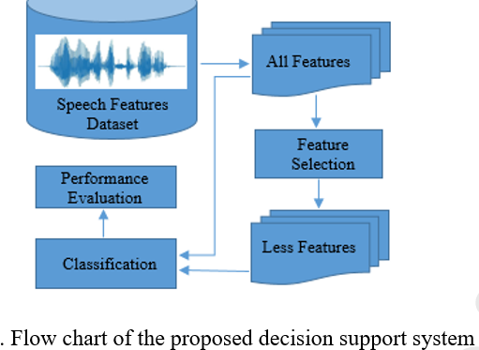
3. INTRODUCTION TO PYTHON
Python
what is Python? Chances you are asking yourself this. You may have found this book because you want to learn to program but don’t know anything about programming languages. Or you may have heard of programming languages like C, C++, C#, or Java and want to know what Python is and how it compares to “big name” languages. Hopefully I can explain it for you.

3.1 Python Features
Python's features include −
- Easy-to-learn − Python has few keywords, simple structure, and a clearly defined syntax. This allows the student to pick up the language quickly.
- Easy-to-read − Python code is more clearly defined and visible to the eyes.
- Easy-to-maintain − Python's source code is fairly easy-to-maintain.
- A broad standard library − Python's bulk of the library is very portable and cross-platform compatible on UNIX, Windows, and Macintosh.
- Interactive Mode − Python has support for an interactive mode which allows interactive testing and debugging of snippets of code.
- Portable − Python can run on a wide variety of hardware platforms and has the same interface on all platforms.
- Extendable − You can add low-level modules to the Python interpreter. These modules enable programmers to add to or customize their tools to be more efficient.
- Databases − Python provides interfaces to all major commercial databases.
- GUI Programming − Python supports GUI applications that can be created and ported to many system calls, libraries and windows systems, such as Windows MFC, Macintosh, and the X Window system of Unix.
- Scalable − Python provides a better structure and support for large programs than shell scripting.

Apart from the above-mentioned features, Python has a big list of good features, few are listed below −
- It supports functional and structured programming methods as well as OOP.
- It can be used as a scripting language or can be compiled to byte-code for building large applications.
- It provides very high-level dynamic data types and supports dynamic type checking.
- IT supports automatic garbage collection.

Variables
Variables are nothing but reserved memory locations to store values. This means that when you create a variable you reserve some space in memory.Based on the data type of a variable, the interpreter allocates memory and decides what can be stored in the reserved memory. Therefore, by assigning different data types to variables, you can store integers, decimals or characters in these variables.

3.2 Standard Data Types
The data stored in memory can be of many types. For example, a person's age is stored as a numeric value and his or her address is stored as alphanumeric characters. Python has various standard data types that are used to define the operations possible on them and the storage method for each of them.
Python has five standard data types −
- Numbers
- String
- List
- Tuple
- Dictionary

3.3 Python libraries for machine learning

1. Requests. The most famous http library written by kennethreitz. It’s a must have for every python developer.
2. Scrapy. If you are involved in webscraping then this is a must have library for you. After using this library you won’t use any other.
3. wxPython. A gui toolkit for python. I have primarily used it in place of tkinter. You will really love it.
4. Pillow. A friendly fork of PIL (Python Imaging Library). It is more user friendly than PIL and is a must have for anyone who works with images.
5. SQLAlchemy. A database library. Many love it and many hate it. The choice is yours.
6. BeautifulSoup. I know it’s slow but this xml and html parsing library is very useful for beginners.
7. Twisted. The most important tool for any network application developer. It has a very beautiful api and is used by a lot of famous python developers.
8. NumPy. How can we leave this very important library ? It provides some advance math functionalities to python.
9. SciPy. When we talk about NumPy then we have to talk about scipy. It is a library of algorithms and mathematical tools for python and has caused many scientists to switch from ruby to python.
10. matplotlib. A numerical plotting library. It is very useful for any data scientist or any data analyzer.
11. Pygame. Which developer does not like to play games and develop them ? This library will help you achieve your goal of 2d game development.
12. Pyglet. A 3d animation and game creation engine. This is the engine in which the famous python port of minecraft was made
13. pyQT. A GUI toolkit for python. It is my second choice after wxpython for developing GUI’s for my python scripts.
14. pyGtk. Another python GUI library. It is the same library in which the famous Bittorrent client is created.
15. Scapy. A packet sniffer and analyzer for python made in python.
16. pywin32. A python library which provides some useful methods and classes for interacting with windows.
17. nltk. Natural Language Toolkit – I realize most people won’t be using this one, but it’s generic enough. It is a very useful library if you want to manipulate strings. But it’s capacity is beyond that. Do check it out.
18. nose. A testing framework for python. It is used by millions of python developers. It is a must have if you do test driven development.
19. SymPy. SymPy can do algebraic evaluation, differentiation, expansion, complex numbers, etc. It is contained in a pure Python distribution.
20. IPython. I just can’t stress enough how useful this tool is. It is a python prompt on steroids. It has completion, history, shell capabilities, and a lot more. Make sure that you take a look at it.

Numpy
NumPy’s main object is the homogeneous multidimensional array. It is a table of elements (usually numbers), all of the same type, indexed by a tuple of positive integers. In NumPy dimensions are called axes. The number of axes is rank.
• Offers Matlab-ish capabilities within Python
• Fast array operations
• 2D arrays, multi-D arrays, linear algebra etc.
matplotlib
• High quality plotting library.

4. HARDWARE AND SOFTWARE
4.1 Hardware Specifications
CPU : Intel i3 or above
RAM: 4 Gb
HARD DISK : 160 GB

4.2 Software Specifications
Essential libraries in python for Machine learning
4.2.1 Numpy: Numpy is a Python package. It stands for 'Numerical Python'. It is a library consisting of multidimensional array objects and a collection of routines for processing of array.
Numeric, the ancestor of Numpy, was developed by Jim Hugunin. Another package Numarray was also developed, having some additional functionalities. In 2005, Travis Oliphant created NumPy package by incorporating the features of Numarray into Numeric package. There are many contributors to this open source project.

Operations using NumPy
Using NumPy, a developer can perform the following operations −
- Mathematical and logical operations on arrays.
- Fourier transforms and routines for shape manipulation.
- Operations related to linear algebra. NumPy has in-built functions for linear algebra and random number generation.

4.2.2 scikit-learn
Scikit-learn provides a range of supervised and unsupervised learning algorithms via a consistent interface in Python.
It is licensed under a permissive simplified BSD license and is distributed under many Linux distributions, encouraging academic and commercial use.
The library is built upon the SciPy (Scientific Python) that must be installed before you can use scikit-learn. This stack that includes:
- NumPy: Base n-dimensional array package
- SciPy: Fundamental library for scientific computing
- Matplotlib: Comprehensive 2D/3D plotting
- IPython: Enhanced interactive console
- Sympy: Symbolic mathematics
- Pandas: Data structures and analysis
Extensions or modules for SciPy care conventionally named SciKits. As such, the module provides learning algorithms and is named scikit-learn.
The vision for the library is a level of robustness and support required for use in production systems. This means a deep focus on concerns such as easy of use, code quality, collaboration, documentation and performance.
Although the interface is Python, c-libraries are leverage for performance such as numpy for arrays and matrix operations, LAPACK, LibSVM and the careful use of cython.
Some popular groups of models provided by scikit-learn include:
- Clustering: for grouping unlabeled data such as KMeans.
- Cross Validation: for estimating the performance of supervised models on unseen data.
- Datasets: for test datasets and for generating datasets with specific properties for investigating model behavior.
- Dimensionality Reduction: for reducing the number of attributes in data for summarization, visualization and feature selection such as Principal component analysis.
- Ensemble methods: for combining the predictions of multiple supervised models.
- Feature extraction: for defining attributes in image and text data.
- Feature selection: for identifying meaningful attributes from which to create supervised models.
- Parameter Tuning: for getting the most out of supervised models.
- Manifold Learning: For summarizing and depicting complex multi-dimensional data.
- Supervised Models: a vast array not limited to generalized linear models, discriminate analysis, naive bayes, lazy methods, neural networks, support vector machines and decision trees.

4.2.3 pandas:
Pandas is an open-source Python Library providing high-performance data manipulation and analysis tool using its powerful data structures. The name Pandas is derived from the word Panel Data – an Econometrics from Multidimensional data.
In 2008, developer Wes McKinney started developing pandas when in need of high performance, flexible tool for analysis of data.
Prior to Pandas, Python was majorly used for data munging and preparation. It had very little contribution towards data analysis. Pandas solved this problem. Using Pandas, we can accomplish five typical steps in the processing and analysis of data, regardless of the origin of data — load, prepare, manipulate, model, and analyze.
Python with Pandas is used in a wide range of fields including academic and commercial domains including finance, economics, Statistics, analytics, etc.

Key Features of Pandas
- Fast and efficient DataFrame object with default and customized indexing.
- Tools for loading data into in-memory data objects from different file formats.
- Data alignment and integrated handling of missing data.
- Reshaping and pivoting of date sets.
- Label-based slicing, indexing and subsetting of large data sets.
- Columns from a data structure can be deleted or inserted.
- Group by data for aggregation and transformations.
- High performance merging and joining of data.
- Time Series functionality.

4.2.4 matplotlib:
Matplotlib is one of the most popular Python packages used for data visualization. It is a cross-platform library for making 2D plots from data in arrays. Matplotlib is written in Python and makes use of NumPy, the numerical mathematics extension of Python. It provides an object-oriented API that helps in embedding plots in applications using Python GUI toolkits such as PyQt, WxPythonotTkinter. It can be used in Python and IPython shells, Jupyter notebook and web application servers also.
Matplotlib has a procedural interface named the Pylab, which is designed to resemble MATLAB, a proprietary programming language developed by MathWorks. Matplotlib along with NumPy can be considered as the open source equivalent of MATLAB.
Matplotlib was originally written by John D. Hunter in 2003. The current stable version is 2.2.0 released in January 2018.
4.2.5 OS and environment :
4.2.5.1 windows10 : Windows 10 is the most recent version of the operating system from Microsoft. Officially it was released in 2015 and was initially offered free of charge to legitimate users of Windows 7 and Windows 8.1. This new version combines features from those two previous installments to suit the users in a better way for both desktop/laptop computers as well as mobile devices.
4.2.5.2 Anaconda(Python)
Anaconda is a free opensource distribution of the Python and R programming languages for scientific computing (data science, machine learning applications, large-scale data processing, predictive analytics, etc.), that aims to simplify
package management and deployment. Package versions are managed by the package management system conda.The Anaconda distribution is used by over 15 million users and includes more than 1500 popular data-science packages suitable for Windows, Linux, and MacOS.

5 . MACHINE LEARNING TECHNIQUES
Here mainly used 4 machine leaning algorithms for detecting whether the person having the parkinson’s disease or not , those are given below.
1.support vector machine(SVM)
2.random forest classifier
3.naive bayes algorithm
4.logistic Regression algorithm .
5.1.support vector machine algorithm :
“Support Vector Machine” (SVM) is a supervised machine learning algorithm which can be used for both classification or regression challenges. However, it is mostly used in classification problems. In the SVM algorithm, we plot each data item as a point in n-dimensional space (where n is number of features you have) with the value of each feature being the value of a particular coordinate. Then, we perform classification by finding the hyper-plane that differentiates the two classes very well (look at the below snapshot).
Fig 5.1.1
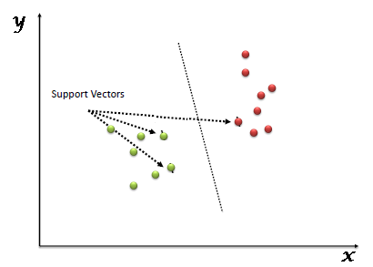

Working of SVM :
- Identify the right hyper-plane (Scenario-1): Here, we have three hyper-planes (A, B and C). Now, identify the right hyper-plane to classify star and circle.
Fig 5.1.2
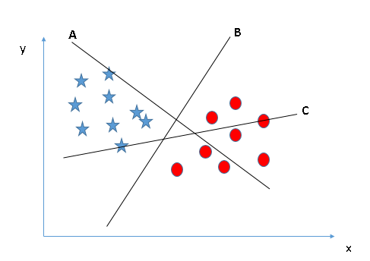
You need to remember a thumb rule to identify the right hyper-plane: “Select the hyper-plane which segregates the two classes better”. In this scenario, hyper-plane “B” has excellently performed this job.
- Identify the right hyper-plane (Scenario-2): Here, we have three hyper-planes (A, B and C) and all are segregating the classes well. Now, How can we identify the right hyper-plane?

Fig 5.1.3
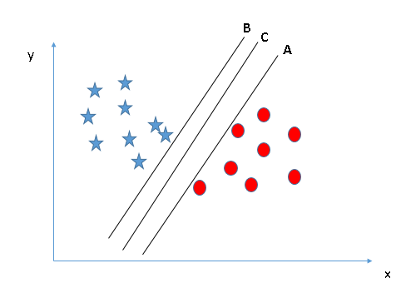
Here, maximizing the distances between nearest data point (either class) and hyper-plane will help us to decide the right hyper-plane. This distance is called as Margin. Let’s look at the below snapshot:
Fig 5.1.4
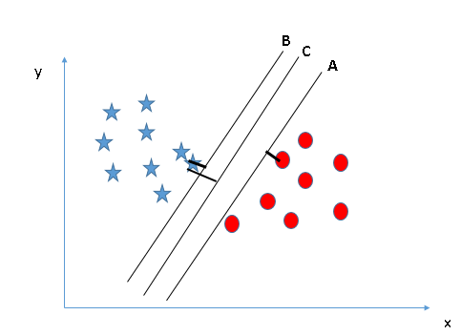
- Above, you can see that the margin for hyper-plane C is high as compared to both A and B. Hence, we name the right hyper-plane as C. Another lightning reason for selecting the hyper-plane with higher margin is robustness. If we
select a hyper-plane having low margin then there is high chance of miss-classification.
- Identify the right hyper-plane (Scenario-3):Hint: Use the rules as discussed in previous section to identify the right hyper-plane.
Fig 5.1.5
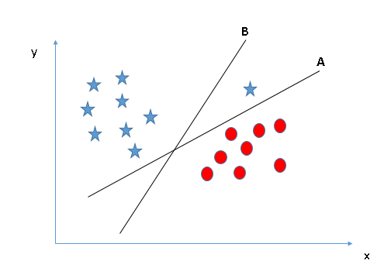
Some of you may have selected the hyper-plane B as it has higher margin compared to A. But, here is the catch, SVM selects the hyper-plane which classifies the classes accurately prior to maximizing margin. Here, hyper-plane B has a classification error and A has classified all correctly. Therefore, the right hyper-plane is A.
- Can we classify two classes (Scenario-4)?: Below, I am unable to segregate the two classes using a straight line, as one of the stars lies in the territory of other(circle) class as an outlier.

Fig 5.1.6
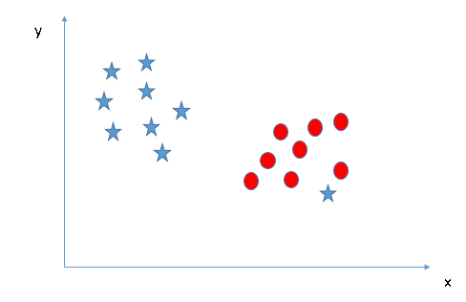
As I have already mentioned, one star at other end is like an outlier for star class. The SVM algorithm has a feature to ignore outliers and find the hyper-plane that has the maximum margin. Hence, we can say, SVM classification is robust to outliers.

Fig 5.1.7
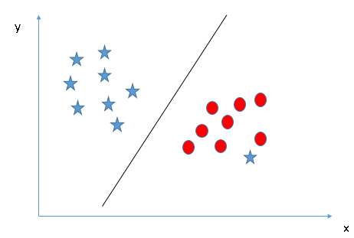
- Find the hyper-plane to segregate to classes (Scenario-5): In the scenario below, we can’t have linear hyper-plane between the two classes, so how does SVM classify these two classes? Till now, we have only looked at the linear hyper-plane.
Fig 1.5.8
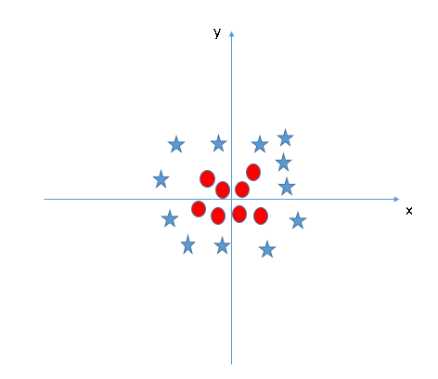
SVM can solve this problem. Easily! It solves this problem by introducing additional feature. Here, we will add a new feature z=x^2+y^2. Now, let’s plot the data points on axis x and z.
Fig 1.5.9

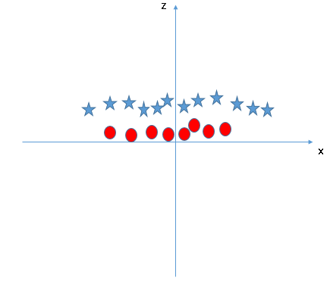
- In above plot, points to consider are:
  - All values for z would be positive always because z is the squared sum of both x and y
  - In the original plot, red circles appear close to the origin of x and y axes, leading to lower value of z and star relatively away from the origin result to higher value of z.
In the SVM classifier, it is easy to have a linear hyper-plane between these two classes. But, another burning question which arises is, should we need to add this feature manually to have a hyper-plane. No, the SVM algorithm has a technique called the kernel trick. The SVM kernel is a function that takes low dimensional input space and transforms it to a higher dimensional space i.e. it converts not separable problem to separable problem. It is mostly useful in non-linear separation problem. Simply put, it does some extremely complex data transformations, then finds out the process to separate the data based on the labels or outputs you’ve defined.
When we look at the hyper-plane in original input space it looks like a circle:
Fig 5.1.10
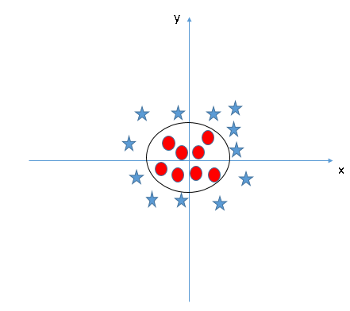
Now, let’s look at the methods to apply SVM classifier algorithm in a data science challenge.

Implementation of SVM in Python:
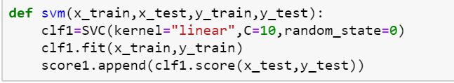
5.2 random forest classifier :
Random forest is a supervised learning algorithm which is used for both classification as well as regression. But however, it is mainly used for classification problems. As we know that a forest is made up of trees and more trees means more robust forest. Similarly, random forest algorithm creates decision trees on data samples and then gets the prediction from each of them and finally selects the best solution by means of voting. It is an ensemble method which is better than a single decision tree because it reduces the over-fitting by averaging the result.

Working of Random Forest Algorithm
We can understand the working of Random Forest algorithm with the help of following steps −
- Step 1 − First, start with the selection of random samples from a given dataset.
- Step 2 − Next, this algorithm will construct a decision tree for every sample. Then it will get the prediction result from every decision tree.
- Step 3 − In this step, voting will be performed for every predicted result.
- Step 4 − At last, select the most voted prediction result as the final prediction result.
The following diagram will illustrate its working –

Fig 5.2

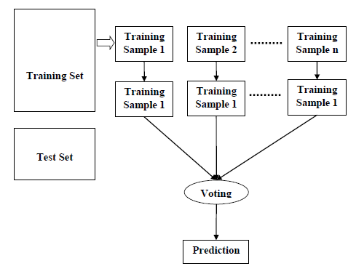

Implementation in Python
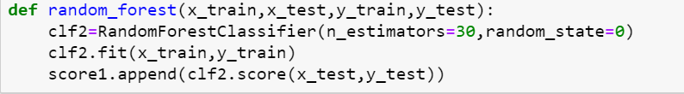
5.3 naïve bayes classifier
Naive Bayes is the most straightforward and fast classification algorithm, which is suitable for a large chunk of data. Naive Bayes classifier is successfully used in various applications such as spam filtering, text classification, sentiment analysis, and recommender systems. It uses Bayes theorem of probability for prediction of unknown class.
Naive Bayes is a statistical classification technique based on Bayes Theorem. It is one of the simplest supervised learning algorithms. Naive Bayes classifier is the fast, accurate and reliable algorithm. Naive Bayes classifiers have high accuracy and speed on large datasets.
Naive Bayes classifier assumes that the effect of a particular feature in a class is independent of other features. For example, a loan applicant is desirable or not depending on his/her income, previous loan and transaction history, age, and location. Even if these features are interdependent, these features are still considered independently. This assumption simplifies computation, and that's why it is considered as naive. This assumption is called class conditional independence.
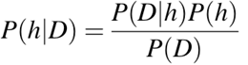
- P(h): the probability of hypothesis h being true (regardless of the data). This is known as the prior probability of h.
- P(D): the probability of the data (regardless of the hypothesis). This is known as the prior probability.
- P(h|D): the probability of hypothesis h given the data D. This is known as posterior probability.
- P(D|h): the probability of data d given that the hypothesis h was true. This is known as posterior probability.

Working of Naive Bayes classifier.
Let’s understand the working of Naive Bayes through an example. Given an example of weather conditions and playing sports. You need to calculate the probability of playing sports. Now, you need to classify whether players will play or not, based on the weather condition.

First Approach (In case of a single feature)
Naive Bayes classifier calculates the probability of an event in the following steps:
- Step 1: Calculate the prior probability for given class labels
- Step 2: Find Likelihood probability with each attribute for each class
- Step 3: Put these value in Bayes Formula and calculate posterior probability.
- Step 4: See which class has a higher probability, given the input belongs to the higher probability class.
For simplifying prior and posterior probability calculation you can use the two tables frequency and likelihood tables. Both of these tables will help you to calculate the prior and posterior probability. The Frequency table contains the occurrence of labels for all features. There are two likelihood tables. Likelihood Table 1 is showing prior probabilities of labels and Likelihood Table 2 is showing the posterior probability.
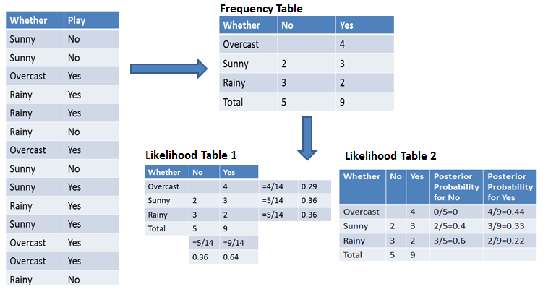
Now suppose you want to calculate the probability of playing when the weather is overcast.
Probability of playing:
P(Yes | Overcast) = P(Overcast | Yes) P(Yes) / P (Overcast) .....................(1)
- Calculate Prior Probabilities:
P(Overcast) = 4/14 = 0.29
P(Yes)= 9/14 = 0.64
- Calculate Posterior Probabilities:
P(Overcast |Yes) = 4/9 = 0.44
- Put Prior and Posterior probabilities in equation (1)
P (Yes | Overcast) = 0.44 * 0.64 / 0.29 = 0.98(Higher)
Similarly, you can calculate the probability of not playing:

Probability of not playing:
P(No | Overcast) = P(Overcast | No) P(No) / P (Overcast) .....................(2)
- Calculate Prior Probabilities:
P(Overcast) = 4/14 = 0.29
P(No)= 5/14 = 0.36
- Calculate Posterior Probabilities:
P(Overcast |No) = 0/9 = 0
- Put Prior and Posterior probabilities in equation (2)
P (No | Overcast) = 0 * 0.36 / 0.29 = 0
The probability of a 'Yes' class is higher. So you can determine here if the weather is overcast than players will play the sport.

Second Approach (In case of multiple features)
Now suppose you want to calculate the probability of playing when the weather is overcast, and the temperature is mild.
Probability of playing:
P(Play= Yes | Weather=Overcast, Temp=Mild) = P(Weather=Overcast, Temp=Mild | Play= Yes)P(Play=Yes) ..........(1)
P(Weather=Overcast, Temp=Mild | Play= Yes)= P(Overcast |Yes) P(Mild |Yes) ………..(2)
- Calculate Prior Probabilities: P(Yes)= 9/14 = 0.64
- Calculate Posterior Probabilities: P(Overcast |Yes) = 4/9 = 0.44 P(Mild |Yes) = 4/9 = 0.44
- Put Posterior probabilities in equation (2) P(Weather=Overcast, Temp=Mild | Play= Yes) = 0.44 * 0.44 = 0.1936(Higher)
- Put Prior and Posterior probabilities in equation (1) P(Play= Yes | Weather=Overcast, Temp=Mild) = 0.1936*0.64 = 0.124
Similarly, you can calculate the probability of not playing:
Probability of not playing:
P(Play= No | Weather=Overcast, Temp=Mild) = P(Weather=Overcast, Temp=Mild | Play= No)P(Play=No) ..........(3)
P(Weather=Overcast, Temp=Mild | Play= No)= P(Weather=Overcast |Play=No) P(Temp=Mild | Play=No) ………..(4)
- Calculate Prior Probabilities: P(No)= 5/14 = 0.36
- Calculate Posterior Probabilities: P(Weather=Overcast |Play=No) = 0/9 = 0 P(Temp=Mild | Play=No)=2/5=0.4
- Put posterior probabilities in equation (4) P(Weather=Overcast, Temp=Mild | Play= No) = 0 * 0.4= 0
- Put prior and posterior probabilities in equation (3) P(Play= No | Weather=Overcast, Temp=Mild) = 0*0.36=0
The probability of a 'Yes' class is higher. So you can say here that if the weather is overcast than players will play the sport.

Implementing the Naïve bayes classifier using python :
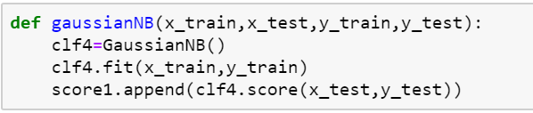

5.4 Logistic Regression :
Logistic regression is basically a supervised classification algorithm. In a classification problem, the target variable(or output), y, can take only discrete values for given set of features(or inputs), X.
Contrary to popular belief, logistic regression IS a regression model. The model builds a regression model to predict the probability that a given data entry belongs to the category numbered as “1”. Just like Linear regression assumes that the data follows a linear function, Logistic regression models the data using the sigmoid function.
Fig 5.4

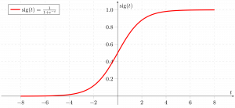
Logistic regression becomes a classification technique only when a decision threshold is brought into the picture. The setting of the threshold value is a very
important aspect of Logistic regression and is dependent on the classification problem itself.
The decision for the value of the threshold value is majorly affected by the values of precision and recall. Ideally, we want both precision and recall to be 1, but this seldom is the case. In case of a Precision-Recall tradeoff we use the following arguments to decide upon the thresold:-
1. Low Precision/High Recall: In applications where we want to reduce the number of false negatives without necessarily reducing the number false positives, we choose a decision value which has a low value of Precision or high value of Recall. For example, in a cancer diagnosis application, we do not want any affected patient to be classified as not affected without giving much heed to if the patient is being wrongfully diagnosed with cancer. This is because, the absence of cancer can be detected by further medical diseases but the presence of the disease cannot be detected in an already rejected candidate.
2. High Precision/Low Recall: In applications where we want to reduce the number of false positives without necessarily reducing the number false negatives, we choose a decision value which has a high value of Precision or low value of Recall. For example, if we are classifying customers whether they will react positively or negatively to a personalised advertisement, we want to be absolutely sure that the customer will react positively to the advertisemnt because otherwise, a negative reaction can cause a loss potential sales from the customer.

Implementation of Logistic Regression using python :

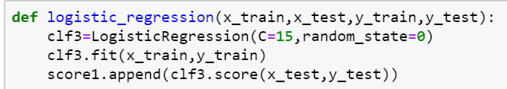

6. FEATURE SELECTION METHODS
Here mainly used 3 feature selection methods those are given below.
1. select from model.
2.recursive feature elimination with combination of random forest classifier (RFE).
3.recurive feature elimination with combination of gradient boosting classifier.

6.1 Select from Model Method :
SelectFromModel is a meta-transformer that can be used along with any estimator that has a coef_ or feature_importances_ attribute after fitting. The features are considered unimportant and removed, if the corresponding coef_ or feature_importances_ values are below the provided threshold parameter. Apart from specifying the threshold numerically, there are built-in heuristics for finding a threshold using a string argument. Available heuristics are “mean”, “median” and float multiples of these like “0.1*mean”. In combination with the threshold criteria, one can use the max_features parameter to set a limit on the number of features to select.
Implementation of select from model using python :
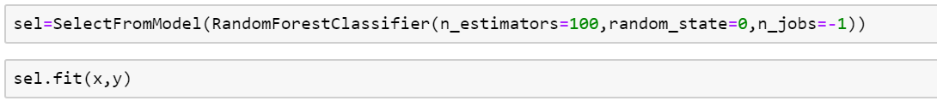
After using this ,only some feature are selected from parkinson’s dataset those are :

After using this select from model feature selection method to select few important features from dataset , we run 4 machine learning algorithms on this data . the accuracy of each algorithm is shown below in bar graph . 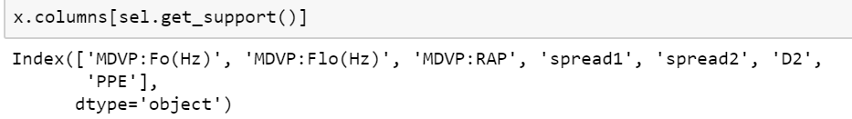
Fig 6.1
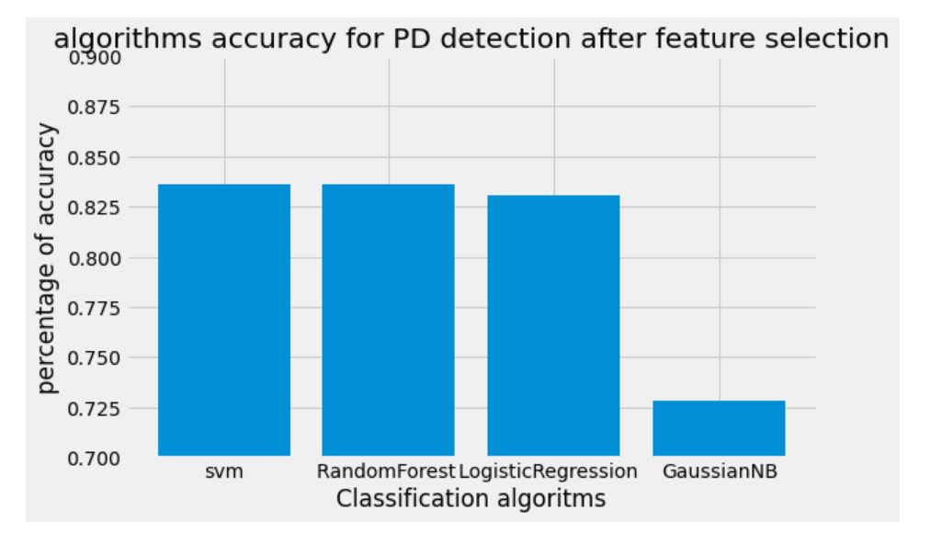

6.2 Recursive feature elimination method combination of Random Forest Classifier
Random forest (RF) is a machine-learning method that may be a good candidate for integrating omics data as it generally works well with high-dimensional problems and can identify strong predictors of a specified outcome without making assumptions about an underlying model . However, a common problem of high-dimensional data sets is the presence of correlated predictors, which impact RF’s ability to identify the strongest predictors by decreasing the estimated importance scores of correlated variables .
A suggested solution is the Random-Forest-Recursive Feature Elimination (RF-RFE) algorithm . RFE was initially proposed to enable support vector machines to perform feature selection by iteratively training a model, ranking features, and then removing the lowest ranking features . This method has been similarly applied to RF and found to be beneficial in the presence of correlated features .
RF is a machine-learning algorithm that ranks the importance of each predictor included in a model by constructing a multitude of decision trees . Each node of a tree considers a different subset of randomly selected predictors, of which the best predictor is selected and split on. The criterion used to determine the best predictor was decreased in node impurity, measured with the estimated response variance, which is the default method used for regression trees in the ranger implementation of RF that was used in this study . Each tree is built using a different random bootstrap sample, which consists of approximately two-thirds of the total observations and is used as a training set to predict the data in the remaining out-of-bag (OOB) sample, or testing set. Predictions for each variable are aggregated
across all trees and the mean square error (MSE) of the OOB estimates is calculated. The MSE_{OOB} and percentage of variance explained are used to evaluate the performance of each RF.
Implementation of recursive feature elimination (RFE) with random forest classifier using python
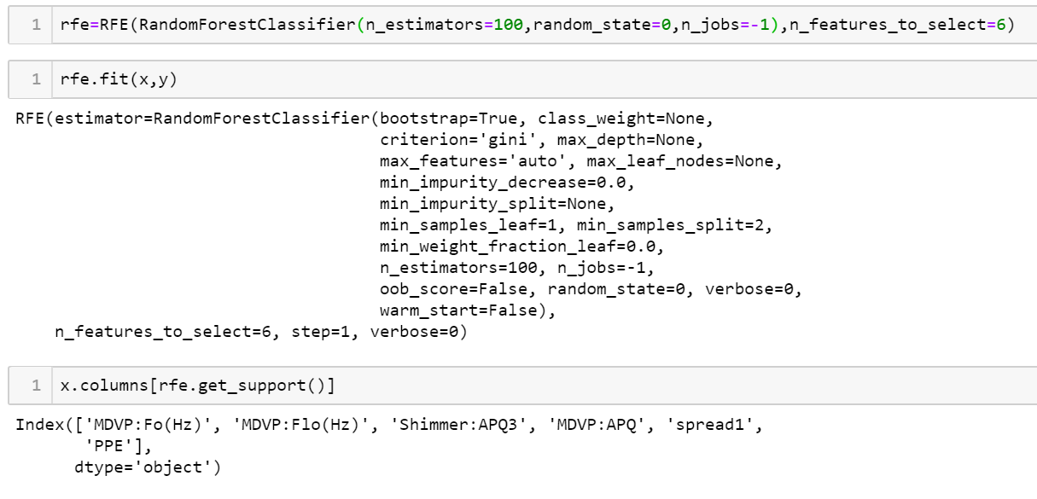
Actually here I am selecting only 6 features from 23 features ,remaining features are eliminated one by one by using this REF feature selection method .

After using this RF-RFE feature selection method to select few important features from dataset , we run 4 machine learning algorithms on this data . the accuracy of each algorithm is shown below in bar graph.

Fig 6.2
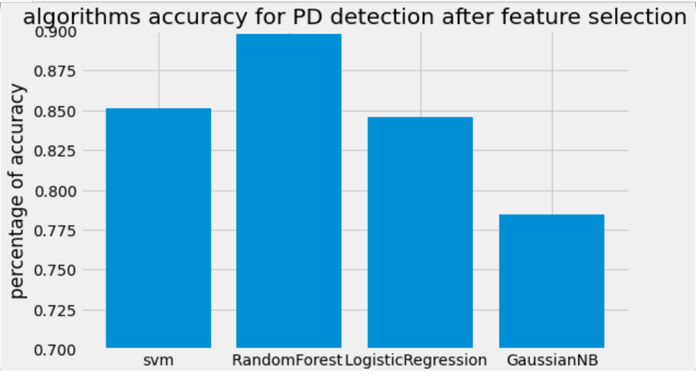
6.3 Recursive feature elimination method combination of Gradient boosting Classifier
A benefit of using ensembles of decision tree methods like gradient boosting is that they can automatically provide estimates of feature importance from a trained predictive model.
A benefit of using gradient boosting is that after the boosted trees are constructed, it is relatively straightforward to retrieve importance scores for each attribute.
Generally, importance provides a score that indicates how useful or valuable each feature was in the construction of the boosted decision trees within the model. The
more an attribute is used to make key decisions with decision trees, the higher its relative importance.
This importance is calculated explicitly for each attribute in the dataset, allowing attributes to be ranked and compared to each other.
Importance is calculated for a single decision tree by the amount that each attribute split point improves the performance measure, weighted by the number of observations the node is responsible for. The performance measure may be the purity (Gini index) used to select the split points or another more specific error function.
The feature importances are then averaged across all of the the decision trees within the model.
Implementation of RFE with Gradient boosting classifier using python: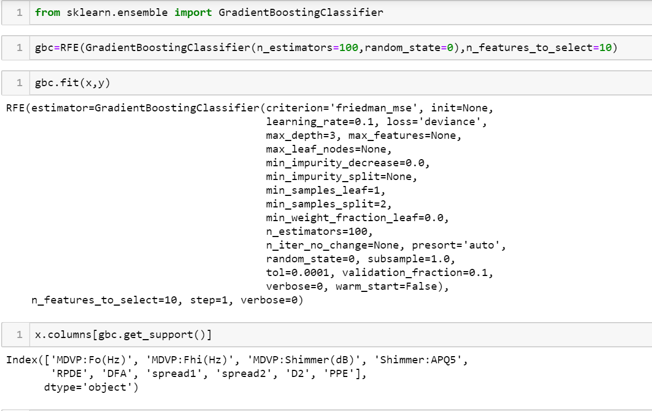
Actually here I am selecting only 10 features from 23 features ,remaining features are eliminated one by one by using this REF feature selection method .
After using this RFE with gradient boosting classifier feature selection method to select few important features from dataset , we run 4 machine learning algorithms on this data . the accuracy of each algorithm is shown below in bar graph
Fig 6.3

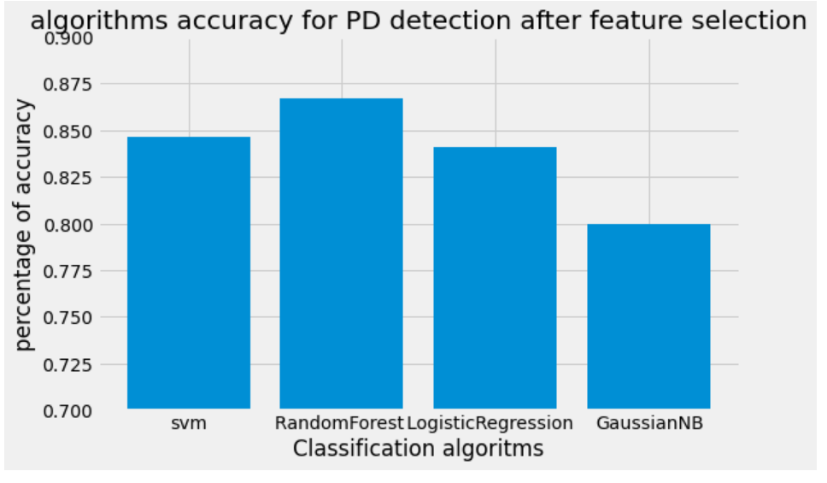

7. COMPARING THE RESULT BEFORE FEATURE SELECTION AND AFTER FEATURE SELECTION
Before feature selection the accuracy of each algorithm is given below :
SVM 0.8358974358974359,
Random Forest Classifier 0.841025641025641,
Logistic Regression 0.8358974358974359,
Naïve bayes 0.6974358974358974.
Fig 7.1

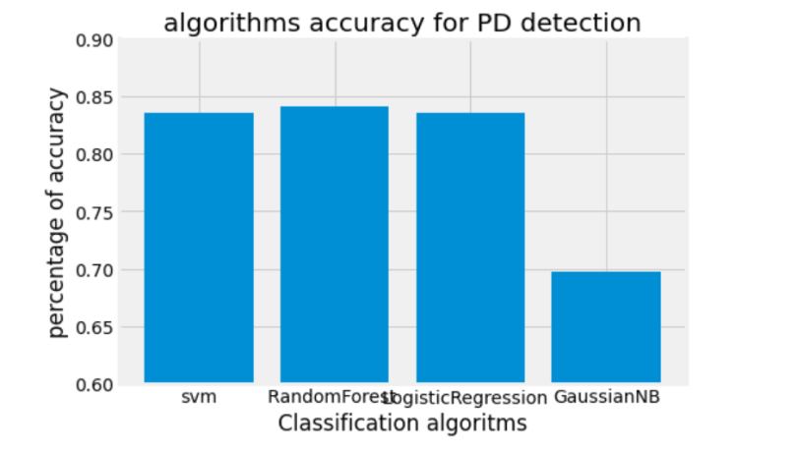
After using select from model feature selection, the accuracy of each algorithm is given below .
SVM0.8358974358974359,
Random Forest Classifier0.841025641025641,
Logistic Regression0.8307692307692308,
Naïve Bayes0.7282051282051282.

After using RFE with Random Forest Classifier feature selection, the accuracy of each algorithm is given below.
SVM0.8507692307692308,
Random Forest classifier0.8974358974358975,
Logistic Regression0.8458974358974359,
Naïve Bayes 0.7846153846153846.

After using RFE with Gradient Boosting Classifier Classifier feature selection, the accuracy of each algorithm is given below.
SVM0.8461538461538461,
Random Forest 0.8666666666666667,
Logistic Regression 0.841025641025641,
Naïve Bayes 0.8.

By considering all these results we got highest accuracy while we are using the RFE with Random Forest classifier feature selection method with the combination of random forest classifier algorithm .

accuracy comparison of before and after feature selection is shown below :
here we are considering the feature selection method RFE with Random Forest Classifier .

Fig 7.2
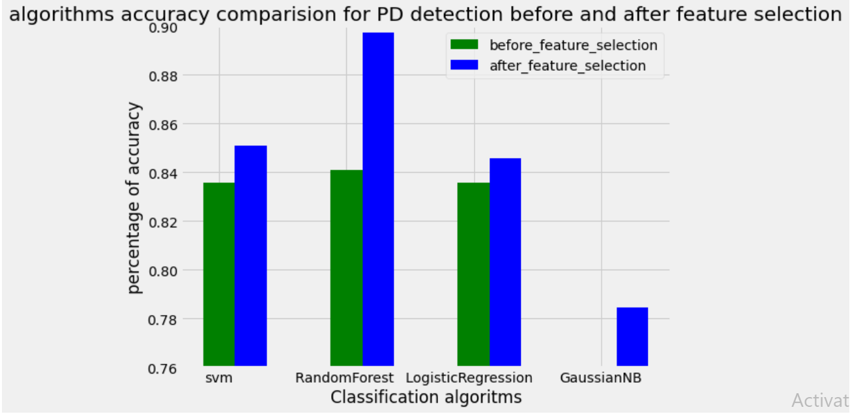
Confusion Matrix for test data

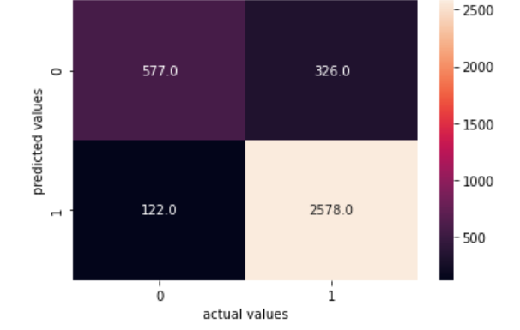
CONCLUSION
In the present study, a FS based decision support system was developed using the features of voice signals of both PD patients and the healthy people for the early diagnosis of Parkinson’s. Different FS methods and different classification methods were used in the experiments. The primary objective in doing so was to improve the performance and the accuracy of the model and also to reduce the computational cost of classification task. Accuracies of the classification methods were evaluated with and without FS and the remarkable effect of FS was shown. The results indicate that using FS methods together with classification methods is quite advantageous especially when dealing with speech signals in which hundreds of phonetic features can be obtained. By the help of the developed early diagnosis system, PD can be diagnosed with a high accuracy rate in its early stages and the worse symptoms of the disease can be stopped.
So finally we obtain the results, By comparing all the results we can say Random forest Classifier with RFE feature selection method gives better accuracy that is 89 percentage and higher performance.

References
[1] R. Karabudak, “Parkinson’s Disease,” 2014.
[2] C. O. Sakar and O. Kursun, “Telediagnosis of parkinson’s disease using measurements of
dysphonia,” J. Med. Syst., vol. 34, no. 4, pp. 591–599, Aug. 2010.
[3] K. R. Wan, T. Maszczyk, A. A. Q. See, J. Dauwels, and N. K. K. King, “A review on
microelectrode recording selection of features for machine learning in deep brain stimulation
surgery for Parkinson’s disease,” Clin. Neurophysiol., vol. 130, no. 1, pp. 145–154, Jan. 2019.
[4] M. R. Salmanpour et al., “Optimized machine learning methods for prediction of cognitive
outcome in Parkinson’s disease,” Comput. Biol. Med., vol. 111, Aug. 2019.
[5] T. Í. Pedrosa, F. F. Vasconcelos, L. Medeiros, and L. D. Silva, “Machine learning application to quantify the tremor level for Parkinson’s disease patients,” in Procedia Computer Science, 2018, vol. 138, pp. 215–220.
[6] R. Prashanth and S. Dutta Roy, “Novel and improved stage estimation in Parkinson’s disease using clinical scales and machine learning,” Neurocomputing, vol. 305, pp. 78–103, Aug. 2018.
[7] F. Cavallo, A. Moschetti, D. Esposito, C. Maremmani, and E. Rovini, “Upper limb motor pre
clinical assessment in Parkinson’s disease using machine learning,” Park. Relat. Disord., vol. 63,
pp. 111–116, Jun. 2019.
[8] J. S. Almeida et al., “Detecting Parkinson’s disease with sustained phonation and speech signals using machine learning techniques,” Pattern Recognit. Lett., vol. 125, pp. 55–62, Jul. 2019.

