Git Installation Steps :

[Git - Downloading Package](https://git-scm.com/download/win)

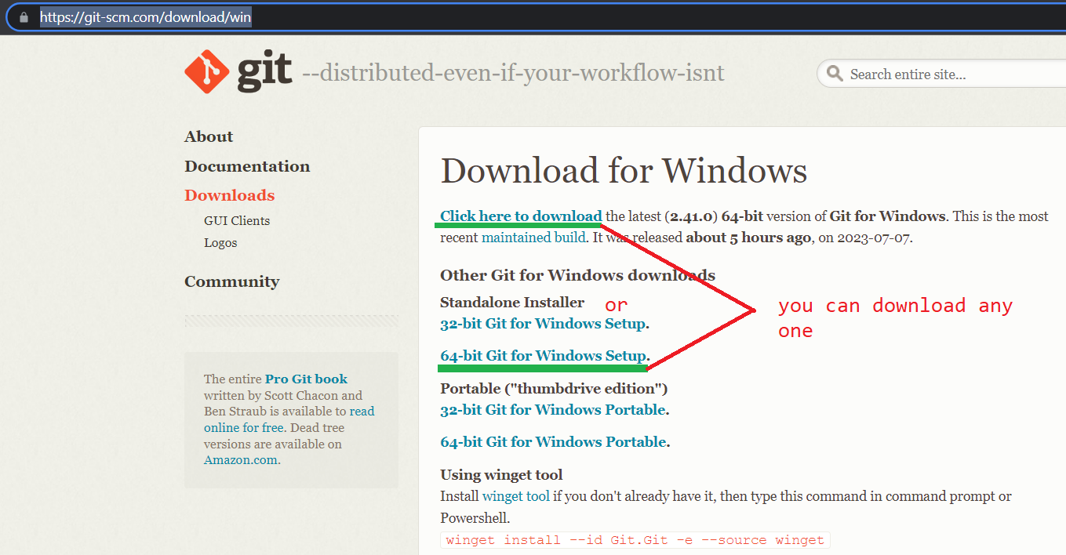

double click on this software

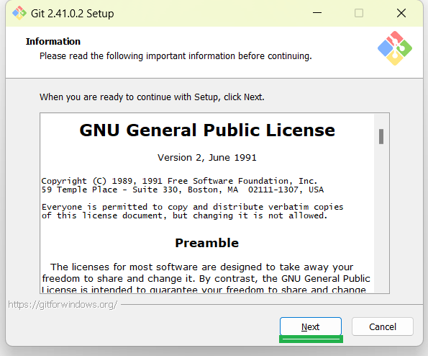

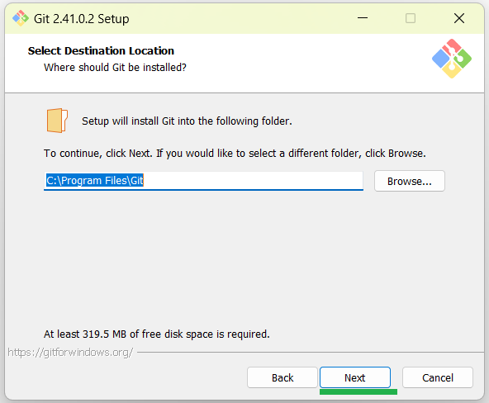

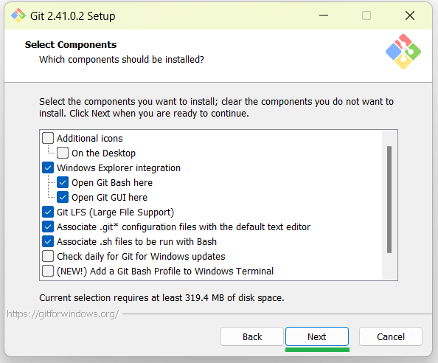

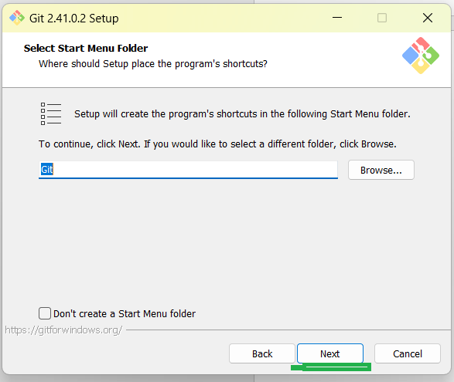

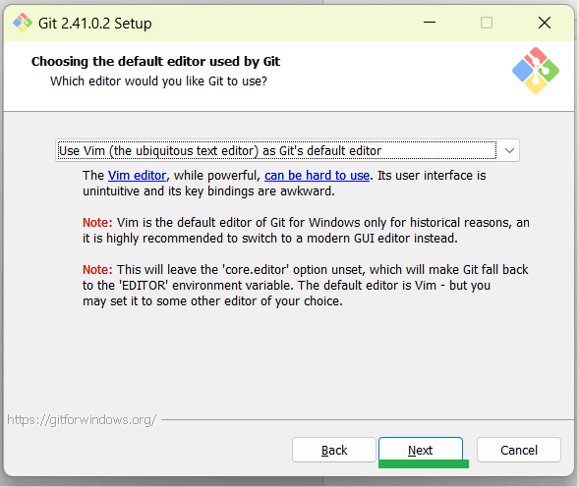

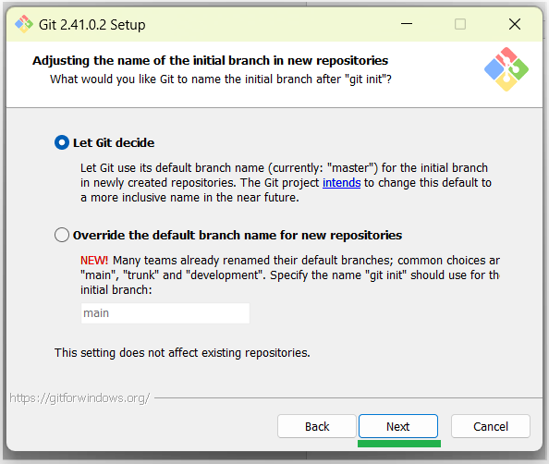

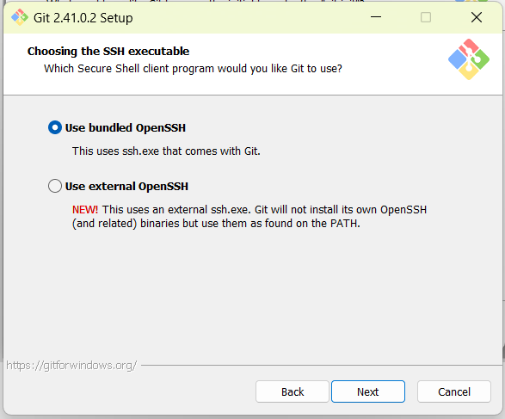

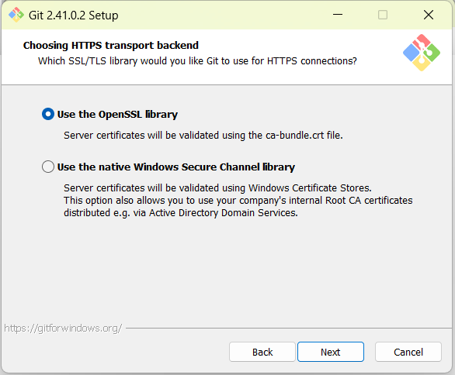

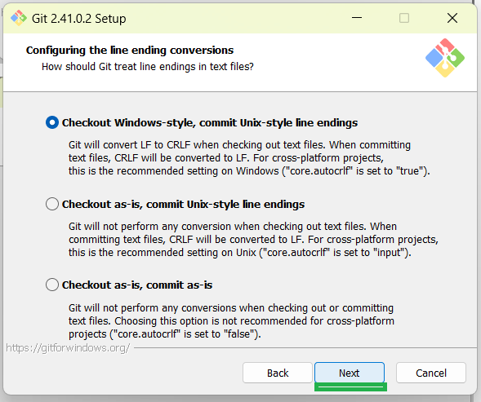88\\\\\\\\\\\\\\\\\\\\\\\\\\\\\\\\\\\\\\\\\\\\\\\\\\\\\\\\\\\\\\\\\\\\\\\\\\\\\\\\\\\\\\\\\\\\\\\\\\\\\\\\\\\\\\\\\\\\\\\\\\\\\\\\\\\\\\\\\\\\\\\\\\\\\\\\\\\\\\\\\\\\\\\\\\\\\\\\\\\\\\\\\\\\\\\\\\\\\\\\\\\\\\\\\\\\\\\\\\\\\\\\\\\\\\\\\\\\\\\\\\\\\\\\\\\\\\\\\\\\\\\\\\\\\\\\\\\\\\\\\\\\\\\\\\\\\\\\\\\\\\\\\\\\\\\\\\\\\\\\\\\\\\\\\\\\\\\\\\\\\\\\\\\\\\\\\\\\\\\\\\\\\\\\\\\\\\\\\\\\\\\\\\\\\\\\\\\\\\\\\\\\\\\\\\\\\\\\\\\\\\\\\\\\\\\\\\\\\\\\\\\\\\\\\\\\\\\\\\\\\\\\\\\\\\\\\\\\\\\\\\\\\\\\\\\\\\\\\\\\\\\\\\\\\\\\\\\\\\\\\\\\\\\\\\\\\\\\\\\\\\\\\\\\\\\\\\\\\\\\\\\\\\\\\\\\\\\\\\\\\\\\\\\\\\\\\\\\\\\\\\\\\\\\\\\\\\\\\\\\\\\\\\\\\\\\\\\\\\\\\\\\\\\\\\\\\\\\\\\\\\\\\\\\\\\\\\\\\\\\\\\\\\\\\\\\\\\\\\\\\\\\\\\\\\\\\\\\\\\\\\\\\\\\\\\\\\\\\\\\\\\\\\\\\\\\\\\\\\\\\\\\\\\\\\\\\\\\\\\\\\\\\\\\\\\\\\\\\\\\\\\\\\\\\\\\\\\\\\\\\\\\\\\\\\\\\\\\\\\\\\\\\\\\\\\\\\\\\\\\\\\\\\\\\\\\\\\\\\\\\\\\\\\\\\\\\\\\\\\\\\\\\\\\\\\\\\\\\\\\\\\\\\\\\\\\\\\\\\\\\\\\\\\\\\\\\\\\\\\\\\\\\\\\\\\\\\\\\\\\\\\\\\\\\\\\\\\\\\\\\\\\\\\\\\\\\\\\\\\\\\\\\\\\\\\\\\\\\\\\\\\\\\\\\\\\\\\\\\\\\\\\\\\\\\\\\\\\\\\\\\\\\\\\\\\\\\\\\\\\\\\\\\\\\\\\\\\\\\\\\\\\\\\\\\\\\\\\\\\\\\\\\\\\\\\\\\\\\\\\\\\\\\\\\\\\\\\\\\\\\\\\\\\\\\\\\\\\\\\\\\\\\\\\\\\\\\\\\\\\\\\\\\\\\\\\\\\\\\\\\\\\\\\\\\\\\\\\\\\\\\\\\\\\\\\\\\\\\\\\\\\\\\\\\\\\\\\\\\\\\\\\\\\\\\\\\\\\\\\\\\\\\\\\\\\\\\\\\\\\\\\\\\\\\\\\\\\\\\\\\\\\\\\\\\\\\\\\\\\\\\\\\\\\\\\\\\\\\\\\\\\\\\\\\\\\\\\\\\\\\\\\\\\\\\\\\\\\\\\\\\\\\\\\\\\\\\\\\\\\\\\\\\\\\\\\\\\\\\\\\\\\\\\\\\\\\\\\\\\\\\\\\\\\\\\\\\\\\\\\\\\\\\\\\\\\\\\\\\\\\\\\\\\\\\\\\\\\\\\\\\\\\\\\\\\\\\\\\\\\\\\\\\\\\\\\\\\\\\\\\\\\\\\\\\\\\\\\\\\\\\\\\\\\\\\\\\\\\\\\\\\\\\\\\\\\\\\\\\\\\\\\\\\\\\\\\\\\\\\\\\\\\\\\\\\\\\\\\\\\\\\\\\\\\\\\\\\\\\\\\\\\\\\\\\\\\\\\\\\\\\\\\\\\\\\\\\\\\\\\\\\\\\\\\\\\\\\\\\\\\\\\\\\\\\\\\\\\\\\\\\\\\\\\\\\\\\\\\\\\\\\\\\\\\\\\\\\\\\\\\\\\\\\\\\\\\\\\\\\\\\\\\\\\\\\\\\\\\\\\\\\\\\\\\\\\\\\\\\\\\\\\\\\\\\\\\\\\\\\\\\\\\\\\\\\\\\\\\\\\\\\\\\\\\\\\\\\\\\\\\\\\\\\\\\\\\\\\\\\\\\\\\\\\\\\\\\\\\\\\\\\\\\\\\\\\\\\\\\\\\\\\\\\\\\\\\\\\\\\\\\\\\\\\\\\\\\\\\\\\\\\\\\\\\\\\\\\\\\\\\\\\\\\\\\\\\\\\\\\\\\\\\\\\\\\\\\\\\\\\\\\\\\\\\\\\\\\\\\\\\\\\\\\\\\\\\\\\\\\\\\\\\\\\\\\\\\\\\\\\\\\\\\\\\\\\\\\\\\\\\\\\\\\\\\\\\\\\\\\\\\\\\\\\\\\\\\\\\\\\\\\\\\\\\\\\\\\\\\\\\\\\\\\\\\\\\\\\\\\\\\\\\\\\\\\\\\\\\\\\\\\\\\\\\\\\\\\\\\\\\\\\\\\\\\\\\\\\\\\\\\\\\\\\\\\\\\\\\\\\\\\\\\\\\\\\\\\\\\\\\\\\\\\\\\\\\\\\\\\\\\\\\\\\\\\\\\\\\\\\\\\\\\\\\\\\\\\\\\\\\\\\\\\\\\\\\\\\\\\\\\\\\\\\\\\\\\\\\\\\\\\\\\\\\\\\\\\\\\\\\\\\\\\\\\\\\\\\\\\\\\\\\\\\\\\\\\\\\\\\\\\\\\\\\\\\\\\\\\\\\\\\\\\\\\\\\\\\\\\\\\\\\\\\\\\\\\\\\\\\\\\\\\\\\\\\\\\\\\\\\\\\\\\\\\\\\\\\\\\\\\\\\\\\\\\\\\\\\\\\\\\\\\\\\\\\\\\\\\\\\\\\\\\\\\\\\\\\\\\\\\\\\\\\\\\\\\\\\\\\\\\\\\\\\\\\\\\\\\\\\\\\\\\\\\\\\\\\\\\\\\\\\\\\\\\\\\\\\\\\\\\\\\\\\\\\\\\\\\\\\\\\\\\\\\\\\\\\\\\\\\\\\\\\\\\\\\\\\\\\\\\\\\\\\\\\\\\\\\\\\\\\\\\\\\\\\\\\\\\\\\\\\\\\\\\\\\\\\\\\\\\\\\\\\\\\\\\\\\\\\\\\\\\\\\\\\\\\\\\\\\\\\\\\\\\\\\\\\\\\\\\\\\\\\\\\\\\\\\\\\\\\\\\\\\\\\\\\\\\\\\\\\\\\\\\\\\\\\\\\\\\\\\\\\\\\\\\\\\\\\\\\\\\\\\\\\\\\\\\\\\\\\\\\\\\\\\\\\\\\\\\\\\\\\\\\\\\\\\\\\\\\\\\\\\\\\\\\\\\\\\\\\\\\\\\\\\\\\\\\\\\\\\\\\\\\\\\\\\\\\\\\\\\\\\\\\\\\\\\\\\\\\\\\\\\\\\\\\\\\\\\\\\\\\\\\\\\\\\\\\\\\\\\\\\\\\\\\\\\\\\\\\\\\\\\\\\\\\\\\\\\\\\\\\\\\\\\\\\\\\\\\\\\\\\\\\\\\\\\\\\\\\\\\\\\\\\\\\\\\\\\\\\\\\\\\\\\\\\\\\\\\\\\\\\\\\\\\\\\\\\\\\\\\\\\\\\\\\\\\\\\\\\\\\\\\\\\\\\\\\\\\\\\\\\\\\\\\\\\\\\\\\\\\\\\\\\\\\\\\\\\\\\\\\\\\\\\\\\\\\\\\\\\\\\\\\\\\\\\\\\\\\\\\\\\\\\\\\\\\\\\\\\\\\\\\\\\\\\\\\\\\\\\\\\\\\\\\\\\\\\\\\\\\\\\\\\\\\\\\\\\\\\\\\\\\\\\\\\\\\\\\\\\\\\\\\\\\\\\\\\\\\\\\\\\\\\\\\\\\\\\\\\\\\\\\\\\\\\\\\\\\\\\\\\\\\\\\\\\\\\\\\\\\\\\\\\\\\\\\\\\\\\\\\\\\\\\\\\\\\\\\\\\\\\\\\\\\\\\\\\\\\\\\\\\\\\\\\\\\\\\\\\\\\\\\\\\\\\\\\\\\\\\\\\\\\\\\\\\\\\\\\\\\\\\\\\\\\\\\\\\\\\\\\\\\\\\\\\\\\\\\\\\\\\\\\\\\\\\\\\\\\\\\\\\\\\\\\\\\\\\\\\\\\\\\\\\\\\\\\\\\\\\\\\\\\\\\\\\\\\\\\\\\\\\\\\\\\\\\\\\\\\\\\\\\\\\\\\\\\\\\\\\\\\\\\\\\\\\\\\\\\\\\\\\\\\\\\\\\\\\\\\\\\\\\\\\\\\\\\\\\\\\\\\\\\\\\\\\\\\\\\\\\\\\\\\\\\\\\\\\\\\\\\\\\\\\\\\\\\\\\\\\\\\\\\\\\\\\\\\\\\\\\\\\\\\\\\\\\\\\\\\\\\\\\\\\\\\\\\\\\\\\\\\\\\\\\\\\\\\\\\\\\\\\\\\\\\\\\\\\\\\\\\\\\\\\\\\\\\\\\\\\\\\\\\\\\\\\\\\\\\\\\\\\\\\\\\\\\\\\\\\\\\\\\\\\\\\\\\\\\\\\\\\\\\\\\\\\\\\\\\\\\\\\\\\\\\\\\\\\\\\\\\\\\\\\\\\\\\\\\\\\\\\\\\\\\\\\\\\\\\\\\\\\\\\\\\\\\\\\\\\\\\\\\\\\\\\\\\\\\\\\\\\\\\\\\\\\\\\\\\\\\\\\\\\\\\\\\\\\\\\\\\\\\\\\\\\\\\\\\\\\\\\\\\\\\\\\\\\\\\\\\\\\\\\\\\\\\\\\\\\\\\\\\\\\\\\\\\\\\\\\\\\\\\\\\\\\\\\\\\\\\\\\\\\\\\\\\\\\\\\\\\\\\\\\\\\\\\\\\\\\\\\\\\\\\\\\\\\\\\\\\\\\\\\\\\\\\\\\\\\\\\\\\\\\\\\\\\\\\\\\\\\\\\\\\\\\\\\\\\\\\\\\\\\\\\\\\\\\\\\\\\\\\\\\\\\\\\\\\\\\\\\\\\\\\\\\\\\\\\\\\\\\\\\\\\\\\\\\\\\\\\\\\\\\\\\\\\\\\\\\\\\\\\\\\\\\\\\\\\\\\\\\\\\\\\\\\\\\\\\\\\\\\\\\\\\\\\\\\\\\\\\\\\\\\\\\\\\\\\\\\\\\\\\\\\\\\\\\\\\\\\\\\\\\\\\\\\\\\\\\\\\\\\\\\\\\\\\\\\\\\\\\\\\\\\\\\\\\\\\\\\\\\\\\\\\\\\\\\\\\\\\\\\\\\\\\\\\\\\\\\\\\\\\\\\\\\\\\\\\\\\\\\\\\\\\\\\\\\\\\\\\\\\\\\\\\\\\\\\\\\\\\\\\\\\\\\\\\\\\\\\\\\\\\\\\\\\\\\\\\\\\\\\\\\\\\\\\\\\\\\\\\\\\\\\\\\\\\\\\\\\\\\\\\\\\\\\\\\\\\\\\\\\\\\\\\\\\\\\\\\\\\\\\\\\\\\\\\\\\\\\\\\\\\\\\\\\\\\\\\\\\\\\\\\\\\\\\\\\\\\\\\\\\\\\\\\\\\\\\\\\\\\\\\\\\\\\\\\\\\\\\\\\\\\\\\\\\\\\\\\\\\\\\\\\\\\\\\\\\\\\\\\\\\\\\\\\\\\\\\\\\\\\\\\\\\\\\\\\\\\\\\\\\\\\\\\\\\\\\\\\\\\\\\\\\\\\\\\\\\\\\\\\\\\\\\\\\\\\\\\\\\\\\\\\\\\\\\\\\\\\\\\\\\\\\\\\\\\\\\\\\\\\\\\\\\\\\\\\\\\\\\\\\\\\\\\\\\\\\\\\\\\\\\\\\\\\\\\\\\\\\\\\\\\\\\\\\\\\\\\\\\\\\\\\\\\\\\\\\\\\\\\\\\\\\\\\\\\\\\\\\\\\\\\\\\\\\\\\\\\\\\\\\\\\\\\\\\\\\\\\\\\\\\\\\\\\\\\\\\\\\\\\\\\\\\\\\\\\\\\\\\\\\\\\\\\\\\\\\\\\\\\\\\\\\\\\\\\\\\\\\\\\\\\\\\\\\\\\\\\\\\\\\\\\\\\\\\\\\\\\\\\\\\\\\\\\\\\\\\\\\\\\\\\\\\\\\\\\\\\\\\\\\\\\\\\\\\\\\\\\\\\\\\\\\\\\\\\\\\\\\\\\\\\\\\\\\\\\\\\\\\\\\\\\\\\\\\\\\\\\\\\\\\\\\\\\\\\\\\\\\\\\\\\\\\\\\\\\\\\\\\\\\\\\\\\\\\\\\\\\\\\\\\\\\\\\\\\\\\\\\\\\\\\\\\\\\\\\\\\\\\\\\\\\\\\\\\\\\\\\\\\\\\\\\\\\\\\\\\\\\\\\\\\\\\\\\\\\\\\\\\\\\\\\\\\\\\\\\\\\\\\\\\\\\\\\\\\\\\\\\\\\\\\\\\\\\\\\\\\\\\\\\\\\\\\\\\\\\\\\\\\\\\\\\\\\\\\\\\\\\\\\\\\\\\\\\\\\\\\\\\\\\\\\\\\\\\\\\\\\\\\\\\\\\\\\\\\\\\\\\\\\\\\\\\\\\\\\\\\\\\\\\\\\\\\\\\\\\\\\\\\\\\\\\\\\\\\\\\\\\\\\\\\\\\\\\\\\\\\\\\\\\\\\\\\\\\\\\\\\\\\\\\\\\\\\\\\\\\\\\\\\\\\\\\\\\\\\\\\\\\\\\\\\\\\\\\\\\\\\\\\\\\\\\\\\\\\\\\\\\\\\\\\\\\\\\\\\\\\\\\\\\\\\\\\\\\\\\\\\\\\\\\\\\\\\\\\\\\\\\\\\\\\\\\\\\\\\\\\\\\\\\\\\\\\\\\\\\\\\\\\\\\\\\\\\\\\\\\\\\\\\\\\\\\\\\\\\\\\\\\\\\\\\\\\\\\\\\\\\\\\\\\\\\\\\\\\\\\\\\\\\\\\\\\\\\\\\\\\\\\\\\\\\\\\\\\\\\\\\\\\\\\\\\\\\\\\\\\\\\\\\\\\\\\\\\\\\\\\\\\\\\\\\\\\\\\\\\\\\\\\\\\\\\\\\\\\\\\\\\\\\\\\\\\\\\\\\\\\\\\\\\\\\\\\\\\\\\\\\\\\\\\\\\\\\\\\\\\\\\\\\\\\\\\\\\\\\\\\\\\\\\\\\\\\\\\\\\\\\\\\\\\\\\\\\\\\\\\\\\\\\\\\\\\\\\\\\\\\\\\\\\\\\\\\\\\\\\\\\\\\\\\\\\\\\\\\\\\\\\\\\\\\\\\\\\\\\\\\\\\\\\\\\\\\\\\\\\\\\\\\\\\\\\\\\\\\\\\\\\\\\\\\\\\\\\\\\\\\\\\\\\\\\\\\\\\\\\\\\\\\\\\\\\\\\\\\\\\\\\\\\\\\\\\\\\\\\\\\\\\\\\\\\\\\\\\\\\\\\\\\\\\\\\\\\\\\\\\\\\\\\\\\\\\\\\\\\\\\\\\\\\\\\\\\\\\\\\\\\\\\\\\\\\\\\\\\\\\\\\\\\\\\\\\\\\\\\\\\\\\\\\\\\\\\\\\\\\\\\\\\\\\\\\\\\\\\\\\\\\\\\\\\\\\\\\\\\\\\\\\\\\\\\\\\\\\\\\\\\\\\\\\\\\\\\\\\\\\\\\\\\\\\\\\\\\\\\\\\\\\\\\\\\\\\\\\\\\\\\\\\\\\\\\\\\\\\\\\\\\\\\\\\\\\\\\\\\\\\\\\\\\\\\\\\\\\\\\\\\\\\\\\\\\\\\\\\\\\\\\\\\\\\\\\\\\\\\\\\\\\\\\\\\\\\\\\\\\\\\\\\\\\\\\\\\\\\\\\\\\\\\\\\\\\\\\\\\\\\\\\\\\\\\\\\\\\\\\\\\\\\\\\\\\\\\\\\\\\\\\\\\\\\\\\\\\\\\\\\\\\\\\\\\\\\\\\\\\\\\\\\\\\\\\\\\\\\\\\\\\\\\\\\\\\\\\\\\\\\\\\\\\\\\\\\\\\\\\\\\\\\\\\\\\\\\\\\\\\\\\\\\\\\\\\\\\\\\\\\\\\\\\\\\\\\\\\\\\\\\\\\\\\\\\\\\\\\\\\\\\\\\\\\\\\\\\\\\\\\\\\\\\\\\\\\\\\\\\\\\\\\\\\\\\\\\\\\\\\\\\\\\\\\\\\\\\\\\\\\\\\\\\\\\\\\\\\\\\\\\\\\\\\\\\\\\\\\\\\\\\\\\\\\\\\\\\\\\\\\\\\\\\\\\\\\\\\\\\\\\\\\\\\\\\\\\\\\\\\\\\\\\\\\\\\\\\\\\\\\\\\\\\\\\\\\\\\\\\\\\\\\\\\\\\\\\\\\\\\\\\\\\\\\\\\\\\\\\\\\\\\\\\\\\\\\\\\\\\\\\\\\\\\\\\\\\\\\\\\\\\\\\\\\\\\\\\\\\\\\\\\\\\\\\\\\\\\\\\\\\\\\\\\\\\\\\\\\\\\\\\\\\\\\\\\\\\\\\\\\\\\\\\\\\\\\\\\\\\\\\\\\\\\\\\\\\\\\\\\\\\\\\\\\\\\\\\\\\\\\\\\\\\\\\\\\\\\\\\\\\\\\\\\\\\\\\\\\\\\\\\\\\\\\\\\\\\\\\\\\\\\\\\\\\\\\\\\\\\\\\\\\\\\\\\\\\\\\\\\\\\\\\\\\\\\\\\\\\\\\\\\\\\\\\\\\\\\\\\\\\\\\\\\\\\\\\\\\\\\\\\\\\\\\\\\\\\\\\\\\\\\\\\\\\\\\\\\\\\\\\\\\\\\\\\\\\\\\\\\\\\\\\\\\\\\\\\\\\\\\\\\\\\\\\\\\\\\\\\\\\\\\\\\\\\\\\\\\\\\\\\\\\\\\\\\\\\\\\\\\\\\\\\\\\\\\\\\\\\\\\\\\\\\\\\\\\\\\\\\\\\\\\\\\\\\\\\\\\\\\\\\\\\\\\\\\\\\\\\\\\\\\\\\\\\\\\\\\\\\\\\\\\\\\\\\\\\\\\\\\\\\\\\\\\\\\\\\\\\\\\\\\\\\\\\\\\\\\\\\\\\\\\\\\\\\\\\\\\\\\\\\\\\\\\\\\\\\\\\\\\\\\\\\\\\\\\\\\\\\\\\\\\\\\\\\\\\\\\\\\\\\\\\\\\\\\\\\\\\\\\\\\\\\\\\\\\\\\\\\\\\\\\\\\\\\\\\\\\\\\\\\\\\\\\\\\\\\\\\\\\\\\\\\\\\\\\\\\\\\\\\\\\\\\\\\\\\\\\\\\\\\\\\\\\\\\\\\\\\\\\\\\\\\\\\\\\\\\\\\\\\\\\\\\\\\\\\\\\\\\\\\\\\\\\\\\\\\\\\\\\\\\\\\\\\\\\\\\\\\\\\\\\\\\\\\\\\\\\\\\\\\\\\\\\\\\\\\\\\\\\\\\\\\\\\\\\\\\\\\\\\\\\\\\\\\\\\\\\\\\\\\\\\\\\\\\\\\\\\\\\\\\\\\\\\\\\\\\\\\\\\\\\\\\\\\\\\\\\\\\\\\\\\\\\\\\\\\\\\\\\\\\\\\\\\\\\\\\\\\\\\\\\\\\\\\\\\\\\\\\\\\\\\\\\\\\\\\\\\\\\\\\\\\\\\\\\\\\\\\\\\\\\\\\\\\\\\\\\\\\\\\\\\\\\\\\\\\\\\\\\\\\\\\\\\\\\\\\\\\\\\\\\\\\\\\\\\\\\\\\\\\\\\\\\\\\\\\\\\\\\\\\\\\\\\\\\\\\\\\\\\\\\\\\\\\\\\\\\\\\\\\\\\\\\\\\\\\\\\\\\\\\\\\\\\\\\\\\\\\\\\\\\\\\\\\\\\\\\\\\\\\\\\\\\\\\\\\\\\\\\\\\\\\\\\\\\\\\\\\\\\\\\\\\\\\\\\\\\\\\\\\\\\\\\\\\\\\\\\\\\\\\\\\\\\\\\\\\\\\\\\\\\\\\\\\\\\\\\\\\\\\\\\\\\\\\\\\\\\\\\\\\\\\\\\\\\\\\\\\\\\\\\\\\\\\\\\\\\\\\\\\\\\\\\\\\\\\\\\\\\\\\\\\\\\\\\\\\\\\\\\\\\\\\\\\\\\\\\\\\\\\\\\\\\\\\\\\\\\\\\\\\\\\\\\\\\\\\\\\\\\\\\\\\\\\\\\\\\\\\\\\\\\\\\\\\\\\\\\\\\\\\\\\\\\\\\\\\\\\\\\\\\\\\\\\\\\\\\\\\\\\\\\\\\\\\\\\\\\\\\\\\\\\\\\\\\\\\\\\\\\\\\\\\\\\\\\\\\\\\\\\\\\\\\\\\\\\\\\\\\\\\\\\\\\\\\\\\\\\\\\\\\\\\\\\\\\\\\\\\\\\\\\\\\\\\\\\\\\\\\\\\\\\\\\\\\\\\\\\\\\\\\\\\\\\\\\\\\\\\\\\\\\\\\\\\\\\\\\\\\\\\\\\\\\\\\\\\\\\\\\\\\\\\\\\\\\\\\\\\\\\\\\\\\\\\\\\\\\\\\\\\\\\\\\\\\\\\\\\\\\\\\\\\\\\\\\\\\\\\\\\\\\\\\\\\\\\\\\\\\\\\\\\\\\\\\\\\\\\\\\\\\\\\\\\\\\\\\\\\\\\\\\\\\\\\\\\\\\\\\\\\\\\\\\\\\\\\\\\\\\\\\\\\\\\\\\\\\\\\\\\\\\\\\\\\\\\\\\\\\\\\\\\\\\\\\\\\\\\\\\\\\\\\\\\\\\\\\\\\\\\\\\\\\\\\\\\\\\\\\\\\\\\\\\\\\\\\\\\\\\\\\\\\\\\\\\\\\\\\\\\\\\\\\\\\\\\\\\\\\\\\\\\\\\\\\\\\\\\\\\\\\\\\\\\\\\\\\\\\\\\\\\\\\\\\\\\\\\\\\\\\\\\\\\\\\\\\\\\\\\\\\\\\\\\\\\\\\\\\\\\\\\\\\\\\\\\\\\\\\\\\\\\\\\\\\\\\\\\\\\\\\\\\\\\\\\\\\\\\\\\\\\\\\\\\\\\\\\\\\\\\\\\\\\\\\\\\\\\\\\\\\\\\\\\\\\\\\\\\\\\\\\\\\\\\\\\\\\\\\\\\\\\\\\\\\\\\\\\\\\\\\\\\\\\\\\\\\\\\\\\\\\\\\\\\\\\\\\\\\\\\\\\\\\\\\\\\\\\\\\\\\\\\\\\\\\\\\\\\\\\\\\\\\\\\\\\\\\\\\\\\\\\\\\\\\\\\\\\\\\\\\\\\\\\\\\\\\\\\\\\\\\\\\\\\\\\\\\\\\\\\\\\\\\\\\\\\\\\\\\\\\\\\\\\\\\\\\\\\\\\\\\\\\\\\\\\\\\\\\\\\\\\\\\\\\\\\\\\\\\\\\\\\\\\\\\\\\\\\\\\\\\\\\\\\\\\\\\\\\\\\\\\\\\\\\\\\\\\\\\\\\\\\\\\\\\\\\\\\\\\\\\\\\\\\\\\\\\\\\\\\\\\\\\\\\\\\\\\\\\\\\\\\\\\\\\\\\\\\\\\\\\\\\\\\\\\\\\\\\\\\\\\\\\\\\\\\\\\\\\\\\\\\\\\\\\\\\\\\\\\\\\\\\\\\\\\\\\\\\\\\\\\\\\\\\\\\\\\\\\\\\\\\\\\\\\\\\\\\\\\\\\\\\\\\\\\\\\\\\\\\\\\\\\\\\\\\\\\\\\\\\\\\\\\\\\\\\\\\\\\\\\\\\\\\\\\\\\\\\\\\\\\\\\\\\\\\\\\\\\\\\\\\\\\\\\\\\\\\\\\\\\\\\\\\\\\\\\\\\\\\\\\\\\\\\\\\\\\\\\\\\\\\\\\\\\\\\\\\\\\\\\\\\\\\\\\\\\\\\\\\\\\\\\\\\\\\\\\\\\\\\\\\\\\\\\\\\\\\\\\\\\\\\\\\\\\\\\\\\\\\\\\\\\\\\\\\\\\\\\\\\\\\\\\\\\\\\\\\\\\\\\\\\\\\\\\\\\\\\\\\\\\\\\\\\\\\\\\\\\\\\\\\\\\\\\\\\\\\\\\\\\\\\\\\\\\\\\\\\\\\\\\\\\\\\\\\\\\\\\\\\\\\\\\\\\\\\\\\\\\\\\\\\\\\\\\\\\\\\\\\\\\\\\\\\\\\\\\\\\\\\\\\\\\\\\\\\\\\\\\\\\\\\\\\\\\\\\\\\\\\\\\\\\\\\\\\\\\\\\\\\\\\\\\\\\\\\\\\\\\\\\\\\\\\\\\\\\\\\\\\\\\\\\\\\\\\\\\\\\\\\\\\\\\\\\\\\\\\\\\\\\\\\\\\\\\\\\\\\\\\\\\\\\\\\\\\\\\\\\\\\\\\\\\\\\\\\\\\\\\\\\\\\\\\\\\\\\\\\\\\\\\\\\\\\\\\\\\\\\\\\\\\\\\\\\\\\\\\\\\\\\\\\\\\\\\\\\\\\\\\\\\\\\\\\\\\\\\\\\\\\\\\\\\\\\\\\\\\\\\\\\\\\\\\\\\\\\\\\\\\\\\\\\\\\\\\\\\\\\\\\\\\\\\\\\\\\\\\\\\\\\\\\\\\\\\\\\\\\\\\\\\\\\\\\\\\\\\\\\\\\\\\\\\\\\\\\\\\\\\\\\\\\\\\\\\\\\\\\\\\\\\\\\\\\\\\\\\\\\\\\\\\\\\\\\\\\\\\\\\\\\\\\\\\\\\\\\\\\\\\\\\\\\\\\\\\\\\\\\\\\\\\\\\\\\\\\\\\\\\\\\\\\\\\\\\\\\\\\\\\\\\\\\\\\\\\\\\\\\\\\\\\\\\\\\\\\\\\\\\\\\\\\\\\\\\\\\\\\\\\\\\\\\\\\\\\\\\\\\\\\\\\\\\\\\\\\\\\\\\\\\\\\\\\\\\\\\\\\\\\\\\\\\\\\\\\\\\\\\\\\\\\\\\\\\\\\\\\\\\\\\\\\\\\\\\\\\\\\\\\\\\\\\\\\\\\\\\\\\\\\\\\\\\\\\\\\\\\\\\\\\\\\\\\\\\\\\\\\\\\\\\\\\\\\\\\\\\\\\\\\\\\\\\\\\\\\\\\\\\\\\\\\\\\\\\\\\\\\\\\\\\\\\\\\\\\\\\\\\\\\\\\\\\\\\\\\\\\\\\\\\\\\\\\\\\\\\\\\\\\\\\\\\\\\\\\\\\\\\\\\\\\\\\\\\\\\\\\\\\\\\\\\\\\\\\\\\\\\\\\\\\\\\\\\\\\\\\\\\\\\\\\\\\\\\\\\\\\\\\\\\\\\\\\\\\\\\\\\\\\\\\\\\\\\\\\\\\\\\\\\\\\\\\\\\\\\\\\\\\\\\\\\\\\\\\\\\\\\\\\\\\\\\\\\\\\\\\\\\\\\\\\\\\\\\\\\\\\\\\\\\\\\\\\\\\\\\\\\\\\\\\\\\\\\\\\\\\\\\\\\\\\\\\\\\\\\\\\\\\\\\\\\\\\\\\\\\\\\\\\\\\\\\\\\\\\\\\\\\\\\\\\\\\\\\\\\\\\\\\\\\\\\\\\\\\\\\\\\\\\\\\\\\\\\\\\\\\\\\\\\\\\\\\\\\\\\\\\\\\\\\\\\\\\\\\\\\\\\\\\\\\\\\\\\\\\\\\\\\\\\\\\\\\\\\\\\\\\\\\\\\\\\\\\\\\\\\\\\\\\\\\\\\\\\\\\\\\\\\\\\\\\\\\\\\\\\\\\\\\\\\\\\\\\\\\\\\\\\\\\\\\\\\\\\\\\\\\\\\\\\\\\\\\\\\\\\\\\\\\\\\\\\\\\\\\\\\\\\\\\\\\\\\\\\\\\\\\\\\\\\\\\\\\\\\\\\\\\\\\\\\\\\\\\\\\\\\\\\\\\\\\\\\\\\\\\\\\\\\\\\\\\\\\\\\\\\\\\\\\\\\\\\\\\\\\\\\\\\\\\\\\\\\\\\\\\\\\\\\\\\\\\\\\\\\\\\\\\\\\\\\\\\\\\\\\\\\\\\\\\\\\\\\\\\\\\\\\\\\\\\\\\\\\\\\\\\\\\\\\\\\\\\\\\\\\\\\\\\\\\\\\\\\\\\\\\\\\\\\\\\\\\\\\\\\\\\\\\\\\\\\\\\\\\\\\\\\\\\\\\\\\\\\\\\\\\\\\\\\\\\\\\\\\\\\\\\\\\\\\\\\\\\\\\\\\\\\\\\\\\\\\\\\\\\\\\\\\\\\\\\\\\\\\\\\\\\\\\\\\\\\\\\\\\\\\\\\\\\\\\\\\\\\\\\\\\\\\\\\\\\\\\\\\\\\\\\\\\\\\\\\\\\\\\\\\\\\\\\\\\\\\\\\\\\\\\\\\\\\\\\\\\\\\\\\\\\\\\\\\\\\\\\\\\\\\\\\\\\\\\\\\\\\\\\\\\\\\\\\\\\\\\\\\\\\\\\\\\\\\\\\\\\\\\\\\\\\\\\\\\\\\\\\\\\\\\\\\\\\\\\\\\\\\\\\\\\\\\\\\\\\\\\\\\\\\\\\\\\\\\\\\\\\\\\\\\\\\\\\\\\\\\\\\\\\\\\\\\\\\\\\\\\\\\\\\\\\\\\\\\\\\\\\\\\\\\\\\\\\\\\\\\\\\\\\\\\\\\\\\\\\\\\\\\\\\\\\\\\\\\\\\\\\\\\\\\\\\\\\\\\\\\\\\\\\\\\\\\\\\\\\\\\\\\\\\\\\\\\\\\\\\\\\\\\\\\\\\\\\\\\\\\\\\\\\\\\\\\\\\\\\\\\\\\\\\\\\\\\\\\\\\\\\\\\\\\\\\\\\\\\\\\\\\\\\\\\\\\\\\\\\\\\\\\\\\\\\\\\\\\\\\\\\\\\\\\\\\\\\\\\\\\\\\\\\\\\\\\\\\\\\\\\\\\\\\\\\\\\\\\\\\\\\\\\\\\\\\\\\\\\\\\\\\\\\\\\\\\\\\\\\\\\\\\\\\\\\\\\\\\\\\\\\\\\\\\\\\\\\\\\\\\\\\\\\\\\\\\\\\\\\\\\\\\\\\\\\\\\\\\\\\\\\\\\\\\\\\\\\\\\\\\\\\\\\\\\\\\\\\\\\\\\\\\\\\\\\\\\\\\\\\\\\\\\\\\\\\\\\\\\\\\\\\\\\\\\\\\\\\\\\\\\\\\\\\\\\\\\\\\\\\\\\\\\\\\\\\\\\\\\\\\\\\\\\\\\\\\\\\\\\\\\\\\\\\\\\\\\\\\\\\\\\\\\\\\\\\\\\\\\\\\\\\\\\\\\\\\\\\\\\\\\\\\\\\\\\\\\\\\\\\\\\\\\\\\\\\\\\\\\\\\\\\\\\\\\\\\\\\\\\\\\\\\\\\\\\\\\\\\\\\\\\\\\\\\\\\\\\\\\\\\\\\\\\\\\\\\\\\\\\\\\\\\\\\\\\\\\\\\\\\\\\\\\\\\\\\\\\\\\\\\\\\\\\\\\\\\\\\\\\\\\\\\\\\\\\\\\\\\\\\\\\\\\\\\\\\\\\\\\\\\\\\\\\\\\\\\\\\\\\\\\\\\\\\\\\\\\\\\\\\\\\\\\\\\\\\\\\\\\\\\\\\\\\\\\\\\\\\\\\\\\\\\\\\\\\\\\\\\\\\\\\\\\\\\\\\\\\\\\\\\\\\\\\\\\\\\\\\\\\\\\\\\\\\\\\\\\\\\\\\\\\\\\\\\\\\\\\\\\\\\\\\\\\\\\\\\\\\\\\\\\\\\\\\\\\\\\\\\\\\\\\\\\\\\\\\\\\\\\\\\\\\\\\\\\\\\\\\\\\\\\\\\\\\\\\\\\\\\\\\\\\\\\\\\\\\\\\\\\\\\\\\\\\\\\\\\\\\\\\\\\\\\\\\\\\\\\\\\\\\\\\\\\\\\\\\\\\\\\\\\\\\\\\\\\\\\\\\\\\\\\\\\\\\\\\\\\\\\\\\\\\\\\\\\\\\\\\\\\\\\\\\\\\\\\\\\\\\\\\\\\\\\\\\\\\\\\\\\\\\\\\\\\\\\\\\\\\\\\\\\\\\\\\\\\\\\\\\\\\\\\\\\\\\\\\\\\\\\\\\\\\\\\\\\\\\\\\\\\\\\\\\\\\\\\\\\\\\\\\\\\\\\\\\\\\\\\\\\\\\\\\\\\\\\\\\\\\\\\\\\\\\\\\\\\\\\\\\\\\\\\\\\\\\\\\\\\\\\\\\\\\\\\\\\\\\\\\\\\\\\\\\\\\\\\\\\\\\\\\\\\\\\\\\\\\\\\\\\\\\\\\\\\\\\\\\\\\\\\\\\\\\\\\\\\\\\\\\\\\\\\\\\\\\\\\\\\\\\\\\\\\\\\\\\\\\\\\\\\\\\\\\\\\\\\\\\\\\\\\\\\\\\\\\\\\\\\\\\\\\\\\\\\\\\\\\\\\\\\\\\\\\\\\\\\\\\\\\\\\\\\\\\\\\\\\\\\\\\\\\\\\\\\\\\\\\\\\\\\\\\\\\\\\\\\\\\\\\\\\\\\\\\\\\\\\\\\\\\\\\\\\\\\\\\\\\\\\\\\\\\\\\\\\\\\\\\\\\\\\\\\\\\\\\\\\\\\\\\\\\\\\\\\\\\\\\\\\\\\\\\\\\\\\\\\\\\\\\\\\\\\\\\\\\\\\\\\\\\\\\\\\\\\\\\\\\\\\\\\\\\\\\\\\\\\\\\\\\\\\\\\\\\\\\\\\\\\\\\\\\\\\\\\\\\\\\\\\\\\\\\\\\\\\\\\\\\\\\\\\\\\\\\\\\\\\\\\\\\\\\\\\\\\\\\\\\\\\\\\\\\\\\\\\\\\\\\\\\\\\\\\\\\\\\\\\\\\\\\\\\\\\\\\\\\\\\\\\\\\\\\\\\\\\\\\\\\\\\\\\\\\\\\\\\\\\\\\\\\\\\\\\\\\\\\\\\\\\\\\\\\\\\\\\\\\\\\\\\\\\\\\\\\\\\\\\\\\\\\\\\\\\\\\\\\\\\\\\\\\\\\\\\\\\\\\\\\\\\\\\\\\\\\\\\\\\\\\\\\\\\\\\\\\\\\\\\\\\\\\\\\\\\\\\\\\\\\\\\\\\\\\\\\\\\\\\\\\\\\\\\\\\\\\\\\\\\\\\\\\\\\\\\\\\\\\\\\\\\\\\\\\\\\\\\\\\\\\\\\\\\\\\\\\\\\\\\\\\\\\\\\\\\\\\\\\\\\\\\\\\\\\\\\\\\\\\\\\\\\\\\\\\\\\\\\\\\\\\\\\\\\\\\\\\\\\\\\\\\\\\\\\\\\\\\\\\\\\\\\\\\\\\\\\\\\\\\\\\\\\\\\\\\\\\\\\\\\\\\\\\\\\\\\\\\\\\\\\\\\\\\\\\\\\\\\\\\\\\\\\\\\\\\\\\\\\\\\\\\\\\\\\\\\\\\\\\\\\\\\\\\\\\\\\\\\\\\\\\\\\\\\\\\\\\\\\\\\\\\\\\\\\\\\\\\\\\\\\\\\\\\\\\\\\\\\\\\\\\\\\\\\\\\\\\\\\\\\\\\\\\\\\\\\\\\\\\\\\\\\\\\\\\\\\\\\\\\\\\\\\\\\\\\\\\\\\\\\\\\\\\\\\\\\\\\\\\\\\\\\\\\\\\\\\\\\\\\\\\\\\\\\\\\\\\\\\\\\\\\\\\\\\\\\\\\\\\\\\\\\\\\\\\\\\\\\\\\\\\\\\\\\\\\\\\\\\\\\\\\\\\\\\\\\\\\\\\\\\\\\\\\\\\\\\\\\\\\\\\\\\\\\\\\\\\\\\\\\\\\\\\\\\\\\\\\\\\\\\\\\\\\\\\\\\\\\\\\\\\\\\\\\\\\\\\\\\\\\\\\\\\\\\\\\\\\\\\\\\\\\\\\\\\\\\\\\\\\\\\\\\\\\\\\\\\\\\\\\\\\\\\\\\\\\\\\\\\\\\\\\\\\\\\\\\\\\\\\\\\\\\\\\\\\\\\\\\\\\\\\\\\\\\\\\\\\\\\\\\\\\\\\\\\\\\\\\\\\\\\\\\\\\\\\\\\\\\\\\\\\\\\\\\\\\\\\\\\\\\\\\\\\\\\\\\\\\\\\\\\\\\\\\\\\\\\\\\\\\\\\\\\\\\\\\\\\\\\\\\\\\\\\\\\\\\\\\\\\\\\\\\\\\\\\\\\\\\\\\\\\\\\\\\\\\\\\\\\\\\\\\\\\\\\\\\\\\\\\\\\\\\\\\\\\\\\\\\\\\\\\\\\\\\\\\\\\\\\\\\\\\\\\\\\\\\\\\\\\\\\\\\\\\\\\\\\\\\\\\\\\\\\\\\\\\\\\\\\\\\\\\\\\\\\\\\\\\\\\\\\\\\\\\\\\\\\\\\\\\\\\\\\\\\\\\\\\\\\\\\\\\\\\\\\\\\\\\\\\\\\\\\\\\\\\\\\\\\\\\\\\\\\\\\\\\\\\\\\\\\\\\\\\\\\\\\\\\\\\\\\\\\\\\\\\\\\\\\\\\\\\\\\\\\\\\\\\\\\\\\\\\\\\\\\\\\\\\\\\\\\\\\\\\\\\\\\\\\\\\\\\\\\\\\\\\\\\\\\\\\\\\\\\\\\\\\\\\\\\\\\\\\\\\\\\\\\\\\\\\\\\\\\\\\\\\\\\\\\\\\\\\\\\\\\\\\\\\\\\\\\\\\\\\\\\\\\\\\\\\\\\\\\\\\\\\\\\\\\\\\\\\\\\\\\\\\\\\\\\\\\\\\\\\\\\\\\\\\\\\\\\\\\\\\\\\\\\\\\\\\\\\\\\\\\\\\\\\\\\\\\\\\\\\\\\\\\\\\\\\\\\\\\\\\\\\\\\\\\\\\\\\\\\\\\\\\\\\\\\\\\\\\\\\\\\\\\\\\\\\\\\\\\\\\\\\\\\\\\\\\\\\\\\\\\\\\\\\\\\\\\\\\\\\\\\\\\\\\\\\\\\\\\\\\\\\\\\\\\\\\\\\\\\\\\\\\\\\\\\\\\\\\\\\\\\\\\\\\\\\\\\\\\\\\\\\\\\\\\\\\\\\\\\\\\\\\\\\\\\\\\\\\\\\\\\\\\\\\\\\\\\\\\\\\\\\\\\\\\\\\\\\\\\\\\\\\\\\\\\\\\\\\\\\\\\\\\\\\\\\\\\\\\\\\\\\\\\\\\\\\\\\\\\\\\\\\\\\\\\\\\\\\\\\\\\\\\\\\\\\\\\\\\\\\\\\\\\\\\\\\\\\\\\\\\\\\\\\\\\\\\\\\\\\\\\\\\\\\\\\\\\\\\\\\\\\\\\\\\\\\\\\\\\\\\\\\\\\\\\\\\\\\\\\\\\\\\\\\\\\\\\\\\\\\\\\\\\\\\\\\\\\\\\\\\\\\\\\\\\\\\\\\\\\\\\\\\\\\\\\\\\\\\\\\\\\\\\\\\\\\\\\\\\\\\\\\\\\\\\\\\\\\\\\\\\\\\\\\\\\\\\\\\\\\\\\\\\\\\\\\\\\\\\\\\\\\\\\\\\\\\\\\\\\\\\\\\\\\\\\\\\\\\\\\\\\\\\\\\\\\\\\\\\\\\\\\\\\\\\\\\\\\\\\\\\\\\\\\\\\\\\\\\\\\\\\\\\\\\\\\\\\\\\\\\\\\\\\\\\\\\\\\\\\\\\\\\\\\\\\\\\\\\\\\\\\\\\\\\\\\\\\\\\\\\\\\\\\\\\\\\\\\\\\\\\\\\\\\\\\\\\\\\\\\\\\\\\\\\\\\\\\\\\\\\\\\\\\\\\\\\\\\\\\\\\\\\\\\\\\\\\\\\\\\\\\\\\\\\\\\\\\\\\\\\\\\\\\\\\\\\\\\\\\\\\\\\\\\\\\\\\\\\\\\\\\\\\\\\\\\\\\\\\\\\\\\\\\\\\\\\\\\\\\\\\\\\\\\\\\\\\\\\\\\\\\\\\\\\\\\\\\\\\\\\\\\\\\\\\\\\\\\\\\\\\\\\\\\\\\\\\\\\\\\\\\\\\\\\\\\\\\\\\\\\\\\\\\\\\\\\\\\\\\\\\\\\\\\\\\\\\\\\\\\\\\\\\\\\\\\\\\\\\\\\\\\\\\\\\\\\\\\\\\\\\\\\\\\\\\\\\\\\\\\\\\\\\\\\\\\\\\\\\\\\\\\\\\\\\\\\\\\\\\\\\\\\\\\\\\\\\\\\\\\\\\\\\\\\\\\\\\\\\\\\\\\\\\\\\\\\\\\\\\\\\\\\\\\\\\\\\\\\\\\\\\\\\\\\\\\\\\\\\\\\\\\\\\\\\\\\\\\\\\\\\\\\\\\\\\\\\\\\\\\\\\\\\\\\\\\\\\\\\\\\\\\\\\\\\\\\\\\\\\\\\\\\\\\\\\\\\\\\\\\\\\\\\\\\\\\\\\\\\\\\\\\\\\\\\\\\\\\\\\\\\\\\\\\\\\\\\\\\\\\\\\\\\\\\\\\\\\\\\\\\\\\\\\\\\\\\\\\\\\\\\\\\\\\\\\\\\\\\\\\\\\\\\\\\\\\\\\\\\\\\\\\\\\\\\\\\\\\\\\\\\\\\\\\\\\\\\\\\\\\\\\\\\\\\\\\\\\\\\\\\\\\\\\\\\\\\\\\\\\\\\\\\\\\\\\\\\\\\\\\\\\\\\\\\\\\\\\\\\\\\\\\\\\\\\\\\\\\\\\\\\\\\\\\\\\\\\\\\\\\\\\\\\\\\\\\\\\\\\\\\\\\\\\\\\\\\\\\\\\\\\\\\\\\\\\\\\\\\\\\\\\\\\\\\\\\\\\\\\\\\\\\\\\\\\\\\\\\\\\\\\\\\\\\\\\\\\\\\\\\\\\\\\\\\\\\\\\\\\\\\\\\\\\\\\\\\\\\\\\\\\\\\\\\\\\\\\\\\\\\\\\\\\\\\\\\\\\\\\\\\\\\\\\\\\\\\\\\\\\\\\\\\\\\\\\\\\\\\\\\\\\\\\\\\\\\\\\\\\\\\\\\\\\\\\\\\\\\\\\\\\\\\\\\\\\\\\\\\\\\\\\\\\\\\\\\\\\\\\\\\\\\\\\\\\\\\\\\\\\\\\\\\\\\\\\\\\\\\\\\\\\\\\\\\\\\\\\\\\\\\\\\\\\\\\\\\\\\\\\\\\\\\\\\\\\\\\\\\\\\\\\\\\\\\\\\\\\\\\\\\\\\\\\\\\\\\\\\\\\\\\\\\\\\\\\\\\\\\\\\\\\\\\\\\\\\\\\\\\\\\\\\\\\\\\\\\\\\\\\\\\\\\\\\\\\\\\\\\\\\\\\\\\\\\\\\\\\\\\\\\\\\\\\\\\\\\\\\\\\\\\\\\\\\\\\\\\\\\\\\\\\\\\\\\\\\\\\\\\\\\\\\\\\\\\\\\\\\\\\\\\\\\\\\\\\\\\\\\

+q

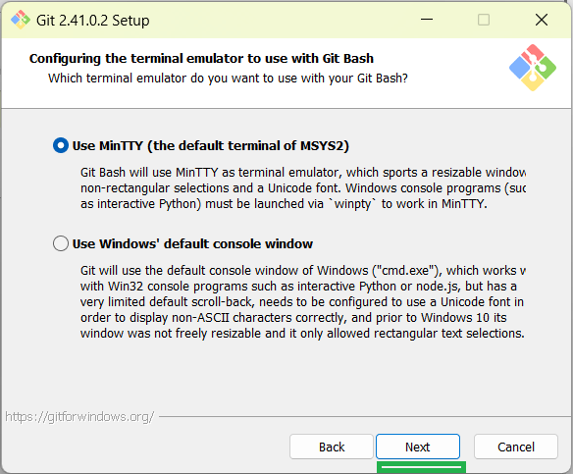

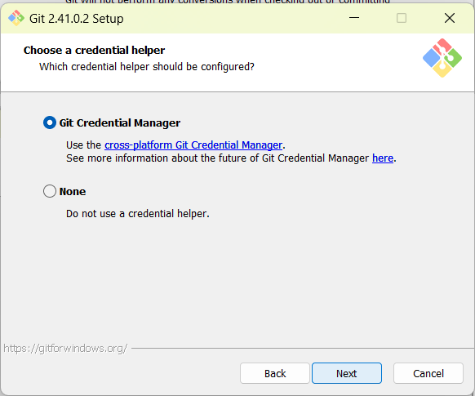

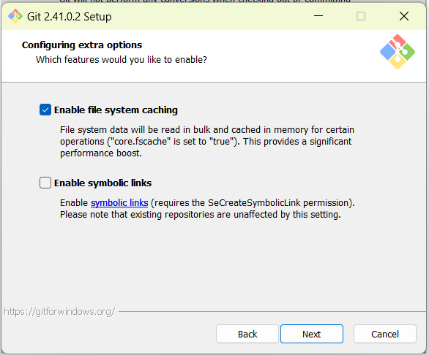

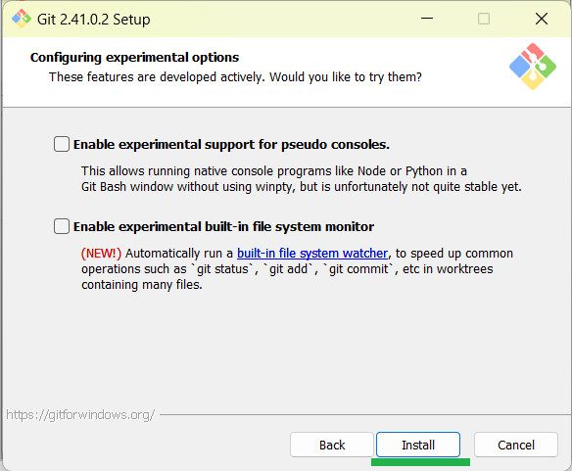

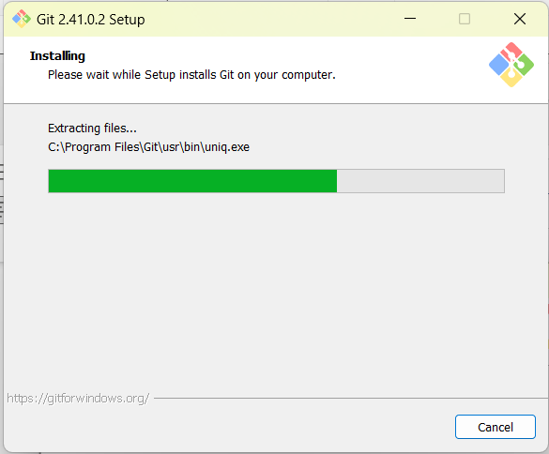

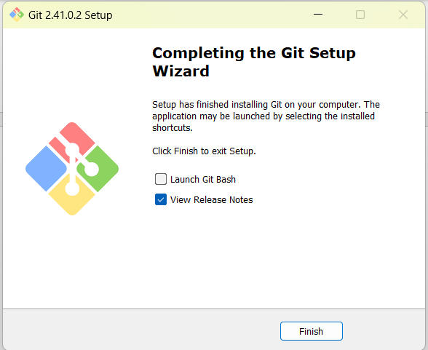

We can create one folder like : my-git-github

C:\RamkumarsJAVA-Kani\16-Git-GitHub\my-git then goto command prompt

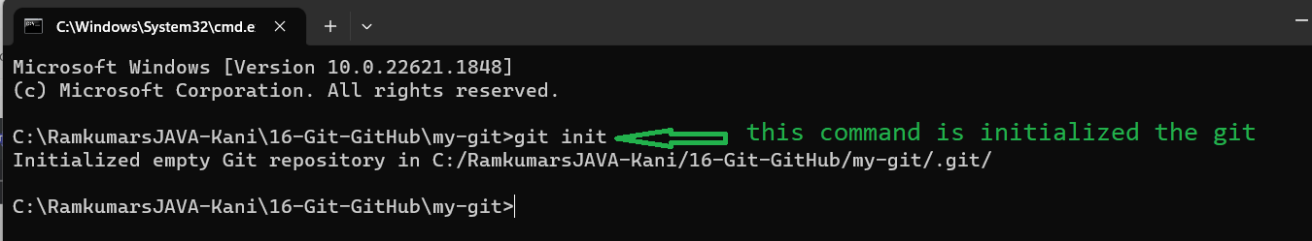

If want to check git is working or not then go for >git status

