**DATE:8/6/24**

**ASSIGNMENT-3**

# 1. Counting Elements

**Given an integer array arr, count how many elements x there are, such that x + 1 is also in arr. If there are duplicates in arr, count them separately.**

**CODE:** def countElements(arr,n): # Initialize count as zero count = 0

# Iterate over each element for i in range(n): # Store element in int x x = arr[i] # Calculate x + 1 xPlusOne = x + 1

# Initialize found as false found = False

# Run loop to search for x + 1 # after the current element for j in range(i + 1,n,1): if (arr[j] == xPlusOne):

found = True break

# Run loop to search for x + 1 # before the current element k = i - 1 while(found == False and k >= 0): if (arr[k] == xPlusOne):

found = True

break k -= 1

# if found is true, increment count if (found == True):

count += 1

return count

# Driver program

if name == ' main ': arr = [1, 2, 3] n = len(arr)

# call countElements function on array print(countElements(arr, n))

OUTPUT:

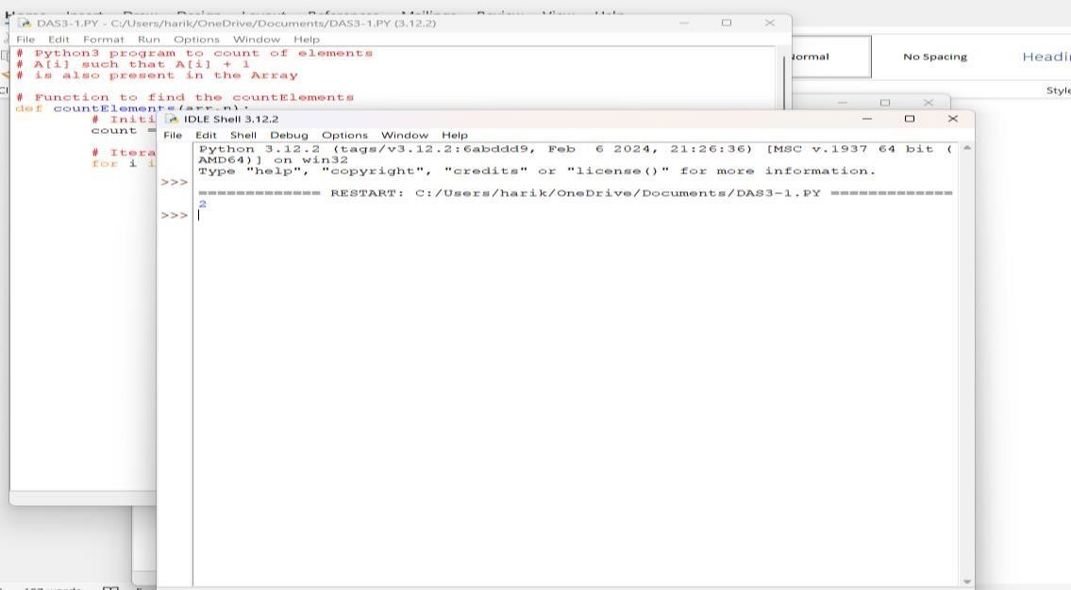

# 2.Perform String Shifts

**You are given a string s containing lowercase English letters, and a matrix shift, where shift[i] = [directioni, amounti]:**

* **directioni can be 0 (for left shift) or 1 (for right shift).**
* **amounti is the amount by which string s is to be shifted.**
* **A left shift by 1 means remove the first character of s and append it to the end.**
* **Similarly, a right shift by 1 means remove the last character of s and add it to the beginning.**

**Return the final string after all operations.**

**CODE:** def stringShift(s, shift):

val = 0 for i in range(len(shift)): # If shift[i][0] = 0, then left shift # Otherwise, right shift

val += -shift[i][1] if shift[i][0] == 0 else shift[i][1]

# Stores length of the string

Len = len(s)

# Effective shift calculation val = val % Len # Stores modified string result = ""

# Right rotation if (val > 0): result = s[Len - val:Len] + s[0: Len - val]

# Left rotation else:

result = s[-val: Len] + s[0: -val] print(result)

# Driver Code s = "abc" shift = [ [ 0, 1 ],

[ 1, 2 ] ] stringShift(s, shift)

**OUTPUT:**

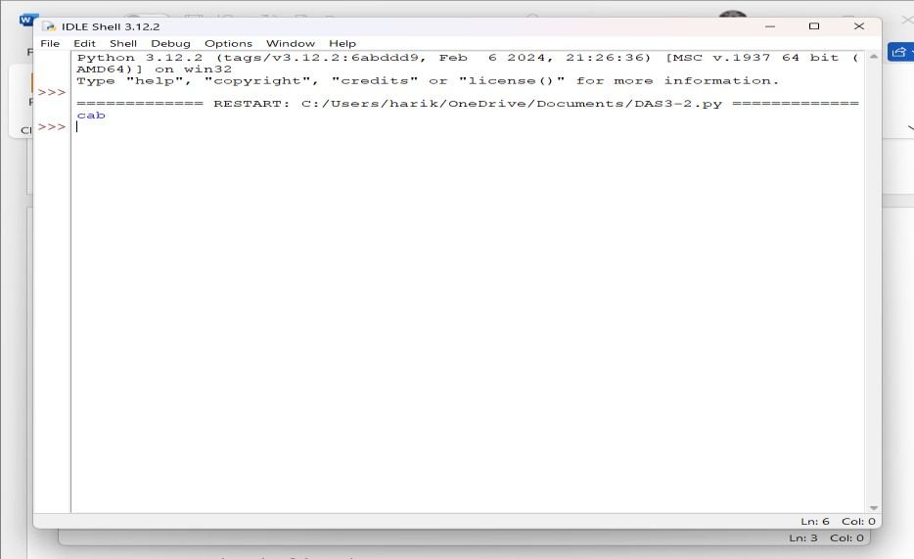

# 3. Leftmost Column with at Least a One

**A row-sorted binary matrix means that all elements are 0 or 1 and each row of the matrix is sorted in non-decreasing order.**

**Given a row-sorted binary matrix binaryMatrix, return *the index (0-indexed) of the leftmost column with a 1 in it*. If such an index does not exist, return -1.**

**You can't access the Binary Matrix directly. You may only access the matrix using a BinaryMatrix interface:**

* **BinaryMatrix.get(row, col) returns the element of the matrix at index (row, col) (0-indexed).**
* **BinaryMatrix.dimensions() returns the dimensions of the matrix as a list of 2 elements [rows, cols], which means the matrix is rows x cols.**

**Submissions making more than 1000 calls to BinaryMatrix.get will be judged *Wrong Answer*. Also, any solutions that attempt to circumvent the judge will result in disqualification.**

**For custom testing purposes, the input will**

**CODE:**

# Python3 implementation to find the

# Leftmost Column with atleast a # 1 in a sorted binary matrix import sys

N = 3

# Function to search for the

# leftmost column of the matrix

# with atleast a 1 in sorted # binary matrix def search(mat, n, m): a = sys.maxsize

# Loop to iterate over all the # rows of the matrix

for i in range (n): low = 0 high = m - 1 ans = sys.maxsize

# Binary Search to find the # leftmost occurrence of the 1 while (low <= high): mid = (low + high) // 2

# Condition if the column

# contains the 1 at this # position of matrix if (mat[i][mid] == 1):

if (mid == 0): ans = 0 break

elif (mat[i][mid - 1] == 0):

ans = mid break

if (mat[i][mid] == 1): high = mid - 1 else: low = mid + 1

# If there is a better solution # then update the answer

if (ans < a): a = ans

# Condition if the solution # doesn't exist in the matrix if (a == sys.maxsize): return -1 return a + 1

# Driver Code

if name == " main ":

mat = [[0, 0, 0], [0, 0, 1], [0, 1, 1]] print(search(mat, 3, 3))

**OUTPUT:**

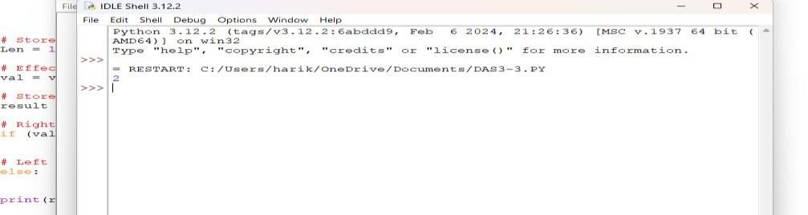

# 4.First Unique Number

**You have a queue of integers, you need to retrieve the first unique integer in the queue. Implement the FirstUnique class:**

* **FirstUnique(int[] nums) Initializes the object with the numbers in the queue.** ● **int showFirstUnique() returns the value of the first unique integer of the queue, and returns -1 if there is no such integer.**
* **void add(int value) insert value to the queue**.

**CODE:** class FirstUnique: def init (self, nums: List[int]):

self.cnt = Counter(nums)

self.unique = OrderedDict({v: 1 for v in nums if self.cnt[v] == 1})

def showFirstUnique(self) -> int:

return -1 if not self.unique else next(v for v in self.unique.keys())

def add(self, value: int) -> None:

self.cnt[value] += 1 if self.cnt[value] == 1: self.unique[value] = 1 elif value in self.unique: self.unique.pop(value)

# Your FirstUnique object will be instantiated and called as such:

# obj = FirstUnique(nums)

# param_1 = obj.showFirstUnique()

# obj.add(value)

OUTPUT:

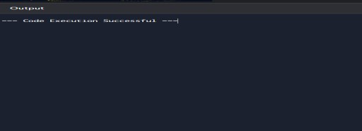

**5. Check If a String Is a Valid Sequence from Root to Leaves Path in a Binary Tree Given a binary tree where each path going from the root to any leaf form a valid sequence, check if a given string is a valid sequence in such binary tree.**

**We get the given string from the concatenation of an array of integers arr and the concatenation of all values of the nodes along a path results in a sequence in the given binary tree.**

**CODE:**

# Python program to see if

# there is a root to leaf path

# with given sequence # Class of Node class Node:

# Constructor to create a # node in Binary Tree def init (self, val):

self.val = val self.left = None self.right = None # Util function def existPathUtil(root, arr, n, index):

# If root is NULL or reached

# end of the array

if not root or index == n: return False

# If current node is leaf if not root.left and not root.right:

if root.val == arr[index] and index == n-1:

return True return False

# If current node is equal to arr[index] this means

# that till this level path has been matched and

# remaining path can be either in left subtree or # right subtree. return ((index < n) and (root.val == arr[index]) and \ (existPathUtil(root.left, arr, n, index+1) or \ existPathUtil(root.right, arr, n, index+1)))

# Function to check given sequence of root to leaf path exist # in tree or not.

# index represents current element in sequence of rooth to

# leaf path def existPath(root, arr, n, index):

if not root: return (n == 0)

return existPathUtil(root, arr, n, 0)

# Driver Code

if name == " main ":

arr = [5, 8, 6, 7]

n = len(arr) root = Node(5) root.left = Node(3) root.right = Node(8) root.left.left = Node(2) root.left.right = Node(4) root.left.left.left = Node(1) root.right.left = Node(6) root.right.left.right = Node(7)

if existPath(root, arr, n, 0):

print("Path Exists") else:

print("Path does not Exist")

OUTPUT:

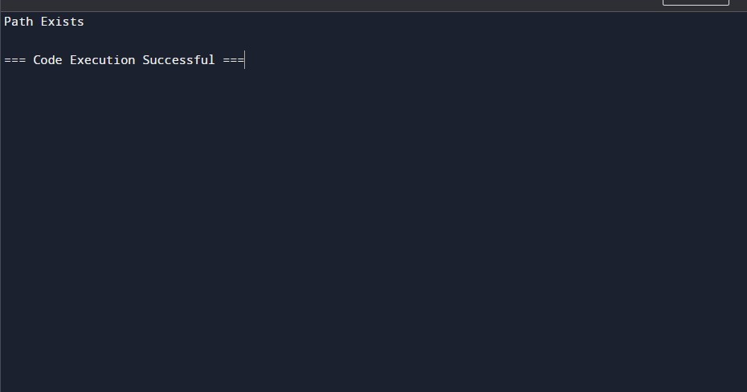

6.Kids With the Greatest Number of Candies

There are n kids with candies. You are given an integer array candies, where each candies[i] represents the number of candies the ith kid has, and an integer extraCandies, denoting the number of extra candies that you have.

Return *a boolean array* result *of length* n*, where* result[i] *is* true *if, after giving the* ith *kid all the* extraCandies*, they will have the greatest number of candies among all the kids, or* false *otherwise*.

Note that multiple kids can have the greatest number of candies.

CODE: class Solution:

def kidsWithCandies(self, candies: List[int], extraCandies: int) -> List[bool]:

n = len(candies) result = [False]*n maxCandies = max(candies) for i in range(n): if candies[i] + extraCandies >= maxCandies:

result[i] = True return result

OUTPUT:

[true,true,true,false,true]

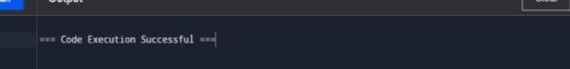

# 7. Max Difference You Can Get From Changing an Integer

**You are given an integer num. You will apply the following steps exactly two times:** ● **Pick a digit x (0 <= x <= 9).**

* **Pick another digit y (0 <= y <= 9). The digit y can be equal to x.**
* **Replace all the occurrences of x in the decimal representation of num by y.** ● **The new integer cannot have any leading zeros, also the new integer cannot be 0.**

**Let a and b be the results of applying the operations to num the first and second times, respectively.**

**Return *the max difference* between a and b.**

**Code: class Solution:**

**def maxDiff(self, num: int) -> int:**

**a, b = str(num), str(num)**

**for c in a:**

**if c != "9": a = a.replace(c, "9") break**

**if b[0] != "1":**

**b = b.replace(b[0], "1") else:**

**for c in b[1:]:**

**if c not in "01":**

**b = b.replace(c, "0") break**

**return int(a) - int(b)**

**OUTPUT:**

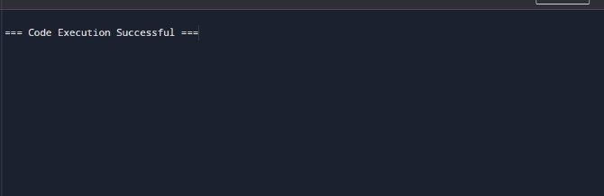

# 8.Check If a String Can Break Another String

**Given two strings: s1 and s2 with the same size, check if some permutation of string s1 can break some permutation of string s2 or vice-versa. In other words s2 can break s1 or vice-versa.**

**A string x can break string y (both of size n) if x[i] >= y[i] (in alphabetical order) for all i between 0 and n-1.**

**CODE: def arePermutation(str1, str2):**

**# Get lengths of both strings n1 = len(str1) n2 = len(str2)**

**# If length of both strings is not same, # then they cannot be Permutation if (n1 != n2): return False**

**# Sort both strings a = sorted(str1) str1 = " ".join(a) b = sorted(str2) str2 = " ".join(b)**

**# Compare sorted strings for i in range(0, n1, 1): if (str1[i] != str2[i]): return False**

**return True**

**# Driver Code**

**if name == ' main ':**

**str1 = "test" str2 = "ttew" if (arePermutation(str1, str2)):**

**print("Yes") else: print("No")**

**OUTPUT:**

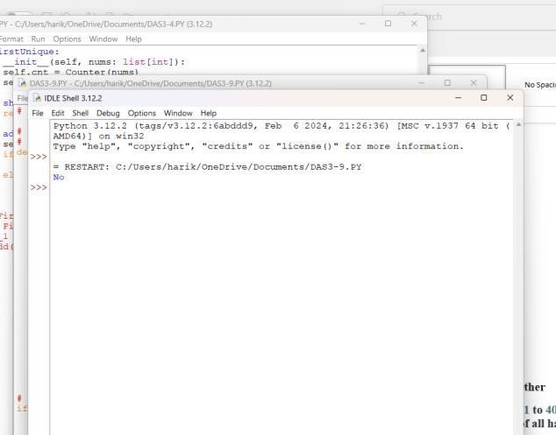

# 9.Number of Ways to Wear Different Hats to Each Other

**There are n people and 40 types of hats labeled from 1 to 40.**

**Given a 2D integer array hats, where hats[i] is a list of all hats preferred by the ith person.**

**Return *the number of ways that the n people wear different hats to each other*. Since the answer may be too large, return it modulo 109 + 7.**

**CODE:** class Solution: def numberWays(self, hats: List[List[int]]) -> int:

g = defaultdict(list) for i, h in enumerate(hats): for v in h:

g[v].append(i) mod = 10**9 + 7 n = len(hats) m = max(max(h) for h in hats) f = [[0] * (1 << n) for _ in range(m + 1)] f[0][0] = 1 for i in range(1, m + 1): for j in range(1 << n):

f[i][j] = f[i - 1][j] for k in g[i]: if j >> k & 1: f[i][j] = (f[i][j] + f[i - 1][j ^ (1 << k)]) % mod return f[m][-1]

OUTPUT:



# 10. Next Permutation

**A permutation of an array of integers is an arrangement of its members into a sequence or linear order.**

● **For example, for arr = [1,2,3], the following are all the permutations of arr: [1,2,3],**

**[1,3,2], [2, 1, 3], [2, 3, 1], [3,1,2], [3,2,1].**

**The next permutation of an array of integers is the next lexicographically greater permutation of its integer. More formally, if all the permutations of the array are sorted in**

**one container according to their lexicographical order, then the next permutation of that**

**array is the permutation that follows it in the sorted container. If such arrangement is not**

**possible, the array must be rearranged as the lowest possible order (i.e., sorted in ascending order).**

* **For example, the next permutation of arr = [1,2,3] is [1,3,2].**
* **Similarly, the next permutation of arr = [2,3,1] is [3,1,2].**
* **While the next permutation of arr = [3,2,1] is [1,2,3] because [3,2,1] does not have a lexicographical larger rearrangement.**

**Given an array of integers nums, *find the next permutation of* nums.**

**The replacement must be in place and use only constant extra memory.**

**CODE:**

def next_permutation(nums):

# Find the first element from the right that is not in decreasing order i = len(nums) - 2 while i >= 0 and nums[i] >= nums[i + 1]: i -= 1

# If such an element is found, find the smallest element from the right that is greater than it if i >= 0:

j = len(nums) - 1 while nums[j] <= nums[i]: j -= 1

# Swap the two elements nums[i], nums[j] = nums[j], nums[i]

# Reverse the elements from i+1 to the end to get the next permutation nums[i + 1:] = reversed(nums[i + 1:])

nums = [3, 2, 1] next_permutation(nums) print(nums)

OUTPUT:

