**QUESTION 1:**

Given an array of integers nums and an integer target, return indices of the two numbers such that they add up to target. You may assume that each input would have exactly one solution, and you may not use the same element twice.

**CODE:**

def two_sum(nums, target):

num_to_index = {} for i, num in enumerate(nums): complement = target - num if complement in num_to_index:

return [num_to_index[complement], i] num_to_index[num]=i

nums = [2, 7, 11, 15] target = 9 print(two_sum(nums, target))

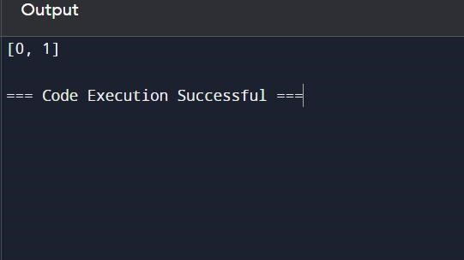

**RESULT:**

the program is executed successfully.

**QUESTION 2:**

You are given two non-empty linked lists representing two non-negative integers. The digits are stored in reverse order, and each of their nodes contains a single digit. Add the two numbers and return the sum as a linked list. You may assume the two numbers do not contain any leading zero, except the number 0 itself.

**CODE:**

class ListNode: def init (self, val=0, next=None):

self.val = val self.next = next

def addTwoNumbers(l1, l2): dummy = ListNode() current, carry = dummy, 0 while l1 or l2 or carry: x = l1.val if l1 else 0 y = l2.val if l2 else 0

carry, out = divmod(x + y + carry, 10) current.next = ListNode(out) current = current.next l1 = l1.next if l1 else None l2 = l2.next if l2 else None return dummy.next def print_linked_list(node): while node:

print(node.val, end=" -> " if node.next else "\n") node = node.next l1 = ListNode(2, ListNode(4, ListNode(3))) l2 = ListNode(5, ListNode(6, ListNode(4))) result = addTwoNumbers(l1, l2)

print_linked_list(result)

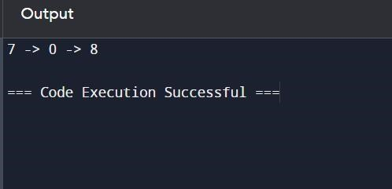

**RESULT:**

the program is executed successfully.

**QUESTION 3:**

Longest Substring without Repeating Characters Given a string s, find the length of the longest substring without repeating characters.

**CODE:**

def lengthOfLongestSubstring(s: str) -> int:

char_set = set() left = 0

max_length = 0

for right in range(len(s)): while s[right] in char_set: char_set.remove(s[left])

left += 1 char_set.add(s[right]) max_length = max(max_length, right - left + 1) return max_length s = "abcabcbb"

print(lengthOfLongestSubstring(s))

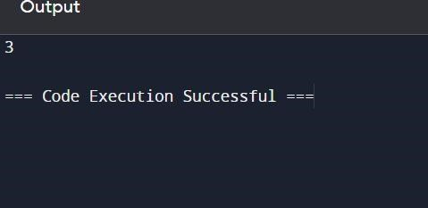

**RESULT:**

the program is executed successfully.

**QUESTION 4:**

Given two sorted arrays nums1 and nums2 of size m and n respectively, return the median of the two sorted arrays. The overall run time complexity should be O(log (m+n)).

**CODE:**

def findMedianSortedArrays(nums1, nums2): if len(nums1) > len(nums2): nums1, nums2 = nums2, nums1 m, n = len(nums1), len(nums2) imin, imax, half_len = 0, m, (m + n + 1) // 2 while imin <= imax: i = (imin + imax) // 2 j = half_len - i

if i < m and nums1[i] < nums2[j - 1]:

imin = i + 1 elif i > 0 and nums1[i - 1] > nums2[j]:

imax = i - 1

else:

max_of_left = max(nums1[i - 1] if i > 0 else float('-inf'), nums2[j - 1] if j > 0 else float('-inf'))

if (m + n) % 2 == 1: return max_of_left min_of_right = min(nums1[i] if i < m else float('inf'), nums2[j] if j < n else float('inf')) return (max_of_left + min_of_right) / 2.0 nums1 = [1, 3] nums2 = [2] print(findMedianSortedArrays(nums1, nums2)) # Output: 2.0 nums1 = [1, 2] nums2 = [3, 4]

print(findMedianSortedArrays(nums1, nums2))

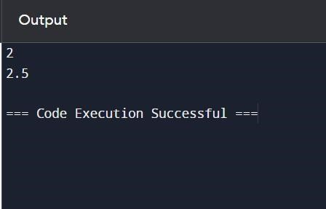

**RESULT:**

the program is executed successfully.

**QUESTION 5:**

Given a string s, return the longest palindromic substring in s.

**CODE:**

def longestPalindrome(s: str) -> str: if not s: return ""

def expandAroundCenter(left: int, right: int) -> str: while left >= 0 and right < len(s) and s[left] == s[right]:

left -= 1 right += 1 return s[left + 1:right] longest = "" for i in range(len(s)): longest = max(longest, expandAroundCenter(i, i), expandAroundCenter(i, i + 1), key=len) return longest s1 = "MALAYALAM"

print(longestPalindrome(s1)) s2 = "12343" print(longestPalindrome(s2))

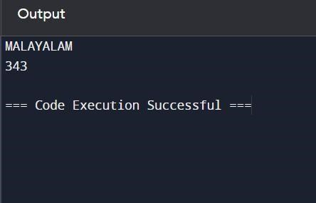

**RESULT:**

the program is executed successfully.

**QUESTION 6:**

The string "PAYPALISHIRING" is written in a zigzag pattern on a given number of rows like this: (you may want to display this pattern in a fixed font for better legibility)

**CODE:**

def convert(s: str, numRows: int) -> str: if numRows == 1 or numRows >= len(s):

return s rows = [''] * numRows current_row, going_down = 0, False

for char in s:

rows[current_row] += char if current_row == 0 or current_row == numRows - 1:

going_down = not going_down current_row += 1 if going_down else -1 return ''.join(rows)

s = "PUNUGUPATIGUNASRI" numRows = 3

print(convert(s, numRows)) numRows = 4

print(convert(s, numRows))

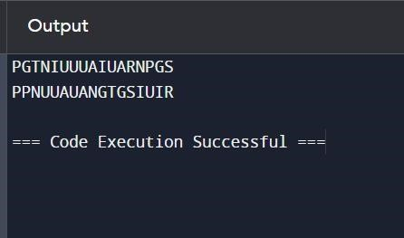

**RESULT:**

the program is executed successfully.

**QUESTION 7:**

Given a signed 32-bit integer x, return x with its digits reversed. If reversing x causes the value to go outside the signed 32-bit integer range [-231, 231 - 1], then return 0. Assume the environment does not allow you to store 64-bit integers (signed or unsigned).

**CODE:**

def reverse(x: int) -> int:

INT_MAX = 2**31 - 1 INT_MIN = -2**31

sign = 1 if x >= 0 else -1 x = abs(x) result = 0 while x: result = result * 10 + x % 10

x //= 10 if result > INT_MAX: return 0 return sign * result x = 123 print(reverse(x)) x = -123 print(reverse(x)) x = 120 print(reverse(x)) x = 1534236469 print(reverse(x))

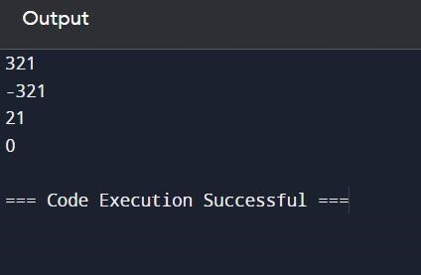

**RESULT:**

the program is executed successfully.

**QUESTION 8:**

Implement the myAtoi(string s) function, which converts a string to a 32-bit signed integer.

**CODE:**

def myAtoi(s: str) -> int:

INT_MAX = 2**31 - 1 INT_MIN = -2**31

s = s.strip() if not s: return 0 sign = 1

if s[0] in ('+', '-'):

sign = -1 if s[0] == '-' else 1 s = s[1:] result = 0 for char in s: if not char.isdigit():

break

result = result * 10 + int(char) if result > INT_MAX: return INT_MAX if sign == 1 else INT_MIN return sign * result s1 = "42" print(myAtoi(s1)) s2 = " -42" print(myAtoi(s2)) s3 = "4193 with words" print(myAtoi(s3)) s4 = "words and 987" print(myAtoi(s4)) s5 = "-91283472332" print(myAtoi(s5))

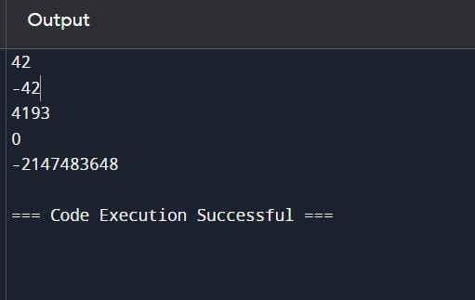

**RESULT:**

the program is executed successfully.

**QUESTION 9:**

Given an integer x, return true if x is a palindrome, and false otherwise.

**CODE:**

def isPalindrome(x: int) -> bool:

str_x = str(x) return str_x == str_x[::-1] x1 = 121 print(isPalindrome(x1)) x2 = -121 print(isPalindrome(x2)) x3 = 10 print(isPalindrome(x3))

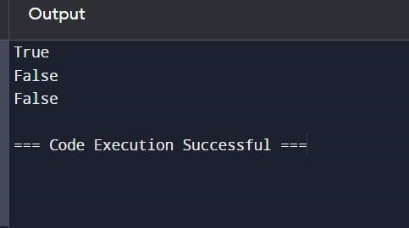

**RESULT:**

the program is executed successfully.

**QUESTION 10:**

Given an input string s and a pattern p, implement regular expression matching with support for '.' and '*' where: ● '.' Matches any single character. ● '*' Matches zero or more of the preceding element. The matching should cover the entire input string (not partial).

**CODE:**

def isMatch(s: str, p: str) -> bool:

m, n = len(s), len(p) dp = [[False] * (n + 1) for _ in range(m + 1)] dp[0][0] = True for j in range(1, n + 1): if p[j - 1] == '*':

dp[0][j] = dp[0][j - 2] for i in range(1, m + 1): for j in range(1, n + 1): if p[j - 1] == '.' or p[j - 1] == s[i - 1]:

dp[i][j] = dp[i - 1][j - 1] elif p[j - 1] == '*': dp[i][j] = dp[i][j - 2] or (dp[i - 1][j] and (p[j - 2] == s[i - 1] or p[j - 2] == '.')) return dp[m][n] s1 = "aa" p1 = "a" print(isMatch(s1, p1)) s2 = "aa" p2 = "a*" print(isMatch(s2, p2)) s3 = "ab" p3 = ".*" print(isMatch(s3, p3)) s4 = "aab" p4 = "c*a*b" print(isMatch(s4, p4))

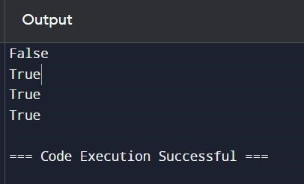

**RESULT:**

the program is executed successfully.

**DATE:4-6-24**

**ASSIGNMENT - 2**

# 11. Container With Most Water

**You are given an integer array height of length n. There are n vertical lines drawn such that the two endpoints of the ith line are (i, 0) and (i, height[i]).**

**Find two lines that together with the x-axis form a container, such that the container contains the most water.**

**Return *the maximum amount of water a container can store*. Notice that you may not slant the container.**

**CODE:**

def maxArea(A, Len) :

area = 0 for i in range(Len) : for j in range(i + 1, Len) : # Calculating the max area area = max(area, min(A[j], A[i]) * (j - i)) return area

# Driver code a

= [ 1, 5, 4, 3 ] b = [ 3, 1, 2, 4, 5 ] len1 = len(a) print(maxArea(a, len1)) len2 = len(b) print(maxArea(b, len2)) OUTPUT:

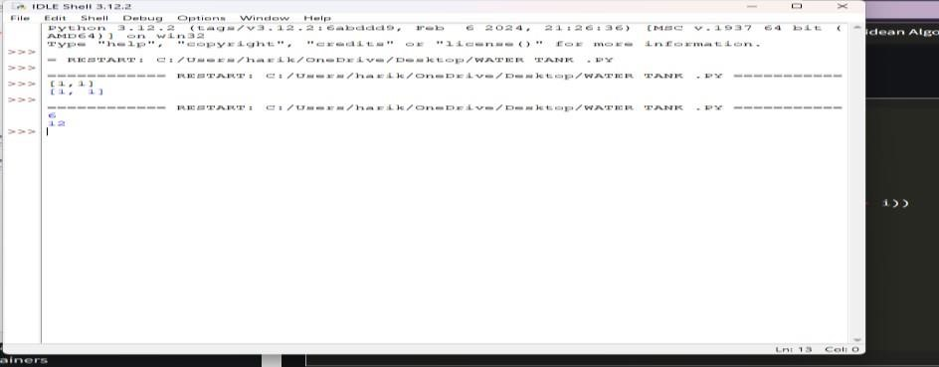

**12. Roman numerals are represented by seven different symbols: I, V, X, L, C, D and M.**

**Symbol Value I**

**1**

**V 5**

**X 10**

**L 50**

1. **100**
2. **500**

**M 1000**

**For example, 2 is written as II in Roman numeral, just two one's added together. 12 is written as**

**XII, which is simply X + II. The number 27 is written as XXVII, which is XX + V + II. Roman numerals are usually written largest to smallest from left to right. However, the numeral for four is not IIII. Instead, the number four is written as IV. Because the one is before the five**

**we subtract it making four. The same principle applies to the number nine, which is written as**

**IX. There are six instances where subtraction is used:**

* **I can be placed before V (5) and X (10) to make 4 and 9.**
* **X can be placed before L (50) and C (100) to make 40 and 90.**
* **C can be placed before D (500) and M (1000) to make 400 and 900. Given an integer, convert it to a roman numeral.**

**CODE:**

def value(r): if (r == 'I'): return 1

if (r == 'V'): return 5

if (r == 'X'):

return 10 if (r == 'L'):

return 50

if (r == 'C'):

return 100 if (r == 'D'): return 500

if (r == 'M'): return 1000 return -1 def romanToDecimal(str):

res = 0 i = 0 while (i < len(str)):

# Getting value of symbol s[i] s1 = value(str[i]) if (i + 1 < len(str)):

# Getting value of symbol s[i + 1] s2 = value(str[i + 1]) # Comparing both values if (s1 >= s2):

# Value of current symbol is greater # or equal to the next symbol res = res + s1 i = i + 1 else:

# Value of current symbol is greater # or equal to the next symbol res = res + s2 - s1 i = i + 2

else:

res = res + s1 i = i + 1 return res # Driver code print("Integer form of Roman Numeral is"), print(romanToDecimal("MCMIV")) OUTPUT:

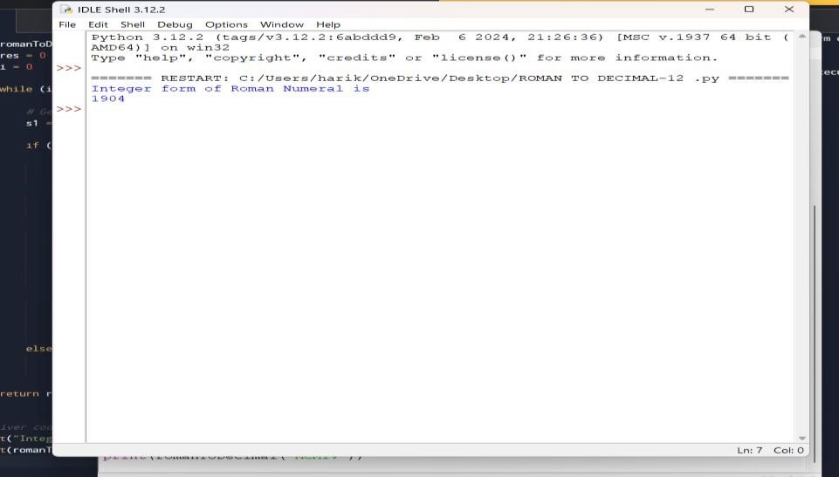

# 13. Roman to Integer

**Roman numerals are represented by seven different symbols: I, V, X, L, C, D and M. Symbol Value**

**I 1**

**V 5**

**X 10**

**L 50**

1. **100**
2. **500**

**M 1000**

**For example, 2 is written as II in Roman numeral, just two ones added together. 12 is written as**

**XII, which is simply X + II. The number 27 is written as XXVII, which is XX + V + II. Roman numerals are usually written largest to smallest from left to right. However, the numeral for four is not IIII. Instead, the number four is written as IV. Because the one is before the five**

**we subtract it making four. The same principle applies to the number nine, which is written as**

**IX. There are six instances where subtraction is used:**

* **I can be placed before V (5) and X (10) to make 4 and 9.**
* **X can be placed before L (50) and C (100) to make 40 and 90.**
* **C can be placed before D (500) and M (1000) to make 400 and 900.**

**Code:**

roman = {'I':1,'V':5,'X':10,'L':50,'C':100,'D':500,'M':1000} class Solution: def romanToInt(self, S: str) -> int: summ= 0

for i in range(len(S)-1,-1,-1): num = roman[S[i]] if 3*num < summ: summ = summ-num else:

summ = summ+num return sum OUTPUT:

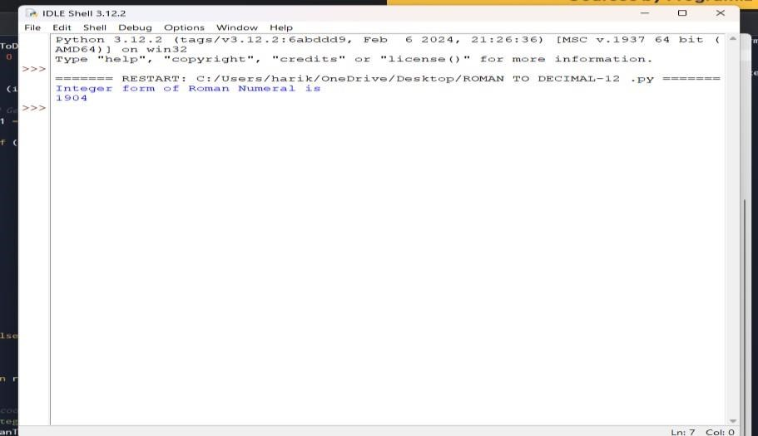

**14. Longest Common Prefix**

**Write a function to find the longest common prefix string amongst an array of strings. If there is no common prefix, return an empty string ""**

**CODE:**

def longestCommonPrefix( a): size = len(a)

# if size is 0, return empty string if (size == 0):

return ""

if (size == 1): return a[0]

# sort the array of strings a.sort()

# find the minimum length from # first and last string

end = min(len(a[0]), len(a[size - 1])) # find the common prefix between

# the first and last string i

= 0 while (i < end and a[0][i] == a[size - 1][i]): i += 1

pre = a[0][0: i]

return pre

# Driver Code if name == " main ":

input = ["geeksforgeeks", "geeks",

"geek", "geezer"]

print("The longest Common Prefix is :" ,

longestCommonPrefix(inp)

OUTPUT:

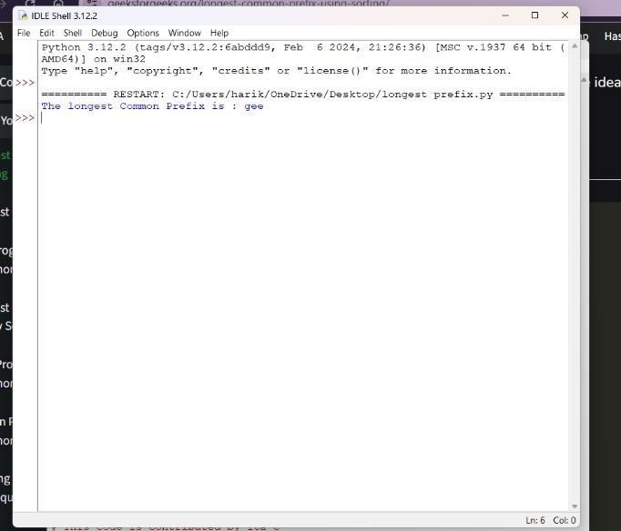

**15. 3Sum**

**Given an integer array nums, return all the triplets [nums[i], nums[j], nums[k]] such that i != j, i**

**!= k, and j != k, and nums[i] + nums[j] + nums[k] == 0.**

**Notice that the solution set must not contain duplicate triplets.**

**Example 1:**

**Input: nums = [-1,0,1,2,-1,-4] Output: [[-1,-1,2],[-1,0,1]] Explanation:**

**nums[0] + nums[1] + nums[2] = (-1) + 0 + 1 = 0. nums[1] + nums[2] + nums[4] = 0 + 1 + (-1) = 0. nums[0] + nums[3] + nums[4] = (-1) + 2 + (-1) = 0.**

**The distinct triplets are [-1,0,1] and [-1,-1,2].**

**Notice that the order of the output and the order of the triplets does not matter.**

**CODE:**

def findTriplets(nums, n, Sum): i =

0 j = 0 k = 0

# list to store all unique triplets. triplet = []

# list to store already found triplets # to avoid duplication. uniqTriplets = [] # Variable used to hold triplet # converted to string form. temp

= ""

# Variable used to store current # triplet which is stored in vector # if it is unique.

newTriplet = [0, 0, 0] # Sort the input array.

nums.sort() # Iterate over the array from the # start and consider it as the # first element. for i in range(n - 2): # index of the first element in # the remaining elements.

j = i + 1

# index of the last element. k

= n - 1

while(j < k):

# If sum of triplet is equal to

# given value, then check if # this triplet is unique or not. # To check uniqueness, convert # triplet to string form and # then check if this string is # present in set or not. If # triplet is unique, then store # it in list.

if(nums[i] + nums[j] + nums[k] == Sum):

temp = str(nums[i]) + ":" + str(nums[j]) + ":" + str(nums[k]) if temp not in uniqTriplets: uniqTriplets.append(temp) newTriplet[0] = nums[i] newTriplet[1] = nums[j] newTriplet[2] = nums[k] triplet.append(newTriplet) newTriplet = [0, 0, 0]

# Increment the first index # and decrement the last

# index of remaining elements. j

+= 1

k -= 1

# If sum is greater than given # value then to reduce sum # decrement the last index.

elif(nums[i] + nums[j] + nums[k] > Sum): k -= 1

# If sum is less than given value # then to increase sum increment

# the first index of remaining # elements. else: j += 1

# If no unique triplet is found, then # return 0. if(len(triplet) == 0): return 0

# Print all unique triplets stored in # list. for i in range(len(triplet)): print(triplet[i], end = ", ") return 1

# Driver Code nums = [12, 3, 6, 1, 6, 9] n = len(nums) Sum = 24

# Function call if(not findTriplets(nums, n, Sum)): print("No triplets can be formed.") output:

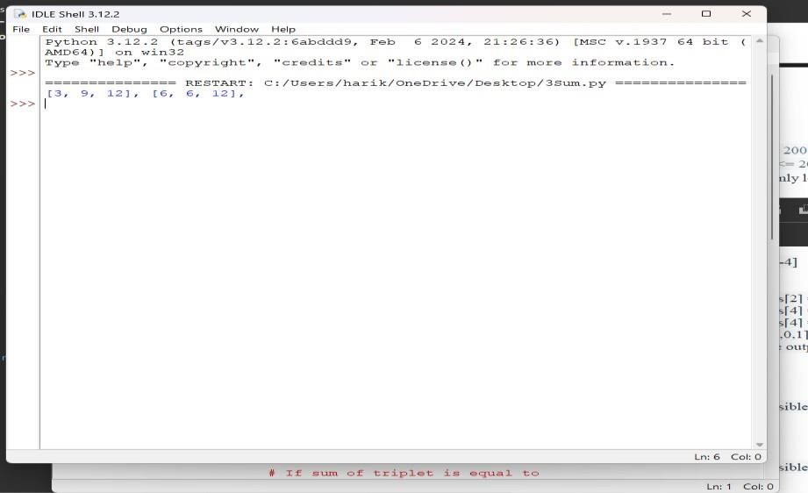

# 16. 3Sum Closest

**Given an integer array nums of length n and an integer target, find three integers in nums such that the sum is closest to target.**

**Return *the sum of the three integers*.**

**You may assume that each input would have exactly one solution.**

**CODE:**

import sys

# Function to return the sum of a # triplet which is closest to x def solution(arr, x):

# To store the closest sum closestSum = sys.maxsize

# Run three nested loops each loop # for each element of triplet for i in range (len(arr)) :

for j in range(i + 1, len(arr)): for k in range(j + 1, len( arr)):

# Update the closestSum

if(abs(x - closestSum) > abs(x - (arr[i] + arr[j] + arr[k]))):

closestSum = (arr[i] + arr[j] + arr[k])

# Return the closest sum found return closestSum

# Driver code if name == " main ":

arr = [ -1, 2, 1, -4 ] x = 1

print(solution(arr, x))

**output:**

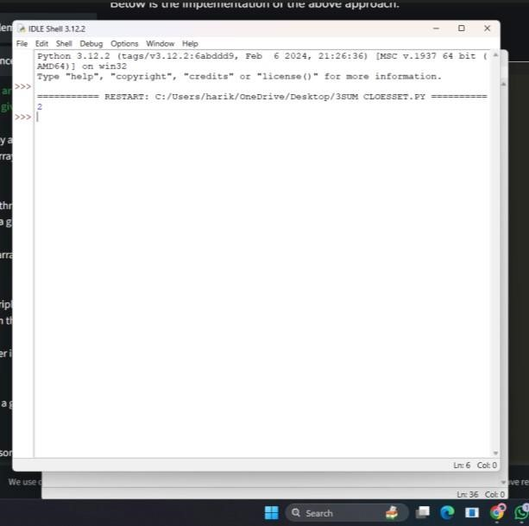

**.**

# 17. Letter Combinations of a Phone Number

**Given a string containing digits from 2-9 inclusive, return all possible letter combinations that the number could represent. Return the answer in any order.**

**A mapping of digits to letters (just like on the telephone buttons) is given below. Note that 1 does not map to any letters.**

CODE:

# Python3 implementation of the approach from collections import deque

# Function to return a list that contains # all the generated letter combinations

def letterCombinationsUtil(number, n, table):

list = []

q = deque()

q.append("")

while len(q) != 0:

s = q.pop()

# If complete word is generated # push it in the list if len(s) == n:

list.append(s)

else:

# Try all possible letters for current digit # in number[] for letter in table[number[len(s)]]:

q.append(s + letter)

# Return the generated list return list

# Function that creates the mapping and # calls letterCombinationsUtil def letterCombinations(number, n):

# table[i] stores all characters that # corresponds to ith digit in phone

table = ["0", "1", "abc", "def", "ghi", "jkl",

"mno", "pqrs", "tuv", "wxyz"]

list = letterCombinationsUtil(number, n, table)

s = "" for word in list:

s += word + " "

print(s) return

# Driver code number = [2, 3] n

= len(number)

# Function call letterCombinations(number, n)

OUTPUT:

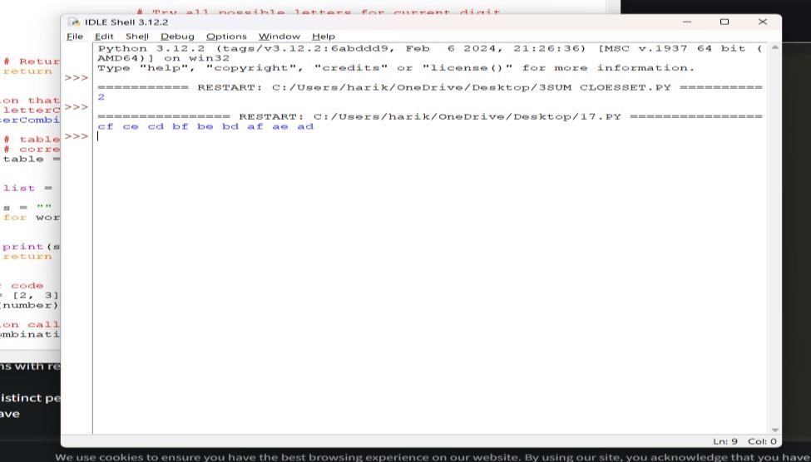

# 18. 4Sum

**Given an array nums of n integers, return *an array of all the unique quadruplets***

**[nums[a], nums[b], nums[c], nums[d]] such that:**

* **0 <= a, b, c, d < n**
* **a, b, c, and d are distinct.**
* **nums[a] + nums[b] + nums[c] + nums[d] == target**

**CODE:**

**# Store the pair of indices class Pair: def init (self, x, y):**

**self.index1 = x self.index2 = y**

**# Function to find the all the unique quadruplets # with the elements at different indices def GetQuadruplets(nums, target):**

**# Store the sum mapped to a list of pair indices map = {}**

**# Generate all possible pairs for the map for i in range(len(nums) - 1):**

**for j in range(i + 1, len(nums)): # Find the sum of pairs of elements sum = nums[i] + nums[j]**

**# If the sum doesn't exist then update with the new pairs if sum not in map: map[sum] = [Pair(i, j)]**

**# Otherwise, add the new pair of indices to the current sum else:**

**map[sum].append(Pair(i, j))**

**# Store all the Quadruplets ans = set()**

**for i in range(len(nums) - 1): for j in range(i + 1, len(nums)):**

**lookUp = target - (nums[i] + nums[j])**

**# If the sum with value (K - sum) exists if lookUp in map:**

**# Get the pair of indices of sum temp = map[lookUp]**

**for pair in temp:**

**# Check if i, j, k and l are distinct or not**

**if pair.index1 != i and pair.index1 != j and pair.index2 != i and pair.index2 != j: l1 = [nums[pair.index1], nums[pair.index2], nums[i], nums[j]]**

**# Sort the list to avoid duplicacy l1.sort()**

**# Update the set**

**ans.add(tuple(l1))**

**# Print all the Quadruplets print(*reversed(list(ans)), sep = '\n')**

**# Driver Code**

**arr = [1, 0, -1, 0, -2, 2]**

**K = 0**

**GetQuadruplets(arr, K)**

**OUTPUT:**

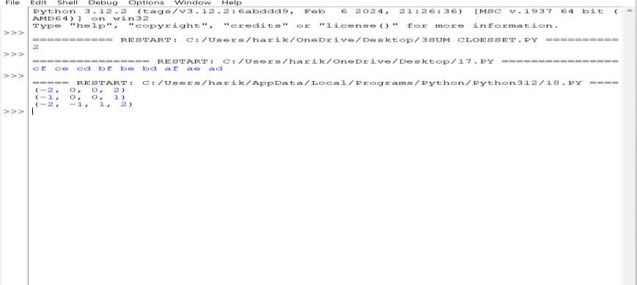

**19. Remove Nth Node From End of List**

**Given the head of a linked list, remove the nth node from the end of the list and return its head.**

**CODE:**

# Python code for the deleting a node from end # in two traversal

class Node:

def init (self, value):

self.data = value self.next

= None

def length(head): temp = head count = 0 while(temp != None): count += 1 temp = temp.next return count

def printList(head): ptr = head while(ptr != None): print (ptr.data, end =" ") ptr = ptr.next

print()

def deleteNthNodeFromEnd(head, n): Length = length(head) nodeFromBeginning = Length - n + 1 prev

= None temp = head for i in range(1, nodeFromBeginning):

prev = temp temp = temp.next if(prev == None): head = head.next return head else:

prev.next = prev.next.next return head

if name == ' main ': head = Node(1) head.next

= Node(2) head.next.next = Node(3)

head.next.next.next = Node(4) head.next.next.next.next = Node(5) print("Linked List before Deletion:") printList(head)

head = deleteNthNodeFromEnd(head, 4)

print("Linked List after Deletion:") printList(head)

OUTPUT:

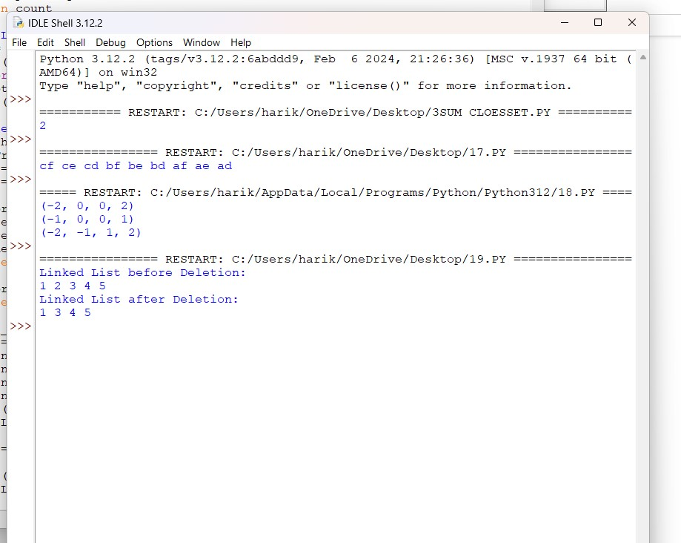

# 20. Valid Parentheses

**Given a string s containing just the characters '(', ')', '{', '}', '[' and ']', determine if the input string is valid.**

**An input string is valid if:**

1. **Open brackets must be closed by the same type of brackets.**
2. **Open brackets must be closed in the correct order.**
3. **Every close bracket has a corresponding open bracket of the same type.**

CODE: def areBracketsBalanced(expr): stack = []

# Traversing the Expression for char in expr: if char in ["(", "{", "["]:

# Push the element in the stack stack.append(char) else:

# IF current character is not opening # bracket, then it must be closing. # So stack cannot be empty at this point. if not stack: return False current_char = stack.pop() if current_char == '(': if char != ")": return False if current_char == '{': if char != "}": return False if current_char == '[': if char != "]": return False # Check Empty Stack if stack:

return False return True

# Driver Code

if name == " main ": expr = "{()}[]"

# Function call if areBracketsBalanced(expr): print("Balanced") else: print("Not Balanced")

OUTPUT:

