**Lab-4**

**-Jagadeesh Utukuru**

**1) website for Snapmenu**

[**https://snapmenu-umxf.b12sites.com/index**](https://snapmenu-umxf.b12sites.com/index)

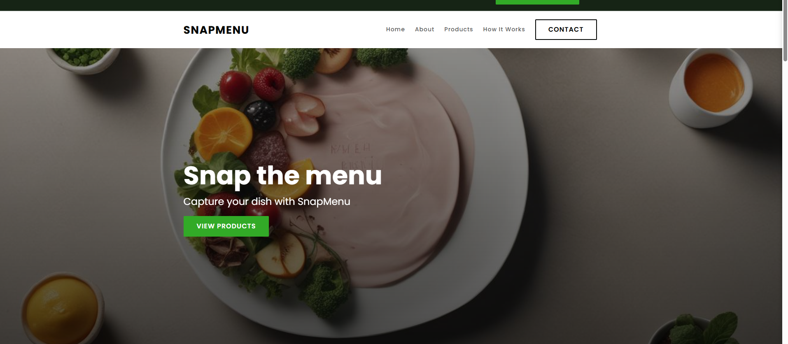

**2) Youtube channel data analysis**

**3) Stability AI**

**Chatgpt**

