**OPIM 5894 Assignment 3**

Name: Jagadeesh Utukuru

**1. Tic Tac Toe Game**

Rules of Tic Tac Toe (<https://en.wikipedia.org/wiki/Tic-tac-toe>):

1. The game is played on a 3x3 grid.
2. One player uses "X" and the other uses "O".
3. Players take turns placing their mark in an empty cell.
4. The first player to get three of their marks in a row (horizontally, vertically, or diagonally) wins.
5. If all 9 cells are filled and no player has three in a row, the game ends in a draw.

Implementing a chatbot with Dify to play Tic Tac Toe follows the same design process as the Twenty Questions game. The crucial aspect is providing clear instructions to the chatbot. Sample screenshots showcasing the chatbot in action can be found in "TicTacToe screenshots.docx."

**Deliverables**:

1. The instructions you used for the chatbot under **Orchestrate**.

1. The public URL of your chatbot.

https://udify.app/chat/3j2i92IYGMcLphFI

1. Export the DSL of your app (see <https://docs.dify.ai/guides/management/app-management>) and attach it along with this document.
2. Screenshots of playing with the chatbot, including one at the beginning and one at the end. A screenshot of a computer

   AI-generated content may be incorrect.

1. Is this chatbot good at this game? What might be the reasons?

Yeah, this chatbot is good at this game and it is because of the model that we are using. I am using Chat gpts 40 mini for this chatbot which is pretty good. And the clear instructions that I gave probably added up for the better performance of this chatbot.

f. (optional) Check if the chatbot plays better when using a reasoning model (e.g., o3-mini or DeepSeek R1).

I checked this with other chatgpt model and the performance wise, I did not see much difference I would say. I should have tried some low performance models from google and meta to see significant difference.

**2. RAG for Nvidia**

Build a chatbot that can answer questions related to Nvidia. The chatbot has three routes:

1) For inquiries about the annual financial report, retrieve answers from **Nvidia2025.pdf**.

2) For general questions related to Nvidia, using the **Google Search** tool (see <https://docs.dify.ai/guides/tools/tool-configuration/google>) to find answers.

3) If the question is unrelated to Nvidia, prompt users to stay on topic and ask about Nvidia.

**Deliverables**:

a. A screenshot of the overall workflow

b. Screenshot(s) of responses to the following questions:

* What is the net cash flow of Nvidia?
* A screenshot of a computer

  AI-generated content may be incorrect.
* When was Nvidia founded?
* A screenshot of a chat

  AI-generated content may be incorrect.
* What is the market cap of Google?

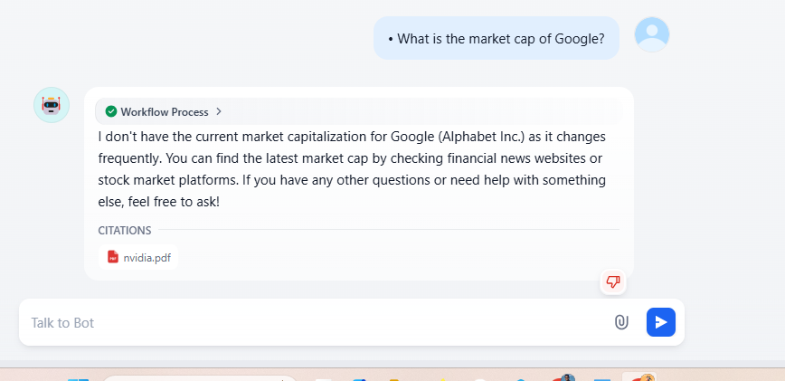

1. The public URL of your chatbot.

<https://udify.app/chat/0A5gu579wJcHNNI1>

d. Export the DSL of your app (see <https://docs.dify.ai/guides/management/app-management>) and attach it along with this document.