Name: V.Jagadeesh Register Number: 192312454
EXP 9
Aim: To simulate and compare Round Robin, Maximum-CQI, and Traffic-Aware resource-block allocation strategies in an OFDMA system using throughput, Jain’s fairness, and resource-block utilization.
CODE
clc;
clear;
close all;
%% Input parameters
rng(7); % Repeatable random results
K = 4; % Number of users
NRB = 24; % Number of resource blocks
BRB = 180e3; % Bandwidth per RB in Hz
Tslot = 1e-3; % Scheduling interval in seconds
etaMax = 6; % Maximum spectral efficiency, bit/s/Hz
avgSNRdB = [5 10 15 8]; % Average user SNR in dB
trafficMbps = [8 12 5 10]; % Offered traffic in Mbit/s
% Bits requested during one scheduling interval
demandBits = trafficMbps * 1e6 * Tslot;
%% Generate channel quality for each user and RB
% Independent SNR variation around each user's average SNR
snrVariation = 4 * randn(K, NRB);
snrDB = avgSNRdB(:) + snrVariation;
snrLinear = 10.^(snrDB / 10);
% Shannon-based spectral efficiency with an upper limit
spectralEfficiency = min(log2(1 + snrLinear), etaMax);

% Achievable bits on each RB during one scheduling interval
rateBps = BRB * spectralEfficiency;
bitsPerRB = rateBps * Tslot;
strategyNames = {'Round Robin', 'Maximum CQI', 'Traffic Aware'};
allocations = zeros(K, NRB, 3);
%% Strategy 1: Round-robin allocation
for n = 1:NRB
user = mod(n - 1, K) + 1;
allocations(user, n, 1) = 1;
end
%% Strategy 2: Maximum-CQI allocation
for n = 1:NRB
[~, user] = max(snrDB(:, n));
allocations(user, n, 2) = 1;
end
%% Strategy 3: Traffic-aware channel-quality allocation
servedBits = zeros(K, 1);
for n = 1:NRB
remainingBits = max(demandBits(:) - servedBits, 0);
if all(remainingBits <= 0)
break;
end
normalizedDemand = remainingBits ./ max(demandBits(:), eps);
metric = bitsPerRB(:, n) .* normalizedDemand;
% Prevent allocation to a user whose demand has been satisfied
metric(remainingBits <= 0) = -inf;
[~, user] = max(metric);
allocations(user, n, 3) = 1;
deliveredBits = min(bitsPerRB(user, n), remainingBits(user));
servedBits(user) = servedBits(user) + deliveredBits;
end
%% Performance calculations
userThroughputMbps = zeros(K, 3);

totalThroughputMbps = zeros(1, 3);
jainFairness = zeros(1, 3);
utilization = zeros(1, 3);
unservedTrafficMbps = zeros(K, 3);
rbPerUser = zeros(K, 3);
for s = 1:3
allocation = allocations(:, :, s);
deliveredBits = sum(allocation .* bitsPerRB, 2);
% Throughput is restricted to requested traffic
usefulBits = min(deliveredBits, demandBits(:));
userThroughputMbps(:, s) = usefulBits / Tslot / 1e6;
totalThroughputMbps(s) = sum(userThroughputMbps(:, s));
throughput = userThroughputMbps(:, s);
jainFairness(s) = sum(throughput)^2 / (K * sum(throughput.^2) + eps);
allocatedRBs = sum(allocation(:));
utilization(s) = allocatedRBs / NRB * 100;
unservedTrafficMbps(:, s) = max(trafficMbps(:) - throughput, 0);
rbPerUser(:, s) = sum(allocation, 2);
end
%% Display results
fprintf('\nOFDMA RESOURCE-BLOCK ALLOCATION RESULTS\n');
fprintf('=======================================\n');
for s = 1:3
fprintf('\n%s\n', strategyNames{s});
fprintf('User\tRBs\tThroughput (Mbit/s)\tUnserved (Mbit/s)\n');
for k = 1:K
fprintf('%d\t%d\t%8.3f\t\t%8.3f\n', ...
k, rbPerUser(k, s), userThroughputMbps(k, s), unservedTrafficMbps(k, s));
end
fprintf('Total throughput: %.3f Mbit/s\n', totalThroughputMbps(s));
fprintf('Jain fairness : %.4f\n', jainFairness(s));
fprintf('RB utilization : %.2f %%%\n', utilization(s));
end
%% Allocation maps plotting

figure('Name', 'OFDMA Resource-Block Allocation');
for s = 1:3
subplot(3, 1, s);
[userIndex, rbIndex] = find(allocations(:, :, s));
stem(rbIndex, userIndex, 'filled', 'LineWidth', 1.1);
grid on;
xlim([1 NRB]); ylim([0.5 K + 0.5]); yticks(1:K);
xlabel('Resource-block index'); ylabel('Allocated user');
title(strategyNames{s});
end
%% Throughput comparison plotting
figure('Name', 'User Throughput Comparison');
bar(userThroughputMbps);
xlabel('User'); ylabel('Throughput (Mbit/s)');
title('User Throughput Under Different Allocation Strategies');
legend(strategyNames, 'Location', 'best');
OUTPUT:
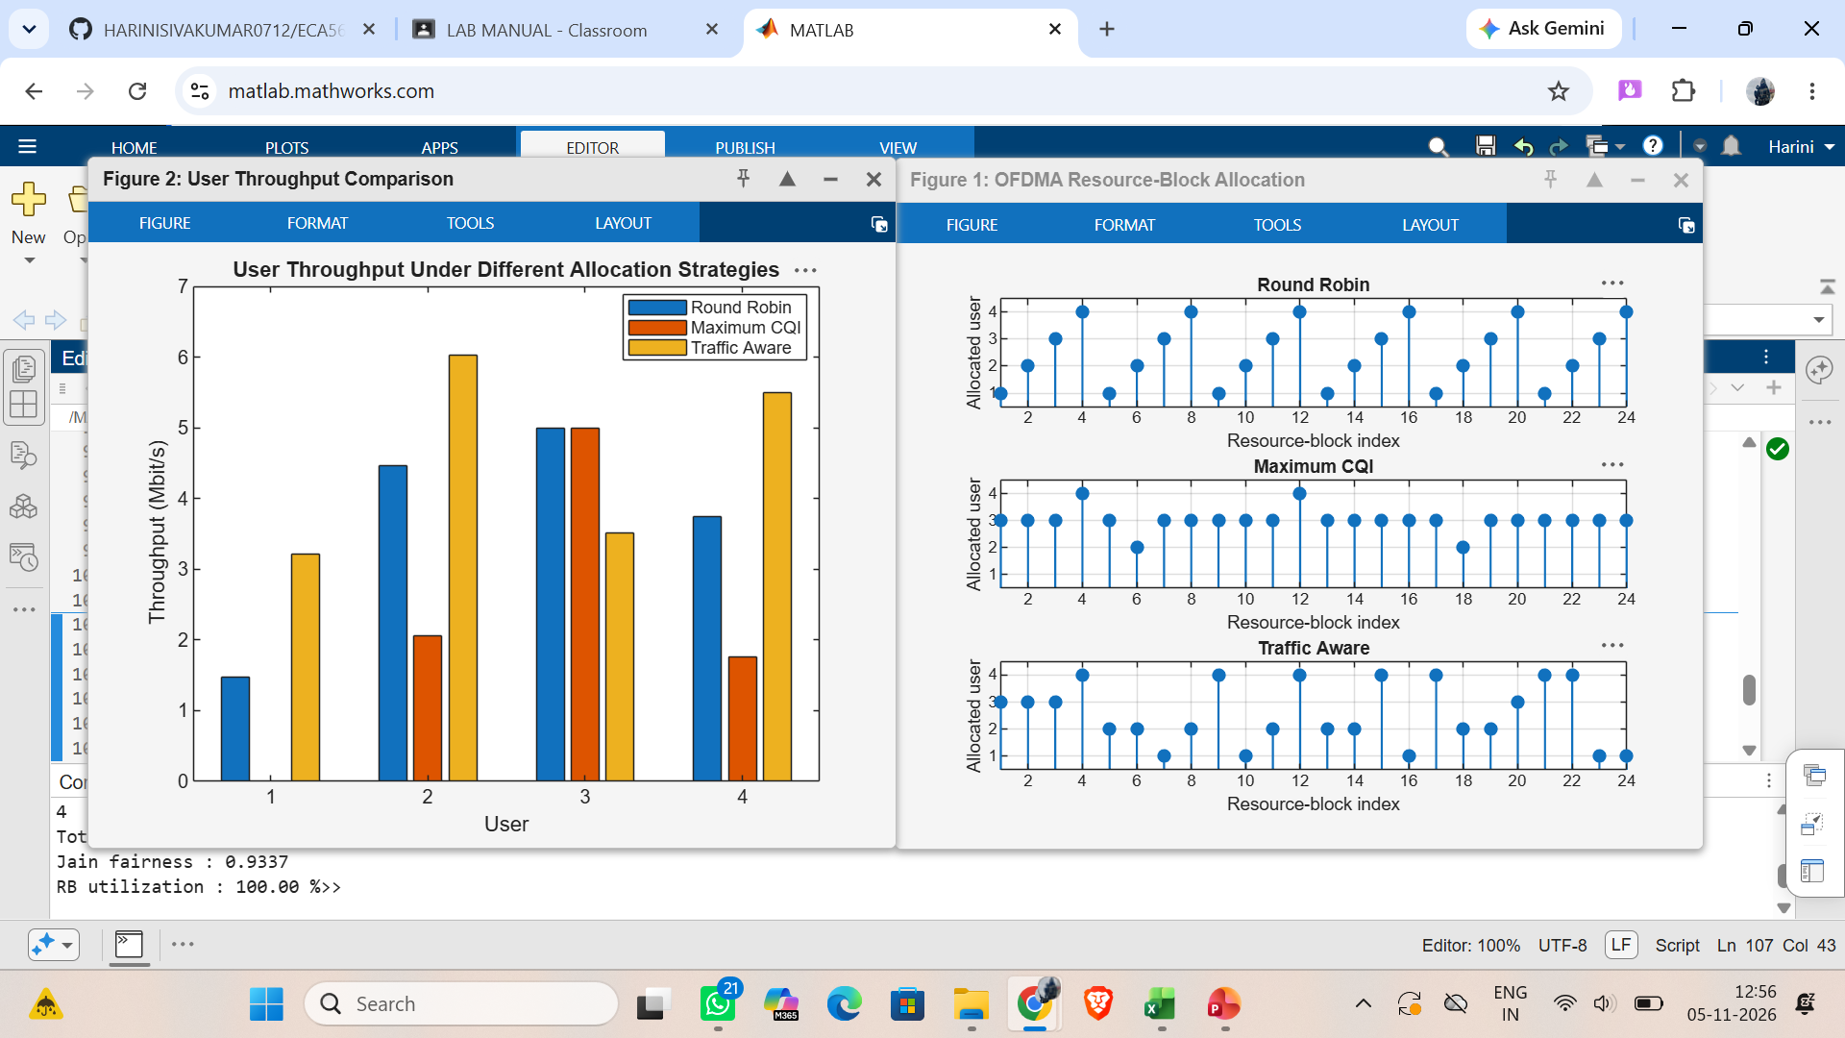
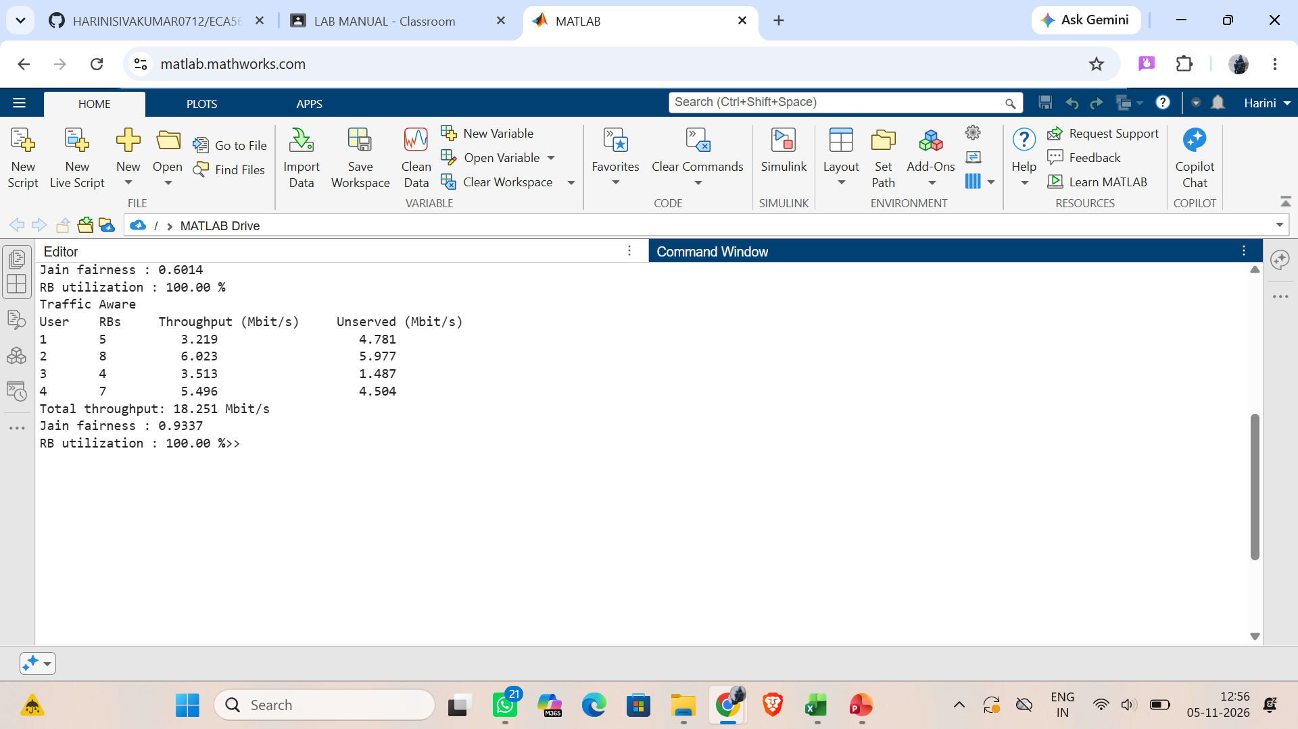
Name: V.Jagadeesh Register Number: 192312454
EXP 10
Aim: To evaluate the bit error rate (BER) performance of a two-user power-domain NOMA system with successive interference cancellation (SIC) and compare it with an OFDMA benchmark over different SNR values.
CODE:
clc; clear; close all;
%% 1. Input Parameters Setup
N_bits = 50000; % Data length per SNR point
SNR_dB = 0:2:20; % SNR operating range
alpha1 = 0.75; % Far user (User 1) power allocation
coefficient
alpha2 = 1 - alpha1; % Near user (User 2) power allocation
coefficient
ber_User1 = zeros(length(SNR_dB), 1); ber_User2 =
zeros(length(SNR_dB), 1);
ber_OFDMA = zeros(length(SNR_dB), 1);
%% 2. Data Processing Execution Loops
for s = 1:length(SNR_dB)
snr_linear = 10^(SNR_dB(s)/10);
noise_variance = 1 / snr_linear;
% Source Bits Generation
bits_u1 = randi([0 1], N_bits, 1); bits_u2 = randi([0 1],

N_bits, 1);
% BPSK Constellation Mapping
x1 = 2*bits_u1 - 1; x2 = 2*bits_u2 - 1;
% Power-Domain NOMA Superposition Generation
x_noma = sqrt(alpha1)*x1 + sqrt(alpha2)*x2;
% Waveform Processing Over Multi-User AWGN Channel
noise = sqrt(noise_variance/2) * (randn(N_bits, 1) +
1i*randn(N_bits, 1));
y_noma = real(x_noma + noise); % BPSK real-domain extraction
%% 3. Cognitive Receiver Hierarchy: Processing User 1 (Direct
Detection)
dec_u1 = y_noma > 0;
est_x1 = 2*dec_u1 - 1;
ber_User1(s) = sum(bits_u1 ~= dec_u1) / N_bits;
%% 4. Successive Interference Cancellation (SIC) Processing
Loop
% Subtract reconstructed User 1 signal components from the raw
matrix
y_sic = y_noma - sqrt(alpha1)*est_x1;
dec_u2 = y_sic > 0;
ber_User2(s) = sum(bits_u2 ~= dec_u2) / N_bits;
%% 5. Baseline Evaluation Benchmark Processing: Orthogonal
System (OFDMA)
y_ofdma = x1 + sqrt(noise_variance*2)/sqrt(2)*randn(N_bits,
1);
dec_ofdma = y_ofdma > 0;
ber_OFDMA(s) = sum(bits_u1 ~= dec_ofdma) / N_bits;
end
%% 6. Serial Performance Graph Rendering
figure('Name', 'NOMA SIC Evaluation Matrix');
semilogy(SNR_dB, ber_User1, 'ro-', 'LineWidth', 1.2); hold on;
semilogy(SNR_dB, ber_User2, 'bs-', 'LineWidth', 1.2);
semilogy(SNR_dB, ber_OFDMA, 'k--', 'LineWidth', 1.2);

grid on; xlabel('Channel SNR Scaling Index (dB)'); ylabel('Bit
Error Rate (BER)');
title('NOMA Power-Domain Transceiver Performance Chart');
legend('User 1 (Far Node Direct Dec)', 'User 2 (Near Node Post-SIC
Dec)', 'Baseline OFDMA Orthogonal Benchmark', 'Location', 'best');
OUTPUT:
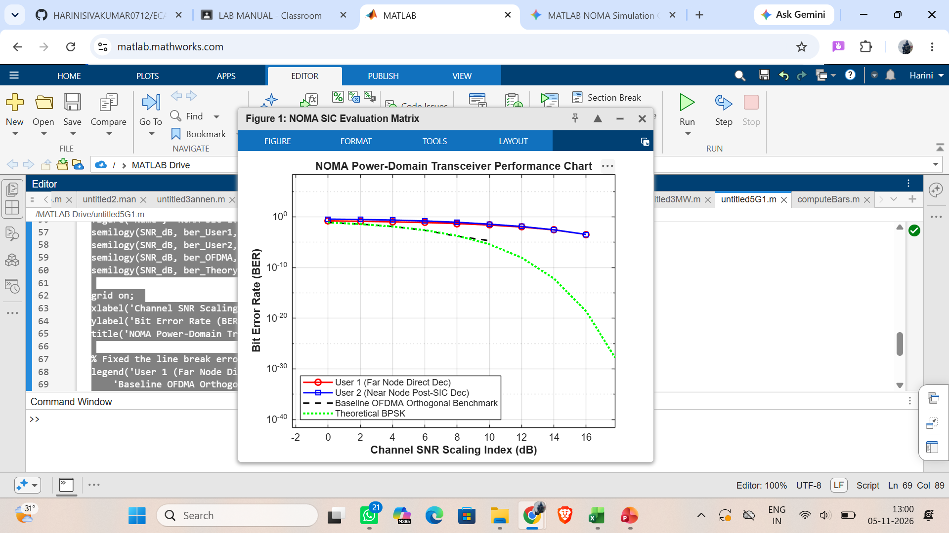
Name: V.Jagadeesh Register Number: 192312454
EXP 11
Aim: To compare OFDM and FBMC waveforms in terms of peak-to-average power ratio (PAPR) and power spectral density (PSD) using MATLAB simulation.
CODE
clc; clear; close all;
%% 1. Input Parameters Setup
N = 64; % Total subcarriers
M = 12; % Active subcarriers (centered)
N_cp = 16; % Cyclic prefix for OFDM
K_fbmc = 4; % Overlapping factor for FBMC
N_sym = 100; % Number of symbols to simulate

rng(42); % Set seed for reproducible results
% Active subcarrier index allocation
active_idx = (N/2 - M/2 + 1) : (N/2 + M/2);
%% 2. Data Generation and QAM Mapping
num_bits_per_sym = M * 2; % 4-QAM = 2 bits/symbol
data_bits = randi([0 1], num_bits_per_sym, N_sym);
% Modulate bits to QAM symbols
qam_mod = zeros(M, N_sym);
for s = 1:N_sym
bits = data_bits(:, s);
for m = 1:M
b_idx = (m-1)*2 + 1;
% Simple QAM Gray Mapping
real_part = 1 - 2*bits(b_idx);
imag_part = 1 - 2*bits(b_idx+1);
qam_mod(m, s) = (real_part + 1i*imag_part)/sqrt(2);
end
end
%% 3. OFDM Waveform Generation
ofdm_tx_sig = [];
for s = 1:N_sym
ifft_in = zeros(N, 1);
ifft_in(active_idx) = qam_mod(:, s);
time_sym = ifft(ifft_in) * sqrt(N);
% Append Cyclic Prefix
cp_part = time_sym(end - N_cp + 1:end);
ofdm_tx_sig = [ofdm_tx_sig; cp_part; time_sym];
end
%% 4. FBMC Waveform Generation (OQAM Processing)
% PHYDYAS Prototype Filter Coefficients for K=4
H1 = 0.97195983; H2 = 0.70710678; H3 = 0.23514752;
g = zeros(1, 4*N);
for t = 0:(4*N-1)
g(t+1) = 1 - 2*H1*cos(2*pi*t/(4*N)) + 2*H2*cos(4*pi*t/(4*N)) - 2*H3*cos(6*pi*t/(4*N));
end

g = g / sqrt(sum(g.^2)); % Normalize filter energy
fbmc_tx_sig = zeros(N*N_sym + 4*N, 1);
% OQAM Implementation via synthesis equation scaling
for s = 1:N_sym
for m = 1:M
k = active_idx(m);
sym_data = qam_mod(m, s);
% Split into In-phase (Real) and Quadrature (Imag) components
r_data = real(sym_data);
i_data = imag(sym_data);
% Phase tracking offsets for orthogonality constraint
phase_r = exp(1i * pi * (k-1) * (0 - (4-1)/2));
phase_i = exp(1i * pi * (k-1) * (N/2 - (4-1)/2)) * 1i;
% Time domain modulation & windowing arrays
t_arr = 0:(4*N-1);
carrier_r = exp(1i * 2 * pi * (k-1) * t_arr / N) * phase_r;
carrier_i = exp(1i * 2 * pi * (k-1) * t_arr / N) * phase_i;
shift_r = (s-1)*N + 1;
shift_i = (s-1)*N + N/2 + 1;
fbmc_tx_sig(shift_r : shift_r + 4*N - 1) = fbmc_tx_sig(shift_r : shift_r + 4*N - 1) +
(r_data * g .* carrier_r).';
fbmc_tx_sig(shift_i : shift_i + 4*N - 1) = fbmc_tx_sig(shift_i : shift_i + 4*N - 1) +
(i_data * g .* carrier_i).';
end
end
%% 5. Metric Calculations (PAPR)
window_len_ofdm = N + N_cp;
ofdm_papr_vals = zeros(N_sym, 1);
for s = 1:N_sym
seg = ofdm_tx_sig((s-1)*window_len_ofdm + 1 : s*window_len_ofdm);
ofdm_papr_vals(s) = max(abs(seg).^2) / mean(abs(seg).^2);
end

max_ofdm_papr = 10 * log10(max(ofdm_papr_vals));
fbmc_papr_vals = zeros(N_sym, 1);
for s = 1:N_sym
seg = fbmc_tx_sig((s-1)*N + 1 : (s-1)*N + N);
if mean(abs(seg).^2) > 0
fbmc_papr_vals(s) = max(abs(seg).^2) / mean(abs(seg).^2);
end
end
max_fbmc_papr = 10 * log10(max(fbmc_papr_vals));
%% 6. Display Performance Metrics
fprintf('\nWAVEFORM COMPARISON SIMULATION RESULTS\n');
fprintf('=======================================\n');
fprintf('OFDM Max Inst. PAPR : %.3f dB\n', max_ofdm_papr);
fprintf('FBMC Max Inst. PAPR : %.3f dB\n', max_fbmc_papr);
%% 7. Plotting Power Spectral Density (PSD)
[psd_ofdm, f_ofdm] = periodogram(ofdm_tx_sig, [], 2048, 1, 'centered');
[psd_fbmc, f_fbmc] = periodogram(fbmc_tx_sig, [], 2048, 1, 'centered');
figure('Name', 'Waveform Spectral Evaluation');
plot(f_ofdm, 10*log10(psd_ofdm/max(psd_ofdm)), 'r-', 'LineWidth', 1.2); hold on;
plot(f_fbmc, 10*log10(psd_fbmc/max(psd_fbmc)), 'b-', 'LineWidth', 1.2); grid on;
xlabel('Normalized Frequency (\times \pi rad/sample)');
ylabel('Relative Power Density (dB)');
title('PSD Comparison: OFDM vs. FBMC');
legend('OFDM (Rectangular Window)', 'FBMC (PHYDYAS Prototype Filter)', 'Location',
'southoutside');
ylim([-80 5]);
OUTPUT:


