**A Simple HTML Document**

Example

<!DOCTYPE html>  
<html>  
<head>  
<title>Page Title</title>  
</head>  
<body>  
  
<h1>My First Heading</h1>  
<p>My first paragraph.</p>  
  
</body>  
</html>

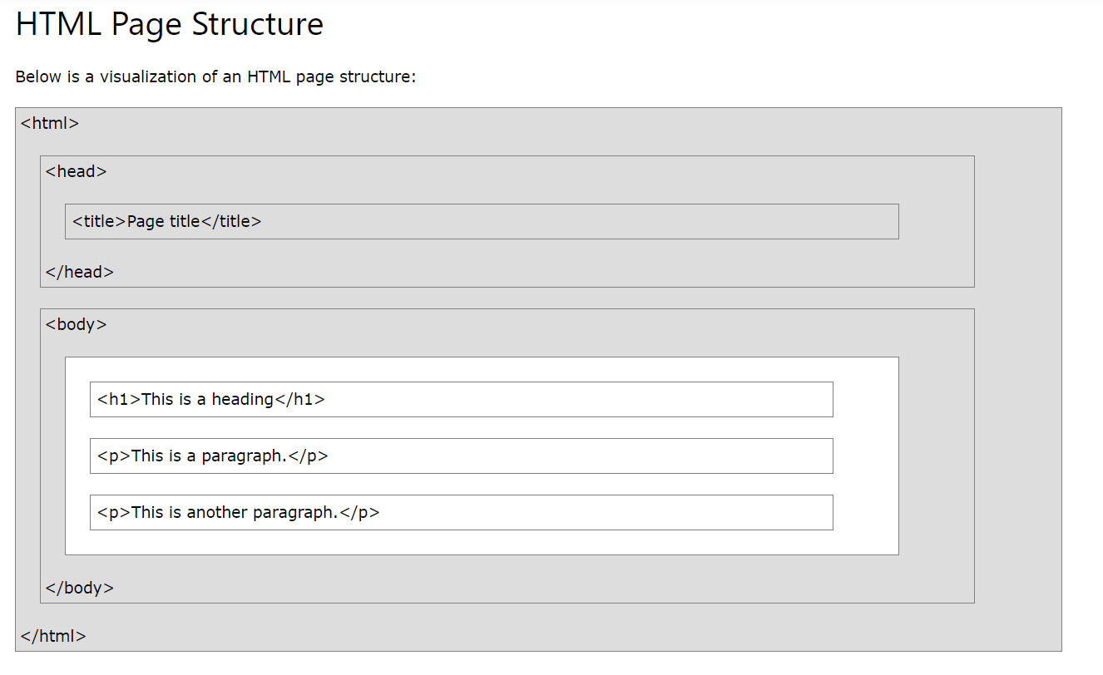

### Example Explained

* The <!DOCTYPE html> declaration defines that this document is an HTML5 document
* The <html> element is the root element of an HTML page
* The <head> element contains meta information about the HTML page
* The <title> element specifies a title for the HTML page (which is shown in the browser's title bar or in the page's tab)
* The <body> element defines the document's body, and is a container for all the visible contents, such as headings, paragraphs, images, hyperlinks, tables, lists, etc.
* The <h1> element defines a large heading
* The <p> element defines a paragraph

**New Semantic Tags Added by HTML5**

The new tags added as part of HTML5 to define the structure and content of a web page. The elements are:

* [header](https://html.com/tags/header/)
* [main](https://html.com/tags/main/)
* [nav](https://html.com/tags/nav/)
* [article](https://html.com/tags/article/)
* [section](https://html.com/tags/section/)
* [aside](https://html.com/tags/aside/)
* [address](https://html.com/tags/address/)
* [footer](https://html.com/tags/footer/)

<html>

<!--Only the head and body elements are supposed to be direct descendants of the html element. All others should be descendants of either the head or body-->

<head>

<!--The head element must be a direct descendant of the html element-->

<!--The head element is a very busy place for most websites, so we've created a tutorial to walk you through the different elements and tasks accomplished in the head element. You can find it at the following address: https://html.com/document/metadata/ -->

<title>Your Webpage Title Goes Here</title>

<meta charset="UTF-8">  
<meta name="description" content="Free Web tutorials">  
<meta name="keywords" content="HTML, CSS, JavaScript">  
<meta name="author" content="John Doe">

<meta name="viewport" content="width=device-width, initial-scale=1.0">

<!--The metadata will not be displayed on the page, but are used by browsers (how to display content or reload page), by search engines (keywords), and other web services -->

<base href="https://www.w3schools.com/" target="_blank">

<!-- The <base> element specifies the base URL and/or target for all relative URLs in a page. -- >

The <link> tag is most often used to link to external style sheets:

<link rel="stylesheet" href="mystyle.css">

Similarly js files as well.

<style>

This is for internal styling

We can specify css code here

</style>

<script>

This is for internal scripts

We can write js code here

</script>

</head>

<body>

<!--The body element contains the full visible content of the web page-->

<header>

<!--The header typically includes your logo, tagline, and may contain a nav element-->

<nav>

<!--The nav element isn't used for every single link but for navigational menus-->

</nav>

</header>

<main>

<!--The main element cannot be used inside of anything other than the body element. It is intended to hold the main content of the page.-->

<nav>

<!--You can use a nav element just about anywhere-->

</nav>

<article>

<!--If your web page contains a blog post or news article it makes sense to wrap the whole article in article tags-->

<aside>

<!--The aside tag can be used within an article or outside of it. It is used to mark content that is related but not central to the main content of the page-->

</aside>

<section>

<!--Sections are used to seperate major parts of an element, such as chapters of an HTML ebook, or to cordone off the comments section from the rest of the main element-->

</section>

<address>

<!--An address element inside of an article element is used to provide contact info for the author of the article-->

</address>

</article>

<aside>

<!--The aside element would also be used to mark a sidebar if used outside of the main element-->

<section>

<!--Within a sidebar you could use section elements to identify the different parts of the sidebar. For example, you could put adds in one section, related posts in a second section, and a newsletter signup form in a third section element.-->

</section>

</aside>

</main>

<footer>

<!--The footer typically contains links to things like About Us, Privacy Policy, Contact Us and so forth. It may also contain a nav, address, section, or aside element.-->

<address>

<!--Put an address element in the footer and you're indicating that the contact info within the element is for the owner of the website rather than the author of the article.-->

</address>

</footer>

</body>

## </html> HTML Elements and Doctypes:

## Older HTML Documents

In older documents (HTML 4 or XHTML), the declaration is more complicated because the declaration must refer to a DTD (Document Type Definition).

**HTML 4.01:**

<!DOCTYPE HTML PUBLIC "-//W3C//DTD HTML 4.01 Transitional//EN" "http://www.w3.org/TR/html4/loose.dtd">

**XHTML 1.1:**

<!DOCTYPE html PUBLIC "-//W3C//DTD XHTML 1.1//EN" "http://www.w3.org/TR/xhtml11/DTD/xhtml11.dtd">

The declaration is not an HTML tag. It is an "information" to the browser about what document type to expect.

In **HTML 5**, the declaration is simple:

<!DOCTYPE html>

## The <!DOCTYPE> declaration is NOT case sensitive.

### Examples

<!DOCTYPE html>

<!DocType html>

<!Doctype html>

<!doctype html>