### **Detecting Ascending Triangle Patterns in Bitcoin's 4-Hour Historical Data**

ASCENDING TRIANGLE PATTERN

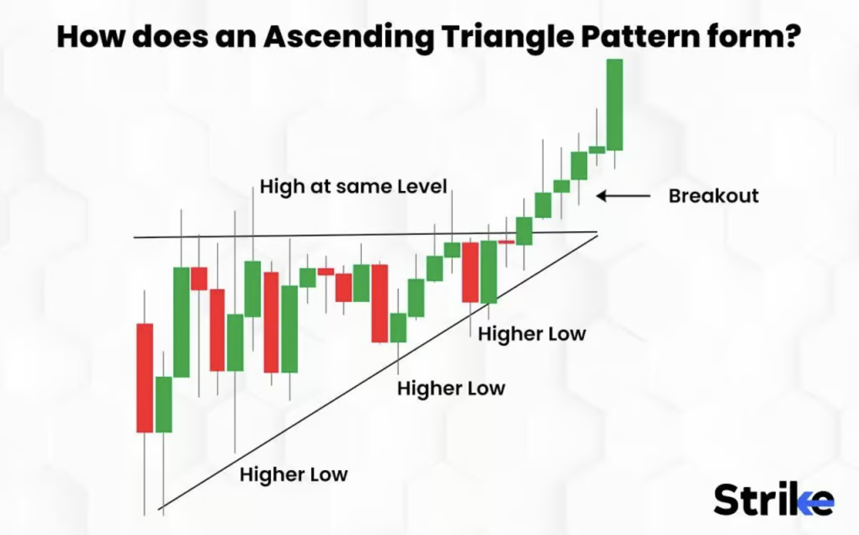

### **Machine Learning Assignment: Ascending Triangle Pattern Detection**

#### **Objective:**

The goal of this assignment is to detect how many times an **Ascending Triangle** pattern occurred in historical Bitcoin price data (2017-2023) in a **4 hour** timeframe, identify the specific dates when these patterns started and ended, and explain how the pattern could be detected in real-time. **Note:** It is not important whether a breakout occurred after the Ascending Triangle pattern.

#### **Data:**

* You are provided with the file **"bitcoin_2017_to_2023.csv"**, which contains historical Bitcoin price data.
* The file includes the following columns:
  + timestamp: The date and time of the entry (e.g., 8/1/23 13:19).
  + open: The opening price of Bitcoin at the specific timestamp.
  + high: The highest price of Bitcoin at that timestamp.
  + low: The lowest price of Bitcoin at that timestamp.
  + close: The closing price of Bitcoin at that timestamp.
  + volume: The trading volume at that timestamp.
  + quote_asset_volume: The total quote asset volume traded at that timestamp.
  + number_of_trades: The number of trades executed at that timestamp.
  + taker_buy_base_asset_volume: The volume of base asset bought by takers.
  + taker_buy_quote_asset_volume: The volume of quote asset bought by takers.

#### **Task:**

1. **Data Understanding**: Load and explore the CSV data.
   * Provide a summary of the dataset, including the range of dates, description of columns, and relevant statistics (e.g., mean, max, min).
   * Perform necessary preprocessing steps such as handling missing values, converting timestamps to a suitable format, and sorting data chronologically.
2. **Pattern Definition**: Explain the key characteristics of an Ascending Triangle pattern:
   * A flat or horizontal upper trendline that touches resistance levels (use high values for this).
   * A rising lower trendline that touches higher lows (use low values for this).
   * You are expected to describe how you interpret this pattern using the provided data.
3. **Note**: Breakout occurrence after the pattern is **not required**.
4. **Pattern Detection Algorithm**:
   * Implement an algorithm to detect the **Ascending Triangle** pattern based on the high and low price columns.
   * You can use a technical analysis approach, machine learning model, or a hybrid method of your choice. Justify your approach.
5. **Pattern Identification**:
   * For each detected occurrence of the Ascending Triangle, provide:
     + The start timestamp (when the pattern begins to form).
     + The end timestamp (when the pattern completes).
   * Count the total number of occurrences within the dataset.
   * **Output** how many times the Ascending Triangle pattern occurred and the specific timestamps when each pattern started and ended.
6. **Visualization**:
   * Plot the Bitcoin price data (high, low, and close prices) and highlight the detected Ascending Triangle patterns.
   * Show visualizations of the detected patterns, clearly marking the upper and lower trendlines.
7. **Real-Time Detection (New Task)**:
   * Discuss how you would approach detecting the Ascending Triangle pattern in **real-time** as new data comes in.
   * What strategies or methods would you use to detect the pattern while it is forming, instead of detecting it retrospectively? Be sure to consider the constraints of real-time data processing.
8. **Bonus (Optional)**:
   * Suggest possible strategies for using detected Ascending Triangle patterns for trading (e.g., potential buy signals based on pattern completion), even if breakouts are not considered.
   * Evaluate the performance of your pattern detection using a backtesting method or another evaluation metric.

#### **Deliverables:**

* A Python or Jupyter Notebook containing:
  + Code for loading, exploring, preprocessing, pattern detection, and visualization of the data.
  + Comments and explanations for each step.
* A short report (max 1-2 pages) summarizing your approach, including:
  + The total number of Ascending Triangle patterns detected.
  + The timestamps for each pattern's start and end.
  + An explanation of how you would detect the pattern in real-time.
* Any visualizations highlighting the detected patterns in the historical data.

#### **Evaluation Criteria:**

* **Accuracy** of detecting the Ascending Triangle pattern based on the high and low columns.
* **Clarity** in your explanation and approach.
* **Code quality**: Clean, well-documented, and efficient code.
* **Visualization**: Proper use of charts to demonstrate the detected patterns.
* **Real-Time Considerations**: Thoughtful discussion on how to detect the pattern while it is forming.
* **Bonus**: Providing additional trading strategies or performance metrics.