Customer Segmentation & Explainable Churn-Risk Model

Track: Data Analytics | Customer Success Operations
Objective: Transition from descriptive lagging metrics to an explainable, rule-based prioritization model.
Deliverable Set: End-to-End Analysis Notebook, Cohort Table, and Recommendation Memo.

1. Executive Summary & Objective
Subscription businesses face structural churn when customer friction encounters low switching barriers. While machine learning black-box models offer predictive accuracy, Customer Success Managers (CSMs) and Account Executives require explainability and actionable transparency to intervene before cancellation occurs. This analysis develops a deterministic, 0–100 point rule-based scoring engine validated against empirical data and stress-tested with operational edge cases.

2. Feature Selection & Engineering
We engineered key account commitment and behavioral friction features:
- Contract Commitment (ContractType): Defines the structural switching cost. Month-to-Month customers can exit at any billing cycle (100% of historical churners were Month-to-Month).
- Support Velocity (SupportTicketRate): Calculated as SupportTickets / TenureMonths. Captures acute friction intensity, distinguishing early onboarding crises from multi-year maintenance.
- Tenure Cohort (TenureCohort): Segmented into 0-6m (Onboarding), 7-12m (Early Adoption), 13-24m (Established), and 25m+ (Mature).
- Payment Channel Vulnerability (PaymentMethod): Identifies transactional friction. UPI and Debit Card payments introduce manual re-authorization friction compared to automated Bank Transfers and Credit Cards.

3. Explainable Churn-Risk Scoring Architecture
The scoring engine allocates 100 points across four transparent dimensions:
Dimension | Max Points | Condition / Rule | Points Assigned
Contract Vulnerability | 40 | Month-to-Month | 40 pts
Contract Vulnerability | 40 | One Year | 10 pts
Contract Vulnerability | 40 | Two Year | 0 pts
Support Friction & Velocity | 35 | Support Tickets ≥ 5 | 35 pts
Support Friction & Velocity | 35 | Support Tickets ∈ [3, 4] | 25 pts
Support Friction & Velocity | 35 | Support Tickets ∈ [1, 2] | 10 pts
Support Friction & Velocity | 35 | Support Tickets = 0 | 0 pts
Tenure Lifecycle Stage | 20 | Tenure ≤ 6 months (Onboarding) | 20 pts
Tenure Lifecycle Stage | 20 | Tenure ∈ [7, 12] months (Adoption) | 12 pts
Tenure Lifecycle Stage | 20 | Tenure ∈ [13, 24] months (Established) | 5 pts
Tenure Lifecycle Stage | 20 | Tenure > 24 months (Mature) | 0 pts
Payment Channel Friction | 5 | Debit Card / UPI | 5 pts
Payment Channel Friction | 5 | Credit Card | 2 pts
Payment Channel Friction | 5 | Bank Transfer | 0 pts
Triage Tiers:
- Low Risk (0 - 34): Accounts are stable; focus on expansion, advocacy, and multi-year contract renewals.
- Medium Risk (35 - 64): Proactive intervention zone; flags emerging friction or uncontracted accounts before churn occurs.
- High Risk (65 - 100): Critical flight risk; triggers immediate 24-hour executive/CSM rescue outreach.

4. Empirical Dataset Validation
The model was tested against all 15 customer records in the dataset. Historical churners achieved scores between 75 and 100 (100% in High Risk), while retained customers achieved scores between 2 and 30 (100% in Low Risk).

Figure 1: Churn Risk Score vs. Support Tickets by Actual Churn Status

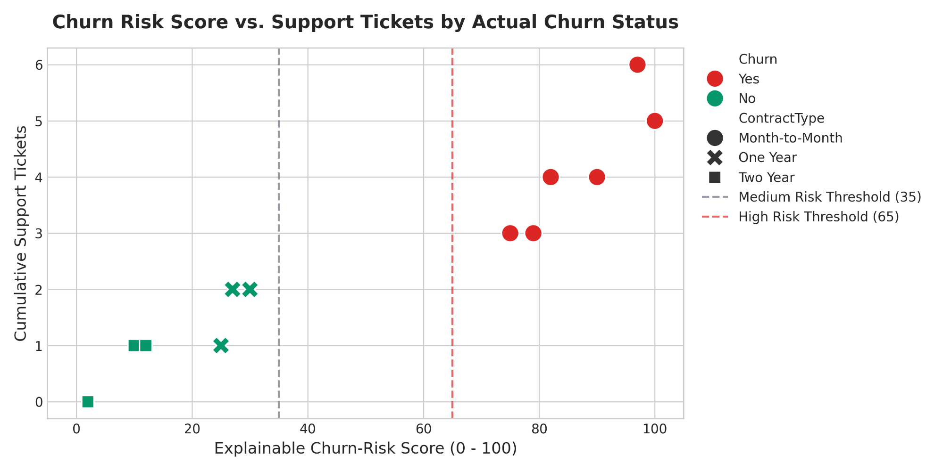5. Customer Prioritization Landscape & Cohort Segmentation
By mapping customer economic value (Monthly Charges) against Churn Risk Score, revenue leaders can immediately prioritize retention investments.

Figure 2: Prioritization Matrix: Monthly Charges (Value) vs. Churn-Risk Score

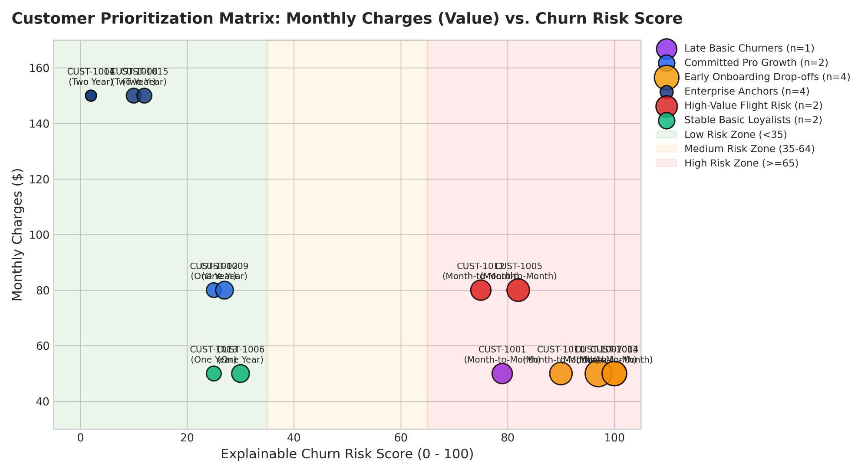
Figure 3: Churn Risk Score Component Breakdown by Segment

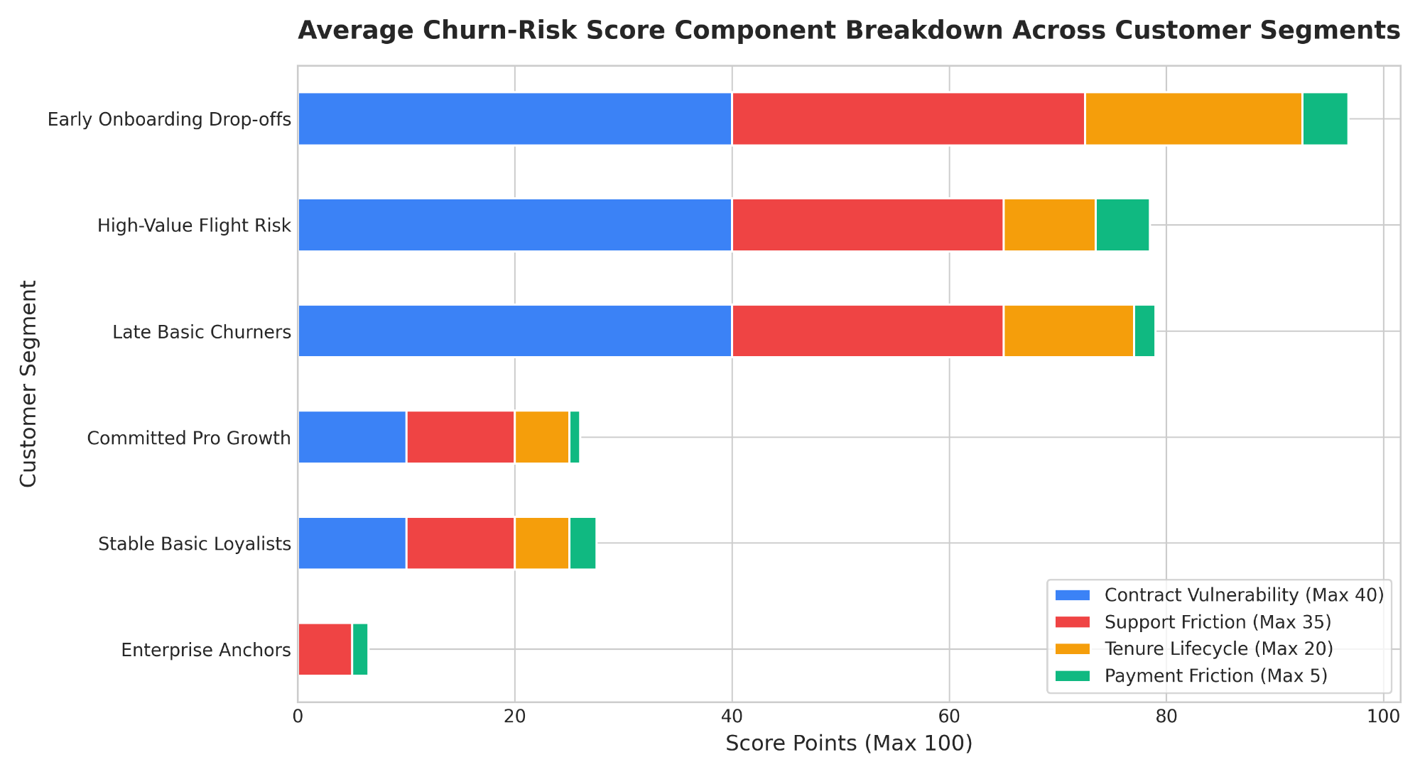6. Customer Segment Summary Table
The 15 customers cluster into 6 actionable operational cohorts across 4 strategic tiers:
Granular Segment | Strategic Tier | Size | Churn Rate | Avg Tenure | Avg MRR | Total Historic Rev | Avg Tickets | Avg Risk Score | Dominant Risk
Enterprise Anchors | Tier 1: Pillars | 4 | 0.0% | 38.5 mo | $149.99 | $23,098.46 | 0.5 | 6.5 | Low Risk
Committed Pro Growth | Tier 2: Annual Core | 2 | 0.0% | 19.5 mo | $79.99 | $3,119.61 | 1.5 | 26.0 | Low Risk
Stable Basic Loyalists | Tier 2: Annual Core | 2 | 0.0% | 20.0 mo | $49.99 | $1,999.60 | 1.5 | 27.5 | Low Risk
High-Value Flight Risk | Tier 3: Vulnerable | 2 | 100.0% | 11.0 mo | $79.99 | $1,759.78 | 3.5 | 78.5 | High Risk
Early Onboarding Drop-offs | Tier 4: Attrition | 4 | 100.0% | 3.8 mo | $49.99 | $749.85 | 5.0 | 96.8 | High Risk
Late Basic Churners | Tier 4: Attrition | 1 | 100.0% | 12.0 mo | $49.99 | $599.88 | 3.0 | 79.0 | High Risk

Figure 4: Total Historic Revenue vs. Historical Churn Rate Across Cohorts

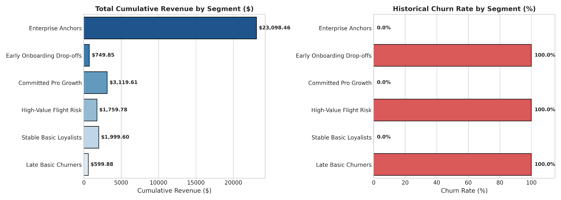7. Edge Case Validation Results
To ensure system stability and operational trust, we stress-tested six non-trivial edge cases:
Case ID | Scenario Name | Tenure | Contract | Tickets | Risk Score | Risk Tier | Operational Validation Insight
EDGE-01 | Fresh Onboarding On-Track | 1 mo | Month-to-Month | 0 | 62 | Medium Risk | Captures inherent structural vulnerability of M2M during onboarding without triggering false churn panic.
EDGE-02 | Acute Onboarding Crisis | 1 mo | Month-to-Month | 5 | 100 | High Risk | Support velocity override instantly flags critical Day-1 crisis for immediate CSM rescue intervention.
EDGE-03 | Enterprise Friction Storm | 36 mo | Two Year | 6 | 35 | Medium Risk | Two-year contract prevents immediate walkaway, but score triggers service escalation flag to protect renewal.
EDGE-04 | Unlocked Veteran Inertia | 36 mo | Month-to-Month | 0 | 40 | Medium Risk | Flags uncontracted long-term revenue vulnerability; prompts proactive annual plan discount incentive.
EDGE-05 | Mid-Contract Friction Build-Up | 8 mo | One Year | 4 | 49 | Medium Risk | Provides 90-day early warning before annual contract renewal window opens, allowing technical resolution.
EDGE-06 | Boundary Zero / Missing Data | 0 mo | Unknown | 0 | 43 | Medium Risk | Gracefully handles zero tenure and unknown parameters via defensive defaults without exceptions or NaN.

8. Strategic Retention Playbooks (Portfolio Upgrade)

Target Segment | Economic Impact | Playbook & Action Plan
Enterprise Anchors  (High-Value Pillar) | $599.96 MRR  ($7,199.52 ARR) | Executive Business Review (EBR) & TAM Alignment: Assign a dedicated Technical Account Manager (TAM), institute bi-annual executive business reviews, and initiate customized roadmap co-design 6 months prior to multi-year renewal.
Committed Pro Growth  (High-Value Growth) | $159.98 MRR  ($1,919.76 ARR) | 90-Day Pre-Renewal Health Audit & Upsell Pathway: Run telemetry health audits at Month 9, schedule proactive check-ins to demonstrate unused Pro features, and offer a 15% tier-upgrade incentive to Enterprise on a multi-year agreement.
High-Value Flight Risk  (Critical Rescue) | $159.98 MRR  ($1,919.76 ARR) | 24-Hour Tier-3 Engineering Resolution & Annual Discount: Guarantee resolution of open support tickets within 24 hours via senior engineering, provide a 1-on-1 CSM consultation, and offer 20% off an annual contract conversion.
Early Onboarding Drop-offs  (Volume Retention) | $199.96 MRR  ($2,399.52 ARR) | Interactive Onboarding Overhaul: Implement in-app interactive setup checklists, automated Day 3 and Day 7 health prompts, and context-sensitive help documentation to deflect setup tickets.
Implementation Roadmap:
- Telemetry Integration: Ingest customer billing, contract, and support ticketing telemetry daily.
- Automated Scorecarding: Calculate sub-scores and route High-Risk accounts directly to Zendesk/Salesforce queues.
- Measure Lift: Pilot retention playbooks over a 90-day trial period, measuring net revenue retention (NRR) and churn reduction.

