JAGADEESWAR REDDY
PORTFOLIO WEBSITE — MASTER BUILD SPECIFICATION
Visual references embedded section-by-section • UX • Motion • Assets • Responsive implementation

How to use this document
This is the single source of truth for design and development. Each page/section includes its supplied visual reference, the intended behavior, animation sequence, assets, and acceptance checks. Treat the images as design references to recreate with live, responsive components—not as full-page background screenshots.
Priority | Instruction
P0 | Smooth, professional interface and accurate section-by-section visual reconstruction.
P0 | Use the actual approved photographs of Jagadeesh; do not replace or alter his identity.
P0 | All navigation, buttons, previews and downloads must function.
P1 | Motion enhances storytelling but never blocks content or accessibility.
P1 | Use CV facts only; confirm any uncertain dates, metrics and contact details before publishing.

01. Global design system
Token | Value / rule | Application
Primary blue | #0B3D91 | Menu panel, strong brand moments.
Action blue | #145FE5 | CTA, links and active accents.
Sky blue | #DCEEFF | Soft section surfaces and data accents.
White | #FFFFFF | Main canvas and active menu row.
Ink | #101828 | Body text and headings.
Muted | #667085 | Metadata and helper copy.
Border | #D8E1EC | Fine rules and grid lines.
Typography | Inter for UI/body; editorial serif (e.g. Cormorant Garamond or Playfair Display) for large display headings. | Preserve the reference’s contrast between clean sans-serif labels and elegant serif titles.
Motion | Micro 120–220ms; UI 250–450ms; reveals 450–750ms; hero object 1,000–1,500ms. | Prefer opacity/transform and easing cubic-bezier(.16,1,.3,1).

Layout: generous whitespace, thin rules, precise alignment, restrained shadows, minimal corner rounding. Avoid generic card-heavy SaaS styling, excessive gradients, overuse of blur, and AI-looking visual clutter.

02. Navigation overlay and hover previews
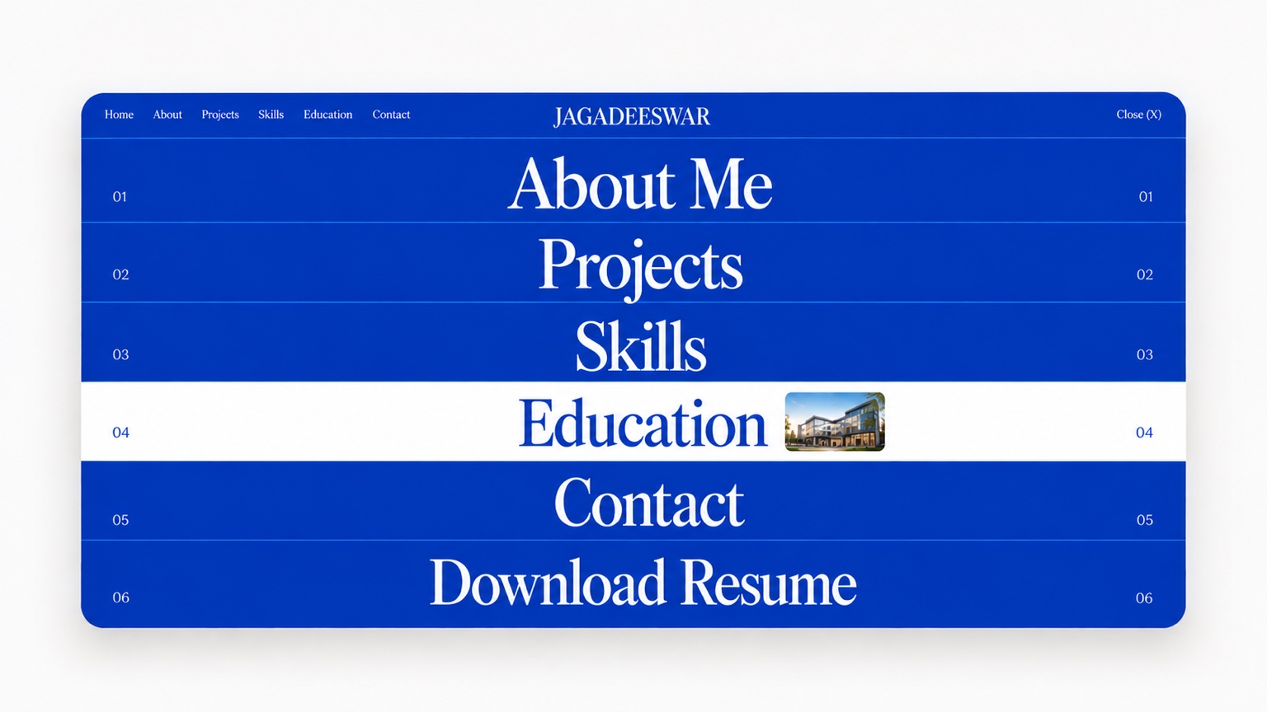
REFERENCE 01 — Full-screen blue menu with Education selected and its thumbnail preview.
Recreate this menu as live UI. Rows are full-width horizontal bands. Each row contains its two-digit index at left and right, with the destination title centered. Close (X) sits top-right; the portfolio wordmark is centered in the top bar.
State / action | Required behavior | Timing
Default | Deep blue panel, white type, fine blue-white separators. | Panel reveal 450–600ms.
Hover / keyboard focus | Selected row becomes white; title and indices become blue; a small contextual image fades in to the right of the title. | 180–260ms row transition; thumbnail 280ms fade/scale.
Click destination | Close menu and scroll directly to the chosen section; start destination entrance choreography. | Exit 300–450ms; section reveal begins on arrival.
Close / Escape | Dismiss overlay, restore previous scroll and return focus to menu opener. | 300–450ms.
Touch | Tap once to select/highlight; tap selected item again or use visible arrow/CTA to navigate. No hover dependency. | Same visual state, no pointer-only controls.

Menu destinations and preview assets:
Index | Label | Preview image | Destination
01 | About Me | Approved portrait crop | About introduction and portrait collage.
02 | Projects | Container / project visual | Selected projects and suspended-container sequence.
03 | Skills | Dashboard or clean skills crop | Skill groups and tools.
04 | Education | Building/campus thumbnail (only if approved) | Education timeline.
05 | Contact | Portrait/contact crop | Contact CTA and social links.
06 | Download Resume | Single CV/document thumbnail | Download one current PDF; do not show multiple résumé options.

03. Home hero — container perspective
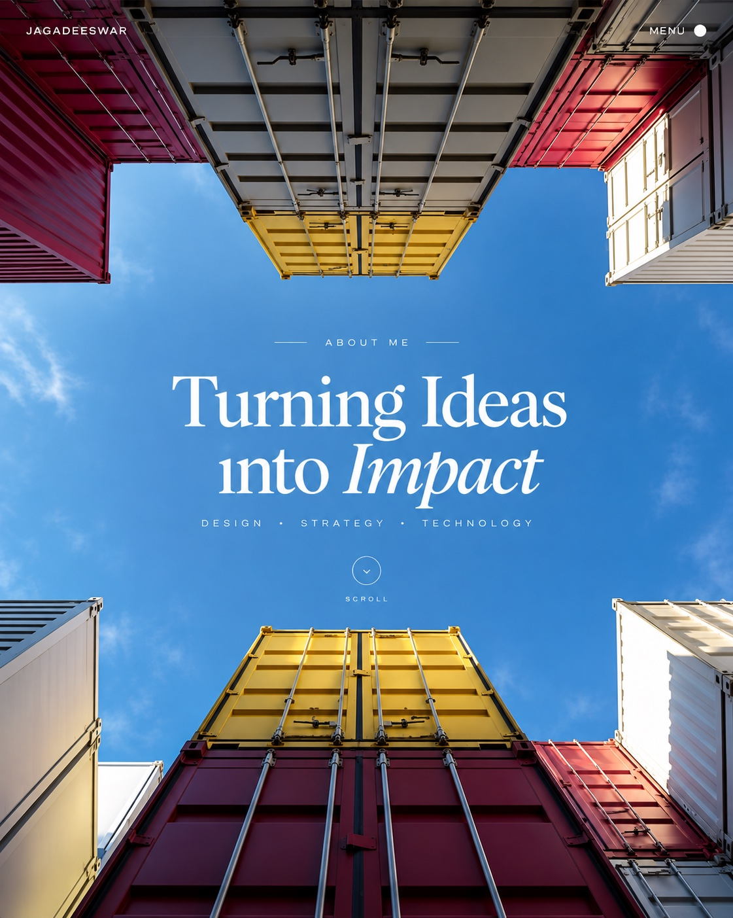
REFERENCE 02 — Opening hero: container architecture frames the sky and centered introduction.
Use this as the first viewport and visual hook. Preserve the open sky region for live text. Brand at top-left, MENU at top-right, eyebrow centered, two-line display headline, descriptor line and scroll cue. The hero should communicate Jagadeesh’s supply-chain perspective immediately.
Order | Element | Animation spec
1 | Hero background | Fade 0→1 over 700ms. Subtle exposure settle; no aggressive zoom.
2 | Top navigation | Y -10px and opacity 0→1 over 500ms; 120ms delay.
3 | Eyebrow | Y +12px, fade over 500ms; 250ms delay.
4 | Headline | Line-by-line fade + rise from 24px over 750ms; 100ms stagger.
5 | Discipline line | Fade + rise over 500ms; starts at 650ms.
6 | Scroll cue | Fade over 450ms after 900ms; one subtle cue pulse maximum.

- Scroll parallax is limited to 10–18px on background imagery; body text remains stable.
- Do not use scroll-jacking. Scroll cue must move to the next section.
- On mobile, crop the image to retain the sky/text safe area; simplify container framing if necessary.

04. About Me — editorial portrait collage
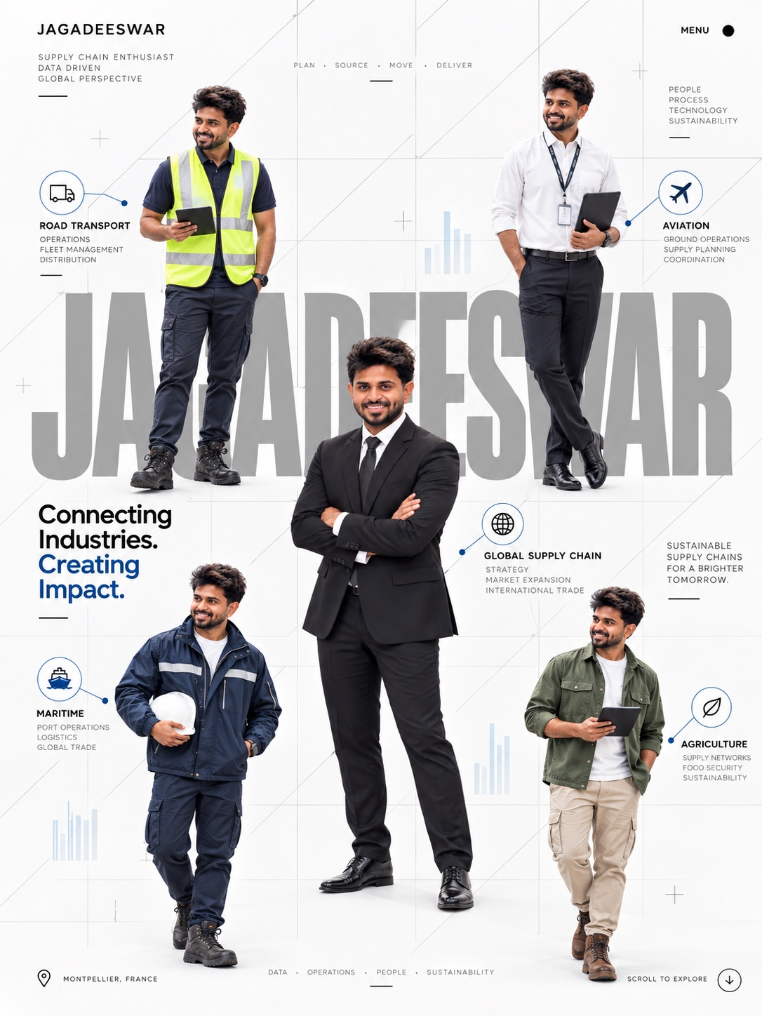
REFERENCE 03 — White grid composition with oversized background name, multiple work portraits and industry callouts.
When About Me is selected, land directly at this section. First viewport should use a white or near-white canvas, faint grid lines, micro-labels, large low-contrast name typography behind the content, and a carefully composed portrait collage. Keep all copy and UI as real text/components.
Sequence | Element | Motion
1 | Background and grid | Fade in 600ms; grid lines reveal softly.
2 | Micro labels | Fade + Y 8px, 400ms after 120ms.
3 | Oversized name | Soft fade/scale 1.02→1 over 800ms; remains behind imagery.
4 | “Connecting Industries. Creating Impact.” | Line-by-line fade + rise from 22px over 700ms; blue emphasis enters last.
5 | Portrait images | Fade + rise from 16px; 650ms each, 90ms stagger; use approved originals only.
6 | Industry callouts/icons | Fade + short horizontal reveal from nearest edge over 450ms.
7 | Location/scroll cue | Fade in after main content; no perpetual animation.

- Do not generate new faces or alter Jagadeesh’s identity. Preserve natural facial features and proportions.
- Desktop may use the five-image collage; mobile becomes a stacked editorial sequence or swipeable portrait rail.
- Callout labels should describe relevant sectors only where supported by the portfolio/CV; avoid implying unverified employment.

05. Projects — suspended container / “Why Choose Me?”
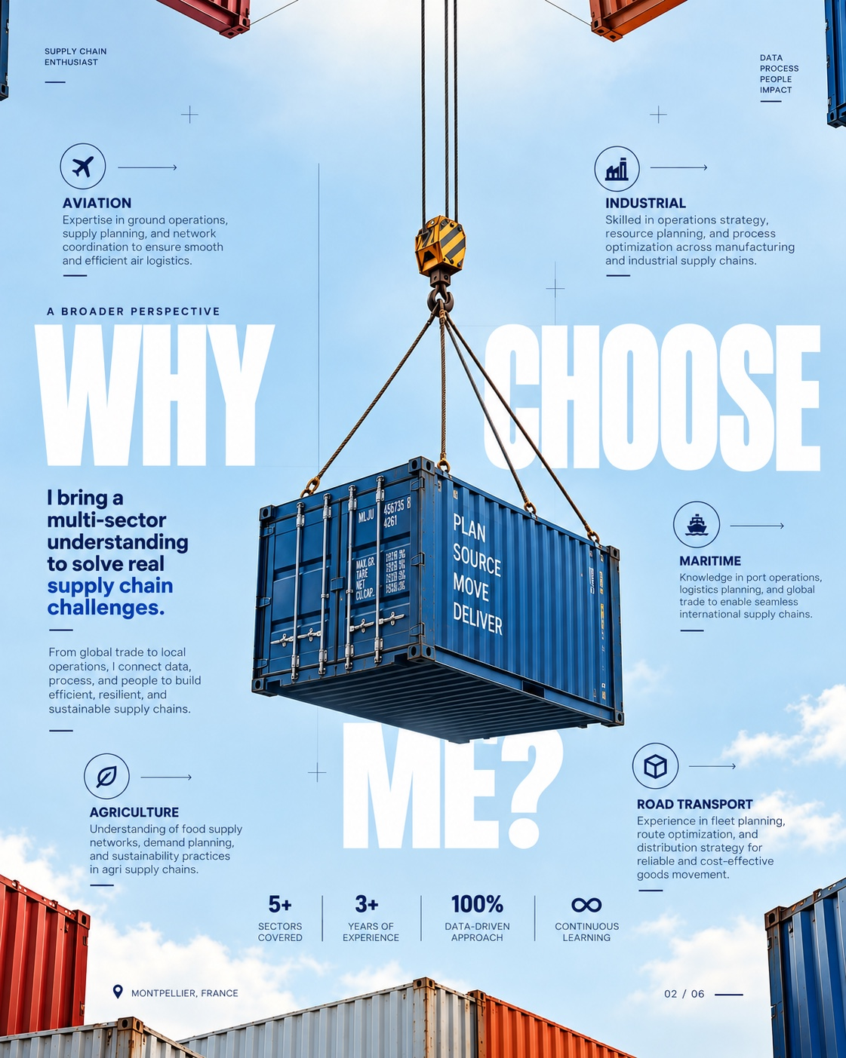
REFERENCE 04 — Container suspended from a crane above the large WHY CHOOSE ME? statement.
The container should feel physically lowered from above. Use separated image layers (sky, cable, hook, container) when available; otherwise create a convincing composite with layered transforms. Avoid a cartoon bounce.
Beat | Visual | Animation
1 | Section sky/background | Fade in over 600ms.
2 | Cables and hook | Reveal downward over 700ms; 100ms delay.
3 | Container | Translate from -18–24% of its height to final position over 1,250ms; opacity 0.7→1; 220ms delay.
4 | Settle | Tiny 2–4px damped settle over 420ms; no elastic bounce.
5 | “WHY CHOOSE ME?” | Rise from below with fade over 700ms as container settles.
6 | Project details/cards | Reveal sequentially, 550–700ms each, 80ms stagger.
7 | Metrics row | Fade/slide up; count-up only verified metrics.

- Trigger when section enters roughly 70–80% of viewport. If user scrolls quickly, finish or skip the animation so content is never hidden.
- Each project entry should include: title, context/problem, Jagadeesh’s role, approach/tools, result (only if documented), and a visual.
- Keep project cards restrained and editorial; avoid dense grids that compete with the hero object.

06. Skills section
Build skill groups rather than a wall of badges. Suggested categories: Supply Chain & Operations; Analytics & BI; Automation & Platforms; Methods. Use the CV to populate exact skill names. Do not invent percentage-based proficiency ratings.
Interaction | Behavior | Motion
Section entrance | Groups fade + rise 16px; 70ms stagger. | 500–650ms.
Hover/focus | Text darkens or underline draws; avoid heavy scaling. | 160–220ms.
Category filter (optional) | Crossfade visible skills; maintain accessible access to all items. | 250–350ms.
Mobile | Stacked groups or accordion; touch targets at least 44px. | 250–350ms.

07. Education section
The menu’s Education row uses a contextual building/campus thumbnail. On activation, scroll directly to the Education section and reveal a clear timeline with institution, qualification, dates, relevant modules and thesis. Use the supplied CV as the factual source.
Element | Animation
Section title | Fade + Y 16px over 550ms.
Timeline rule | Draw top-to-bottom over 650ms.
Education entries | Fade + Y 18px, 550ms each, 100ms stagger.
Thesis/modules | Reveal after the relevant qualification; no typewriter effect.

Confirm degree status and dates against the final CV before launch. Do not use an unapproved campus photo as if it depicts the actual institution.

08. Contact and footer


REFERENCE 05 — Contact invitation, portrait, container visual, working CTAs and structured footer.
The final section should feel like a confident, calm closing frame. Use a concise invitation, working contact method, LinkedIn/social links and a single primary CTA. The footer repeats key navigation and identity information without competing with the contact action.
Element | Behavior
Headline | Fade + Y 18px over 600ms.
Contact/social links | Staggered fade; subtle hover/focus response.
Primary CTA | Color and arrow feedback; clear pressed state; 180–240ms.
Footer | Fade in as it enters view over 500ms; no dramatic transition.

- Validate email, social URLs and contact details before publishing.
- Ensure the Download CV control points to one approved, current PDF.

09. Asset register — image-by-image implementation
Asset | Source/reference | Where used | Implementation note
A1 | Container hero reference | Home hero | Use as direction; source a high-resolution image or build layered scene. Text remains live.
A2 | Portrait collage reference | About Me | Use actual supplied portraits; crop and position per breakpoint.
A3 | Suspended container | Projects | Separate crane/cable/container layers if possible for motion.
A4 | Contact/footer reference | Contact/footer | Rebuild with real responsive elements and approved portrait.
A5 | Menu screenshot | Menu overlay | Rebuild in HTML/CSS; not a flat image.
A6 | Education thumbnail | Menu preview | Use approved campus/building image; otherwise use a neutral education visual.
A7 | Project thumbnails | Project cards | Use actual project screenshots/visuals; never fabricate project outcomes.

Suggested folders: /public/images/hero/, /portraits/, /projects/, /education/, /ui/; /public/icons/; /public/resume/ (one PDF). Use WebP/AVIF, responsive srcsets, explicit dimensions, lazy-load below fold, and preload only the hero. Add descriptive alt text.

10. Technical build and component structure
Layer | Recommendation
Framework | Next.js + React + TypeScript.
Styling | Tailwind CSS with centralized CSS variables/design tokens.
Animation | Framer Motion as primary library; add GSAP only if complex pinned choreography truly requires it.
Scroll | Native smooth scrolling or a carefully validated smooth-scroll library; preserve anchors and keyboard access.
Icons | Lucide/custom SVG with consistent stroke weight.
Content model | Typed data objects or CMS-ready content for projects, skills and education.
Resume | One downloadable PDF; no duplicate CV tiles.
Components | SiteLayout, Header, MenuOverlay, MenuPreviewRow, HomeHero, AboutSection, PortraitCollage, ProjectsSection, SuspendedContainerScene, ProjectCard, SkillsSection, EducationTimeline, ContactSection, Footer, ReducedMotionFallback.

11. Responsive behavior
Viewport | Rules
≥1440px | Full editorial composition, generous margins, layered collage and container scene.
1200–1439px | Reduce outer margins and image scale; preserve heading proportions.
1024–1199px | Simplify overlaps and maintain comfortable line lengths.
768–1023px | Menu remains full-screen; collage becomes 2-column/layered; reduce parallax.
390–767px | Single-column content, touch-first menu, no hover dependency, simplified container scene.
≤389px | Prevent title/CTA overflow; stack buttons; tap targets ≥44×44px.

12. Accessibility, performance and fallback
- Honor prefers-reduced-motion: remove drops, parallax and stagger; show content immediately or use simple fades.
- Keyboard support for every control; visible focus; Escape closes menu; focus returns to opener.
- Semantic heading order, descriptive links, meaningful alt text and adequate contrast.
- Menu traps focus while open; body scroll locks only while overlay is active.
- Optimize images, prevent layout shift, lazy-load below-fold content and avoid heavy blur layers.
- Target smooth 60fps on mainstream devices; animate opacity/transform instead of layout properties.
- Content remains visible if JavaScript or animation fails; no animation may block reading or navigation.

13. QA / definition of done
- ☐ Menu opens/closes, responds to hover and keyboard focus, and shows the correct thumbnail for every row.
- ☐ Selecting a destination lands at the correct section with its heading unobscured.
- ☐ Home hero sequence is readable and does not block interaction.
- ☐ About background, headline, name layer, portraits and callouts appear in the specified order.
- ☐ Container lowers from above with coherent cable/hook movement and restrained settle.
- ☐ “Why Choose Me?” rises after the container settles; project content follows in readable order.
- ☐ Skills and education match the CV; no unsupported ratings or claims.
- ☐ Contact/social links work; the single CV download returns the correct PDF.
- ☐ All breakpoints pass with no horizontal overflow or clipped content.
- ☐ Reduced-motion mode is usable; no broken images, dead controls, console errors or unexpected scroll jumps.

14. Implementation sequence
- Audit supplied references, CV, source portraits and existing code.
- Confirm copy, degree status, public contact details and final CV PDF.
- Set up design tokens, typography, responsive containers and reusable components.
- Build static hero and menu; validate proportions against embedded references.
- Implement menu active/preview behavior for hover, focus and touch.
- Build About collage and staged entrance using real photos.
- Build the Projects container sequence and tune timing on real devices.
- Add Skills, Education, Contact and Footer; wire all navigation and downloads.
- Run accessibility, responsive, performance and functional QA.
- Polish crops, alignment, contrast, transitions and reduced-motion behavior.

Final directive
Build the complete responsive website from this document as a coherent experience—not a static mockup. The embedded images are section-specific visual references. Recreate their composition with live components, use only approved images of Jagadeesh, preserve CV accuracy, and treat smooth professional interaction as the highest quality bar.

SUPPLY CHAIN PORTFOLIO

Experience & Projects
Visual Direction + Motion Blueprint
Continuation of the existing portfolio concept | Image-led, no site header

Global design rules
- No website header or navigation bar anywhere. The portfolio flows as one continuous, immersive page.
- Use one typeface throughout: Inter. Build hierarchy through weight, scale, spacing, and colour—not extra fonts.
- Do not paste reference screenshots as finished website sections. Rebuild layouts with native text, UI components, and original motion; screenshots are visual direction and project imagery.
- Keep the visual language consistent: clean white/light-blue experience sections, deep navy project moments, blue as the primary accent, and orange reserved for the container/tank visual.
- Place all content and images section by section in the same portfolio document/folder. This file is the storyboard and implementation brief.
- Use subtle, deliberate motion. Avoid excessive parallax, bounce, or effects that compete with content.

Section 1 — Experience hero
Purpose: introduce professional experience with a cinematic transition from the previous section. The first featured experience is Wipro.

Visual reference
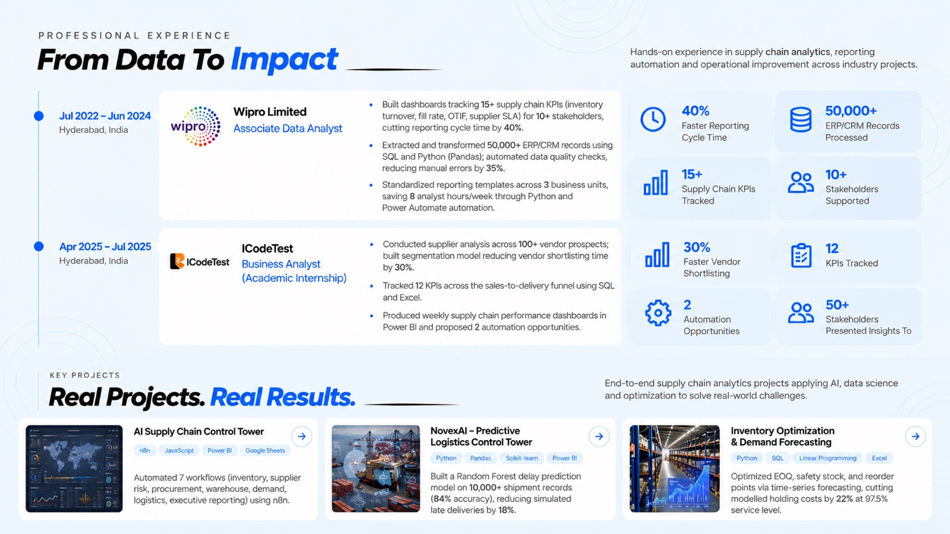
Rebuild this hierarchy responsively: strong section headline, role timeline, employer and title, concise impact bullets, and supporting KPI cards. Do not embed the screenshot as the finished page.

Proposed on-screen copy
Eyebrow: PROFESSIONAL EXPERIENCE
Headline: From Data to Impact
Intro: Hands-on experience in supply chain analytics, reporting automation, and operational improvement across industry projects.
Role 01 — Wipro Limited | Associate Data Analyst | Hyderabad, India | Jul 2022 – Jun 2024
- Built dashboards tracking 15+ supply chain KPIs—including inventory turnover, fill rate, OTIF, and supplier SLA—for 10+ stakeholders, reducing reporting cycle time by 40%.
- Extracted and transformed 50,000+ ERP/CRM records using SQL and Python (Pandas); automated data-quality checks, reducing manual errors by 35%.
- Standardised reporting templates across three business units, saving eight analyst hours per week through Python and Power Automate automation.
KPI tiles: 40% faster reporting cycle | 50,000+ ERP/CRM records processed | 15+ supply chain KPIs tracked | 10+ stakeholders supported

Motion choreography
- Keep the section background/layout in place; no header enters or remains.
- Animate the two layered panels independently: white layer reveals top-to-bottom; blue layer rises bottom-to-top, retaining the overlapping, half-cut crop.
- Phone/device panels enter right-to-left with a short stagger; the main image then rises bottom-to-top.
- Headline and supporting text enter right-to-left after the visual settles, using a soft fade and small horizontal translation.
- The Wipro experience card and bullets fade in sequentially. KPI cards follow with a gentle fade/slide-up; optional count-ups run once only.
- Use roughly 500–800 ms for major reveals and 80–120 ms stagger. Respect reduced-motion preferences.

Section 2 — Experience continuation
Continue the timeline directly below the hero without a new header or abrupt page break.

Visual reference
Recreate the Wipro and ICodeTest cards as editable website elements.

Role 02 — ICodeTest
Business Analyst (Academic Internship) | Hyderabad, India | Apr 2025 – Jul 2025
- Conducted supplier analysis across 100+ vendor prospects and built a segmentation model that reduced vendor-shortlisting time by 30%.
- Tracked 12 KPIs across the sales-to-delivery funnel using SQL and Excel.
- Produced weekly supply chain performance dashboards in Power BI and proposed two automation opportunities.
KPI tiles: 30% faster vendor shortlisting | 12 KPIs tracked | 2 automation opportunities | 50+ stakeholders presented insights to

Motion choreography
- Reveal the timeline line first, then bring each experience card into view with a restrained fade and 16–24 px upward movement.
- Keep dates and company identity anchored; fade achievement bullets in one at a time.
- KPI tiles appear after the related role content. On mobile, stack role content and KPI tiles vertically.

Section 3 — Projects landing

Visual reference
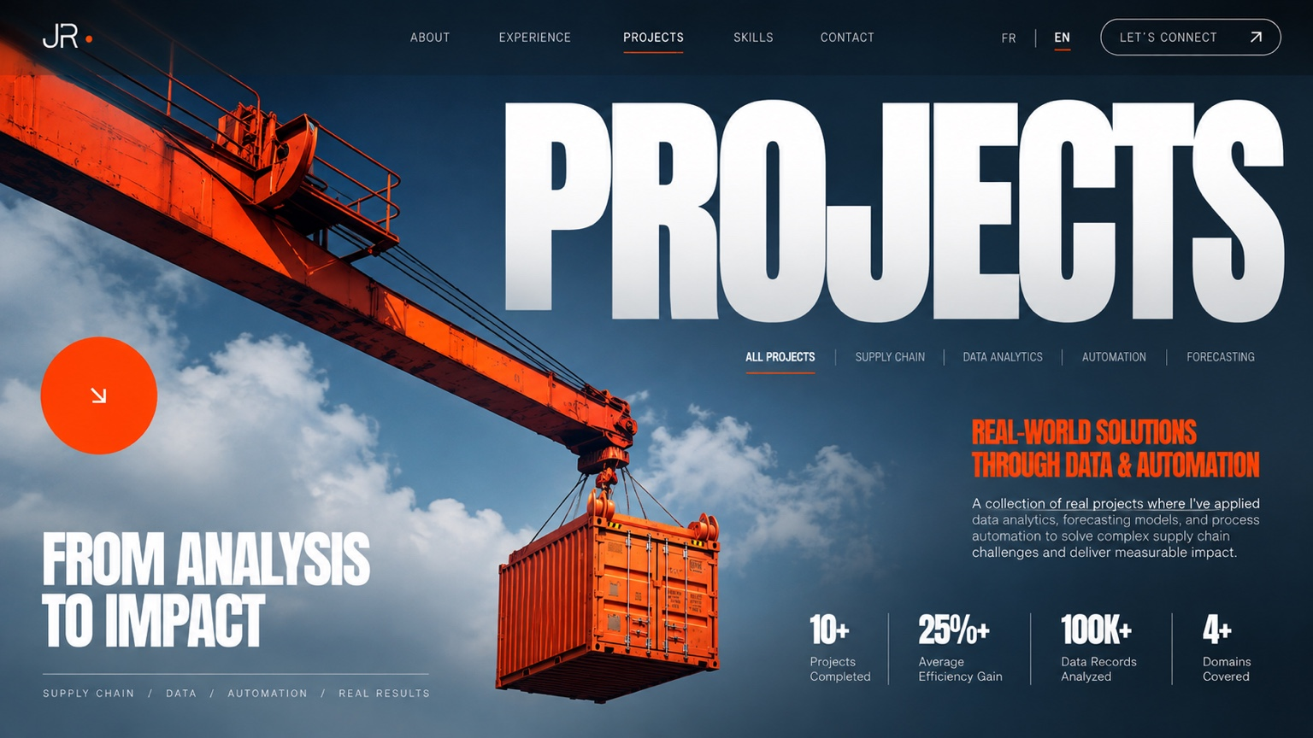
Use the dramatic container/port composition as direction. Rebuild with a clean, high-resolution container/tank asset and carefully composed typography.

Proposed on-screen copy
Eyebrow: SELECTED WORK
Headline: Projects
Accent statement: Real-world solutions through data & automation
Body: A collection of projects applying data analytics, forecasting, and process automation to solve operational and supply chain challenges and deliver measurable impact.
Portfolio metrics: 10+ projects completed | 25%+ average efficiency gain | 100K+ data records analysed | 4+ domains covered
Breadcrumb: SUPPLY CHAIN / DATA / AUTOMATION / REAL RESULTS

Motion choreography
- Establish the deep navy/blue background first.
- Bring the orange container/tank in from the left or lower-left, then settle it into the hero composition.
- Add restrained 3D movement: a small perspective rotation and slow scroll-linked parallax; no continuous spinning.
- Fade in the ‘Projects’ title after the container lands, then reveal the accent statement and supporting copy.
- Bring KPI numbers and labels in last with a staggered fade/slide-up. Keep text crisp and stationary once revealed.

Section 4 — Project cards and case studies
The following screenshots guide project content and dashboard presentation. Recreate charts and interfaces as native UI or high-quality crops; do not use each full screenshot as a flat background.

Project A — Supplier Performance & Risk Intelligence Center
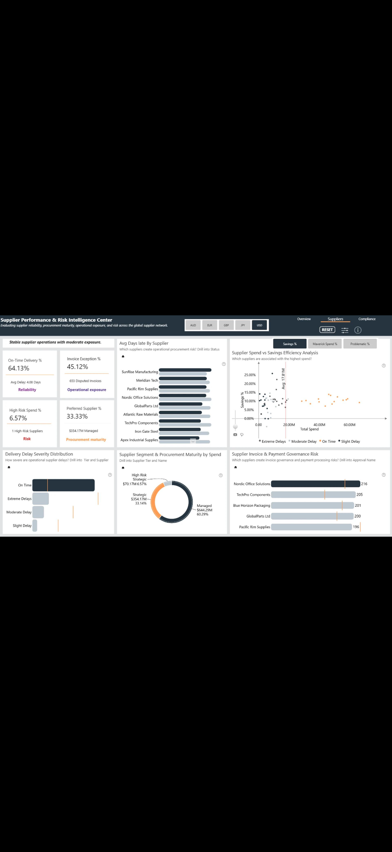
Suggested summary: A supplier intelligence dashboard consolidating delivery reliability, invoice exceptions, spend exposure, procurement maturity, and supplier risk into one decision-support view.
- Showcase supplier scorecards, delivery-delay distribution, spend-versus-savings analysis, invoice/payment governance, and procurement maturity.
- Use only metrics and claims supported by the resume or project data. Label illustrative dashboard figures as sample/demo data.

Project B — Inventory Analytics & Optimization
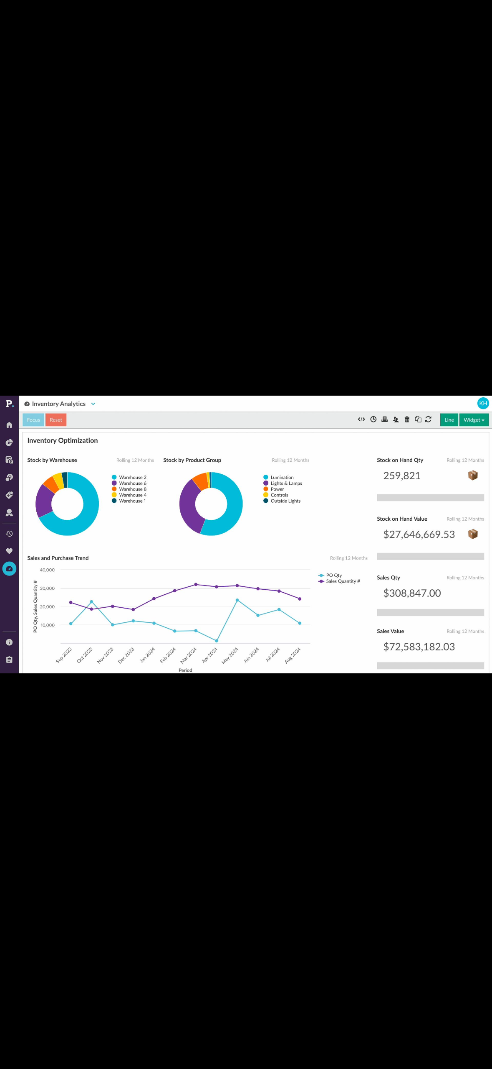
Suggested summary: An inventory analytics interface for monitoring stock by warehouse and product group, tracking sales and purchasing trends, and surfacing stock-on-hand quantity and value.
- Showcase warehouse/product-group mix, stock quantity and value, sales-versus-purchase trends, and time-based comparisons.
- Use a case-study structure: challenge → approach → dashboard/analysis → outcome. Confirm scope and outcomes from the resume before publishing.

Project C — Global Shipment Control Tower
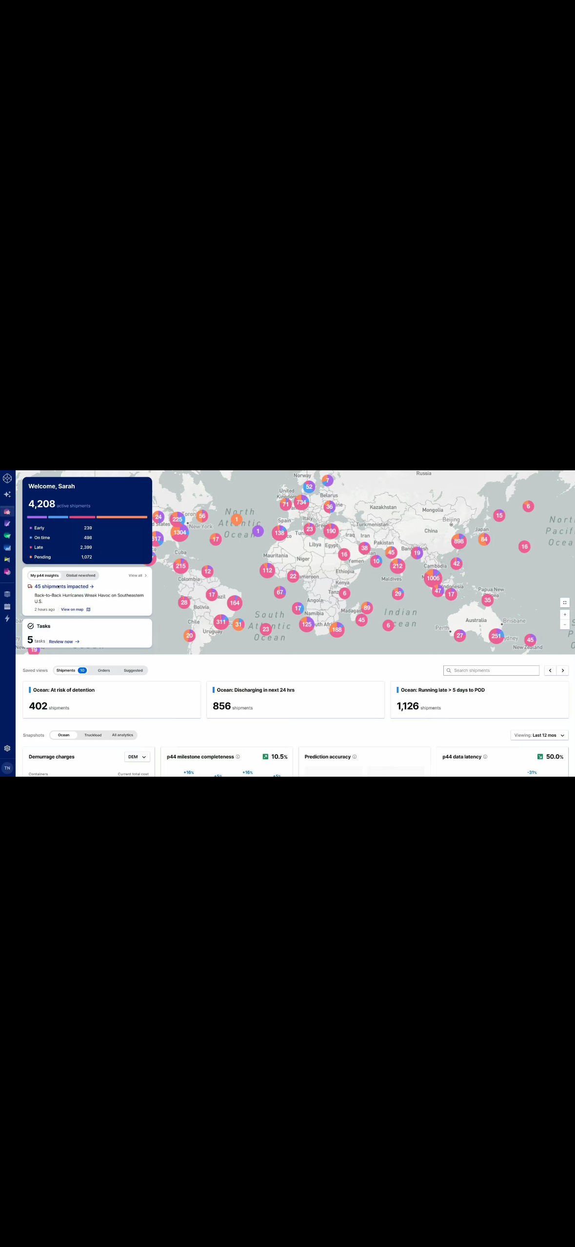
Suggested summary: A shipment visibility control tower bringing shipment status, delay risk, milestone progress, and delivery predictions into one operational workspace.
- Showcase global shipment map, exception alerts, task queue, shipment snapshots, milestone completion, prediction accuracy, and data latency.
- Keep the UI readable at presentation size. Pair a cropped hero image with concise explanatory copy and key features.

Project D — Control Tower Detail View
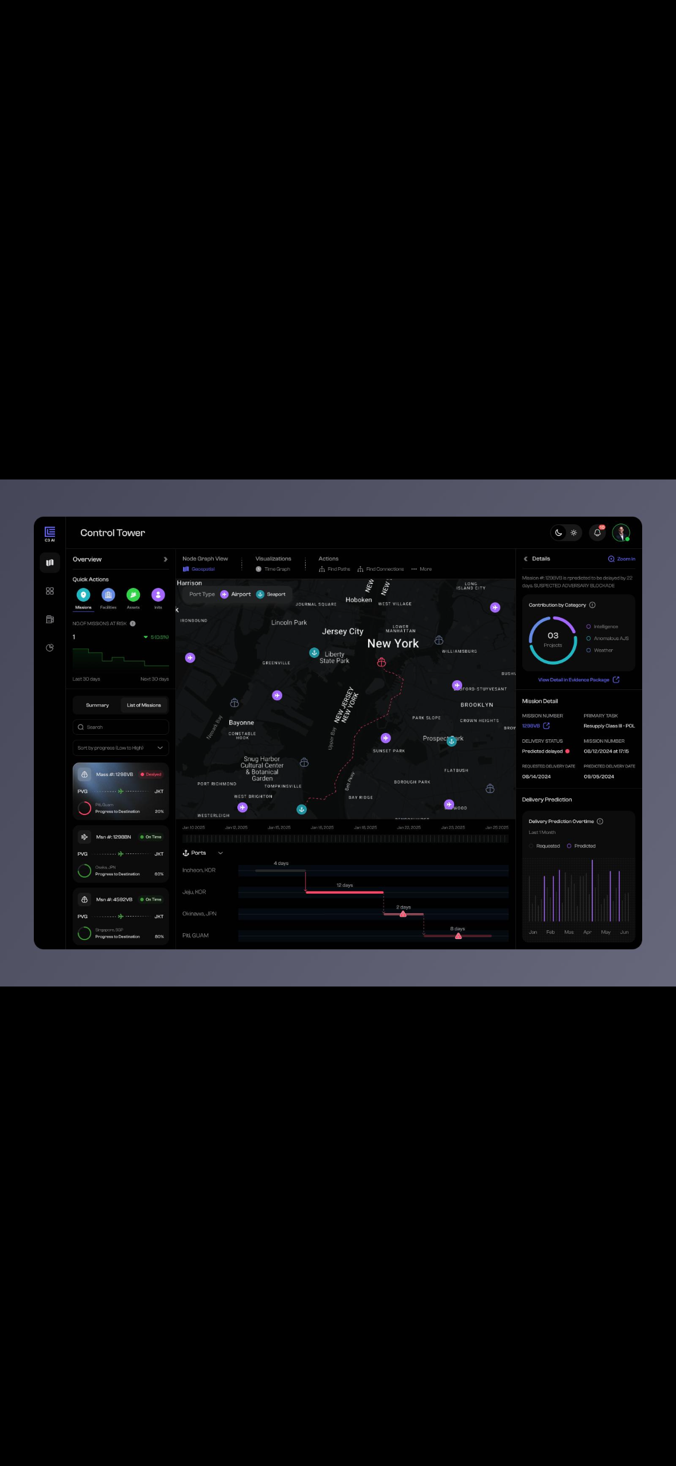
Suggested summary: A detailed control-tower view for investigating an individual shipment, including route context, mission status, port milestones, and delivery prediction.
- Use as a secondary detail image within the shipment-control-tower case study, not as a separate project unless the resume confirms it is distinct.

Project card content pattern
- Project title and one-sentence value proposition.
- Prominent image or interactive preview with consistent aspect ratio.
- Three or four capability tags (e.g. Power BI, SQL, Python, Forecasting, Inventory Optimization, Automation).
- Concise challenge / approach / outcome summary.
- Clear ‘View case study’ interaction; do not invent performance metrics.

Typography and layout system
- Typeface: Inter across all sections, headings, body copy, labels, buttons, and chart annotations.
- Use Inter Bold/ExtraBold for large headlines; Inter Medium/Semibold for section titles and KPI values; Inter Regular for body copy.
- Maintain consistent type scale, line height, and spacing. Do not mix display fonts from the reference screenshots.
- Use responsive content widths and generous whitespace. Keep hierarchy consistent across desktop and mobile.
- Images must be crisp, properly cropped, and adjacent to relevant copy. Avoid large empty black areas around dashboard screenshots.

Content and asset validation before final build
- The resume has not yet been included in this upload. Treat the copy as a draft based on supplied references and verify titles, dates, claims, and metrics against the resume before publication.
- Confirm whether the ICodeTest role and dashboard projects are resume-supported and whether each figure is an actual result or demo value.
- Collect original high-resolution container/tank and hero assets; avoid upscaling low-resolution screenshots.
- Prepare desktop, tablet, and mobile crops. Test motion timing, contrast, text legibility, keyboard access, and reduced-motion behaviour.
- Deliver everything as one continuous portfolio build, with each image adjacent to its corresponding content and motion notes.

PERSONAL PORTFOLIO WEBSITE
Creative Direction & Interactive Experience
Jagadeeswar Reddy | Supply Chain Analyst
Consolidated design brief • Sections, content, motion, interactions and responsive behaviour

01. Project Overview
Create a polished, personal portfolio that presents Jagadeeswar Reddy as a Supply Chain Analyst focused on demand planning, inventory optimization, procurement, analytics and operational automation. The experience should feel modern, confident and human—not like a generic template or an over-produced AI concept. Use the supplied visual references as the design language for the education, skills, contact and resume areas, while keeping all content grounded in the supplied CV.

Creative principles
- White and very light-grey foundation, with a faint grid texture and restrained blue/violet accents.
- Large editorial typography, generous whitespace, clean cards and subtle shadows.
- Use the supplied portrait and portfolio imagery without changing the subject’s identity or facial features.
- Motion should support reading and exploration: soft fades, directional reveals and gentle floating—not constant movement.
- Design intentionally for desktop, tablet and mobile. Replace hover-only behaviour with tap/focus interactions on touch devices.
- Respect reduced-motion preferences and keep all navigation, buttons, links and downloads functional.

02. Education — Academic Journey
Place Education immediately after the introductory/experience content in the page sequence. Treat this as a story about the academic foundation behind the analyst’s work, rather than a static list of qualifications.
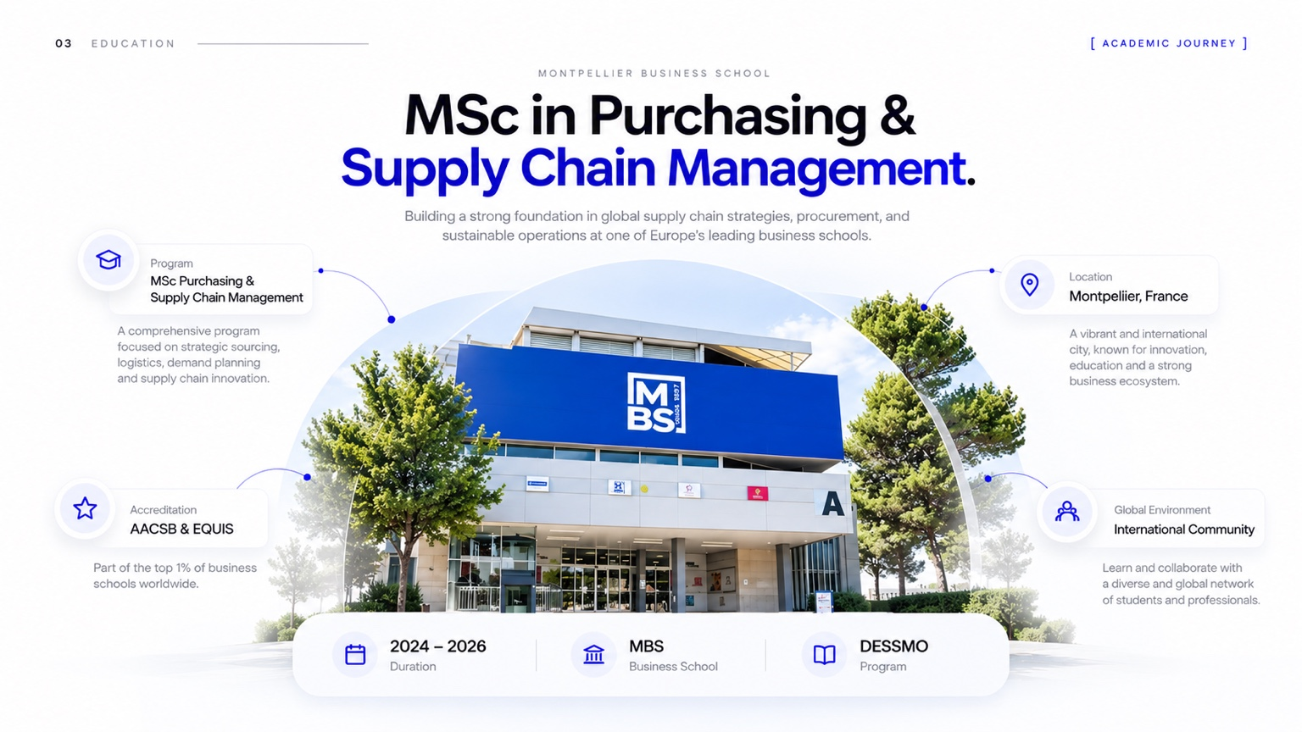
Reference: Academic Journey / education section

Content to include
MSc Purchasing & Supply Chain Management (DESSMO) | 2024–2026
MBS School of Business, France | AACSB & EQUIS accredited
Relevant modules: Strategic Sourcing, Demand Planning, Inventory Management, Logistics & Distribution, Financial Analysis and S&OP.
Thesis: The Impact of Inventory Management Efficiency on Working Capital and Firm Performance.
Bachelor of Commerce in Computer Applications | Tapasya Degree College, Hyderabad, India | 2018–2022.

Narrative copy
My academic journey combines business fundamentals with a focused understanding of purchasing and supply chain management. Through coursework in sourcing, demand planning, inventory and logistics, I developed a practical perspective on how decisions across the supply chain affect service, cost and working capital.

Motion direction
- Reveal the section label and headline with a low-distance fade (opacity 0→1; Y +16px→0; 600–750 ms).
- Bring the campus image in with a gentle scale settle (0.97→1.00) and fade; avoid dramatic zooms.
- Fade the qualification cards and supporting copy in sequence with a 90–130 ms stagger.
- Animate connector lines and small icon accents only after their related card appears.
- Trigger once as the section enters the viewport; do not replay on every scroll.

03. Skills & Expertise — Interactive Skills Landscape
Build the first skills presentation as an immersive composition. The main visual anchor is a laptop showing a supply-chain control-tower dashboard, surrounded by floating operational objects such as cartons, a barcode scanner, analytics tiles and a delivery truck. Skill/category cards should be distributed on both sides, with carefully balanced negative space.

Reference: Floating supply-chain skill landscape

Layout and interaction
- Position the laptop near the centre; float the category cards to the left and right, with staggered vertical alignment.
- Use slow, low-amplitude float loops on decorative objects (approximately 6–12 px over 4–7 seconds), with varied timing so the scene feels organic.
- On hover or focus, category cards lift slightly, sharpen their shadow and reveal a concise supporting line.
- Allow the laptop/dashboard to respond to pointer movement with a very subtle 3D tilt; disable this on touch and reduced-motion settings.
- Use scroll-linked parallax sparingly. The overall composition should remain stable and readable.
- On mobile, stack the skill cards above and below a scaled dashboard visual; do not force the desktop orbit into a narrow viewport.

04. Skills & Expertise — Capability Cards
Follow the immersive visual with a more structured, interactive skills section. Use five capability cards connected visually to a central dashboard or workflow illustration. Cards should expand, reveal examples, or highlight associated tools when selected. The interactions must be meaningful rather than decorative.
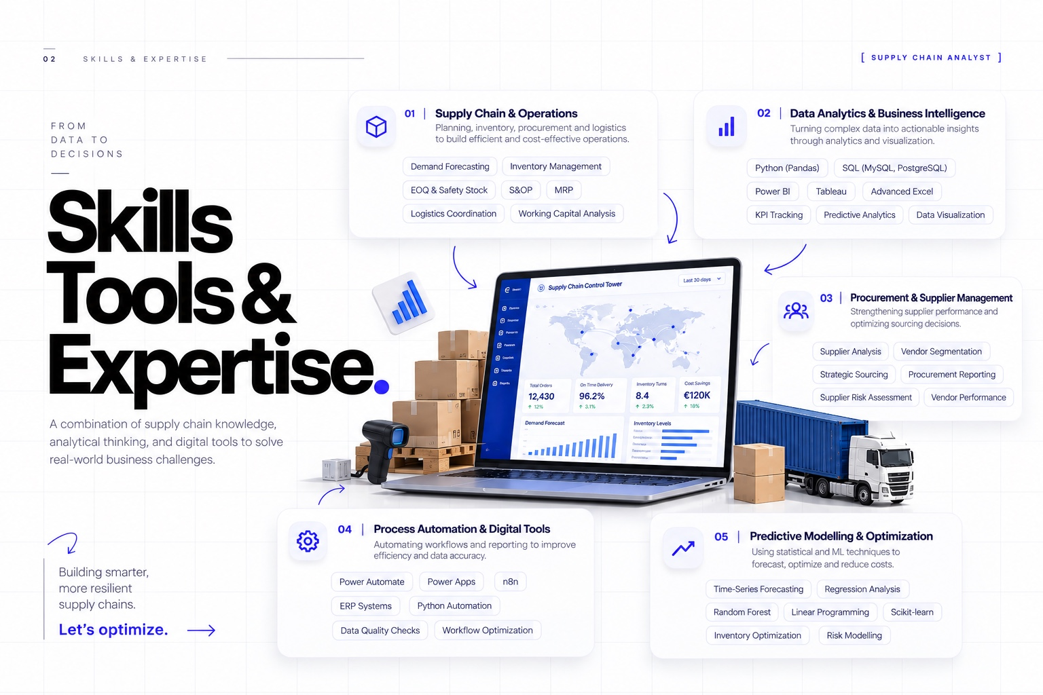
Reference: Skills and expertise capability-card layout

01 | Supply Chain & Operations
Demand Forecasting; Inventory Management (EOQ / Safety Stock); S&OP; MRP; Procurement & Vendor Analysis; Logistics Coordination; Working Capital Analysis.

02 | Data Analytics & Business Intelligence
Python (Pandas, NumPy, Scikit-learn); SQL (MySQL, PostgreSQL); Power BI; Tableau; Advanced Excel (PivotTables, Power Query); KPI Tracking; Predictive Analytics; Data Visualization.

03 | Procurement & Supplier Management
Supplier Analysis; Vendor Segmentation; Strategic Sourcing; Procurement Reporting; Supplier Risk Assessment; Vendor Performance.

04 | Process Automation & Digital Tools
ERP Systems; Power Apps; Power Automate; n8n; Python Automation; Data Quality Checks; Workflow Optimization.

05 | Predictive Modelling & Optimization
Time-Series Forecasting; Regression Analysis; Random Forest; Linear Programming; Scikit-learn; Inventory Optimization; Risk Modelling.

Interaction states
- Default: white cards with fine borders, restrained blue icons and clear labels.
- Hover/focus: card rises 4–6 px; border and icon accent strengthen; a short description or tool list becomes visible.
- Selected: one card remains expanded while the others reduce visual emphasis; selecting another card updates the state.
- Dashboard: animate chart lines/bars only when the relevant capability is selected, using short, calm transitions.
- Keyboard users must be able to reach and activate every card; provide visible focus states and semantic buttons.

05. Global Footer — Open to Opportunities
Use a consistent footer at the end of every page or major page template. The footer should act as a clear, low-friction invitation to connect, not a competing content section.

Suggested copy
OPEN TO OPPORTUNITIES
Let’s connect.
Open to discussing supply chain, analytics, operations and collaboration opportunities.
Primary action: Email Jagadeeswar Reddy
Email: jagadeeswarreddykannapu@gmail.com

Behaviour
- The email CTA must open a new email draft using a mailto link to the address above.
- Reveal the footer headline and supporting copy with a soft fade and slight upward movement.
- Animate the CTA underline or arrow from left to right on hover/focus.
- Keep the email address visible as text as well as linked, so the action is understandable and accessible.
- Reuse the same footer pattern consistently across Home, Projects, Education, Skills, Contact and Resume views.

06. Contact — Let’s Connect
The contact section should feel welcoming and personal, using the supplied portrait as the visual centrepiece and a clean message form on the opposite side. Keep the form visually light and ensure it works well on mobile.
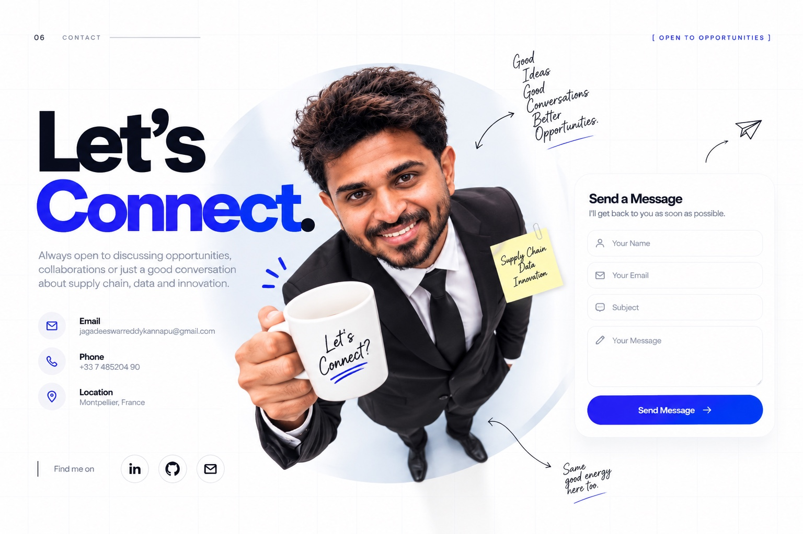
Reference: Contact / Let’s Connect

Content and fields
Headline: Let’s Connect.
Supporting copy: Always open to discussing opportunities, collaborations or a good conversation about supply chain, data and innovation.
Contact details: jagadeeswarreddykannapu@gmail.com | +33 7 485204 90 | Montpellier, France.
Form fields: Your Name, Your Email, Subject and Your Message. Include clear validation and a confirmation state.

Motion direction
- Fade in the headline and supporting copy, with each text block entering from the left (X −24px→0; 550–700 ms).
- Bring the portrait in with a gentle opacity and scale transition; avoid changing or morphing the face.
- Reveal the form from the right (X +24px→0), with fields appearing in a short stagger.
- Draw decorative arrows, underlines or hand-drawn accents from left to right after the main content settles.
- On submit, show a clear success or error message. Do not display a success state unless the form has actually been sent.

07. Resume — Download My Resume
Create a dedicated resume-download section near the end of the experience. It should feel like a tangible document card arriving into the page, with a single clear download action. Do not show multiple resume versions.
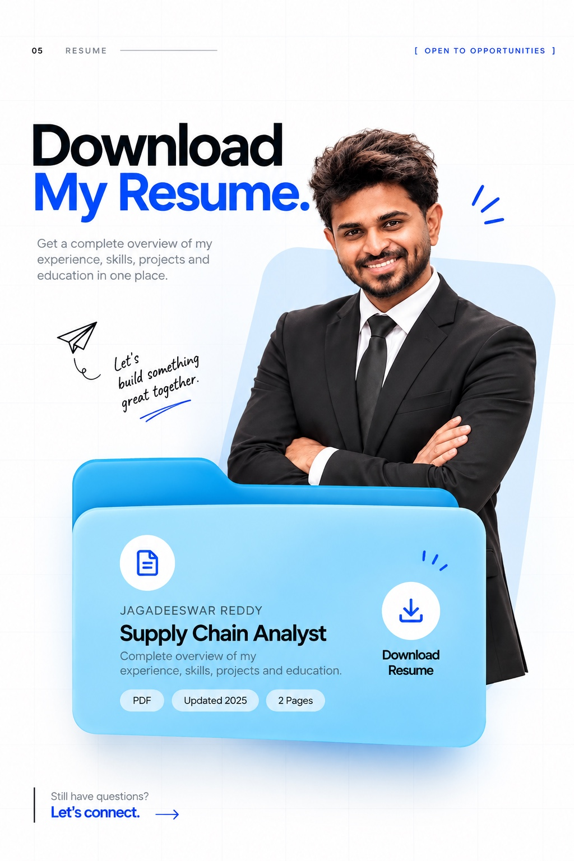
Reference: Resume download card

Content
Headline: Download My Resume.
Supporting copy: Get a complete overview of my experience, skills, projects and education.
Document card: Jagadeeswar Reddy | Supply Chain Analyst | PDF | Updated 2025 | 2 pages.
Primary CTA: Download Resume.

Motion direction
- The resume document/card enters from below (Y +36px→0) with opacity 0→1 over 650–850 ms.
- Decorative lines or small accent strokes draw from left to right after the card settles.
- The download icon may make a restrained 2–3 px response on hover/focus; avoid repeated bouncing.
- The button must link to the approved, current PDF file and use a descriptive accessible label.
- If the resume file is updated, replace the underlying asset without changing the visual component.

08. Site-Wide Motion & Accessibility Rules
Motion | Specification
Motion | Timing | Specification
Section reveal | 500–750 ms | Opacity 0→1; Y +14–20px→0; trigger once.
Text reveal | 500–700 ms | Left-to-right or upward block reveal; avoid word-by-word theatrics.
Card hover | 160–250 ms | Small lift, border emphasis and subtle shadow.
Floating objects | 4–7 s loop | Low-amplitude motion; pause or simplify on reduced motion.
Page transition | 350–550 ms | Soft crossfade or restrained directional slide.
Decorative line draw | 450–800 ms | Left-to-right, after the related content appears.
Accessibility and performance: honour prefers-reduced-motion; ensure contrast and visible keyboard focus; use semantic headings and buttons; provide meaningful image alt text; lazy-load below-the-fold imagery; keep animation transform/opacity-led; avoid layout shifts; and test every interaction at desktop, tablet and mobile breakpoints.

09. Final Page Flow
- Introduction / Profile
- Professional Experience and selected projects (retain the existing approved content)
- Education — Academic Journey
- Skills & Expertise — floating visual composition
- Skills & Expertise — interactive capability cards
- Contact — Let’s Connect
- Resume — Download My Resume
- Global footer — Open to Opportunities (also reused on all page templates)

10. Implementation Checklist
- Integrate these additions into the existing portfolio document and preserve the previously approved sections.
- Use the supplied CV as the source of truth for education, skills, experience, contact details and project claims.
- Place all five supplied reference images within the same master document beside their corresponding specifications.
- Ensure the contact email and footer CTA point to jagadeeswarreddykannapu@gmail.com.
- Ensure the resume CTA downloads the approved two-page PDF, not a placeholder or a second version.
- Build real interactions for cards, links, forms and download actions; avoid inert mock controls.
- Verify all copy, spacing, responsive behaviour, animation, accessibility and asset loading before handover.

