**ARRAYS -1 :**

**C# Sharp to store elements in an array and print it.**

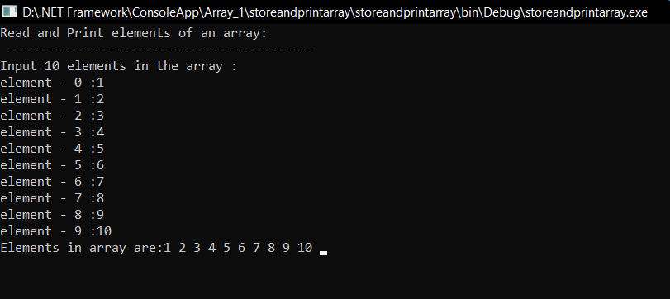

**Write a program in C# Sharp to read n number of values in an array and display it in reverse order.**

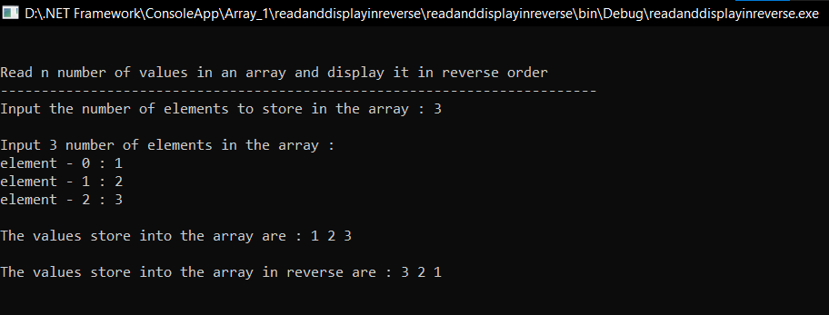

**Write a program in C# Sharp to find the sum of all elements of the array**.

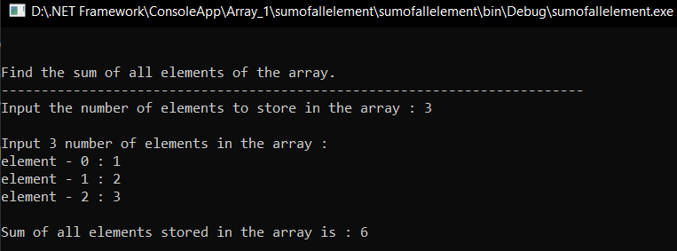

**Write a program in C# Sharp to copy the elements one array into another array.**

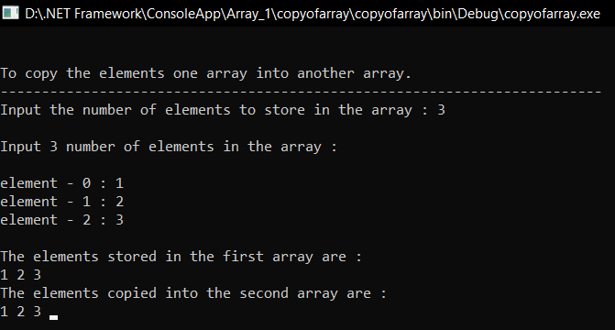

**C# Sharp to count a total number of duplicate elements in an array.**

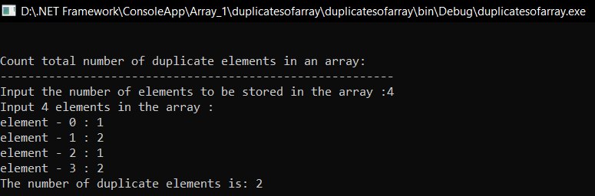

**C# Sharp to print all unique elements in an array**

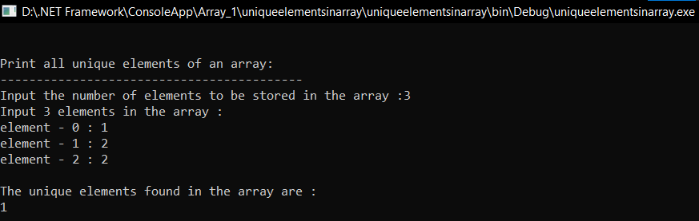

**C# Sharp to merge two arrays of same size sorted in ascending order.**

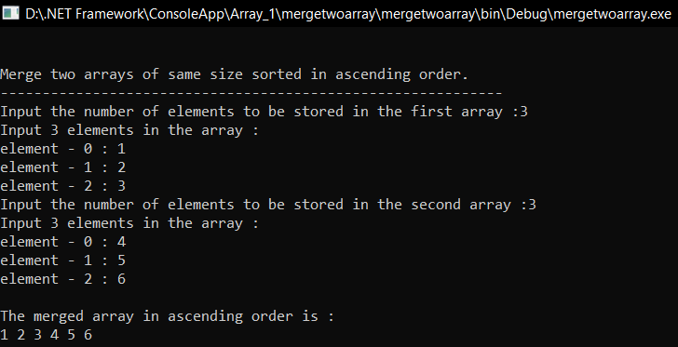

**C# Sharp to count the frequency of each element of an array**

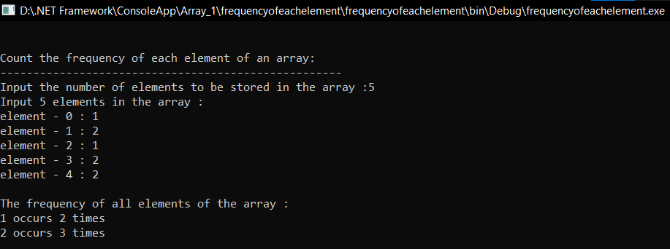

**C# Sharp to find maximum and minimum element in an array.**

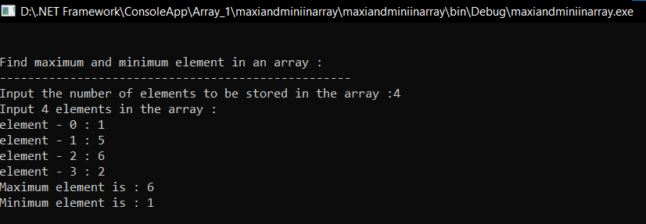

**C# Sharp to separate odd and even integers in separate arrays**

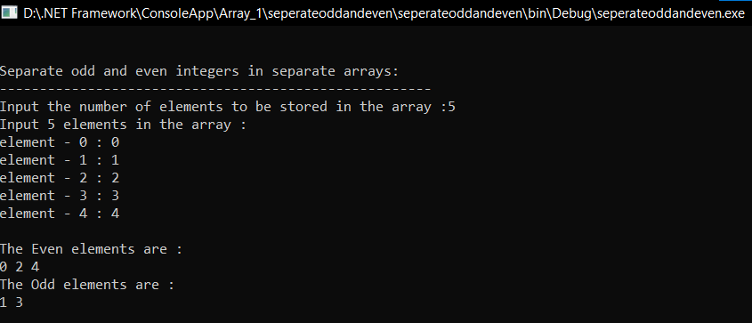

**ARRAYS - 2 :**

**C# Sharp for a 2D array of size 3x3 and print the matrix.**

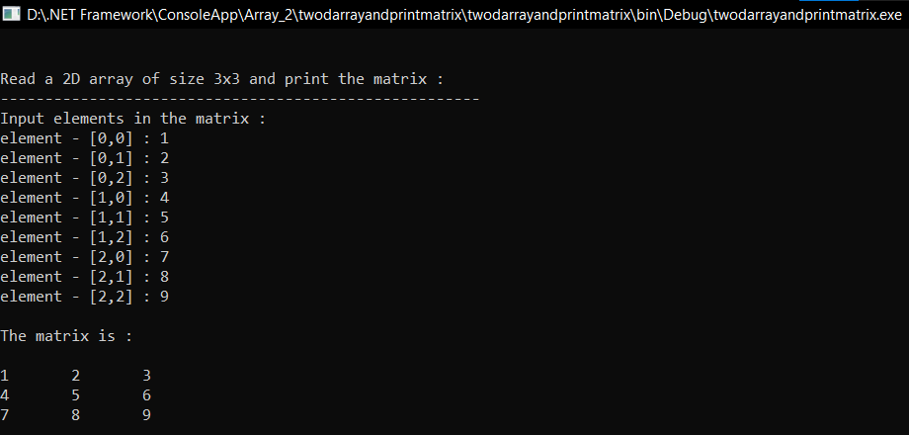

**C# Sharp for addition of two Matrices of same size**

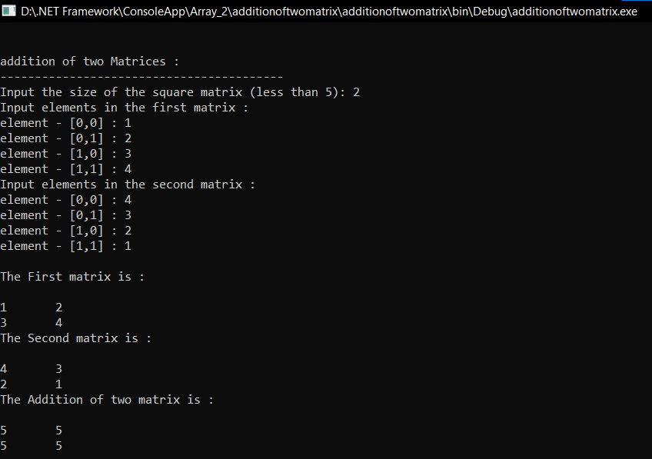

**C# Sharp for subtraction of two Matrices.**

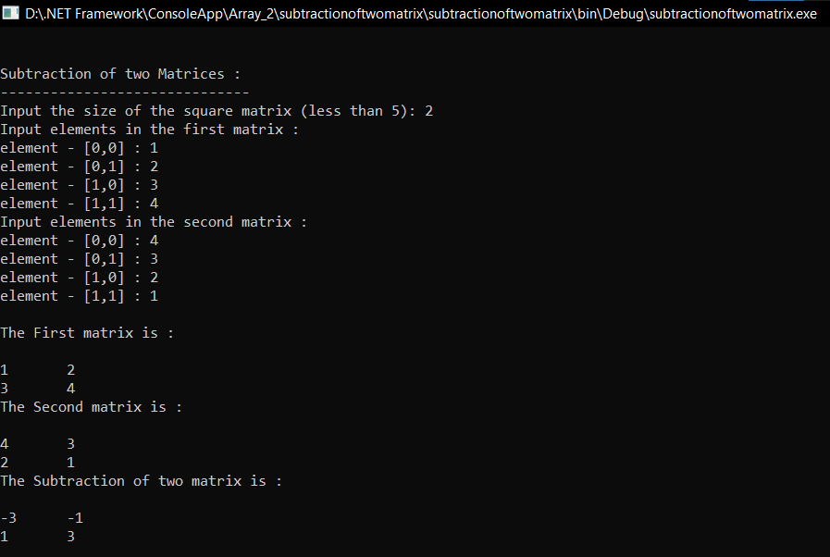

**C# Sharp for multiplication of two square Matrices.**

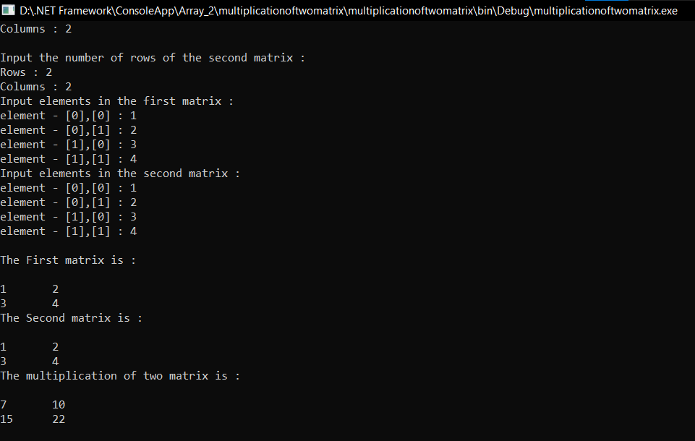

**C# Sharp to find transpose of a given matrix**.

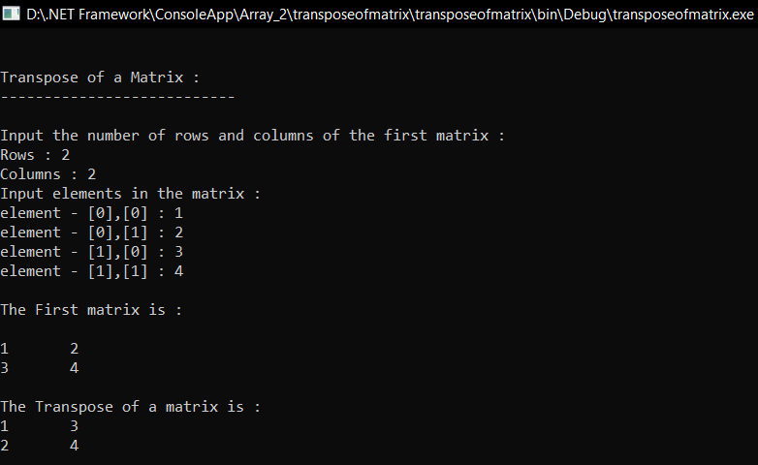

**METHODS :**

**C# Sharp to create a user define function.**

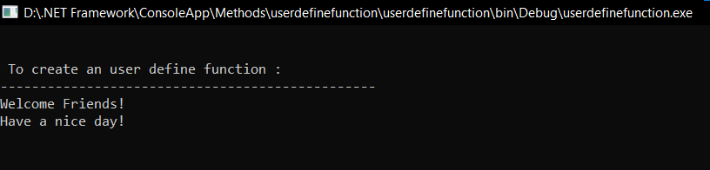

**C# Sharp to create a user define function with parameters.**

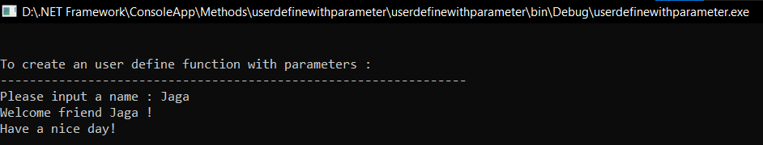

**C# Sharp to create a function for the sum of two numbers**.

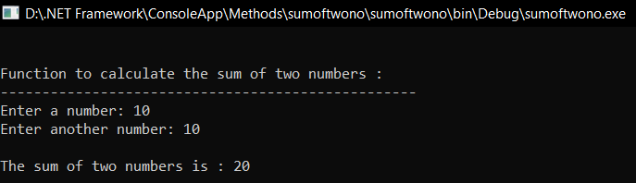

**C# Sharp to create a function to input a string and count number of spaces are in the string**

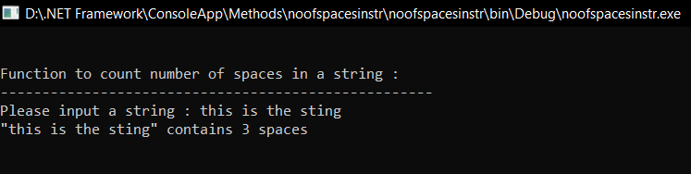

**C# Sharp to calculate the sum of elements in an array.**

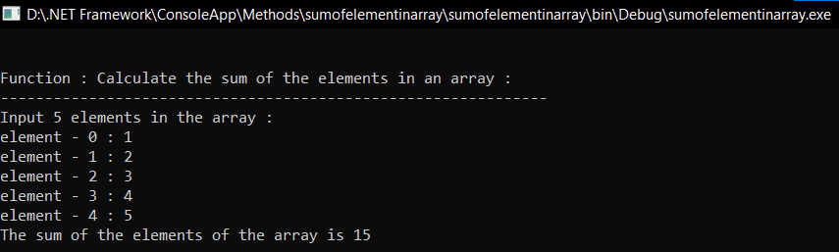

**C# Sharp to create a function to swap the values of two integer numbers**

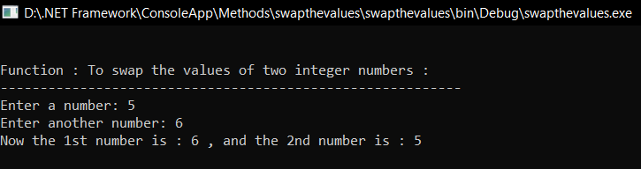

**C# Sharp to create a function to calculate the result of raising an integer number to another**

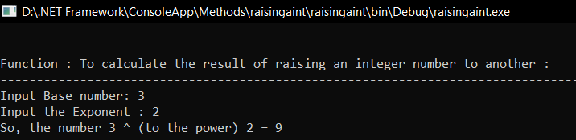

**C# Sharp to create a function to display the n number Fibonacci sequence**

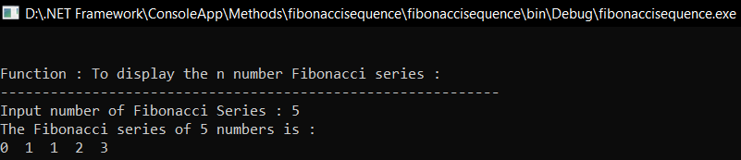

**C# Sharp to create a function to check whether a number is prime or not.**

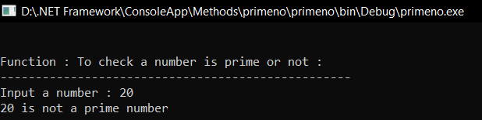

**C# Sharp to create a function to calculate the sum of the individual digits of a given number**

