**BRANCHING - 1:**

1. C# Sharp program to accept two integers and check whether they are equal or not:

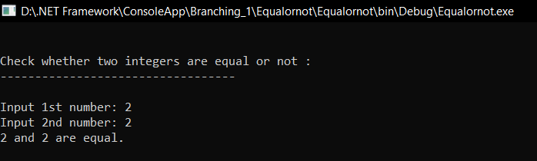

1. C# program to check whether a given number is even or odd:

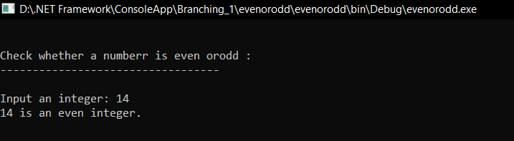

1. C# Sharp program to check whether a given number is positive or negative:

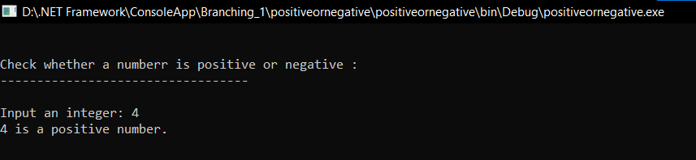

1. C# Sharp program to find whether a given year is a leap year or not:

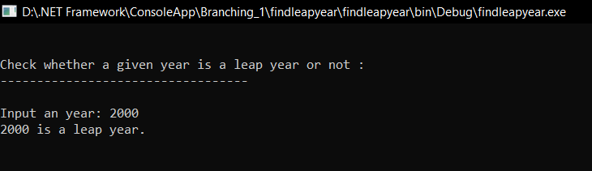

1. C# Sharp program to read age of a candidate and determine whether it is eligible for casting his/her own vote:

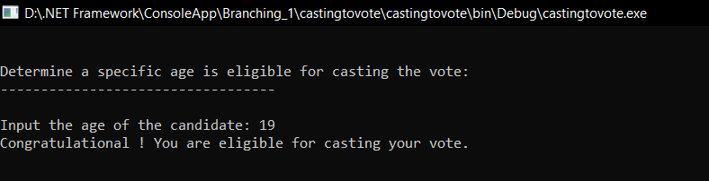

1. C# Sharp program to read the value of an integer m and display the value of n is 1 when m is larger than 0, 0 when m is 0 and -1 when m is less than 0:

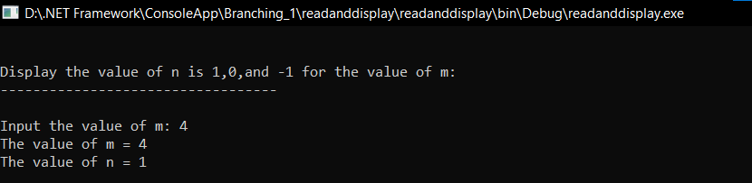

1. C# Sharp program to accept the height of a person in centimeter and categorize the person according to their height:

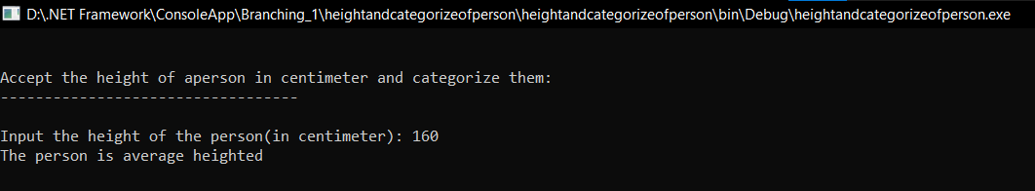

8.C# program to find the largest of three numbers:

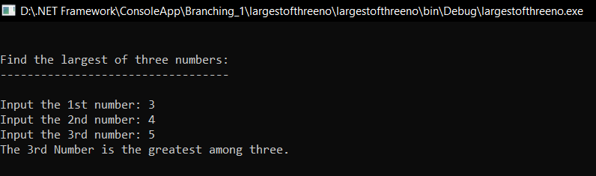

9.C# program to accept a coordinate point in an XY coordinate system and determine in which quadrant the coordinate point lies:

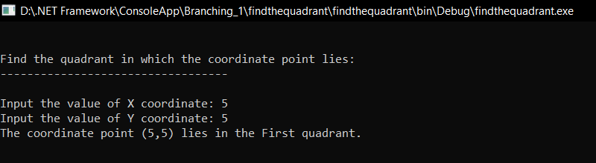

10.C# program to find the eligibility of admission for a professional course based on the following criteria:

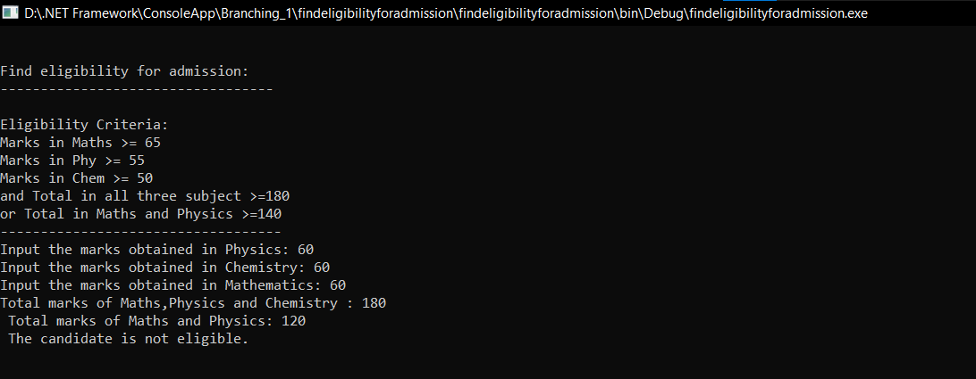

**BRANCHING - 2:**

1. C# Sharp which is a Menu-Driven Program to perform a simple calculation.-Switch Case:

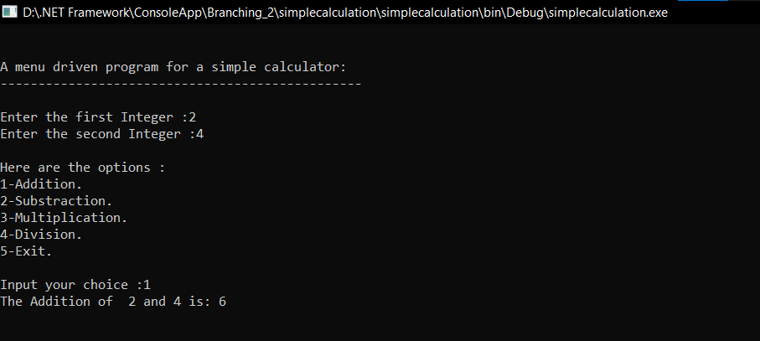

1. C# Sharp which is a Menu-Driven Program to compute the area of the various geometrical shape:

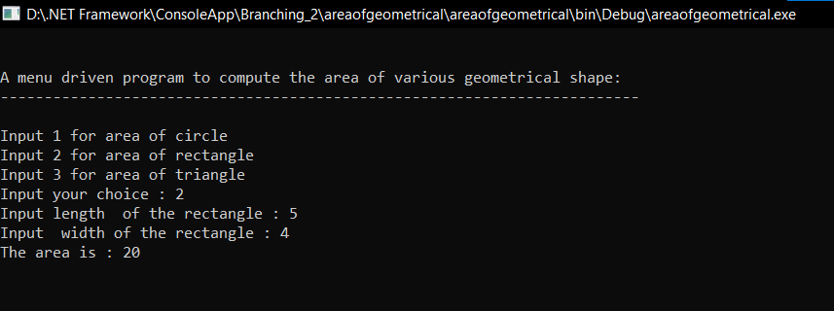

1. C# Sharp to read any Month Number in integer and display the number of days for this month:

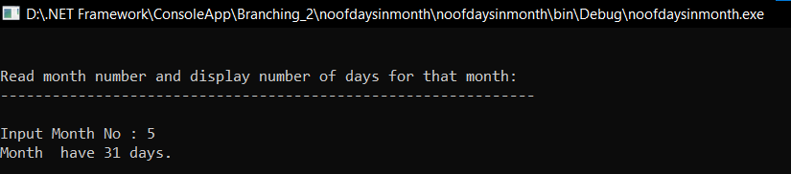

4.C# Sharp to read any Month Number in integer and display Month name in the word:

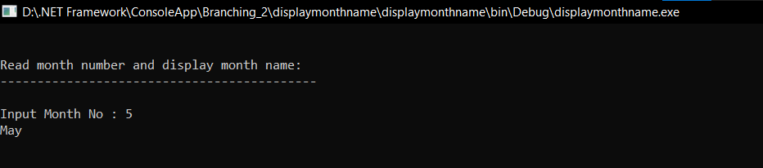

5.C# Sharp to read any digit, display in the word:

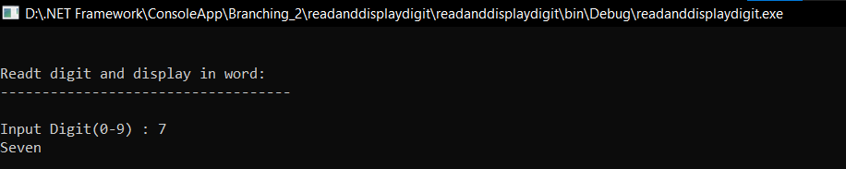

6.C# Sharp to read any day number in integer and display day name in the word:

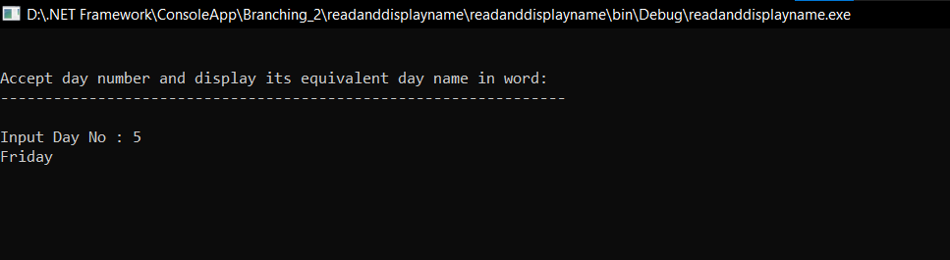

7.C# Sharp to accept a grade and display the equivalent description:

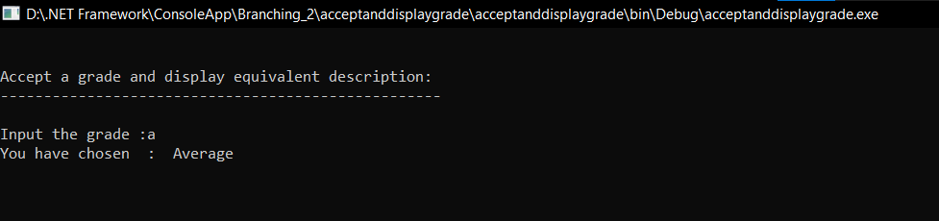

8.C# Sharp to calculate and print the Electricity bill of a given customer. The customer id., name and unit consumed by the user should be taken from the keyboard and display the total amount to pay to the customer. The charge are as follow:

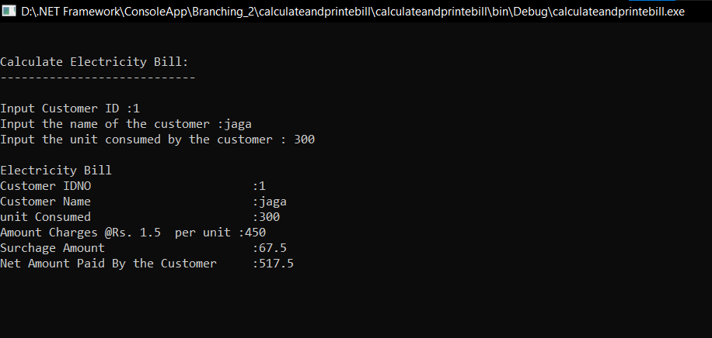

9.C# Sharp program to calculate profit and loss on a transaction:

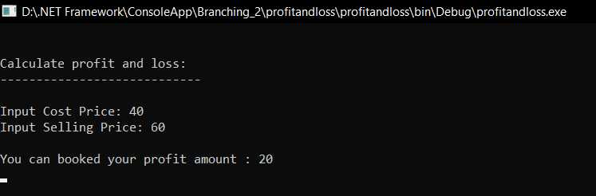

**LOOPING - 1:**

1. C# Sharp to display the first 10 natural numbers:

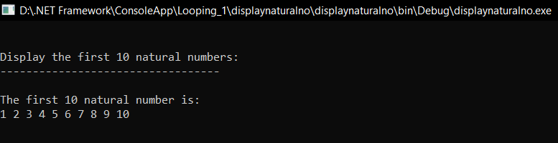

2.C# Sharp program to find the sum of first 10 natural numbers:

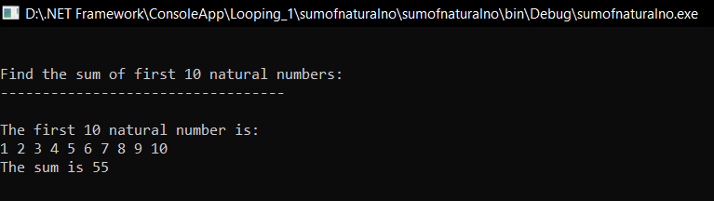

3.C# Sharp to display n terms of natural number and their sum:

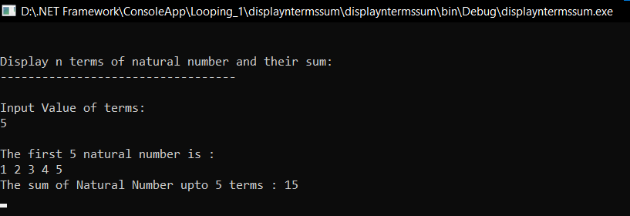

1. C# Sharp to read 10 numbers from keyboard and find their sum and average:

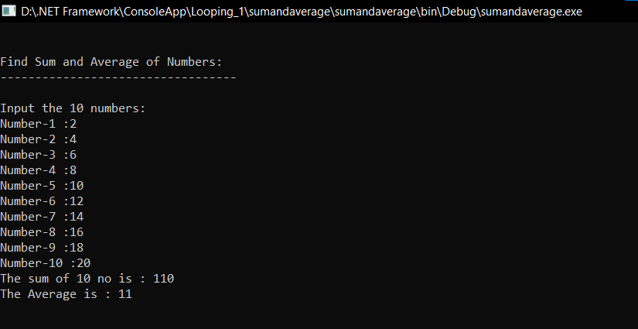

1. C# Sharp to display the cube of the number upto given an integer:

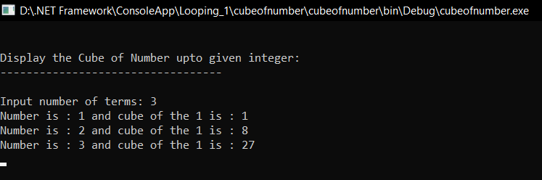

1. C# Sharp to display the multiplication table of a given integer:

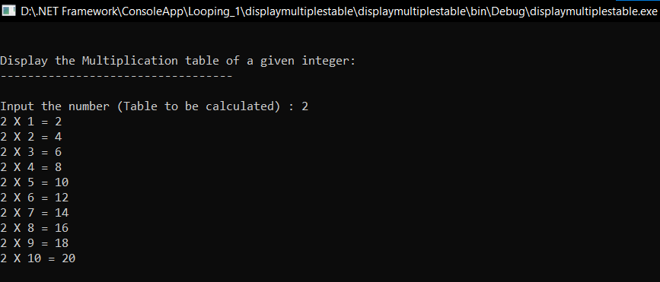

1. C# Sharp to display the multiplication table vertically from 1 to n:

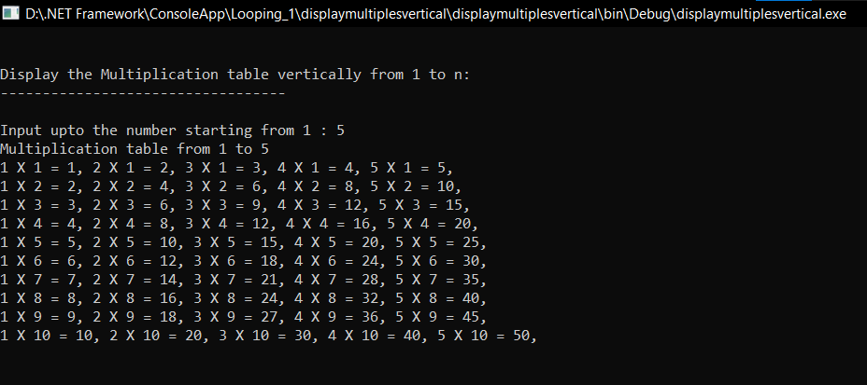

1. C# Sharp to display the n terms of odd natural number and their sum:

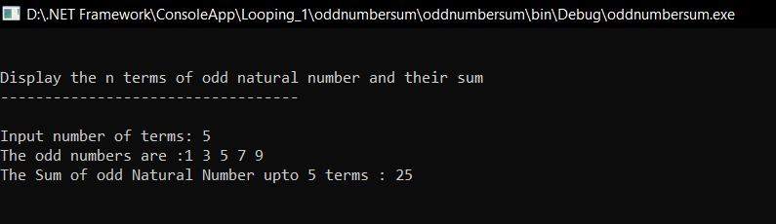

9.C# Sharp to display the pattern like right angle triangle using an asterisk:

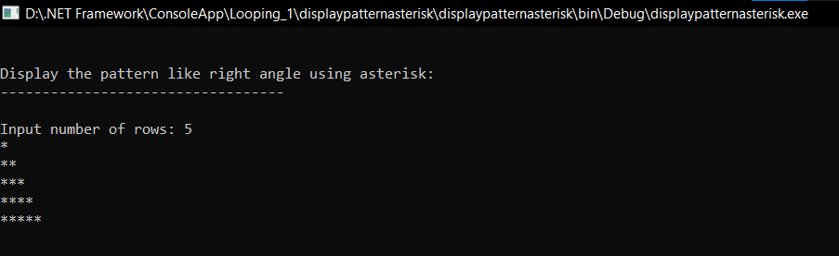

10. C# Sharp to display the pattern like right angle triangle with a number:

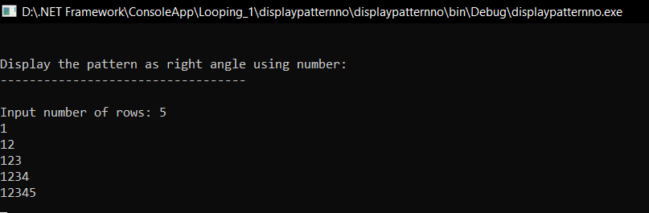

**LOOPING - 2:**

1. C# to display the pattern like a diamond. The pattern is as follows :

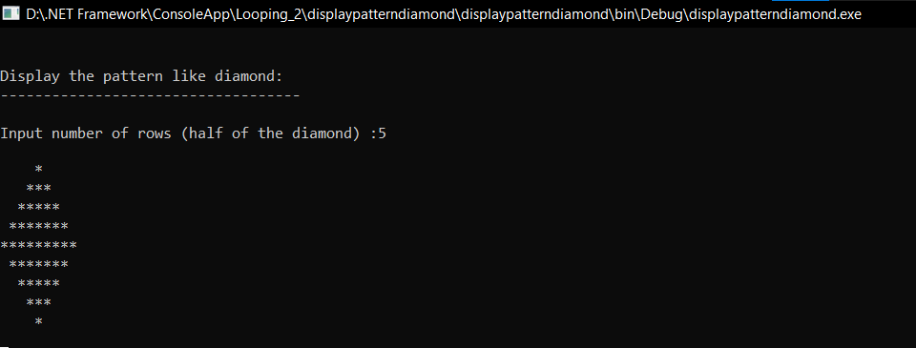

1. C# Sharp to find the prime numbers within a range of numbers:

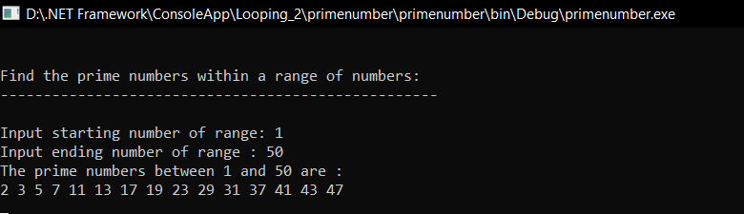

1. C# Sharp to display the such a pattern for n number of rows using a number which will start with the number 1 and the first and a last number of each row will be 1

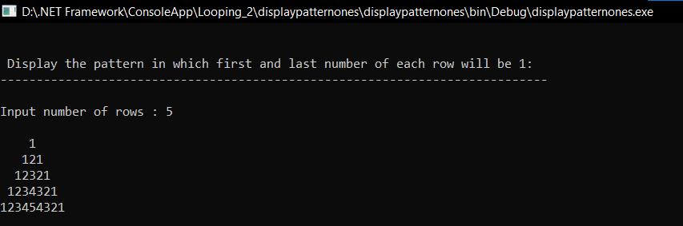

1. C# Sharp to display the number in reverse order:

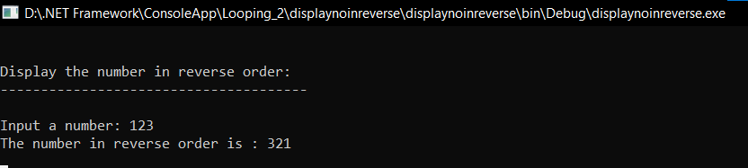

1. C# Sharp to check whether a number is a palindrome or not:

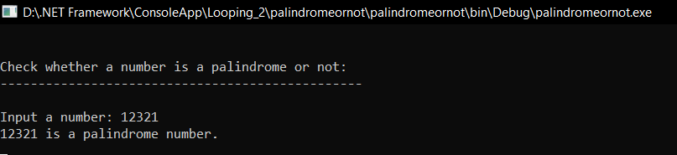

1. C# Sharp to find the number and sum of all integer between 100 and 200 which are divisible by 9:

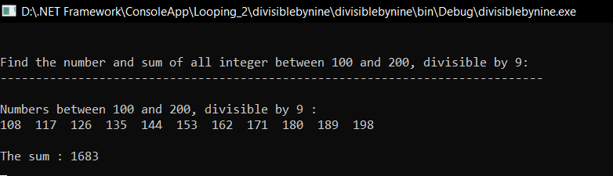

1. C# Sharp to convert a binary number into a decimal number without using array, function and while loop:

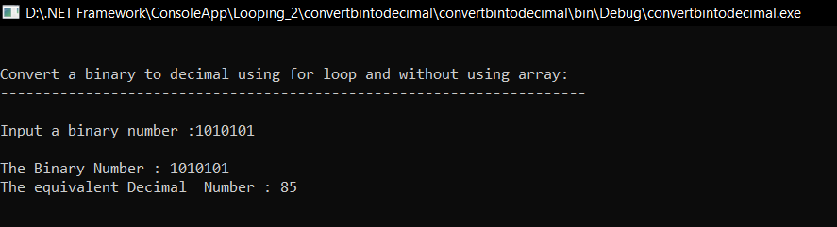

8.C# Sharp program to find HCF (Highest Common Factor) of two numbers:

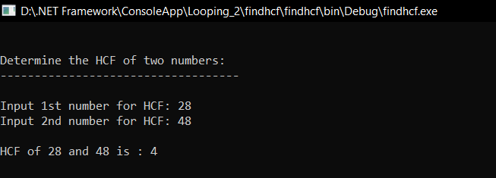

9.C#Sharp program to display alphabet pattern like A with an asterisk:

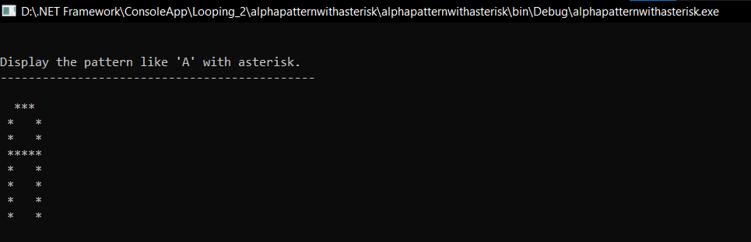

10.C#Sharp program to display alphabet pattern like D with an asterisk:

