**INTERFACE - 1 :**

**CODE :**

using System;

using System.Collections.Generic;

using System.Linq;

using System.Text;

using System.Threading.Tasks;

namespace stallproblem

{

interface Stall

{

void display();

}

class GoldStall : Stall

{

public string StallName { get; private set; }

public int Cost { get;private set; }

public string OwnerName { get; private set; }

public int TvSet { get; private set; }

public GoldStall(string stallName, int cost, string ownerName, int tvSet)

{

this.StallName = stallName;

this.Cost = cost;

this.OwnerName = ownerName;

this.TvSet = tvSet;

}

public void display()

{

Console.WriteLine($"StallName : {StallName}");

Console.WriteLine($"Cost : {Cost}");

Console.WriteLine($"OwnerName : {OwnerName}");

Console.WriteLine($"Number of TV Set : {TvSet}");

}

}

class PremiumStall : Stall

{

public string StallName { get; private set; }

public int Cost { get;private set; }

public string OwnerName { get; private set; }

public int Projector { get; private set; }

public PremiumStall(string stallName, int cost, string ownerName, int projector)

{

this.StallName = stallName;

this.Cost = cost;

this.OwnerName = ownerName;

this.Projector = projector;

}

public void display()

{

Console.WriteLine($"StallName : {StallName}");

Console.WriteLine($"Cost : {Cost}");

Console.WriteLine($"OwnerName : {OwnerName}");

Console.WriteLine($"Number of Projectors : {Projector}");

}

}

class ExecutiveStall : Stall

{

public string StallName { get; private set; }

public int Cost { get; private set; }

public string OwnerName { get; private set; }

public int Screen { get; private set; }

public ExecutiveStall(string stallName, int cost, string ownerName, int screen)

{

this.StallName = stallName;

this.Cost = cost;

this.OwnerName = ownerName;

this.Screen = screen;

}

public void display()

{

Console.WriteLine($"StallName : {StallName}");

Console.WriteLine($"Cost : {Cost}");

Console.WriteLine($"OwnerName : {OwnerName}");

Console.WriteLine($"Number of Screens : {Screen}");

}

}

class Program

{

static void Main(string[] args)

{

Console.WriteLine("ChooseStall Type");

Console.WriteLine("1)Gold Stall");

Console.WriteLine("2)Premium Stall");

Console.WriteLine("3)Executive Stall");

int option;

option = Convert.ToInt32(Console.ReadLine());

switch (option)

{

case 1:

GoldStall g = new GoldStall("The Mechanic", 120000, "Johnson", 10);

g.display();

break;

case 2:

PremiumStall p = new PremiumStall("Knitting plaza", 300000, "Zain", 20);

p.display();

break;

default:

ExecutiveStall e = new ExecutiveStall("Fruits Hunt", 10000, "Uber", 7);

e.display();

break;

}

Console.ReadLine();

}

}

}

**OUTPUT :**

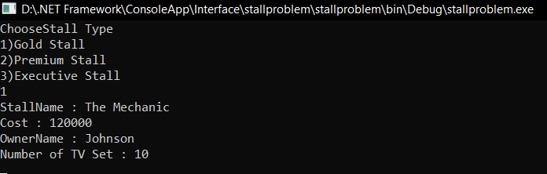

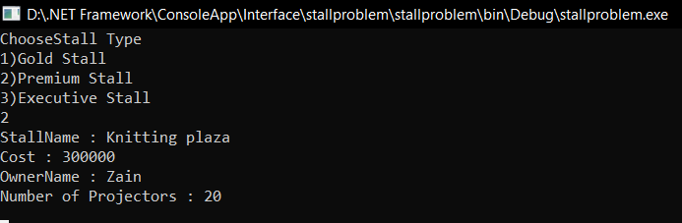

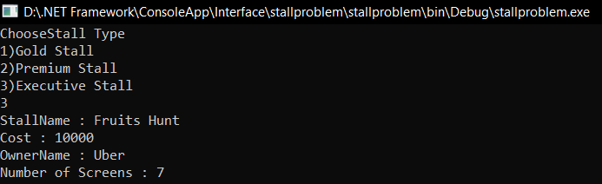

**INTERFACE -2 :**

**CODE :**

using System;

using System.Collections.Generic;

using System.Linq;

using System.Text;

using System.Threading.Tasks;

namespace banksystem

{

interface Bank

{

void InterestCalc(int a);

}

class Deposit : Bank

{

string Customer;

double Balance;

float Rate;

public Deposit(string customer,double balance,float rate)

{

this.Customer = customer;

this.Balance = balance;

this.Rate = rate;

}

public void InterestCalc(int months)

{

float res = 0;

if (Balance>0 && Balance<1000)

{

Console.WriteLine($"Interest rate : {res}");

}

else

{

res = months * Rate;

Console.WriteLine($"Interest rate : {res}");

}

}

}

class Loan : Bank

{

string Customer;

double Balance;

float Rate;

public Loan (string customer, double balance, float rate)

{

this.Customer = customer;

this.Balance = balance;

this.Rate = rate;

}

public void InterestCalc(int months)

{

float res = 0;

if ((Customer== "Individual")&&(months<3))

{

Console.WriteLine($"Interest rate : {res}");

}

else if ((Customer == "Company") && (months < 2))

{

Console.WriteLine($"Interest rate : {res}");

}

else

{

if (Customer == "Individual")

{

months = months - 3;

res = months * Rate;

Console.WriteLine($"Interest rate : {res}");

}

else

{

months = months - 2;

res = months * Rate;

Console.WriteLine($"Interest rate : {res}");

}

}

}

}

class Mortage : Bank

{

string Customer;

double Balance;

float Rate;

public Mortage(string customer, double balance, float rate)

{

this.Customer = customer;

this.Balance = balance;

this.Rate = rate;

}

public void InterestCalc(int months)

{

float res = 0;

if ((Customer == "Individual") && (months < 6))

{

Console.WriteLine($"Interest rate : {res}");

}

else if ((Customer == "Company") && (months < 12))

{

res = (months * Rate)/2;

Console.WriteLine($"Interest rate : {res}");

}

else

{

if (Customer == "Individual")

{

months = months - 6;

res = months * Rate;

Console.WriteLine($"Interest rate : {res}");

}

else

{

res = (12 * Rate) / 2;

months = months - 12;

res += months * Rate;

Console.WriteLine($"Interest rate : {res}");

}

}

}

}

class Program

{

static void Main(string[] args)

{

Console.WriteLine("Choose Types Of Accounts :");

Console.WriteLine("-------------------------------------------");

Console.WriteLine("1. Deposit Account");

Console.WriteLine("2. Loan Account");

Console.WriteLine("3. Mortage Account");

int accountType;

accountType = Convert.ToInt32(Console.ReadLine());

switch(accountType)

{

case 1:

double bal;

float ir;

int m;

Console.Write("Enter Balance :");

bal = Convert.ToDouble(Console.ReadLine());

Console.Write("Enter Interest Rate :");

ir = float.Parse(Console.ReadLine());

Deposit d = new Deposit("Individual", bal, ir);

Console.Write("Enter No.Of.Months :");

m = Convert.ToInt32(Console.ReadLine());

d.InterestCalc(m);

break;

case 2:

double b;

float i;

string acc;

int m1;

Console.Write("Enter Balance :");

b = Convert.ToDouble(Console.ReadLine());

Console.Write("Enter Interest Rate :");

i = float.Parse(Console.ReadLine());

Console.WriteLine("Choose Account Type :");

Console.WriteLine("1.Individual");

Console.WriteLine("2.Company");

int no;

no = Convert.ToInt32(Console.ReadLine());

if(no==1)

{

acc = "Individual";

}

else

{

acc = "Company";

}

Loan l = new Loan(acc, b, i);

Console.Write("Enter No.Of.Months :");

m1 = Convert.ToInt32(Console.ReadLine());

l.InterestCalc(m1);

break;

case 3:

double b1;

float i1;

string acc1;

int m2;

Console.Write("Enter Balance :");

b1 = Convert.ToDouble(Console.ReadLine());

Console.Write("Enter Interest Rate :");

i1 = float.Parse(Console.ReadLine());

Console.WriteLine("Choose Account Type :");

Console.WriteLine("1.Individual");

Console.WriteLine("2.Company");

int no1;

no1 = Convert.ToInt32(Console.ReadLine());

if (no1 == 1)

{

acc1 = "Individual";

}

else

{

acc1 = "Company";

}

Mortage mo = new Mortage(acc1, b1, i1);

Console.Write("Enter No.Of.Months :");

m2 = Convert.ToInt32(Console.ReadLine());

mo.InterestCalc(m2);

break;

}

Console.ReadLine();

}

}

}

**OUTPUT :**

