**COMPETITIVE PROGRAMMING**

3. Print Intersection of 2 sorted arrays-O(m*n)Time Complexity, O(1) Space Complexity

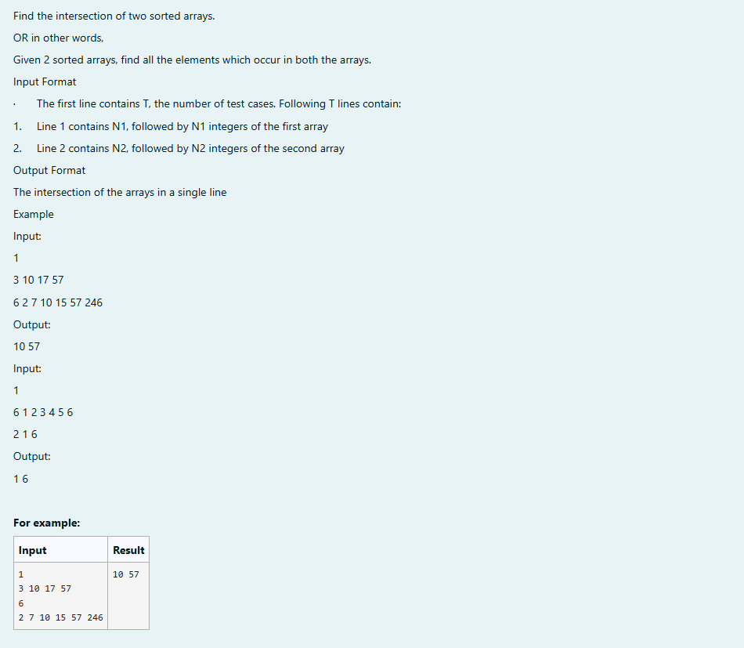

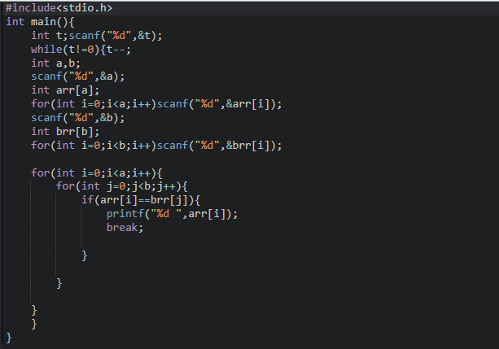

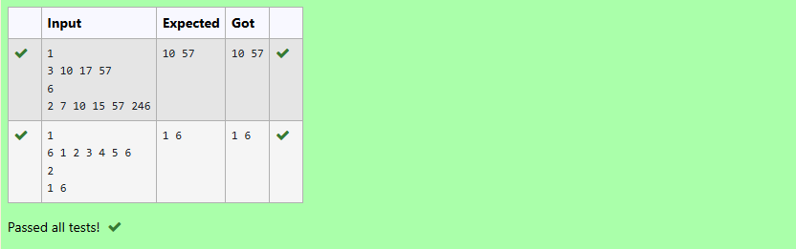

4. Print Intersection of 2 sorted arrays-O(m+n)Time Complexity,O(1) Space Complexity

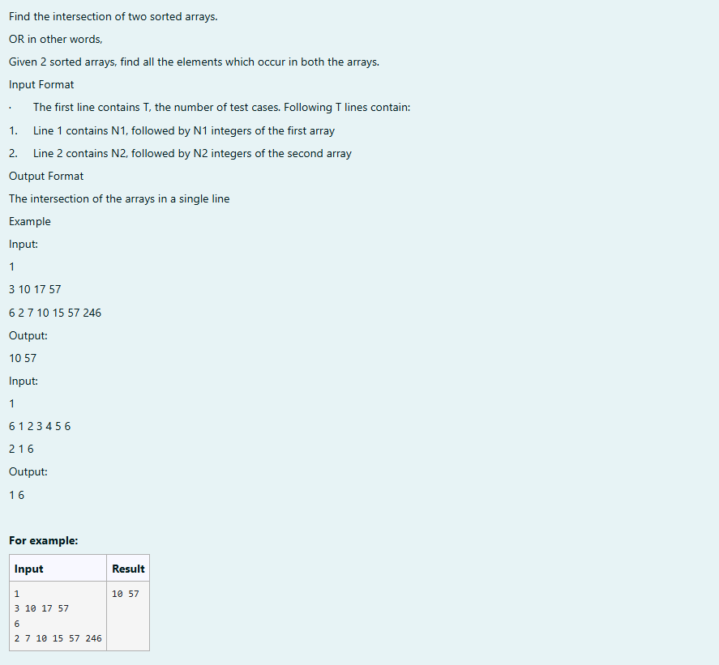

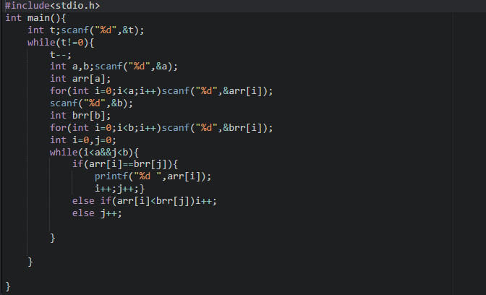

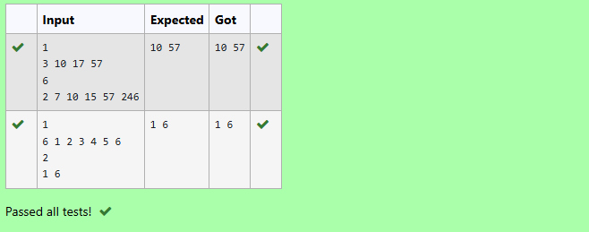

5. Pair with Difference-O(n^2) Time Complexity, O(1) Space Complexity

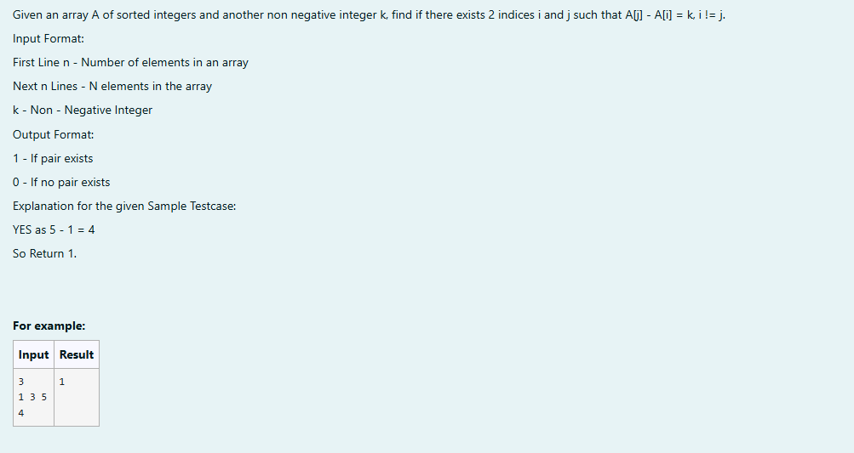

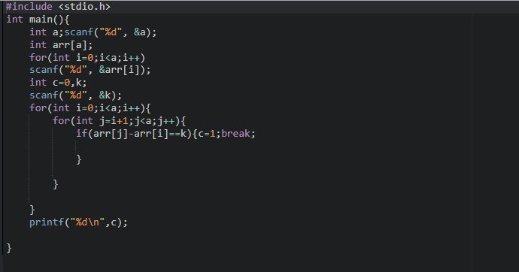

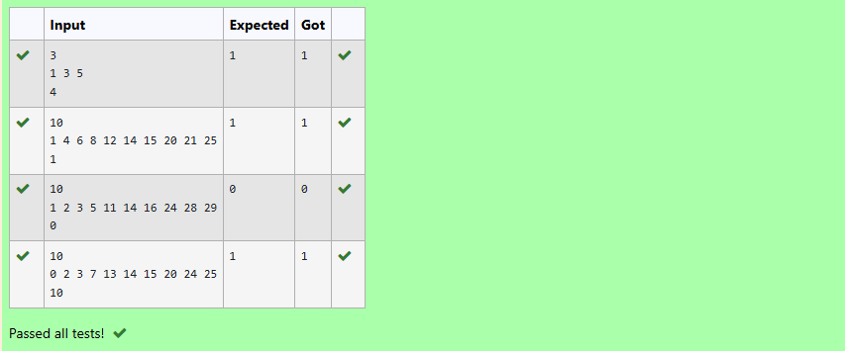

6. Pair with Difference -O(n) Time Complexity, O(1) Space Complexity

