**COMPETITIVE PROGRAMMING**

1. **Finding Duplicates-O(n^2) Time Complexity, O(1) Space Complexity**

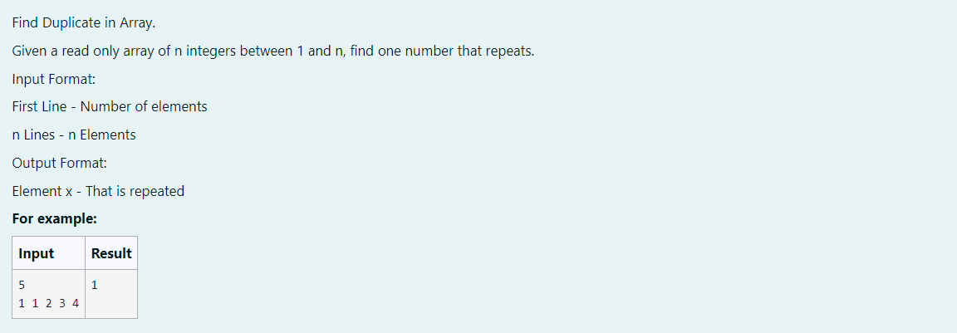

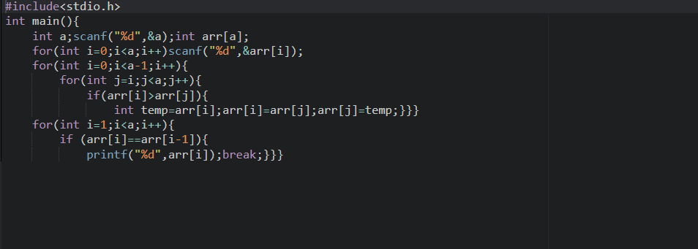

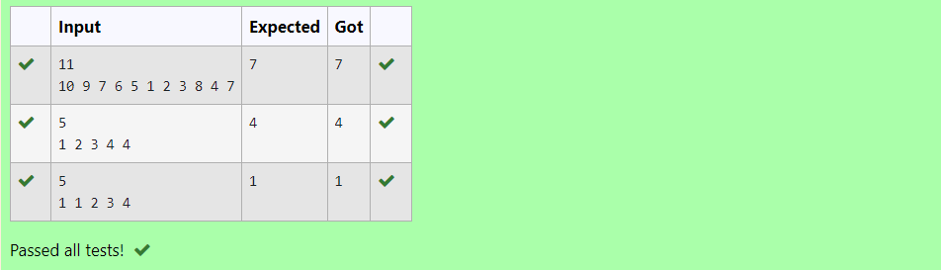

1. **Finding Duplicates-O(n) Time Complexity, O(1) Space Complexity**

