Technology Stack Used

NextJS

TypeScript

Moralis

Web 3 Authentication

Socket.IO (Real time application)

MetaMask (Sign up, Sign In)

MongoDB (Database)

Vercel (Deploy Site)

Features

* User can sign up by MetaMask and store data into MongoDB.
* User sign in by MetaMask and update data into MongoDB.
* User can update their profile by navigate to profile menu.
* User can add post by navigate New Post menu.
* User is able to update post by using edit button (top-right).
* User is able to show all posts
* User is able to show own posts.

Flow

* Initially user show all posts.
* After login or sign up he is navigating to own posts section.
* Login user has ability to edit, add posts as well show posts.
* Login user can update their profile.
* Updated profile reflect in post widget.

**Screenshots**

* 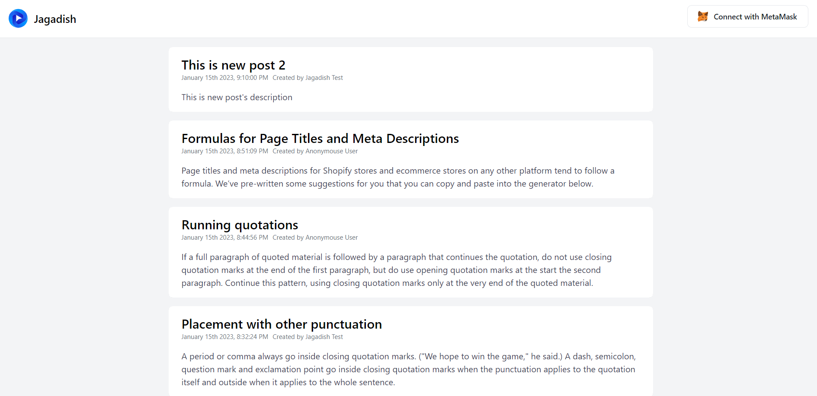User without sign in
* 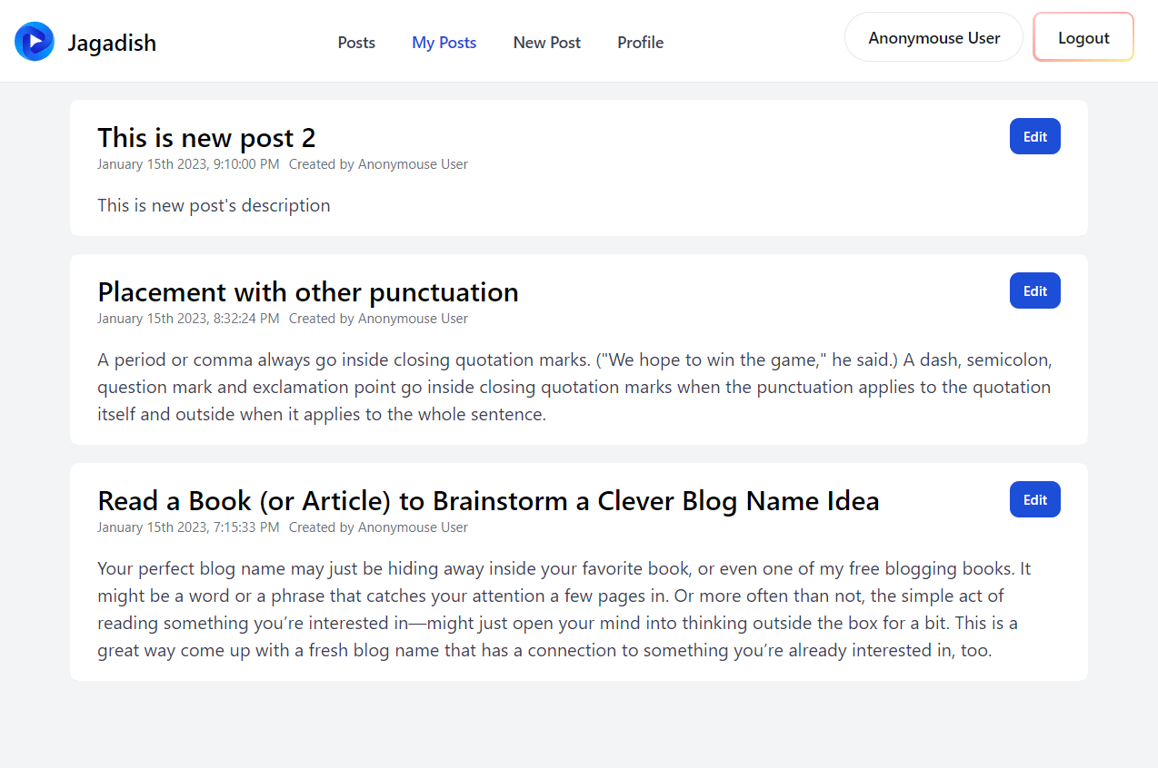Sign in user My Posts Section
* 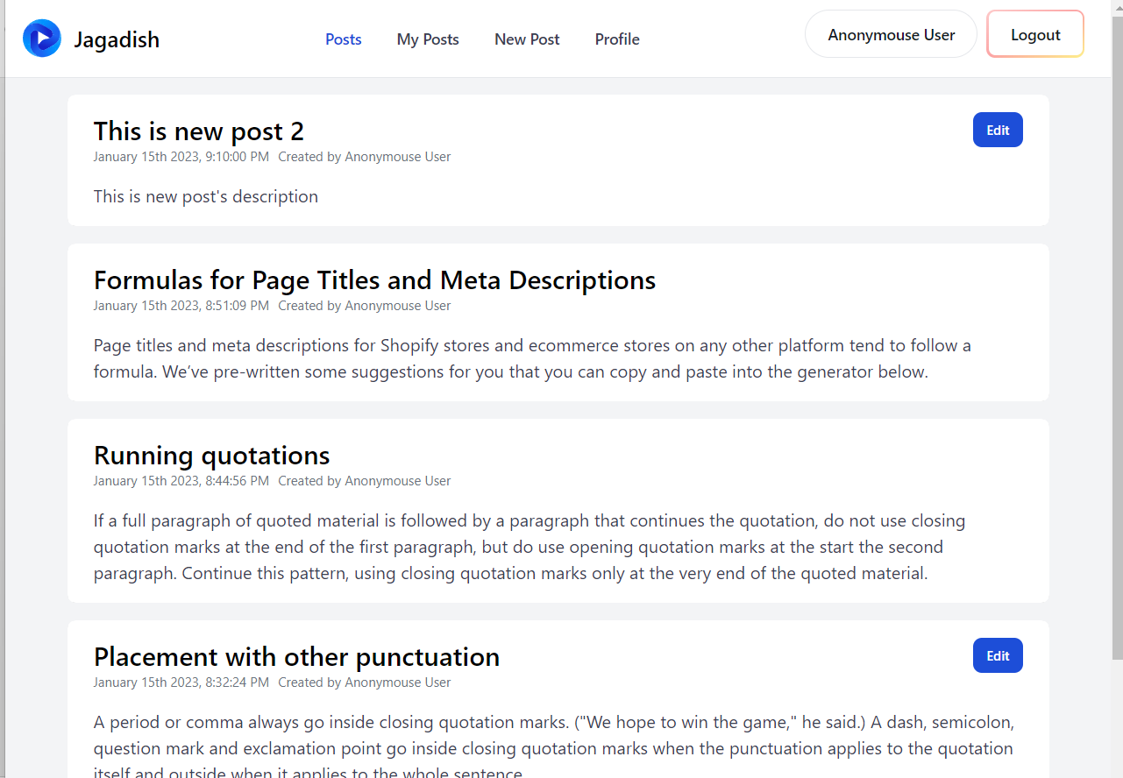Sign in User All Posts section
* 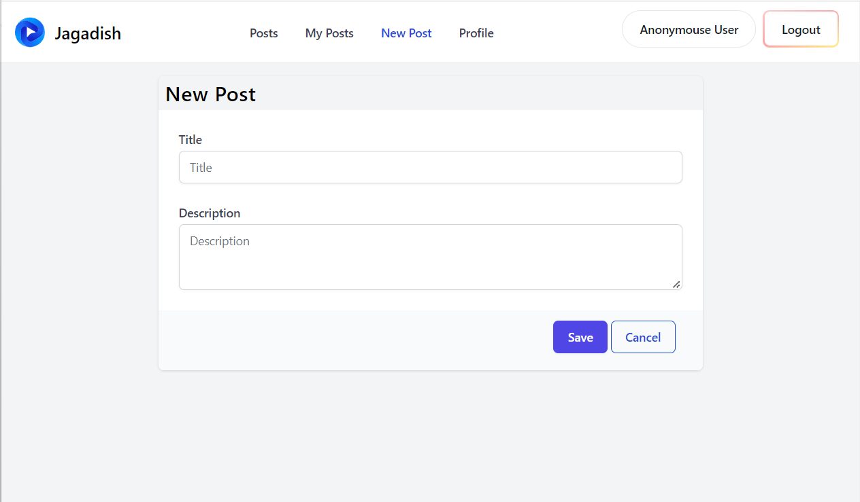Sign in Use new post section
* Sign in user update post section

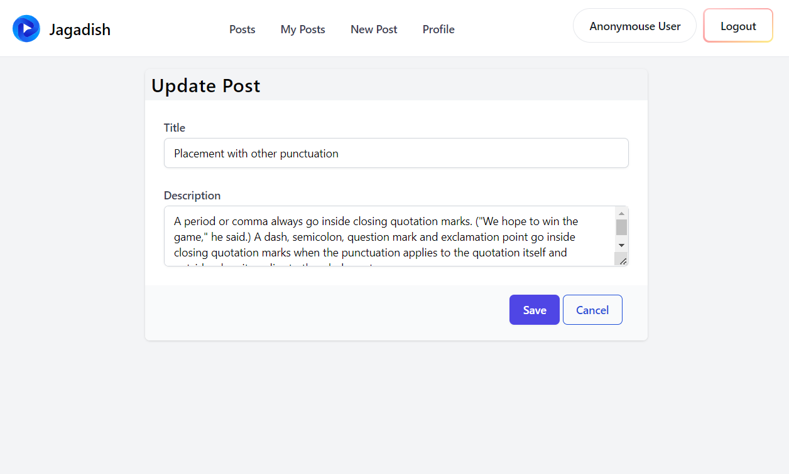

* 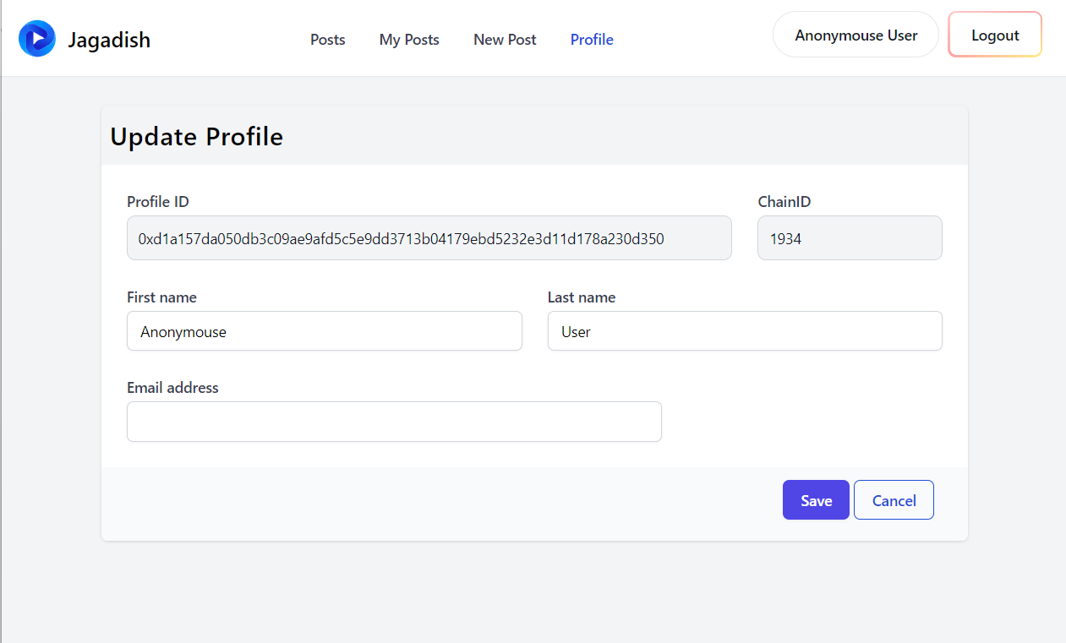 Sign in user profile update section