Cognizant Assignments

README.doc

Created By : Jagadish Anala
Created Date : 17-Jul-2018.
Updated Date : 26-July-2018.

Cognizant Assignments

Following are the two assignments were given to implement:
- Assignment - Read contents of the csv or xml file and person some validations on the data and provide the failed results to the viewable screen.
- Assignment-FE - Read the contents of the csv file and displays the result on top of a screen.

Implementation && Issues

1) First assignment was developed on angularJS & spring boot.
2) Second assignment was developed in angularJS.
3) Second assignment the process button needs to press twice to view the data.
4) Search Filter was developed. Filter is not specific to one particular column. It will filter for the given pattern in all column data.

Code Review

To perform code review the code will be provided to the respective person in a zip file through email or shared location.

Testing Process

Consul Execution
- Download Consul Folder from the shared location.
- Go to command prompt
- Go to consul folder
- Execute consul.cmd (It’s a prerequisite for spring boot application)
- Go to URL : http://localhost:8050/ui - Here we can see consul container ui consists of all services
- Initially we will be having only consul service is running.
- Following is the screen shot for the consul container UI

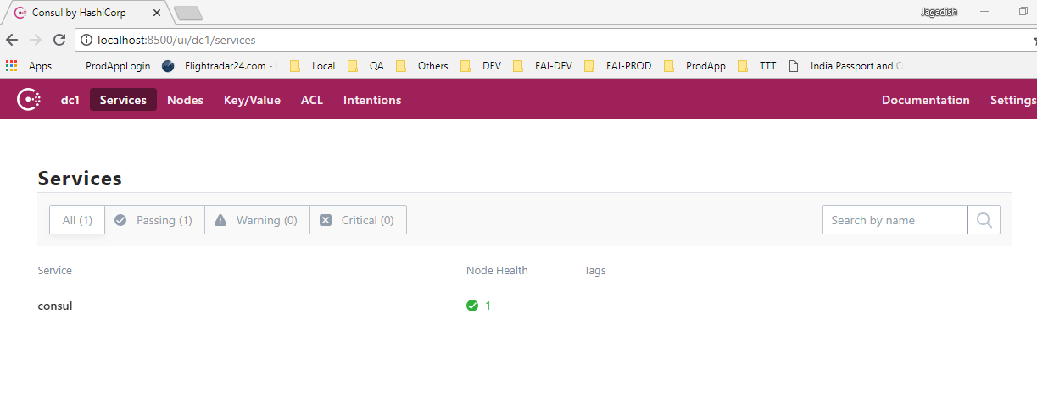

Assignments Spring Boot Application Excecution

- Download CognizantAssignments project from the shared location
- Go to command prompt
- Go to CognizantAssignments project root folder
- Execute run.cmd
- After executing run.cmd it will build and start the application
- Go to URL : http://localhost:8050/ui - Here we can see consul container ui consists of all services
- We can see three services running.
8) make sure CognizantAssignments-service, CognizantAssignments-Service-management, consul are running with out any issues
9) Following is the screen shot for the consul container UI

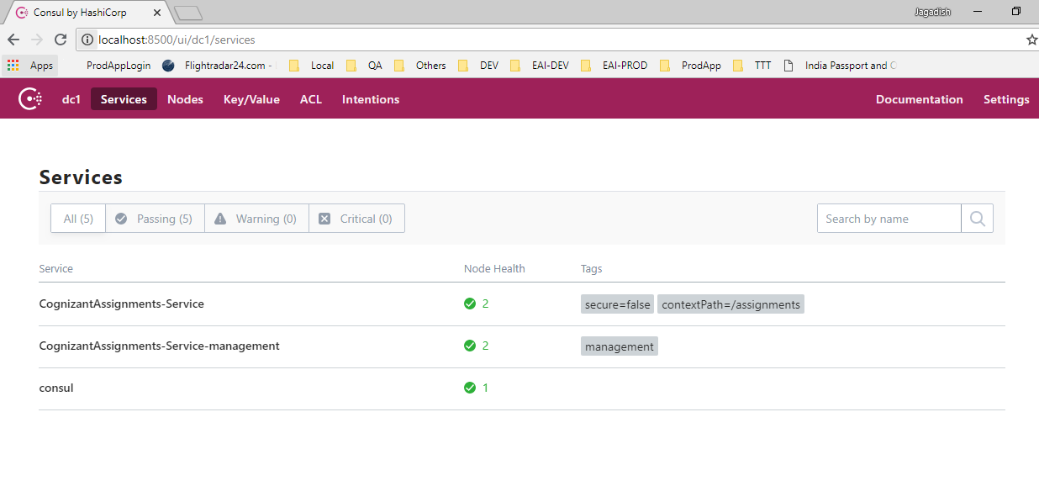
10. Go to Spring Boot Application URL
http://localhost:9080/assignments

11. Following are the screen shots of application

Login Page

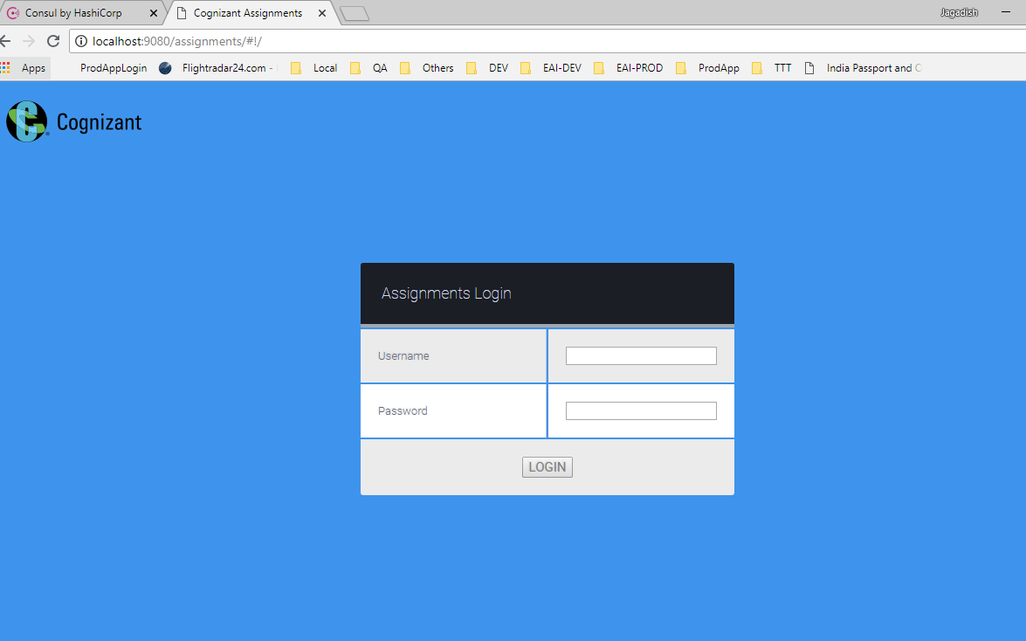

12. Login to the application using admin/admin.
13. If user failed to login following screen will get displayed

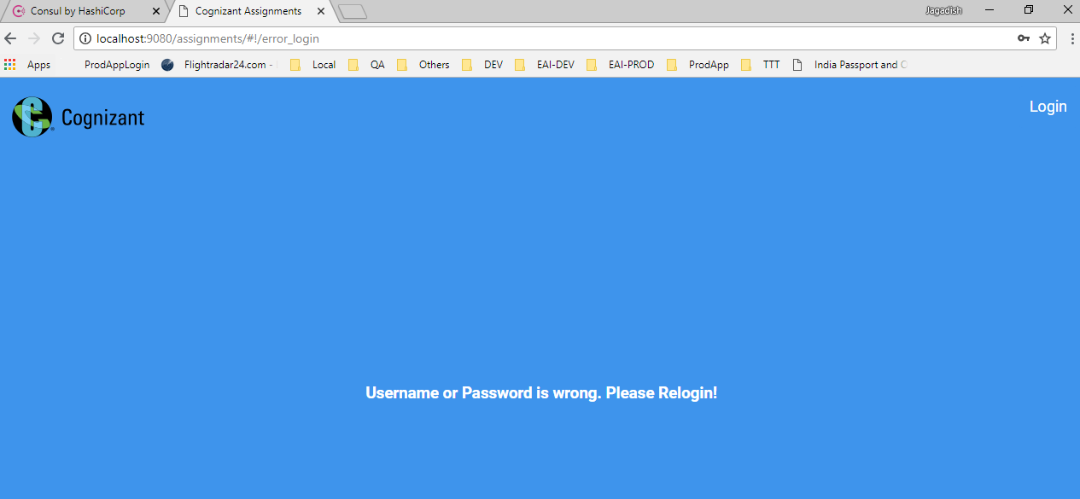
14. if success it will go to the main page
15. Following are the screenshots

Home Page

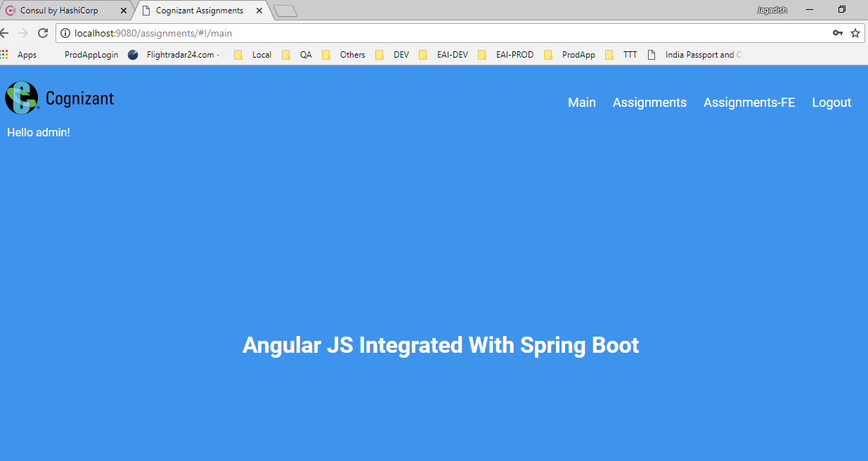

Assignments Page

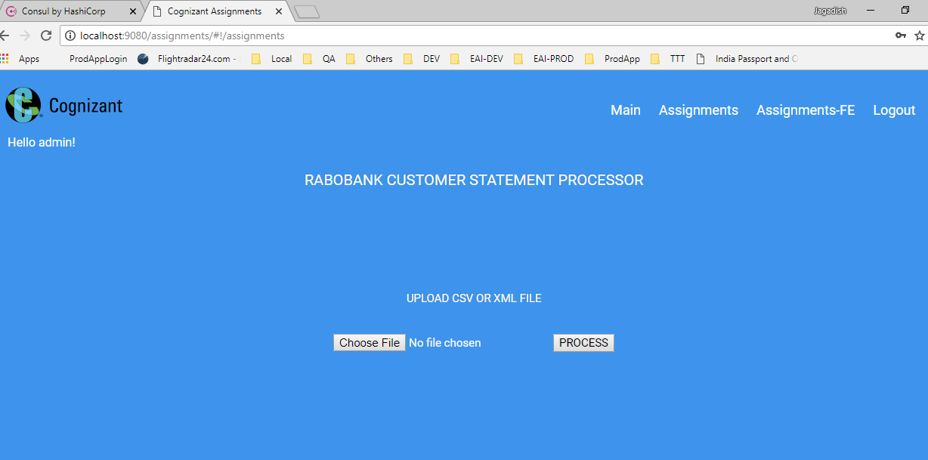

Assignments Results Page

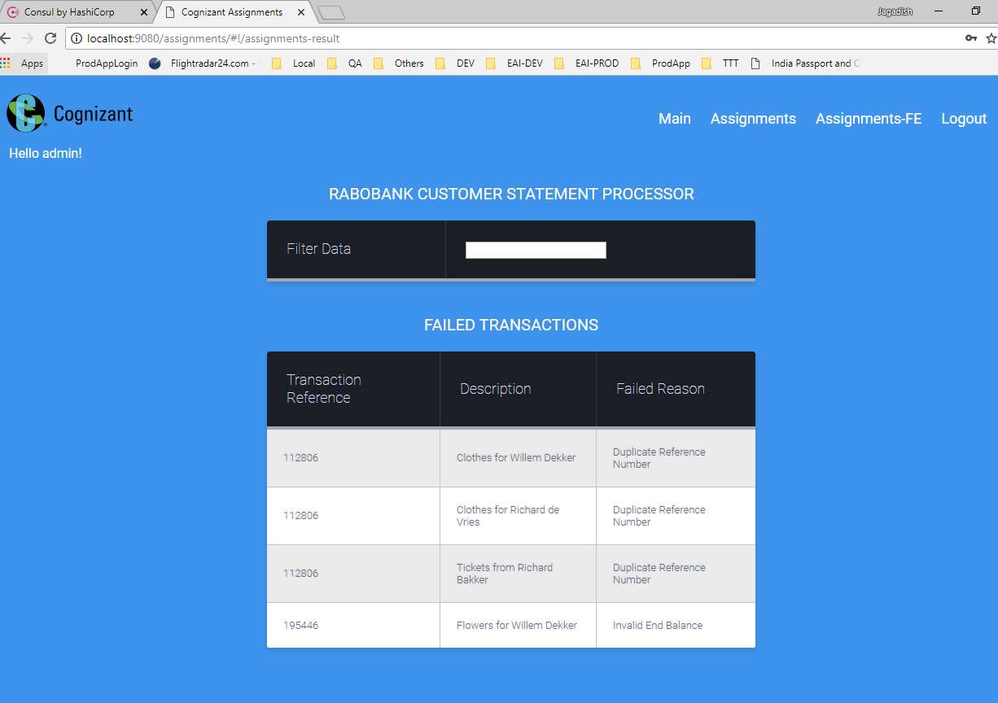

Assignments-FE

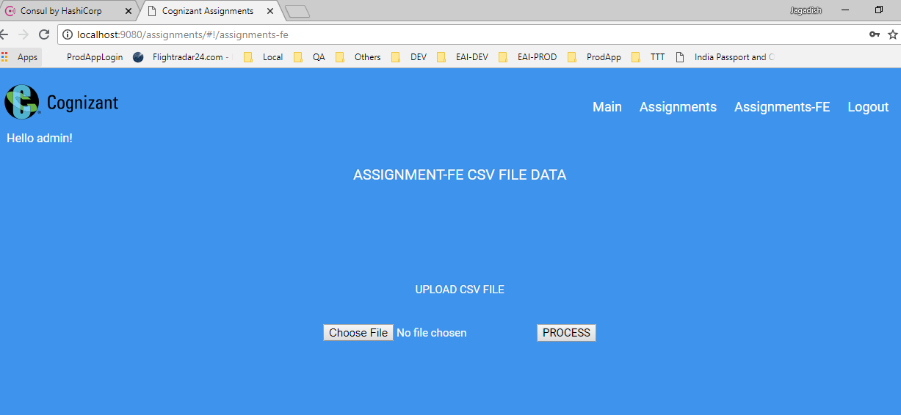

Assignment-FE-Results

