Cognizant Assignments

README.doc

Created By : Jagadish Anala
Created Date : 17-Jul-2018.

Cognizant Assignments

Following are the two assignments were given to implement:
- Assignment - Read contents of the csv or xml file and person some validations on the data and provide the failed results to the viewable screen.
- Assignment-FE - Read the contents of the csv file and displays the result on top of a screen.

Implementation && Issues

1) First assignment was developed on angularJS & spring mvc, rest controllers and spring services.
2) Second assignment was developed in angularJS.
3) Second assignment the process button needs to press twice to view the data.
4) Message properties files were not included.
5) NO UI Level Validations were implemented.
6) All Happy flows with the given data are working fine.
7) Junit test cases were not written.
8) Search Filter was developed. Filter is not specific to one particular column. It will filter for the given pattern in all column data.

Code Review

To perform code review the code will be provided to the respective person in a zip file through email or shared location.

Testing Process

Deploy the given war file in any one of the app servers or import the given code to eclipse IDE and start executing the application and do the manual verification.

Web Application Link

http://localhost:8080/Assignments

Home Page

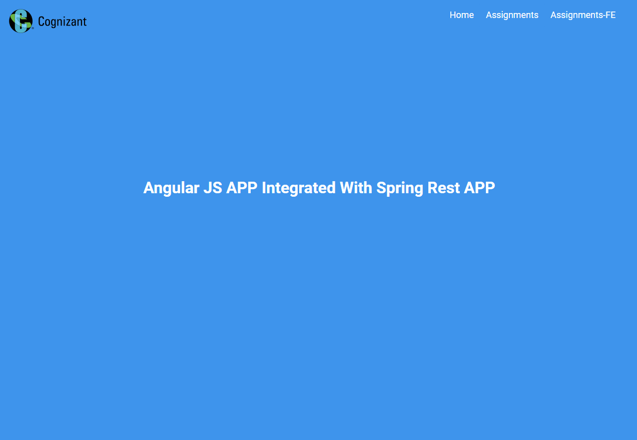

Assignments Page

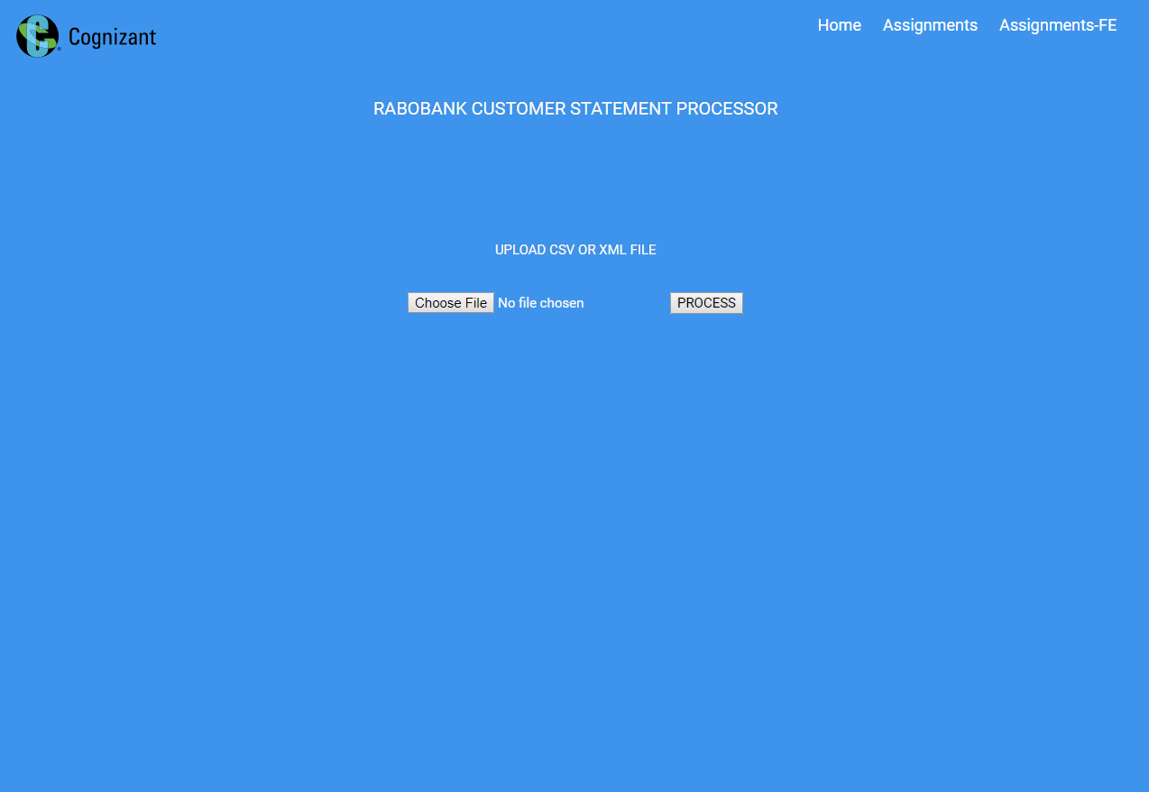

Assignments Results Page

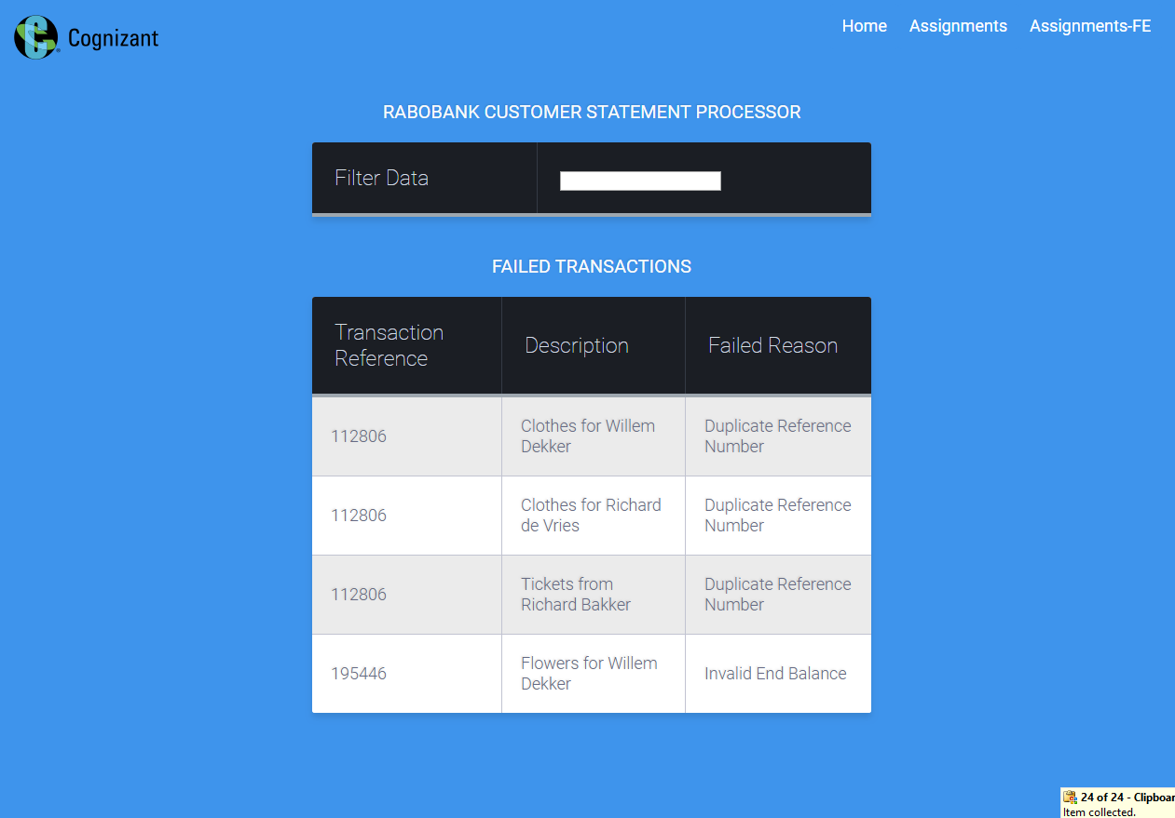

Assignments-FE

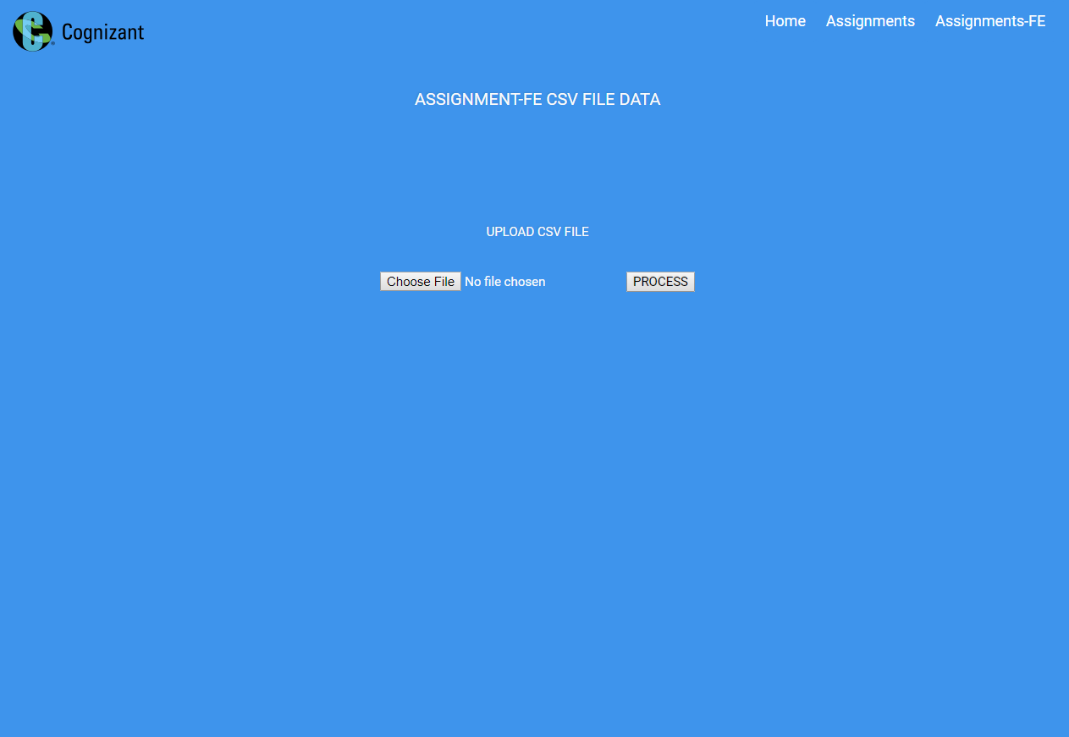

Assignment-FE-Results

