**VISVESVARAYA TECHNOLOGICAL UNIVERSITY**

**JNANA SANGAMA, BELAGAVI – 590 018, KARNATAKA**

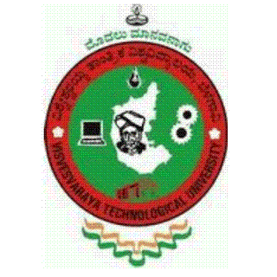

**A MINI PROJECT REPORT ON**

**“DAIRY MANAGEMENT SYSTEM"**

**Submitted By**

|  |  |
| --- | --- |
| **JAGADISH GOWDA P** | **JASWANTH YUVRAJ M R** |
| **USN: 1VK17CS020** | **USN: 1VK17CS021** |

*Submitted in the partial fulfillment of the requirements for the fifth Semester Database Management System Lab (17CSL58)*

**BACHELOR OF ENGINEERING**

**IN**

**COMPUTER SCIENCE AND ENGINEERING**

**UNDER THE GUIDANCE OF**

**Mrs. Sunanda H G Mrs. Pavithra H C**

**Asst. Professor, Dept. of CSE Asst. Professor, Dept. of CSE**



**Janatha Education Society®**

**DEPARTMENT OF COMPUTER SCIENCE AND ENGINEERING**

**VIVEKANANDA INSTITUTE OF TECHNOLOGY**

**GUDIMAVU, KUMBALAGODU POST, KENGERI HOBLI, BENGALURU –560 074**