hort description



Text of the article

This Article will explain in detail about Link between Resume token and Event store:

Resume Token collection is used to capture all the JWT token generated by the services (Email integration service and Kafka integration service) and using the pipeline generate the corresponding event like FORM_LIFE_CYCLE, MAIL_LIFE_CYCLE events.

For Every submission for each event one token generated but captured as two documents for both Email integration service and Kafka integration service with same event ID value.

Once a form is Submitted the JWT token will be generated and captured in **event-store-resume-token** collection. This token will have the event ID field with object ID value which can be linked with the ID in event store.

So if a form consists of Form Life cycle event, Rule Fire event and Mail Life cycle event, three tokens with same event ID will be generated but the **event-store-resume-token** collection will have 6 documents, three is from Email integration service and another three is from Kafka integration service.

Also the time stamp for this token will be captured in UNIX time format : startAtOperationTime : Timestamp({ t: 1707196101, i: 12 }). The below screen shot will show the GMT time as 6 FEB 2024 05:08:21.

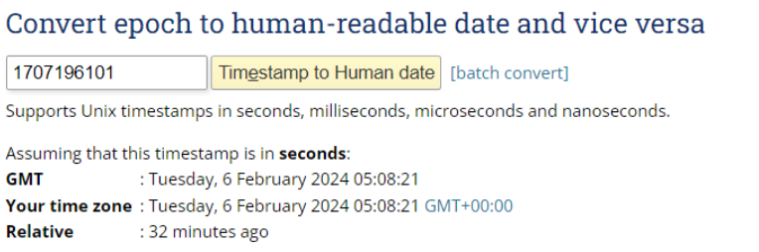

 Once the token was generated it will be wait in pipeline and one by one using the token the event will be generated and capture in Event store.

**event-store-resume-token : {eventId:"BsonObjectId{value=65c1bec5e8c0cf4e38d5cf84}"}**

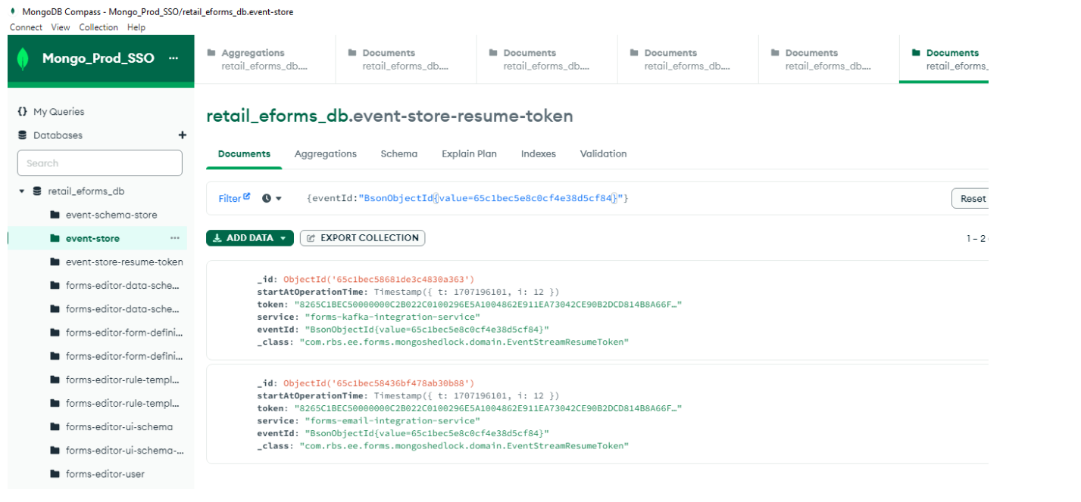

event-store : {_id:ObjectId('65c1bec5e8c0cf4e38d5cf84')}

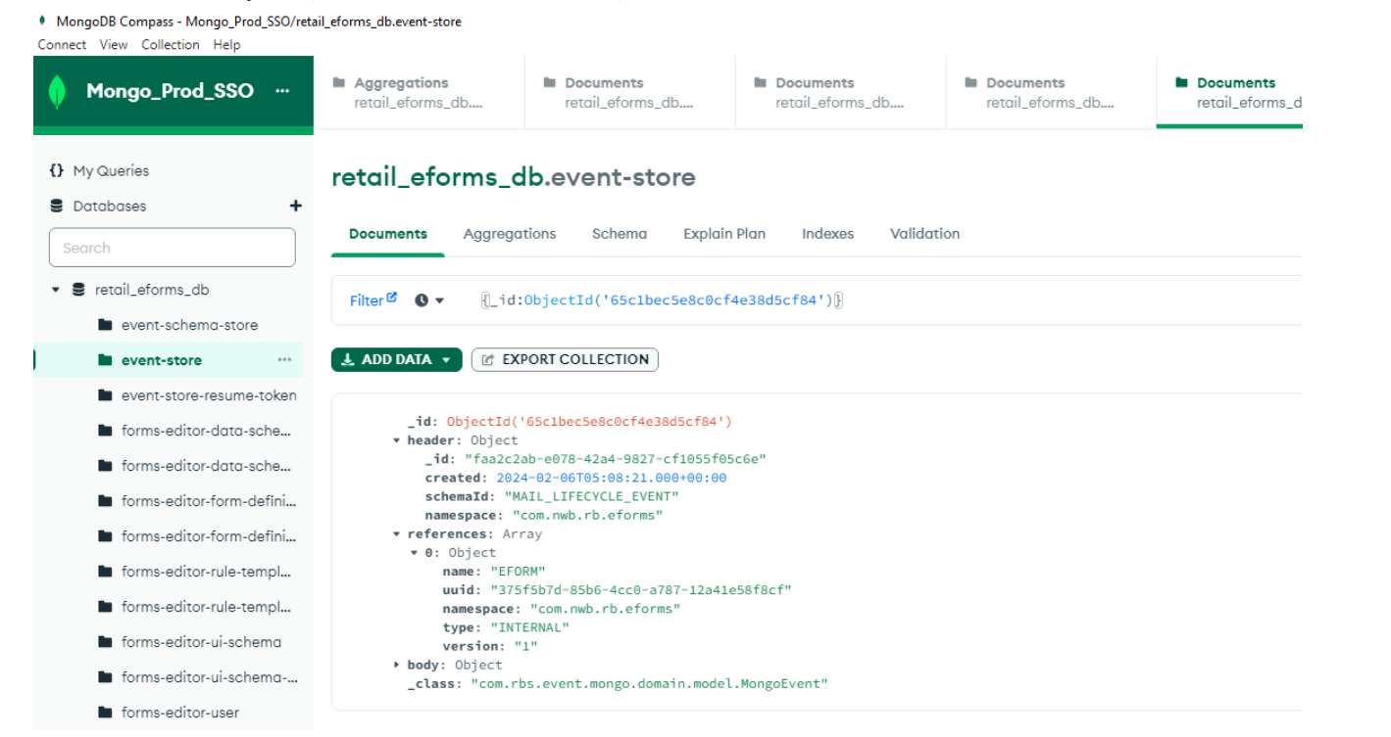

So the event ID value 65c1bec5e8c0cf4e38d5cf84 will be the Object ID in the event store collection. This is how the resume token collection is linked with Event store and using the token the event are getting triggered.