Travel Expense Manager

README.doc

Created By : Jagadish Anala
Created Date : 30-August-2018.

Problem Statement

Let's say you and your group of friends are going on a trip. Each one spends some money during the trip. Design and develop a travel expense manager system which helps in identifying which person
owes which person how much money at the end of the trip.

Rules of the Game
1) We are really, really interested in your object oriented development skills, so please solve the problem keeping this in mind.
2) You have to solve the problem in Ruby, Java, Go or any other object oriented language without using any external libraries/gems except for a testing library for TDD.
3) Your solution must build+run on Linux.
4) Please keep in mind all these problems are to be developed as commandline applications

Implementation
1) The system was developed on angularJS, bootstrap & spring boot.
2) H2 Database was used to store and retrieve the information.

Code Review

To perform code review the code will be provided to the respective person in a zip file through email or shared location.

Testing Process

Travel Expense Manager Spring Boot Application Excecution

- Download TravelExpenseManager project from the shared location or email.
- Go to command prompt
- Go to TravelExpenseManager project root folder
- Execute run.cmd or run.sh based on the OS
- After executing run.cmd or run.sh it will build and start the application
6) Go to Spring Boot Application URL
http://localhost:9080/expenses

7) Following are the screen shots of application

Login Page

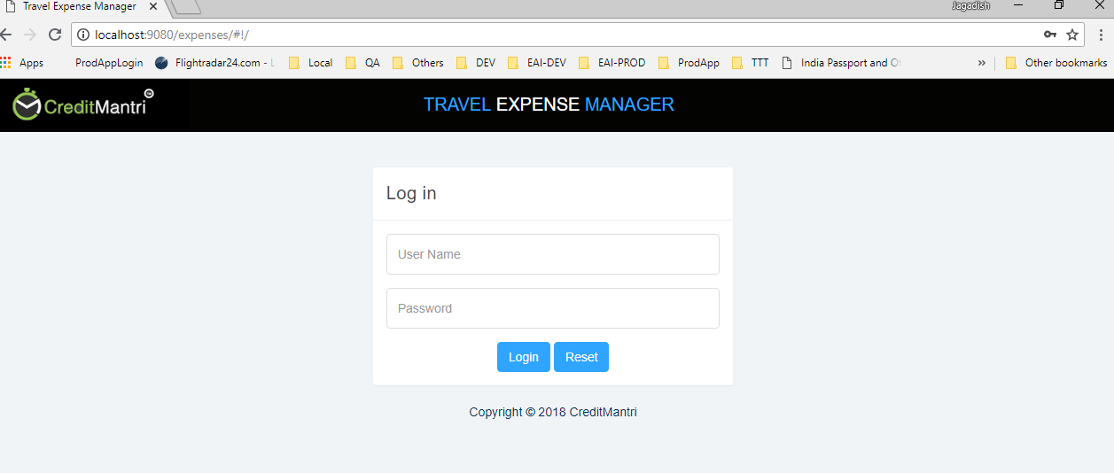

12. Login to the application using admin/admin or
jagadish/jagadish.
13. If user failed to login following screen will get displayed

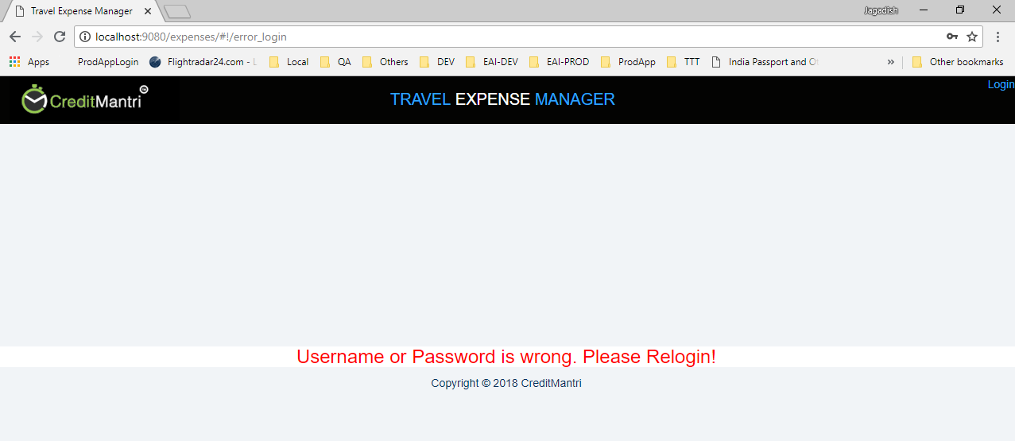
14. if success it will go to the main page
15. Following are the screenshots

Main Page

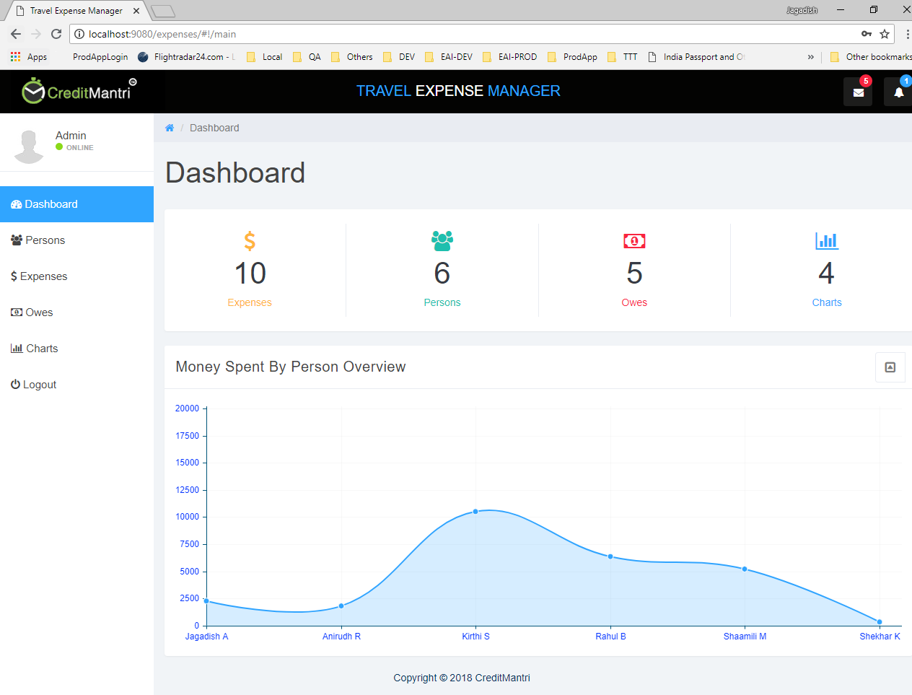

Persons Page

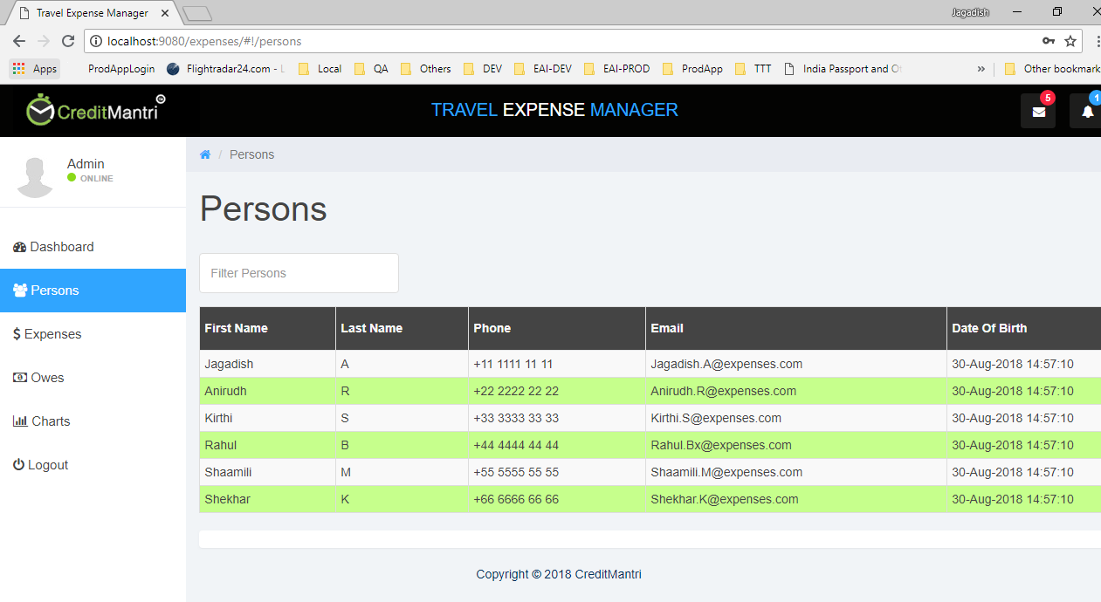

Expenses Page

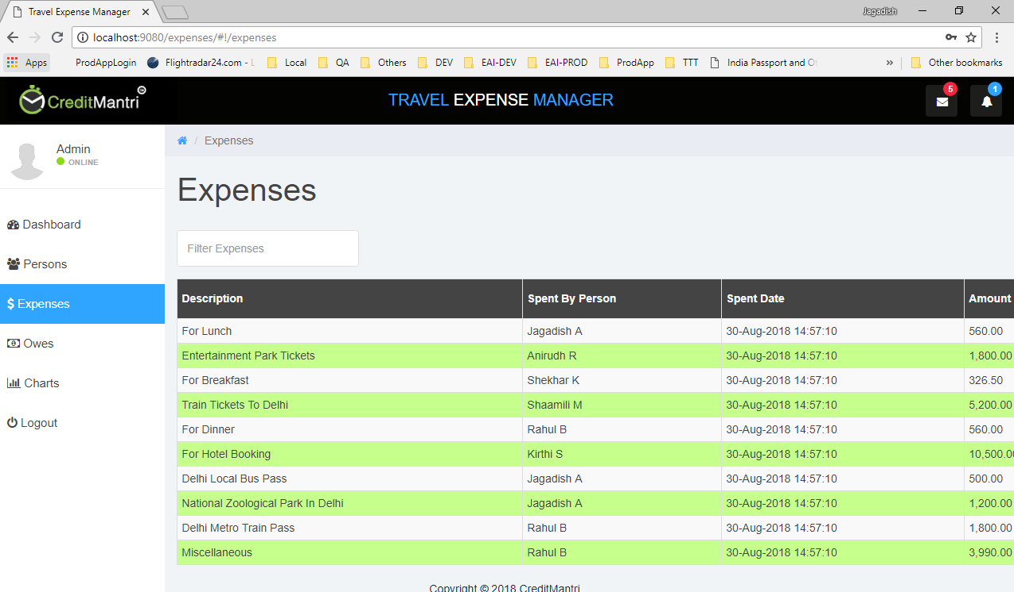

Owes Page

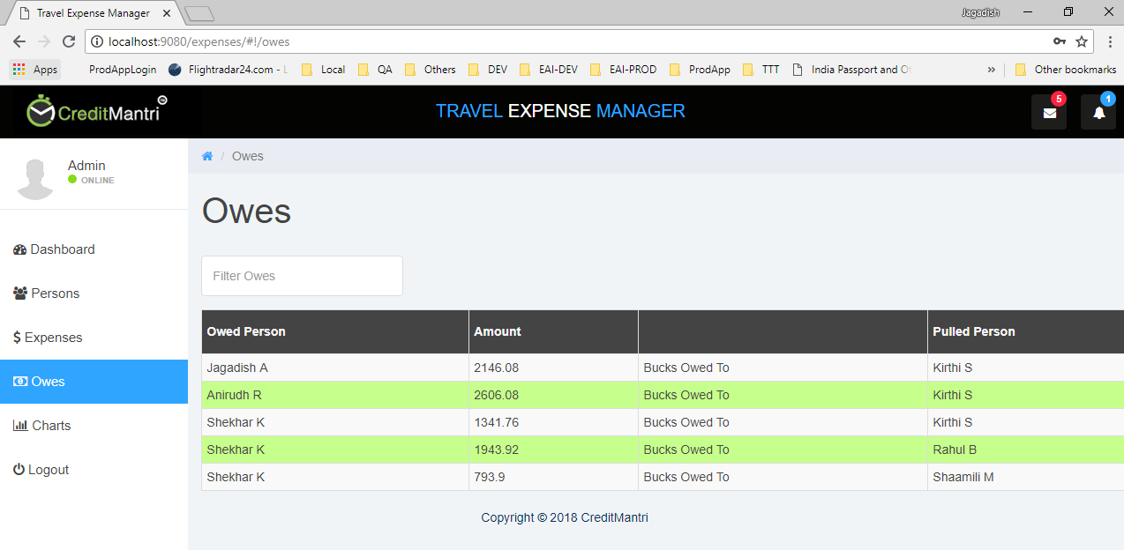

Charts Page

