**Bio-Data**

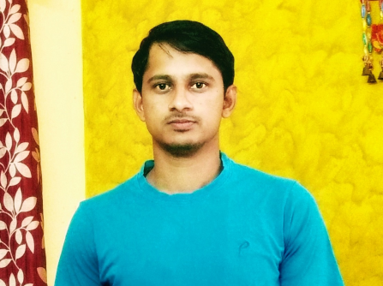

**Personal Details:**

|  |  |
| --- | --- |
| Name | Jagadish Sonamale |
| Date of birth | 01-05-1988 |
| Time of birth | 5:30 AM |
| Caste | Lingayat |
| Height | 5.6 |
| Weight | 67 KGS |
| Moon Sign | Capricorn |
| Complexion | Fair |
| Blood Group | AB+ |
| Educational Qualification | B.E in ECE |
| Profession | Senior Software Engineer(API Development) |
| Company | Capgemin |
| City Living in | Bangalore |
| Native Place | Nideban |

**Family Details:**

|  |  |
| --- | --- |
| Father Name | Sidramappa Sonamale |
| Mother Name | Shantamma Sonamale |
| Siblings | 3 Elder Sisters(Married) |

**Contact Details:**

|  |  |
| --- | --- |
| Phone Number | 8867674783; 9071900413 |
| Address | 33B, Nideban,Bhalki,Bidar-585211 |
| Email Id | Jagadish9084@gmail.com |