**INTRODUCTION :**

**“Online Hall Reservation ”** is a Web base hall booking system provides the searching facilities based various factor. Web base hall booking systems are going to develop web portal for searching wedding halls , function halls . This web portable is use to check the availability of hall hence we need not go and visit the place. The user should have wasted his / her time and the money to search for hall. Information of individual’s hall is stored in database. New owner of hall can insert his details in web portal. As he becomes member of web portal he can edit his information and update date of booking.

Also we have detailed contact information for some particular hall. But we cannot get the availability about hall. So background behind this web portal is that it gives the area wise listing of wedding halls and event halls with the detailed information of individual and also display for particular date the hall is available or not. Just dial is the system in which we can only find the name of Hall in city. In just dial we cannot find Halls in specific area. This system cannot show all information about any Hall. This system is not able to book the Halls online. The A Web Based Hall Booking System is designed to overcome the disadvantage of previous system. We can easily get the list of Wedding Halls and event conducting halls . But we cannot get the availability about Hall. So background behind this web portal is that it gives the area wise listing of Halls with the detailed information of individual and also display for particular date the Hall is available or not. This is a special type of web portal to easily get the information of all halls which display separate calendar for separate Hall. For particular date the Hall. We can see the availability of Hall as well as detailed information about individuals Hall in our web portal .To understanding the requirements and new generation capabilities we have chosen “ ASP.NET with C# ” as front –end and “Microsoft SQL Server Database ” as back-end. ASP.NET is the new technology which is open source and efficient for go ahead with technology with no boundaries of development. We have chosen ASP.NET because it is one of the server –side scripting languages, which was getting client during recession in the market. It provides all facilities to clients with lowest cost and lowest maintenance problems.

**TECHNOLOGY :**

**Active Server Page (ASP.NET) :**

ASP.NET web pages, known officially as "web forms", are the main building block for application development. Web forms are contained in files with an ".aspx" extension; these files typically contain static ([X](http://en.wikipedia.org/wiki/XHTML))[HTML](http://en.wikipedia.org/wiki/HTML)  markup, as well as markup defining server-side Web Controls and User Controls where the developers place all the required static and dynamic content for the web page. Additionally, dynamic code which runs on the server can be placed in a page within a block

<% -- dynamic code -- %>, which is similar to other web development technologies such as [PHP](http://en.wikipedia.org/wiki/PHP), [JSP](http://en.wikipedia.org/wiki/JavaServer_Pages), and [ASP](http://en.wikipedia.org/wiki/Active_Server_Pages). With [ASP.Net Framework 2.0](http://en.wikipedia.org/wiki/ASP.NET#Versions), Microsoft introduced a new code-behind model which allows static text to remain on the .aspx page, while dynamic code remains in the .asp.cs page.

**Microsoft SQL Server :**

MS SQL Server is a relational database management system (RDBMS) developed by Microsoft. This product is built for the basic function of storing retrieving data as required by other applications. It can be run either on the same computer or on another across a network. This tutorial explains some basic and advanced concepts of SQL Server such as how to create and restore data, create login and backup, assign permissions, etc.

**DATABASE TABLES:**

**ADMIN TABLE:**

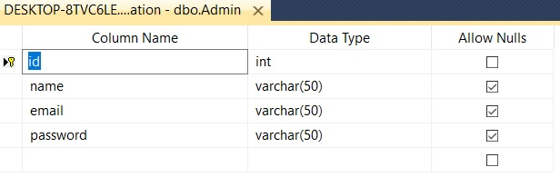

**CUSTOMER TABLE :**

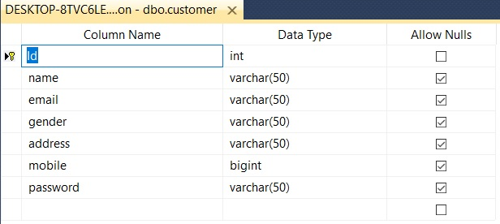

**OWNER TABLE :**

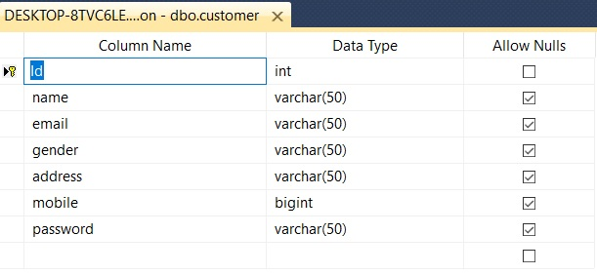

**DATAFLOW DIAGRAM :**

ADMIN

Manage Halls

Manage Owners

Manage Customer

OWNER

Add Halls

View Bookings

CUSTOMER

Search Halls

Book Hall

View Booked

LOGIN

SQL Database

Update Profile

SCREENS :

LOGIN SCREEN :

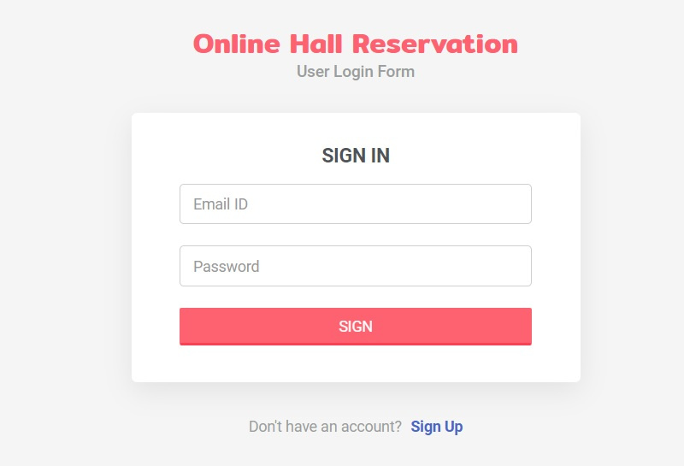

REGISTRATION SCREEN :

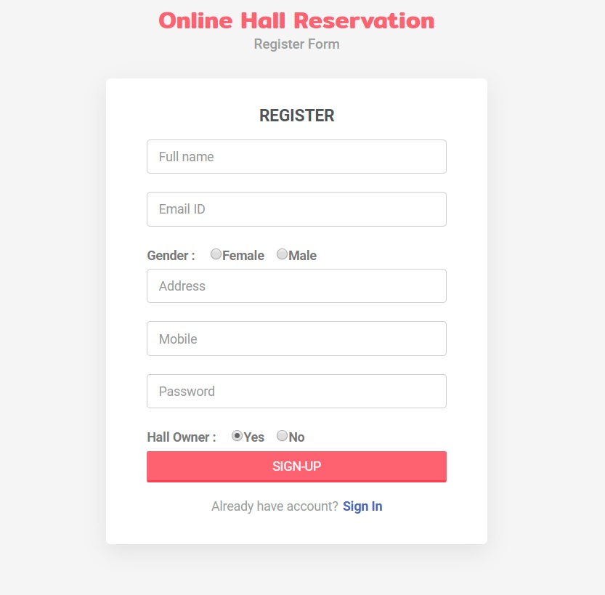

ADMIN DASHBOARD :

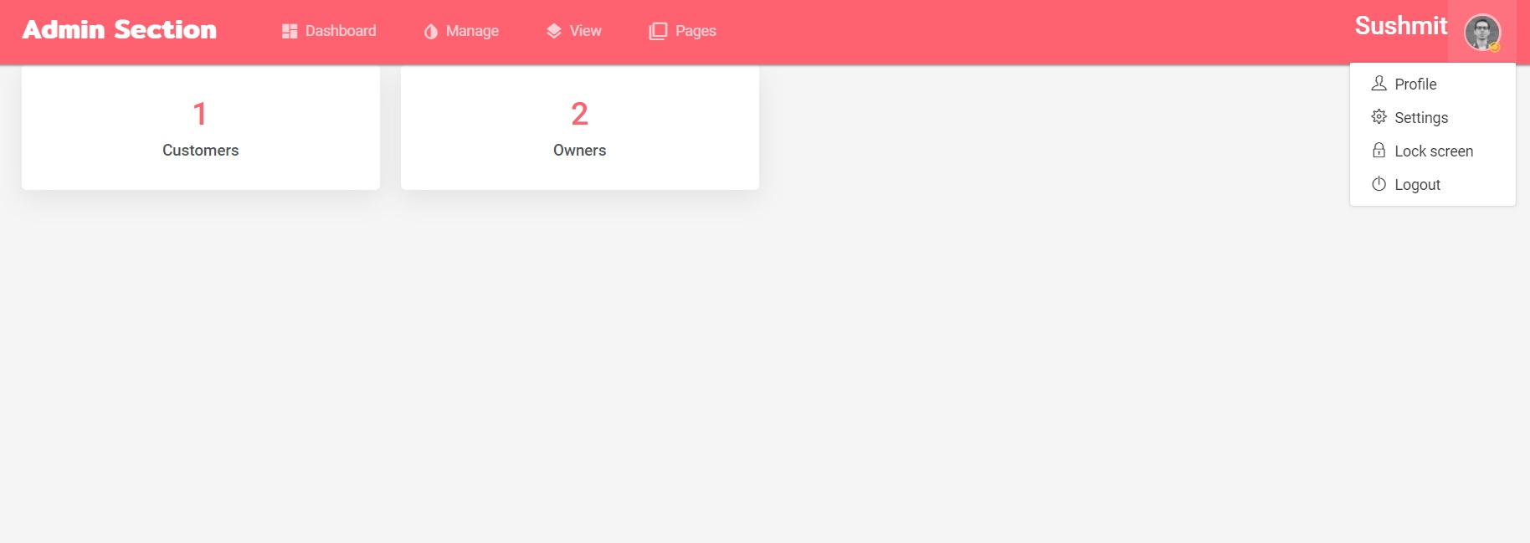

MANAGE OWNERS :

