LINUX BASICS
DEVOPS ASSIGNMENT
Submitted by: Jagadish B Basapur

Objective
Practise essential Linux command-line operations, including file and directory management, viewing files, searching, archiving, downloading, permissions and environment variables.
Environment: Ubuntu on Windows Subsystem for Linux (WSL).
Evidence note: The terminal screenshots supplied by the learner have been separated and placed under the corresponding tasks. Commands and explanations below describe the work visible in the submitted evidence.

Task 1
Question: Create a directory named test_dir using mkdir.
Command(s) used:
mkdir test_dir
ls -l
Explanation: The mkdir command creates a new directory. The command `mkdir test_dir` creates a directory named test_dir in the current working directory. The `ls -l` command lists directory contents in long format and is used here to verify that the directory exists.
Screenshot evidence: The terminal screenshot shows the mkdir command followed by a directory listing containing test_dir.
Figure 1. Terminal evidence for Task 1.

Task 2
Question: Inside test_dir, create an empty file called example.txt.
Command(s) used:
cd ~/test_dir
touch example.txt
ls
Explanation: The touch command creates an empty file when the file does not already exist. The `cd` command changes the current directory to test_dir, and `ls` verifies that example.txt was created.
Screenshot evidence: The screenshot shows the touch command and the file listed in test_dir.
Figure 2. Terminal evidence for Task 2.

Task 3
Question: Rename example.txt to renamed_example.txt using mv.
Command(s) used:
mv example.txt renamed_example.txt
ls -l
Explanation: The mv command moves or renames files and directories. Here it renames example.txt to renamed_example.txt. The `ls -l` command verifies the new filename.
Screenshot evidence: The screenshot shows the mv command and renamed_example.txt in the directory listing.
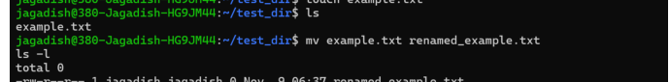
Figure 3. Terminal evidence for Task 3.

Task 4
Question: Use cat to display the contents of /etc/passwd.
Command(s) used:
cat /etc/passwd
Explanation: The cat command displays the contents of a file in the terminal. The /etc/passwd file contains account information for users configured on the Linux system, such as usernames and user IDs.
Screenshot evidence: The screenshot shows the command and the account entries returned from /etc/passwd.
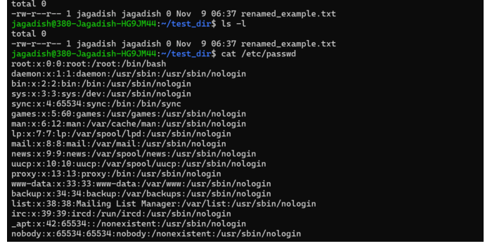
Figure 4. Terminal evidence for Task 4.

Task 5
Question: Display only the first 5 lines of /etc/passwd using head.
Command(s) used:
head -n 5 /etc/passwd
Explanation: The head command displays the beginning of a file. The `-n 5` option limits the output to the first five lines.
Screenshot evidence: The screenshot shows the first five entries from /etc/passwd.
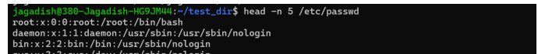
Figure 5. Terminal evidence for Task 5.

Task 6
Question: Display only the last 5 lines of /etc/passwd using tail.
Command(s) used:
tail -n 5 /etc/passwd
Explanation: The tail command displays the end of a file. The `-n 5` option limits the output to the last five lines.
Screenshot evidence: The screenshot shows the last five entries from /etc/passwd.
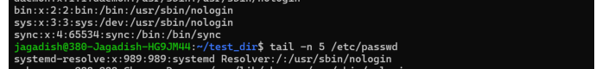
Figure 6. Terminal evidence for Task 6.

Task 7
Question: Use grep to find all lines containing the word "root" in /etc/passwd.
Command(s) used:
grep "root" /etc/passwd
Explanation: The grep command searches text for a specified pattern and prints matching lines. In this task, it displays every line in /etc/passwd that contains the text root.
Screenshot evidence: The screenshot shows the matching root account line returned by grep.
Figure 7. Terminal evidence for Task 7.

Task 8
Question: Compress the test_dir directory into a file named test_dir.zip using zip.
Command(s) used:
zip -r test_dir.zip test_dir
Explanation: The zip command creates a ZIP archive. The `-r` option means recursive, so files and subdirectories inside test_dir are included in the archive.
Screenshot evidence: The screenshot shows test_dir.zip being created and the directory and renamed_example.txt being added. The earlier screenshot also shows that zip was initially unavailable; the zip/unzip package was installed before the successful archive command.
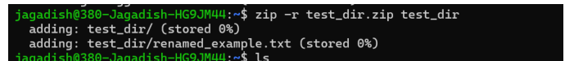
Figure 8. Terminal evidence for Task 8.

Task 9
Question: Unzip test_dir.zip into a new directory named unzipped_dir.
Command(s) used:
unzip test_dir.zip -d unzipped_dir
ls -R unzipped_dir
Explanation: The unzip command extracts files from a ZIP archive. The `-d unzipped_dir` option specifies the destination directory. The `ls -R` command lists the extracted directory structure recursively.
Screenshot evidence: The screenshot shows successful extraction and renamed_example.txt inside unzipped_dir/test_dir.
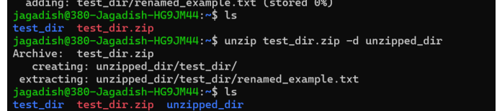
Figure 9. Terminal evidence for Task 9.

Task 10
Question: Use wget to download a file from a URL (for example, https://example.com/sample.txt).
Command(s) used:
wget https://www.gnu.org/licenses/gpl-3.0.txt
ls -lh gpl-3.0.txt
head -n 5 gpl-3.0.txt
Explanation: The wget command downloads a file from a URL using HTTP or HTTPS. The first example URL in the terminal returned HTTP 404 (file not found). A second download from the GNU website returned HTTP 200 OK and saved gpl-3.0.txt. The ls and head commands were used to verify the downloaded file and view its first five lines.
Screenshot evidence: The screenshot includes the failed example.com attempt and the successful GNU download, including the 200 OK response and saved file.
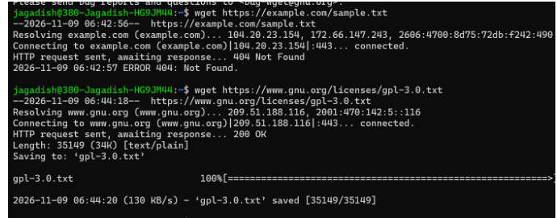
Figure 10. Terminal evidence for Task 10.

Task 11
Question: Create a file named secure.txt and change its permissions to read-only for everyone using chmod.
Command(s) used:
touch secure.txt
chmod 444 secure.txt
ls -l secure.txt
Explanation: The touch command creates the file. The chmod command changes its permissions. The numeric mode 444 grants read permission to the owner, group and others, while removing write and execute permissions. The ls -l command verifies the permissions; the expected permission string is -r--r--r--.
Screenshot evidence: The screenshot shows secure.txt being created, chmod 444 being applied, and the permissions being listed.
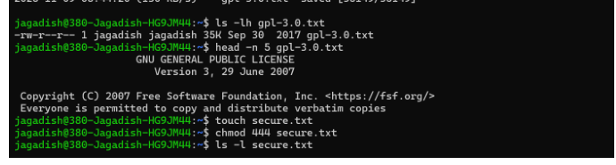
Figure 11. Terminal evidence for Task 11.

Task 12
Question: Use export to set a new environment variable called MY_VAR with the value "Hello, Linux!".
Command(s) used:
export MY_VAR="Hello, Linux!"
echo $MY_VAR
Explanation: The export command sets an environment variable in the current shell and makes it available to child processes started from that shell. The echo command prints the variable's value for verification. The expected output is Hello, Linux!.
Screenshot evidence: The screenshot shows the export command, the echo command and the expected value Hello, Linux!.
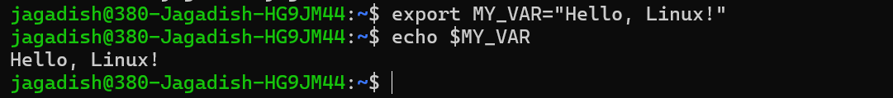
Figure 12. Terminal evidence for Task 12.

Submission checklist
- Save this documentation file inside the folder Linux_Basics_Jagadish.
- Keep the project files and any required supporting files in the same folder.
- Add the GitHub repository URL to the documentation after creating/publishing the repository.
- Compress the complete folder as Linux_Basics_Jagadish.zip.
- Upload only the ZIP file to the assignment submission portal, as instructed.
GitHub repository URL: ______________________________________________
Note: The uploaded screenshots show all 12 tasks, including the successful GNU file download for Task 10 and the environment-variable output for Task 12.

