Python & Bash Assignment
Practical exercises and question-wise explanations
Student: Jagadish Basapur
Environment: Ubuntu on Windows Subsystem for Linux (WSL), using VS Code and Python 3.

Task 1 – Grade Checker
Objective: Accept a score from the user and display the corresponding grade using conditional statements.

Python program
score = int(input("Enter your score: "))
if score >= 90:
Grade = "A"
elif score >= 80:
Grade = "B"
elif score >= 70:
Grade = "C"
elif score >= 60:
Grade = "D"
else:
Grade = "F"
print("your Grade is: ", Grade)

Explanation
- input() asks the user to enter a score.
- int() converts the entered text into an integer so it can be compared with numeric grade boundaries.
- if, elif and else check the score range and assign the appropriate grade.
- print() displays the resulting grade.
Evidence supplied: screenshot showing input score 80 and output grade B.
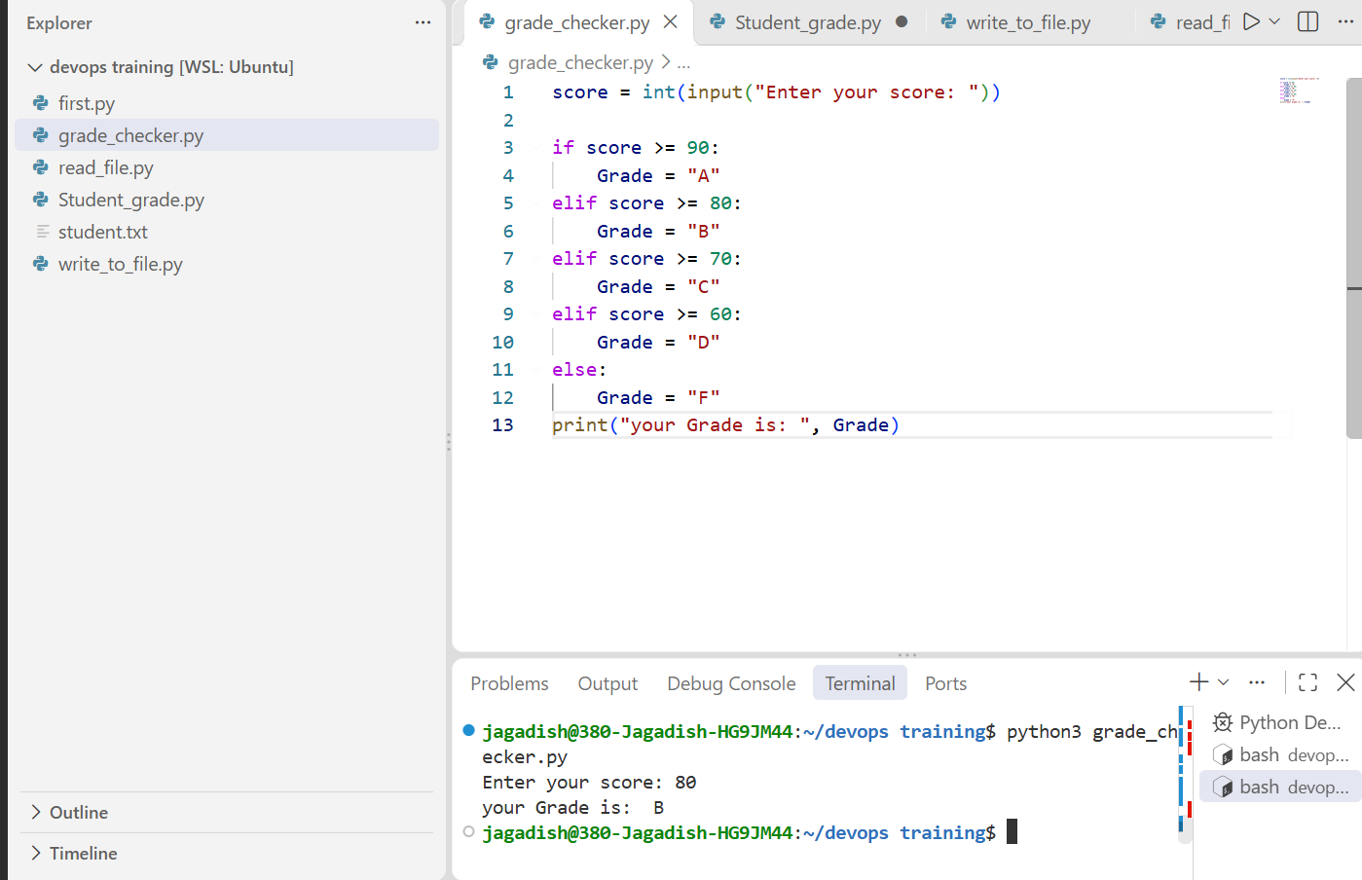

Task 2 – Student Grades
Objective: Store student names and grades in a dictionary, update an existing student's grade or add a new student, and display all entries.

Python program
students = {
"Jagadish": "A",
"Rahul": "B",
"Priya": "C"
}
print("Student Grades:", students)
name = input("Enter student name: ")
grade = input("Enter grade: ")
if name in students:
students[name] = grade
print("Student grade updated successfully!")
else:
students[name] = grade
print("New student added successfully!")
print("\nAll Student Grades:")
for name, grade in students.items():
print(name, ":", grade)

Explanation
- A dictionary stores information as key-value pairs. In this program, student names are keys and grades are values.
- input() collects the student name and grade.
- if name in students checks whether the entered name already exists as a dictionary key.
- students[name] = grade updates the value for an existing key or creates a new key-value pair if the key is not present.
- students.items() returns the dictionary's key-value pairs so the for loop can display every student and grade.
Evidence status: The program source is included. A Task 2 execution screenshot has not yet been supplied.

Task 3 – Write to a File
Objective: Create or open a text file in write mode and write text into it.

Python program
with open("student.txt", "w") as file:
file.write("Hello Jagadish\\n")
file.write("Hello ABC\\n")
file.write("Hello XYZ\\n")
print("Data written to student.txt successfully.")

Explanation
- open("student.txt", "w") opens the file in write mode. If it does not exist, Python creates it; if it exists, its previous contents are overwritten.
- The with statement manages the file and closes it automatically when the indented block ends.
- file.write() writes each text string to the file.
- \\n adds a newline after each line of text.
Evidence supplied: screenshot showing successful execution of write_to_file.py.
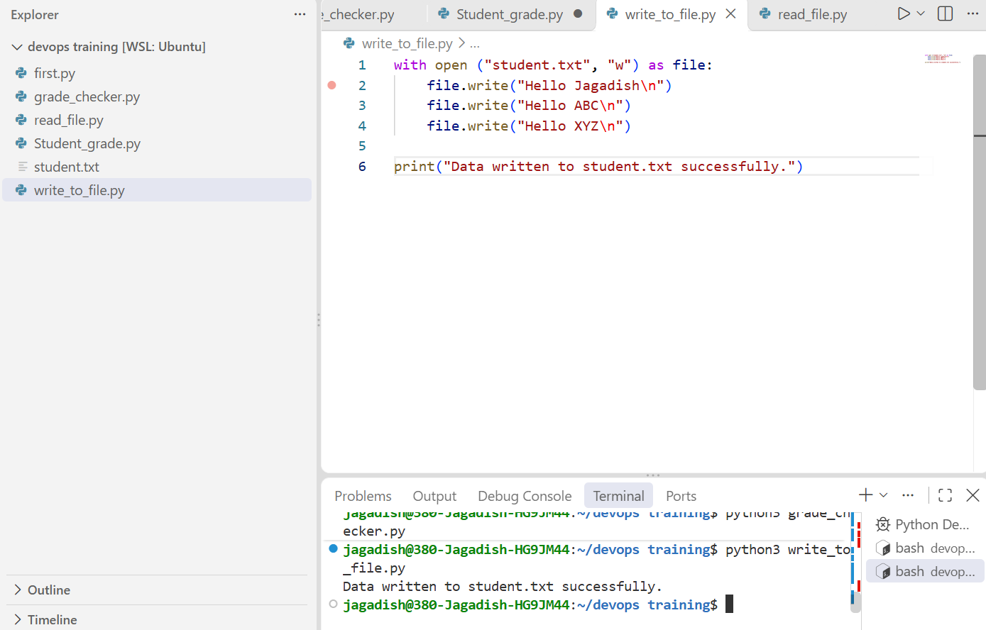

Task 4 – Read from a File
Objective: Open the text file in read mode, read its contents and display them.

Python program
with open("student.txt", "r") as file:
content = file.read()
print(content)

Explanation
- open("student.txt", "r") opens the existing file in read mode.
- file.read() reads the complete file content and returns it as a string.
- The content variable stores the returned text.
- print(content) displays the text in the terminal.
- The with statement automatically closes the file after reading.
Evidence supplied: screenshot showing the file contents Hello Jagadish, Hello ABC and Hello XYZ.
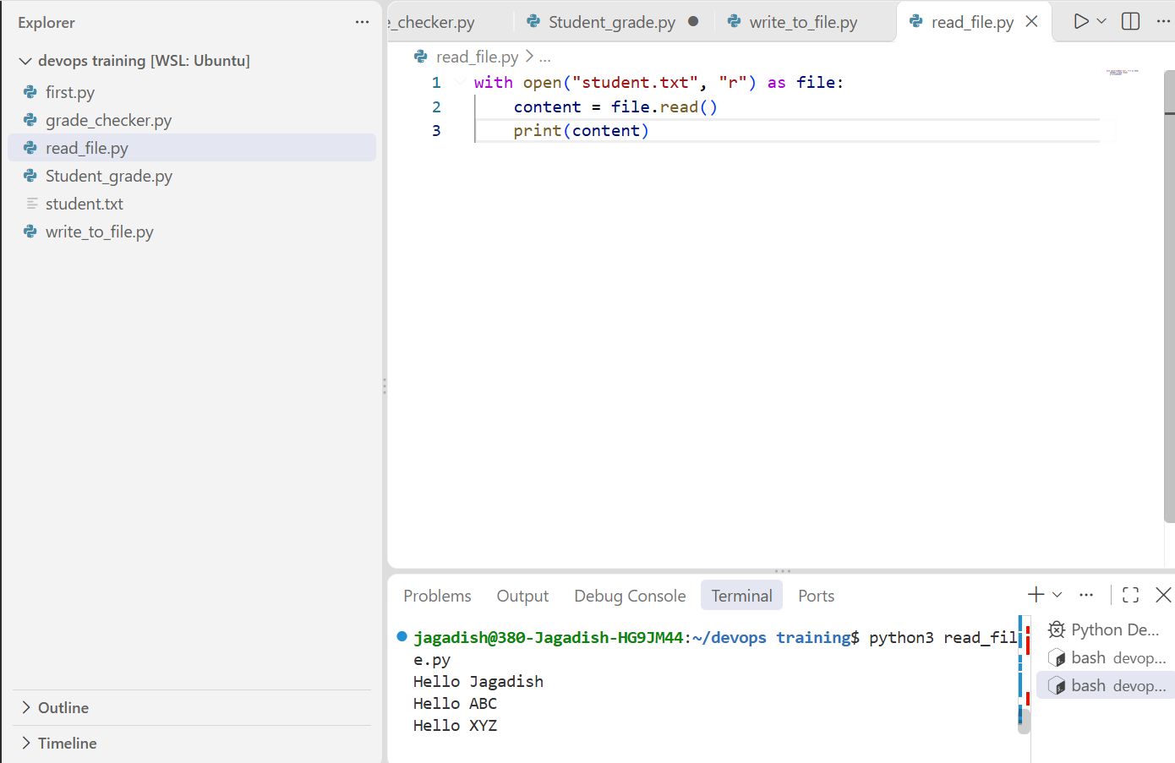

Submission status and notes
The current package includes all four Python source files, the text file used by Tasks 3 and 4, and the screenshots currently provided.
Pending before final submission:
- Capture and add a Task 2 terminal screenshot demonstrating both an update of an existing student and addition of a new student.
- Add the actual GitHub repository URL if the assignment submission requires it.
- Check the original assignment brief for any additional Bash-specific deliverables or formatting rules before uploading.
Note: Task 1 screenshot currently demonstrates score 80 → grade B. The earlier score 85 → B and 45 → F results were also reported in the conversation, but separate screenshots for those tests are not included in this package.

