When to use AJAX based UI

Traditionally, the browser based applications have been lacking the user friendliness provided by the standalone applications with rich user interface. AJAX (Asynchronous Java And XML) is a amalgamation of technologies that provide increased richness and high interactivity to browser based applications. Web applications built using AJAX are termed as Rich Internet Applications (RIA). RIA applications are more engaging, more usable and provide better user experience due to fast responses.

The basic difference between a thick client with rich UI and the browser based application is that the thick client gets to interact with the server most of the time, without user explicitly clicking a button. Whereas the browser based applications would have to wait until the user pressed a SUBMIT/SAVE/REFRESH (or some other) button. At which point the browser made a POST/GET call to the server and had to come back and render a whole new page.

As a first step towards providing a better user experience, client side validations were done using the java script. AJAX takes it to the next level, where requests can be made to the server without the user explicitly clicking on a button. The data exchange between the client and server using AJAX will be done using platform/technology independent XML. This will allow parts of the browser document to be rendered without the annoying and slow full screen rendering. An RIA application can provide more interaction and thus more engaging user interface.

AJAX is neither a technology nor platform by itself, but a group of technologies listed below:

- Data exchange and manipulation using XML and XSLT
- Asynchronous data retrieval using XMLHttpRequest .
- Dynamic data display using DOM (Document Object Model).
- Good old Javascript that binds bind all the above together.
- Java Script Object Notation (JSON) – can be used as an alternative to XML document.

As you can see, AJAX technology suite is not specific to either Java/J2EE or .NET. Both of these support the technologies that make up AJAX. Basically, AJAX brings together the ubiquitous and popular technologies that have existed for quite some time. AJAX is also viewed as an important component of the latest buzz web 2.0. The diagrams below shows the difference between classic vs. AJAX based web applications.

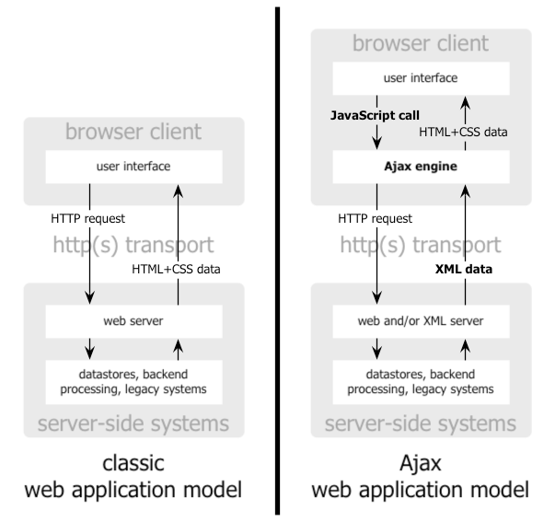
Figure 1 - Classic web app vs. AJAX
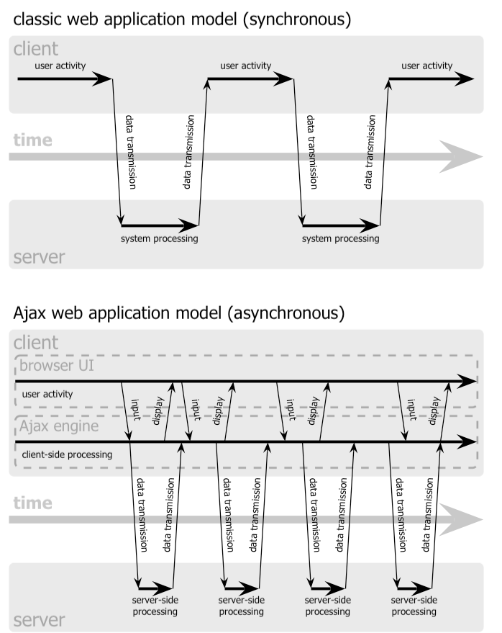
Figure 2 - Synchronous (classic) vs. Asynchronous (AJAX) client-server interaction

These days more and more ISVs are moving towards rich internet applications based on AJAX. This has enabled a new breed of applications, which hitherto was deemed to be impossible to be browser based and made available over internet. On demand CRM solutions by salesforce.com, interactive maps by Google, the new Google Suggest search engine, online photo management by Flickr.
The challenge with applying AJAX is not the technologies – these are all matured, but the application of these technologies to deliver the business solutions to the user in a exhilarating way. Another challenge is to ensure that we provide browser compatibility for our AJAX applications across some of the commonly used browsers such as IE, Firefox, Safari, Netscape and Opera. To that end, several AJAX JavaScript frameworks (commercial and open source) either generate JavaScript code based on server-side logic or tag libraries, or provide a client-side JavaScript library to facilitate cross-browser AJAX development. Some of the more popular frameworks include AJAX.Net, Backbase, Bitkraft, Django, DOJO, DWR (Direct Web Remoting), MochiKit, Prototype, Rico (based on Prototype), Sajax, Sarissa, and Script.aculo.us. Also note the end users should be willing to execute the JavaScript to harness the AJAX feature.

Since AJAX uses JavaScript extensively, you are better off using some development tools and IDE’s that support JavaScript. Eclipse has a JavaScript plug-in. Commercial IDE IntelliJ IDEA has extensive support for JavaScript.

Although several ISV’s have used AJAX successfully, note that it requires different skill sets both for design and development. From the design perspective, you need to understand and break through the traditional MVC framework. You need to create public API’s that are accessed by your AJAX requests, and also bypass/supplement the traditional MVC with direct remote calls from the web application. From the development perspective, you need more familiarity with JavaScript, XML and DOM than is needed for a classic web application. Knowing what AJAX can bring to your web application, exercise caution when implementing Ajax solutions.

Resources and References

Introduction to AJAX
Eclipse JavaScript Plug-in
Direct Web Remoting
Prototype JavaScript Library
RICO for building RIA
Open Source JavaScript Editor
AJAX Resources
Document Object Model
AJAXAnywhere
Java BluePrints AJAX Components
Using AJAX with JAVA technology

