The Module split and interaction diagram

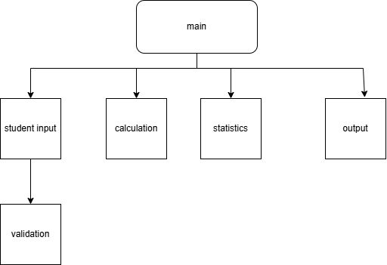
Fig: Module Interaction Diagram
This diagram shows how the Student Result Processing System is divided into different modules.
The main module controls the flow of execution. It calls the input, validation, calculation, statistics, and output modules. Each module performs a specific task, which improves modularity and reusability.
Documentation - Student Result Processing System

Module 1: Main Module
Module Name: main
Input: name of the input file entered by the user.
Pre-condition:
- The input file should exist
- The file should contain valid student data
Logic:
- Ask the user to enter the input file name
- Open the input file
- Call the student input module to read student details
- Call the calculation module to calculate total, percentage, grade, and CGPA
- Call the statistics module to calculate class statistics
- Call the output module to write results into output file
- Close all opened files
Output: student results and statistics stored in output file.

Module 2: Student Input Module
Module Name: student_input
Input: Input file pointer
Pre-condition: Input file must be opened successfully
Logic:
- Read student ID, name and marks from the given input file using the file pointer.
- Validate the data using validation module.
- Store onlyvalid student data in the student structure
Output: List of student records.
Module 3: Validation Module
Module Name: validation
Input:
- Student ID
- Student Name
- Marks
Pre-condition: Input values must not be empty or null.
Logic:
- Check whether student ID contains only letters and numbers(alpha numeric).
- Check whether name contains only alphabets or not.
- Check whether marks are between 0 and 100.
Output: Result of the validation(valid or invalid).

Module 4: Calculation Module
Module Name: calculation
Input: student records
Pre-condition: Marks must be valid
Logic:
- Add marks of all subjects to get total.
- Calculate percentage
- Assign grade based on percentage
- Calculate CGPA
Output: updated student records with Total, Percentage , Grade and CGPA.

Module 5: Statistics Module
Module Name: statistics
Input: Student records
Pre-condition: At least one student record should be present.
Logic:
- Find highest percentage in the class.
- Find lowest percentage in the class.
- Calculate average percentage.
Output: Class Statistic Values .

Module 6: Ouput Module
Module Name: output
Input:
- Student records
- Class statistics
Pre-condition: output file must be writable.
Logic:
Open output file
Write student details in a readable format
Write class statistics
Close output file
Output: Output file containing final student results and statistics.

